EDW Branching Strategy and CI/CD Deployment Process
Version: 1.0
Audience: EDW Team
Purpose: Define the source control, branching strategy, and deployment process for Metameta and Azure Data Factory (ADF).

1. Introduction
This document outlines the branching strategy and CI/CD deployment approach used for Metameta and Azure Data Factory (ADF). The objective is to maintain a controlled promotion process across development, test, UAT, and production environments while ensuring traceability, code quality, and deployment consistency.

2. Metameta Branching Strategy
The following branches are used within the Metameta repository:
• main – Production branch
• team/analyties – Integration branch for development and testing
• feature_branch – Individual development branch

Development Workflow
1. Developers create and work in feature_branch.
2. Completed changes are reviewed and merged into team/analyties.
3. CI/CD pipelines deploy artifacts from team/analyties to DEV and TEST.
4. After successful validation and sign-off, changes are merged into main.
5. Deployments from main are promoted to the Production environment.

Metameta Deployment Flow
feature_branch → team/analyties → DEV → TEST → main → PROD

3. Azure Data Factory (ADF) Branching Strategy
The following branches are used within ADF:
• feature branch – Development activities
• Master – Collaboration and source control branch
• adf_publish – Auto-generated deployment artifacts

Development Workflow
1. Developers implement pipeline changes in feature branches.
2. Changes are merged into Master following review and validation.
3. ADF Publish is executed from Master.
4. Publishing generates ARM templates and deployment artifacts in adf_publish.
5. Release pipelines deploy adf_publish artifacts to higher environments.

ADF Deployment Flow
feature branch → Master → Publish → adf_publish → TEST / UAT / PROD

4. CI/CD Deployment Strategy
The deployment process follows environment promotion principles. Only validated changes are promoted to higher environments. Automated deployment pipelines reduce manual effort and ensure consistency across environments.
Application | Source Branch | Target Environments
Metameta | team/analyties | DEV, TEST
Metameta | main | PROD
ADF | adf_publish | TEST, UAT, PROD

5. Internal Working Model
• All development activities should originate from feature branches.
• Pull requests and code reviews should be completed before merging.
• Environment-specific configurations should be maintained outside source code wherever possible.
• Production deployments must originate only from approved branches.
• Deployment logs and release history should be retained for auditability.

6. Recommended Governance
To maintain a stable delivery process, the following practices are recommended:
• Enforce pull request approvals.
• Protect main and Master branches from direct commits.
• Perform testing in DEV and TEST before production promotion.
• Maintain release documentation for production deployments.
• Use automated validation checks within CI/CD pipelines.

7. Reference Screenshot
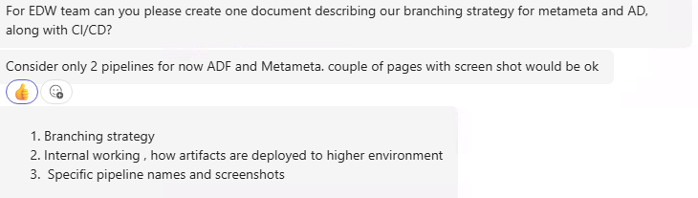
Figure 1: Initial requirements and scope provided for documenting the EDW branching and deployment strategy.

