EDW Leadership Review – Branching Strategy, CI/CD, Governance and Release Management

1. Branching Flow Diagrams (Visio-style)
Metameta
feature_branch
|
v
team/analyties
|
+-------> DEV
|
+-------> TEST
|
v
main
|
v
PROD
ADF
feature branch
|
v
Master
|
v
Publish
|
v
adf_publish
|
+-------> TEST
|
+-------> UAT
|
v
PROD

2. Azure DevOps Pipeline Reference
The following screenshots should be inserted before leadership sign-off:
• Metameta CI/CD Pipeline
• ADF Build/Publish Pipeline
• ADF Release Pipeline
• Environment Deployment History
• Approval Gates Configuration
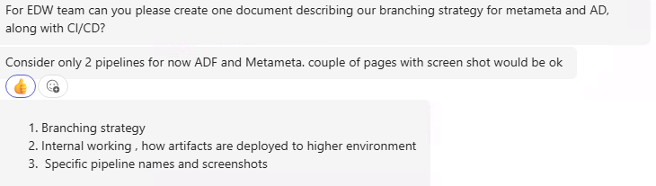

3. RACI Matrix
Activity | Developer | Tech Lead | EDW Lead | Release Manager
Feature Development | R | A | I | I
Code Review | C | A | I | I
Merge to Integration Branch | R | A | I | I
DEV/TEST Deployment | C | A | I | R
UAT Approval | I | C | A | R
Production Approval | I | C | A | R
Production Deployment | I | C | A | R
Rollback Decision | I | C | A | R
R = Responsible, A = Accountable, C = Consulted, I = Informed

4. Release Management Process
1. Development completed in feature branch.
2. Pull Request and code review completed.
3. Merge into integration branch (team/analyties or Master).
4. Automated CI validation executed.
5. Deploy to DEV and TEST.
6. Business/User validation completed.
7. Release approval obtained.
8. Production deployment executed through approved pipeline.
9. Post-deployment validation performed.
10. Release closure and documentation update.

5. Rollback Strategy
Metameta:
• Re-deploy last successful production artifact from main.
• Revert offending commit and redeploy.
• Validate impacted metadata and services.
ADF:
• Re-deploy previous successful adf_publish artifact.
• Restore prior ARM template version from repository.
• Re-publish and redeploy if required.
General Controls:
• Maintain deployment history.
• Retain release artifacts.
• Execute smoke tests after rollback.
• Notify stakeholders and document root cause analysis.

6. Leadership Recommendations
• Protect main and Master branches from direct commits.
• Enforce mandatory pull request approvals.
• Implement automated quality gates.
• Require business approval before Production deployment.
• Maintain release calendar and deployment audit trail.
• Review deployment metrics and rollback incidents quarterly.

