Kubernetes Day 6 3 June 2026
Bhavana@LAPTOP-E0A1LIKM MINGW64 ~/Downloads/Bhavana Work/AWS Devops/AWS-Devops_MC_B17D (main)
$ eksctl create cluster --name prod --nodegroup-name b17dng --node-type t3.micro --nodes 5 --managed

Bhavana@LAPTOP-E0A1LIKM MINGW64 ~/Downloads/Bhavana Work/AWS Devops/AWS-Devops_MC_B17D (main)
$ eksctl get cluster
NAME REGION EKSCTL CREATED
prod us-east-1 True

Bhavana@LAPTOP-E0A1LIKM MINGW64 ~/Downloads/Bhavana Work/AWS Devops/AWS-Devops_MC_B17D (main)
$ kubectl get nodes
NAME STATUS ROLES AGE VERSION
ip-192-168-17-129.ec2.internal Ready <none> 4m57s v1.34.8-eks-3385e9b
ip-192-168-21-182.ec2.internal Ready <none> 4m57s v1.34.8-eks-3385e9b
ip-192-168-31-61.ec2.internal Ready <none> 4m57s v1.34.8-eks-3385e9b
ip-192-168-50-167.ec2.internal Ready <none> 4m52s v1.34.8-eks-3385e9b
ip-192-168-53-4.ec2.internal Ready <none> 4m54s v1.34.8-eks-3385e9b

Bhavana@LAPTOP-E0A1LIKM MINGW64 ~/Downloads/Bhavana Work/AWS Devops/AWS-Devops_MC_B17D (main)
$ cd Kubernetes/ practice/3_June/

Bhavana@LAPTOP-E0A1LIKM MINGW64 ~/Downloads/Bhavana Work/AWS Devops/AWS-Devops_MC_B17D/Kubernetes/practice/3_June (main)
$ ll
total 4
-rw-r--r-- 1 Bhavana 197121 656 Jun 4 05:38 2_instadeploy_v1.yaml
-rw-r--r-- 1 Bhavana 197121 0 Jun 4 05:38 3_instadeploy_v2.yaml

#2_instadeploy_v1.yaml
---
apiVersion: apps/v1
kind: Deployment
metadata:
name: fb-deployment #name should be same in other (v2) version of deployment yaml file
labels:
app: fb-deploy
env: prod

spec:
replicas: 3
strategy:
type: RollingUpdate
rollingUpdate:
maxUnavailable: 1
maxSurge: 1
selector:
matchLabels:
app: fb-app
env: prod
template:
metadata:
labels:
app: fb-app
env: prod
version: v1
spec:
containers:
- name: fb-container
image: dockerhub1105/practicerepo:mc_app_img
ports:
- containerPort: 8080

Bhavana@LAPTOP-E0A1LIKM MINGW64 ~/Downloads/Bhavana Work/AWS Devops/AWS-Devops_MC_B17D/Kubernetes/practice/3_June (main)
$ kubectl apply -f 2_instadeploy_v1.yaml
deployment.apps/fb-deployment created

Bhavana@LAPTOP-E0A1LIKM MINGW64 ~/Downloads/Bhavana Work/AWS Devops/AWS-Devops_MC_B17D/Kubernetes/practice/3_June (main)
$ kubectl get all
NAME READY STATUS RESTARTS AGE
pod/fb-deployment-5c47c87456-gtd42 1/1 Running 0 8s
pod/fb-deployment-5c47c87456-sgbmr 1/1 Running 0 8s
pod/fb-deployment-5c47c87456-xv5gd 1/1 Running 0 8s

NAME TYPE CLUSTER-IP EXTERNAL-IP PORT(S) AGE
service/kubernetes ClusterIP 10.100.0.1 <none> 443/TCP 11m

NAME READY UP-TO-DATE AVAILABLE AGE
deployment.apps/fb-deployment 3/3 3 3 9s

NAME DESIRED CURRENT READY AGE
replicaset.apps/fb-deployment-5c47c87456 3 3 3 10s

Bhavana@LAPTOP-E0A1LIKM MINGW64 ~/Downloads/Bhavana Work/AWS Devops/AWS-Devops_MC_B17D/Kubernetes/practice/3_June (main)
$ kubectl describe deploy fb-deployment
Name: fb-deployment
Namespace: default
CreationTimestamp: Thu, 04 Jun 2026 05:47:52 +0530
Labels: app=fb-deploy
env=prod
Annotations: deployment.kubernetes.io/revision: 1
Selector: app=fb-app,env=prod
Replicas: 3 desired | 3 updated | 3 total | 3 available | 0 unavailable
StrategyType: RollingUpdate
MinReadySeconds: 0
RollingUpdateStrategy: 1 max unavailable, 1 max surge
Pod Template:
Labels: app=fb-app
env=prod
version=v1
Containers:
fb-container:
Image: dockerhub1105/practicerepo:mc_app_img
Port: 8080/TCP
Host Port: 0/TCP
Environment: <none>
Mounts: <none>
Volumes: <none>
Node-Selectors: <none>
Tolerations: <none>
Conditions:
Type Status Reason
---- ------ ------
Available True MinimumReplicasAvailable
Progressing True NewReplicaSetAvailable
OldReplicaSets: <none>
NewReplicaSet: fb-deployment-5c47c87456 (3/3 replicas created)
Events:
Type Reason Age From Message
---- ------ ---- ---- -------
Normal ScalingReplicaSet 64s deployment-controller Scaled up replica set fb-deployment-5c47c87456 from 0 to 3

Bhavana@LAPTOP-E0A1LIKM MINGW64 ~/Downloads/Bhavana Work/AWS Devops/AWS-Devops_MC_B17D/Kubernetes/practice/3_June (main)
$ kubectl get po -o wide
NAME READY STATUS RESTARTS AGE IP NODE NOMINATED NODE READINESS GATES
fb-deployment-5c47c87456-gtd42 1/1 Running 0 3m59s 192.168.10.111 ip-192-168-17-129.ec2.internal <none> <none>
fb-deployment-5c47c87456-sgbmr 1/1 Running 0 3m59s 192.168.40.46 ip-192-168-53-4.ec2.internal <none> <none>
fb-deployment-5c47c87456-xv5gd 1/1 Running 0 3m59s 192.168.49.69 ip-192-168-50-167.ec2.internal <none> <none>

Bhavana@LAPTOP-E0A1LIKM MINGW64 ~/Downloads/Bhavana Work/AWS Devops/AWS-Devops_MC_B17D/Kubernetes/practice/3_June (main)
$ kubectl exec -it fb-deployment-5c47c87456-gtd42 -- bash
root@fb-deployment-5c47c87456-gtd42:/usr/local/tomcat/webapps# ll
total 32
drwxr-xr-x. 1 root root 18 Jun 4 00:18 ./
drwxr-xr-x. 1 root root 57 May 5 23:13 ../
drwxr-x---. 4 root root 54 Jun 4 00:18 ROOT/
-rw-r--r--. 1 root root 30164 May 13 09:19 ROOT.war
Exit
#4_lb-svc.yaml
---
apiVersion: v1
kind: Service
metadata:
name: fb-service
labels:
app: fb-service
env: prod
spec:
type: LoadBalancer
selector:
app: fb-app
env: prod
ports:
- protocol: TCP
port: 80 # This is the load balancer port, which is a external port.
targetPort: 8080 # This is the container port on which the application is running.

Bhavana@LAPTOP-E0A1LIKM MINGW64 ~/Downloads/Bhavana Work/AWS Devops/AWS-Devops_MC_B17D/Kubernetes/practice/3_June (main)
$ kubectl apply -f 4_lb-svc.yaml
service/fb-service created

Bhavana@LAPTOP-E0A1LIKM MINGW64 ~/Downloads/Bhavana Work/AWS Devops/AWS-Devops_MC_B17D/Kubernetes/practice/3_June (main)
$ kubectl get all
NAME READY STATUS RESTARTS AGE
pod/fb-deployment-5c47c87456-gtd42 1/1 Running 0 11m
pod/fb-deployment-5c47c87456-sgbmr 1/1 Running 0 11m
pod/fb-deployment-5c47c87456-xv5gd 1/1 Running 0 11m

NAME TYPE CLUSTER-IP EXTERNAL-IP PORT(S) AGE
service/fb-service LoadBalancer 10.100.183.47 a288533cb3d0148ea9fe08d9dfc0b286-2042922771.us-east-1.elb.amazonaws.com 80:31672/TCP 7s
service/kubernetes ClusterIP 10.100.0.1 <none> 443/TCP 23m

NAME READY UP-TO-DATE AVAILABLE AGE
deployment.apps/fb-deployment 3/3 3 3 11m

NAME DESIRED CURRENT READY AGE
replicaset.apps/fb-deployment-5c47c87456 3 3 3 11m

Bhavana@LAPTOP-E0A1LIKM MINGW64 ~/Downloads/Bhavana Work/AWS Devops/AWS-Devops_MC_B17D/Kubernetes/practice/3_June (main)
$ kubectl get svc
NAME TYPE CLUSTER-IP EXTERNAL-IP PORT(S) AGE
fb-service LoadBalancer 10.100.183.47 a288533cb3d0148ea9fe08d9dfc0b286-2042922771.us-east-1.elb.amazonaws.com 80:31672/TCP 20s
kubernetes ClusterIP 10.100.0.1 <none> 443/TCP 23m

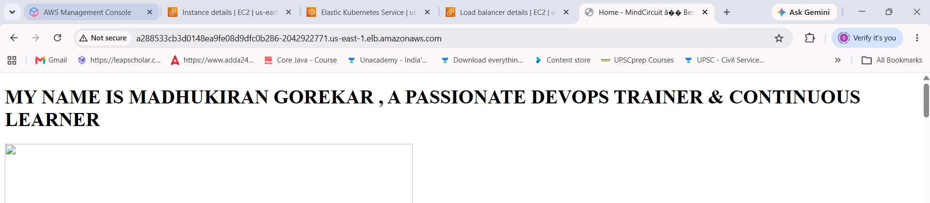
#3_instadeploy_v2.yaml
---
apiVersion: apps/v1
kind: Deployment
metadata:
name: fb-deployment #name should be same in other (v1) version of deployment yaml file
labels:
app: fb-deploy
env: prod
spec:
replicas: 3
strategy:
type: RollingUpdate
rollingUpdate:
maxUnavailable: 1
maxSurge: 1
selector:
matchLabels:
app: fb-app
env: prod
template:
metadata:
labels:
app: fb-app
env: prod
version: v2
spec:
containers:
- name: fb-container
image: dockerhub1105/practicerepo:python_image_v1
ports:
- containerPort: 8080

Bhavana@LAPTOP-E0A1LIKM MINGW64 ~/Downloads/Bhavana Work/AWS Devops/AWS-Devops_MC_B17D/Kubernetes/practice/3_June (main)
$ kubectl apply -f 3_instadeploy_v2.yaml
deployment.apps/fb-deployment configured

Bhavana@LAPTOP-E0A1LIKM MINGW64 ~/Downloads/Bhavana Work/AWS Devops/AWS-Devops_MC_B17D/Kubernetes/practice/3_June (main)
$ kubectl get all
NAME READY STATUS RESTARTS AGE
pod/fb-deployment-7f8bb96d5c-58qbz 1/1 Running 0 15s
pod/fb-deployment-7f8bb96d5c-pbd44 1/1 Running 0 15s
pod/fb-deployment-7f8bb96d5c-shvr5 1/1 Running 0 14s

NAME TYPE CLUSTER-IP EXTERNAL-IP PORT(S) AGE
service/fb-service LoadBalancer 10.100.183.47 a288533cb3d0148ea9fe08d9dfc0b286-2042922771.us-east-1.elb.amazonaws.com 80:31672/TCP 6m15s
service/kubernetes ClusterIP 10.100.0.1 <none> 443/TCP 29m

NAME READY UP-TO-DATE AVAILABLE AGE
deployment.apps/fb-deployment 3/3 3 3 17m

NAME DESIRED CURRENT READY AGE
replicaset.apps/fb-deployment-5c47c87456 0 0 0 17m
replicaset.apps/fb-deployment-7f8bb96d5c 3 3 3 16s

Bhavana@LAPTOP-E0A1LIKM MINGW64 ~/Downloads/Bhavana Work/AWS Devops/AWS-Devops_MC_B17D/Kubernetes/practice/3_June (main)
$ kubectl describe deploy fb-deployment
Name: fb-deployment
Namespace: default
CreationTimestamp: Thu, 04 Jun 2026 05:47:52 +0530
Labels: app=fb-deploy
env=prod
Annotations: deployment.kubernetes.io/revision: 2
Selector: app=fb-app,env=prod
Replicas: 3 desired | 3 updated | 3 total | 3 available | 0 unavailable
StrategyType: RollingUpdate
MinReadySeconds: 0
RollingUpdateStrategy: 1 max unavailable, 1 max surge
Pod Template:
Labels: app=fb-app
env=prod
version=v2
Containers:
fb-container:
Image: dockerhub1105/practicerepo:python_image_v1
Port: 8080/TCP
Host Port: 0/TCP
Environment: <none>
Mounts: <none>
Volumes: <none>
Node-Selectors: <none>
Tolerations: <none>
Conditions:
Type Status Reason
---- ------ ------
Available True MinimumReplicasAvailable
Progressing True NewReplicaSetAvailable
OldReplicaSets: fb-deployment-5c47c87456 (0/0 replicas created)
NewReplicaSet: fb-deployment-7f8bb96d5c (3/3 replicas created)
Events:
Type Reason Age From Message
---- ------ ---- ---- -------
Normal ScalingReplicaSet 18m deployment-controller Scaled up replica set fb-deployment-5c47c87456 from 0 to 3
Normal ScalingReplicaSet 58s deployment-controller Scaled up replica set fb-deployment-7f8bb96d5c from 0 to 1
Normal ScalingReplicaSet 58s deployment-controller Scaled down replica set fb-deployment-5c47c87456 from 3 to 2
Normal ScalingReplicaSet 58s deployment-controller Scaled up replica set fb-deployment-7f8bb96d5c from 1 to 2
Normal ScalingReplicaSet 57s deployment-controller Scaled down replica set fb-deployment-5c47c87456 from 2 to 1
Normal ScalingReplicaSet 57s deployment-controller Scaled up replica set fb-deployment-7f8bb96d5c from 2 to 3
Normal ScalingReplicaSet 57s deployment-controller Scaled down replica set fb-deployment-5c47c87456 from 1 to 0

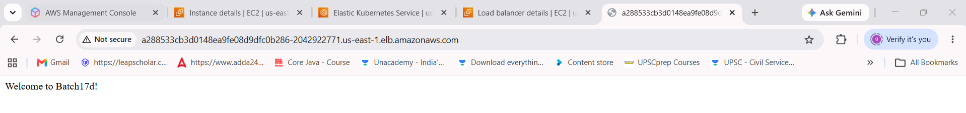
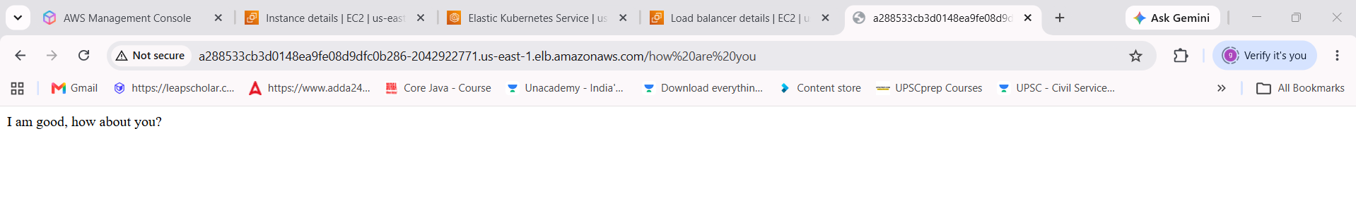
Bhavana@LAPTOP-E0A1LIKM MINGW64 ~/Downloads/Bhavana Work/AWS Devops/AWS-Devops_MC_B17D/Kubernetes/practice/3_June (main)
$ kubectl rollout undo deploy fb-deployment


Bhavana@LAPTOP-E0A1LIKM MINGW64 ~/Downloads/Bhavana Work/AWS Devops/AWS-Devops_MC_B17D/Kubernetes/practice/3_June (main)
$ kubectl delete deploy fb-deployment
deployment.apps "fb-deployment" deleted from default namespace

Bhavana@LAPTOP-E0A1LIKM MINGW64 ~/Downloads/Bhavana Work/AWS Devops/AWS-Devops_MC_B17D/Kubernetes/practice/3_June (main)
$ kubectl get all
NAME TYPE CLUSTER-IP EXTERNAL-IP PORT(S) AGE
service/fb-service LoadBalancer 10.100.183.47 a288533cb3d0148ea9fe08d9dfc0b286-2042922771.us-east-1.elb.amazonaws.com 80:31672/TCP 17m
service/kubernetes ClusterIP 10.100.0.1 <none> 443/TCP 40m

Bhavana@LAPTOP-E0A1LIKM MINGW64 ~/Downloads/Bhavana Work/AWS Devops/AWS-Devops_MC_B17D/Kubernetes/practice/3_June (main)
$ kubectl delete svc fb-service
service "fb-service" deleted from default namespace
Bhavana@LAPTOP-E0A1LIKM MINGW64 ~/Downloads/Bhavana Work/AWS Devops/AWS-Devops_MC_B17D/Kubernetes/practice/3_June (main)
$ kubectl get all
NAME TYPE CLUSTER-IP EXTERNAL-IP PORT(S) AGE
service/kubernetes ClusterIP 10.100.0.1 <none> 443/TCP 41m

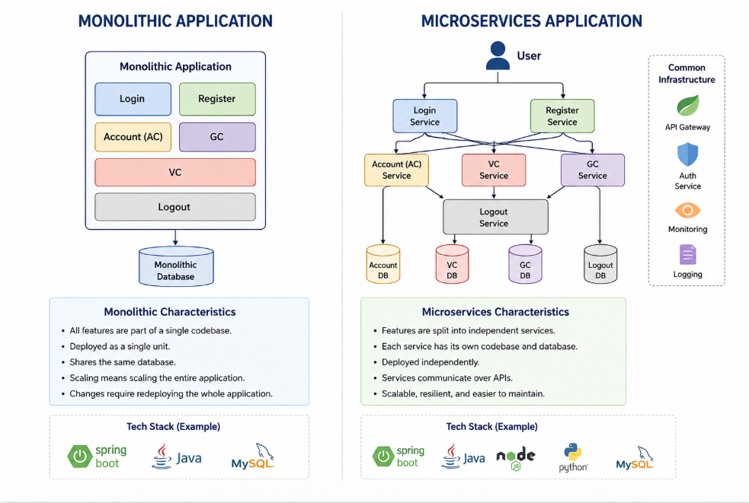
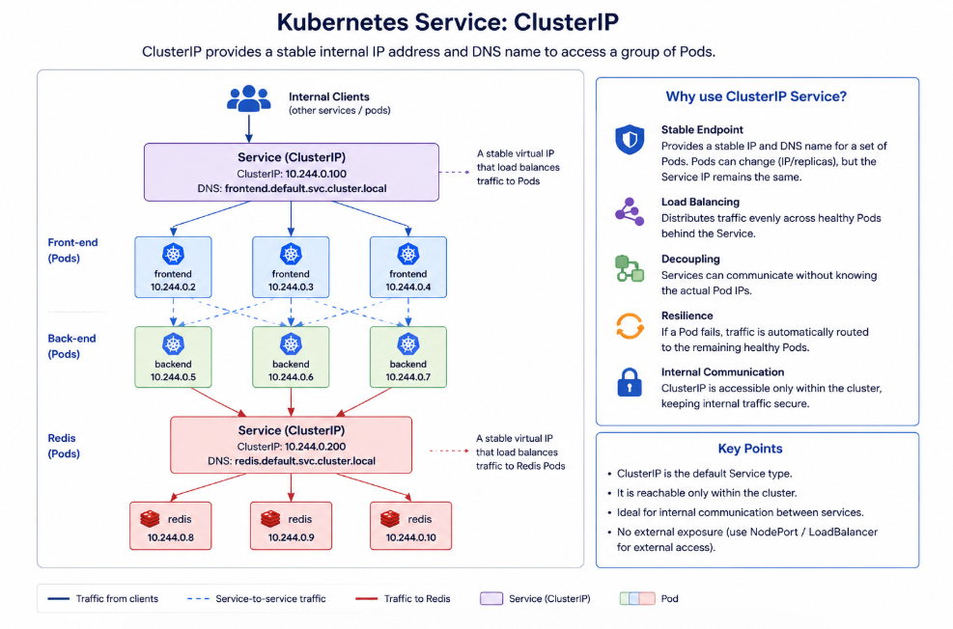

#5_clusterip_svc.yaml
---
apiVersion: v1
kind: Service
metadata:
name: fb-service
labels:
app: fb-service
env: prod
spec:
type: ClusterIP #we use clusterip when we want to access the service only within the cluster.
selector:
app: fb-app
env: prod
ports:
- protocol: TCP
port: 80 # This is the port to access the service, which is a internal port.
targetPort: 8080 # This is the port on which the application is running inside the container.

Bhavana@LAPTOP-E0A1LIKM MINGW64 ~/Downloads/Bhavana Work/AWS Devops/AWS-Devops_MC_B17D/Kubernetes/practice/3_June (main)
$ kubectl apply -f 5_clusterip-svc.yaml
service/fb-service configured

Bhavana@LAPTOP-E0A1LIKM MINGW64 ~/Downloads/Bhavana Work/AWS Devops/AWS-Devops_MC_B17D/Kubernetes/practice/3_June (main)
$ kubectl get all
NAME TYPE CLUSTER-IP EXTERNAL-IP PORT(S) AGE
service/fb-service ClusterIP 10.100.59.42 <none> 80/TCP 27s
service/kubernetes ClusterIP 10.100.0.1 <none> 443/TCP 60m

Bhavana@LAPTOP-E0A1LIKM MINGW64 ~/Downloads/Bhavana Work/AWS Devops/AWS-Devops_MC_B17D/Kubernetes/practice/3_June (main)
$ kubectl get svc
NAME TYPE CLUSTER-IP EXTERNAL-IP PORT(S) AGE
fb-service ClusterIP 10.100.59.42 <none> 80/TCP 50s
kubernetes ClusterIP 10.100.0.1 <none> 443/TCP 60m

Bhavana@LAPTOP-E0A1LIKM MINGW64 ~/Downloads/Bhavana Work/AWS Devops/AWS-Devops_MC_B17D/Kubernetes/practice/3_June (main)
$ kubectl apply -f 3_instadeploy_v2.yaml
deployment.apps/fb-deployment created

Bhavana@LAPTOP-E0A1LIKM MINGW64 ~/Downloads/Bhavana Work/AWS Devops/AWS-Devops_MC_B17D/Kubernetes/practice/3_June (main)
$ kubectl get all
NAME READY STATUS RESTARTS AGE
pod/fb-deployment-58d8bd65b9-n5bzg 1/1 Running 0 9s
pod/fb-deployment-58d8bd65b9-rdrj6 1/1 Running 0 9s
pod/fb-deployment-58d8bd65b9-znrsj 1/1 Running 0 9s

NAME TYPE CLUSTER-IP EXTERNAL-IP PORT(S) AGE
service/fb-service ClusterIP 10.100.59.42 <none> 80/TCP 114s
service/kubernetes ClusterIP 10.100.0.1 <none> 443/TCP 61m

NAME READY UP-TO-DATE AVAILABLE AGE
deployment.apps/fb-deployment 3/3 3 3 10s

NAME DESIRED CURRENT READY AGE
replicaset.apps/fb-deployment-58d8bd65b9 3 3 3 10s

Bhavana@LAPTOP-E0A1LIKM MINGW64 ~/Downloads/Bhavana Work/AWS Devops/AWS-Devops_MC_B17D/Kubernetes/practice/3_June (main)
$ kubectl apply -f 4_lb-svc.yaml
service/fb-service configured

Bhavana@LAPTOP-E0A1LIKM MINGW64 ~/Downloads/Bhavana Work/AWS Devops/AWS-Devops_MC_B17D/Kubernetes/practice/3_June (main)
$ kubectl get all
NAME READY STATUS RESTARTS AGE
pod/fb-deployment-58d8bd65b9-n5bzg 1/1 Running 0 32s
pod/fb-deployment-58d8bd65b9-rdrj6 1/1 Running 0 32s
pod/fb-deployment-58d8bd65b9-znrsj 1/1 Running 0 32s

NAME TYPE CLUSTER-IP EXTERNAL-IP PORT(S) AGE
service/fb-service LoadBalancer 10.100.59.42 ab66a2684e4df455cbdd571b4d131320-1186501111.us-east-1.elb.amazonaws.com 80:30151/TCP 2m18s
service/kubernetes ClusterIP 10.100.0.1 <none> 443/TCP 61m

NAME READY UP-TO-DATE AVAILABLE AGE
deployment.apps/fb-deployment 3/3 3 3 34s

NAME DESIRED CURRENT READY AGE
replicaset.apps/fb-deployment-58d8bd65b9 3 3 3 34s

Bhavana@LAPTOP-E0A1LIKM MINGW64 ~/Downloads/Bhavana Work/AWS Devops/AWS-Devops_MC_B17D/Kubernetes/practice/3_June (main)
$ kubectl get svc
NAME TYPE CLUSTER-IP EXTERNAL-IP PORT(S) AGE
fb-service LoadBalancer 10.100.59.42 ab66a2684e4df455cbdd571b4d131320-1186501111.us-east-1.elb.amazonaws.com 80:30151/TCP 2m31s
kubernetes ClusterIP 10.100.0.1 <none> 443/TCP 62m

Bhavana@LAPTOP-E0A1LIKM MINGW64 ~/Downloads/Bhavana Work/AWS Devops/AWS-Devops_MC_B17D/Kubernetes/practice/3_June (main)
$ kubectl get po -o wide
NAME READY STATUS RESTARTS AGE IP NODE NOMINATED NODE READINESS GATES
fb-deployment-58d8bd65b9-n5bzg 1/1 Running 0 65s 192.168.10.111 ip-192-168-17-129.ec2.internal <none> <none>
fb-deployment-58d8bd65b9-rdrj6 1/1 Running 0 65s 192.168.49.69 ip-192-168-50-167.ec2.internal <none> <none>
fb-deployment-58d8bd65b9-znrsj 1/1 Running 0 65s 192.168.40.46 ip-192-168-53-4.ec2.internal <none> <none>

Bhavana@LAPTOP-E0A1LIKM MINGW64 ~/Downloads/Bhavana Work/AWS Devops/AWS-Devops_MC_B17D/Kubernetes/practice/3_June (main)
$ kubectl exec -it fb-deployment-58d8bd65b9-n5bzg -- bash
bash-5.2# ls
bin boot dev etc home lib lib64 local media mnt opt proc root run sbin srv sys tmp usr var
bash-5.2# curl 10.100.0.1:80

----- you can communicate to other service (i.e internal comm’n use cluterIp service)
^C
bash-5.2# exit
exit
command terminated with exit code 130

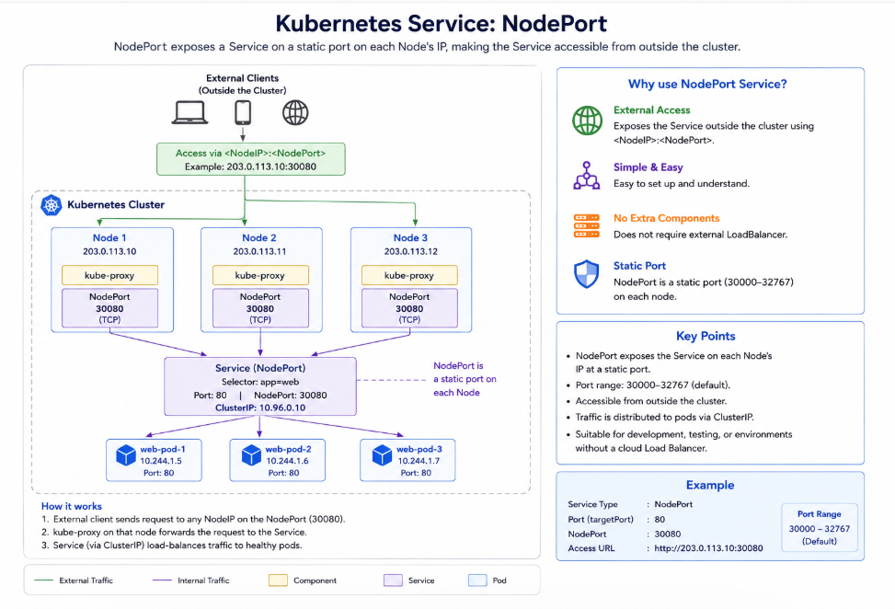

# 6_nodeportip_svc.yaml
---
apiVersion: v1
kind: Service
metadata:
name: fb-service
labels:
app: fb-service
env: prod
spec:
type: NodePort #we use nodeport when we want to access the service outside the cluster using node's IP and nodeport.
selector:
app: fb-app
env: prod
ports:
- protocol: TCP
port: 80 # This is the port to access the service, which is a external port.
targetPort: 8080 # This is the port on which the application is running inside the container.
nodePort: 30080 # This is the port on which we can access the service outside the cluster using node's IP and nodeport. It should be in the range of 30000-32767.

Bhavana@LAPTOP-E0A1LIKM MINGW64 ~/Downloads/Bhavana Work/AWS Devops/AWS-Devops_MC_B17D/Kubernetes/practice/3_June (main)
$ kubectl apply -f 6_nodeportip-svc.yaml
service/fb-service configured

Bhavana@LAPTOP-E0A1LIKM MINGW64 ~/Downloads/Bhavana Work/AWS Devops/AWS-Devops_MC_B17D/Kubernetes/practice/3_June (main)
$ kubectl get all
NAME READY STATUS RESTARTS AGE
pod/fb-deployment-58d8bd65b9-n5bzg 1/1 Running 0 16m
pod/fb-deployment-58d8bd65b9-rdrj6 1/1 Running 0 16m
pod/fb-deployment-58d8bd65b9-znrsj 1/1 Running 0 16m

NAME TYPE CLUSTER-IP EXTERNAL-IP PORT(S) AGE
service/fb-service NodePort 10.100.59.42 <none> 80:30080/TCP 18m
service/kubernetes ClusterIP 10.100.0.1 <none> 443/TCP 77m

NAME READY UP-TO-DATE AVAILABLE AGE
deployment.apps/fb-deployment 3/3 3 3 16m

NAME DESIRED CURRENT READY AGE
replicaset.apps/fb-deployment-58d8bd65b9 3 3 3 16m

Bhavana@LAPTOP-E0A1LIKM MINGW64 ~/Downloads/Bhavana Work/AWS Devops/AWS-Devops_MC_B17D/Kubernetes/practice/3_June (main)
$ kubectl get svc
NAME TYPE CLUSTER-IP EXTERNAL-IP PORT(S) AGE
fb-service NodePort 10.100.59.42 <none> 80:30080/TCP 18m
fb-service LoadBalancer10.100.59.42 ab66a2684e4df455cbdd571b4d131320-1186501111.us-east-1.elb.amazonaws.com 80:30151/TCP 2m31s
kubernetes ClusterIP 10.100.0.1 <none> 443/TCP 78m

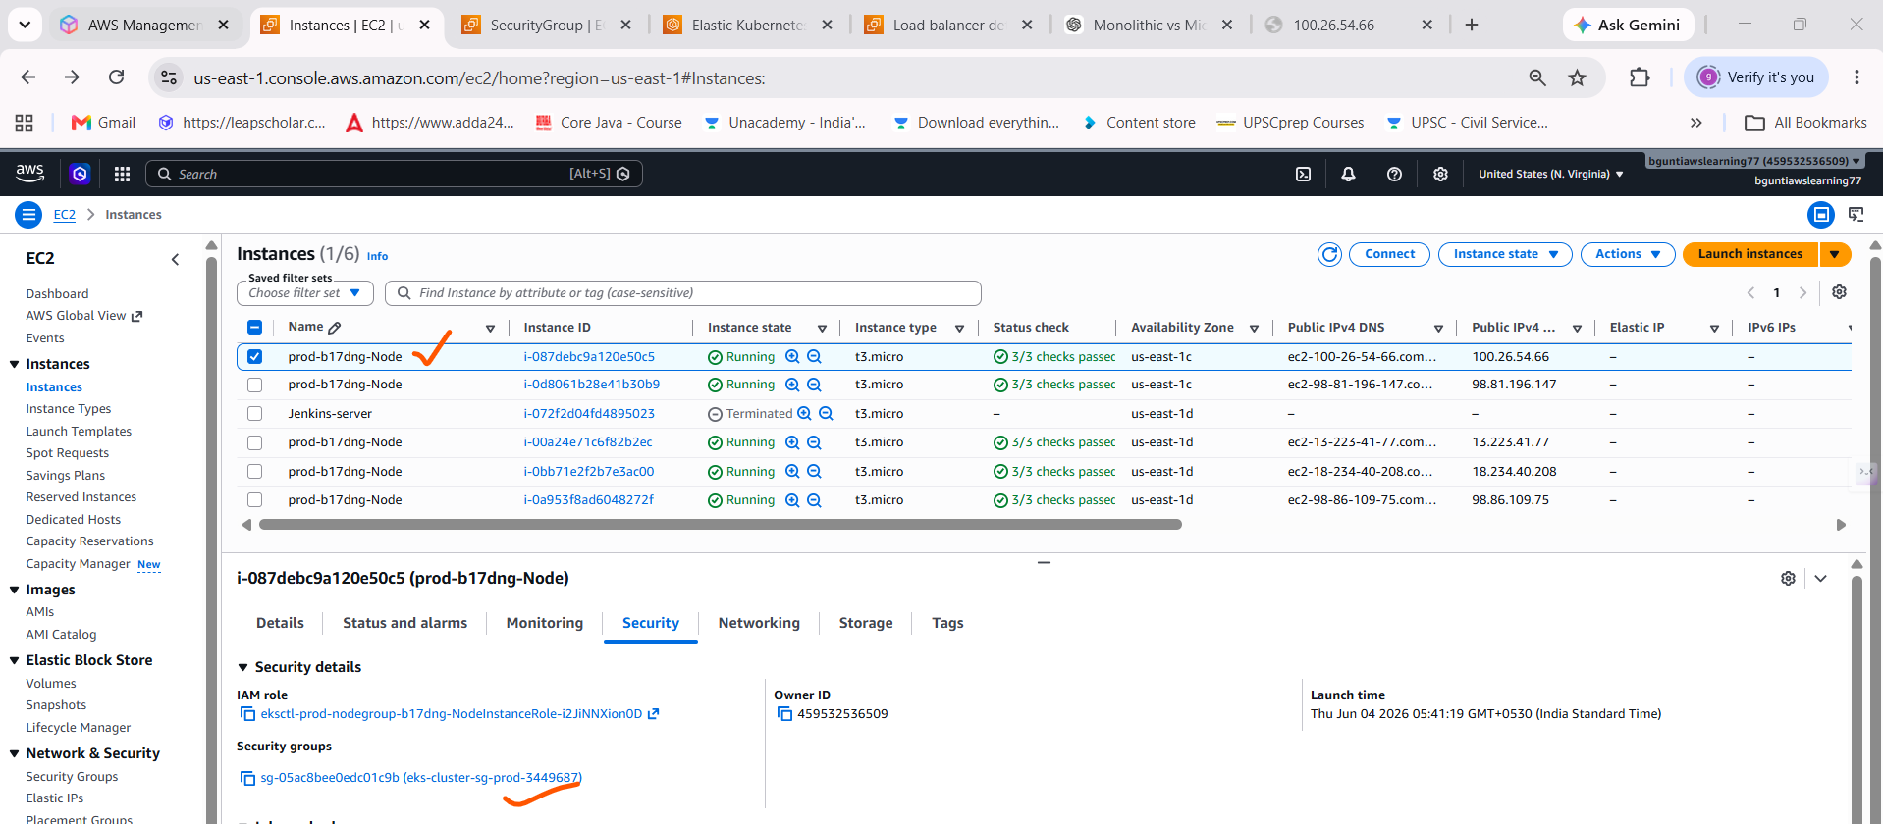

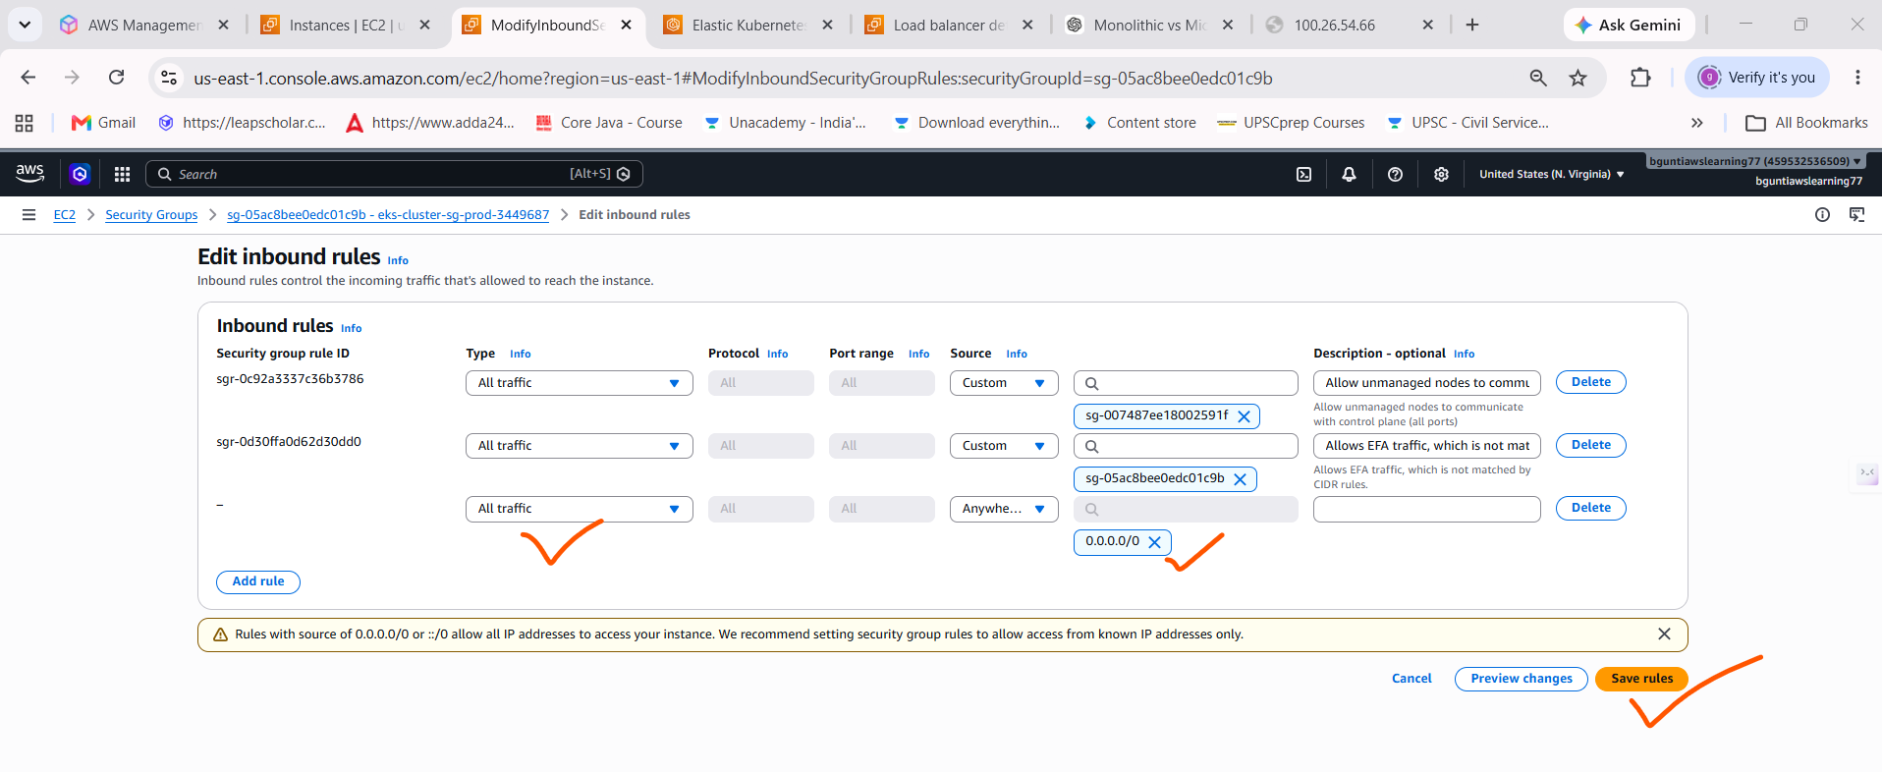
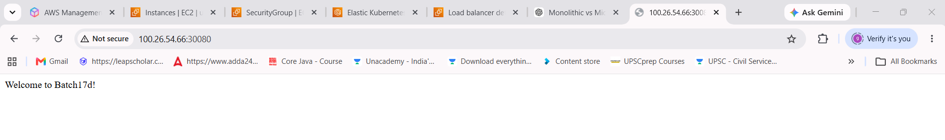
NameSpaces
Interview Answer (Short)
Namespaces in Kubernetes are used to logically separate resources within a cluster. They help with environment isolation (dev, test, prod), access control, resource quotas, and better organization of applications while sharing the same cluster infrastructure.

In Kubernetes, Namespaces are used to logically separate resources within the same cluster. They help organize, secure, and manage applications efficiently.
Why Do We Use Namespaces?
1. Resource Isolation
Different teams or applications can use the same cluster without interfering with each other.
Example:
Namespace: dev
├── nginx-pod
├── frontend-service
Namespace: prod
├── nginx-pod
├── frontend-service
Here, both namespaces can have resources with the same names.

2. Environment Separation
You can create separate environments in a single cluster.
dev
testing
staging
production
This avoids the cost of maintaining multiple clusters.

3. Access Control (RBAC)
Permissions can be assigned namespace-wise.
Example:
Developers → Access only dev
QA Team → Access only testing
Admins → Access all namespaces

4. Resource Quotas
Limit CPU, Memory, and Storage usage per namespace.
Example:
apiVersion: v1
kind: ResourceQuota
metadata:
name: dev-quota
namespace: dev
spec:
hard:
requests.cpu: "4"
requests.memory: 8Gi
This prevents one team from consuming all cluster resources.

5. Better Organization
Instead of having hundreds of Pods and Services in one place:
Without Namespace:
frontend
backend
redis
mysql
jenkins
prometheus
grafana
...
With Namespace:
dev
├── frontend
├── backend
prod
├── frontend
├── backend
monitoring
├── prometheus
├── grafana
cicd
├── jenkins
Much easier to manage.
Real-Time Example
Suppose your company has:
Kubernetes Cluster
│
├── Namespace: dev
│ ├── frontend
│ ├── backend
│ └── mysql
│
├── Namespace: prod
│ ├── frontend
│ ├── backend
│ └── mysql
│
├── Namespace: monitoring
│ ├── prometheus
│ └── grafana
│
└── Namespace: cicd
└── jenkins
All applications run in the same cluster but remain logically separated.

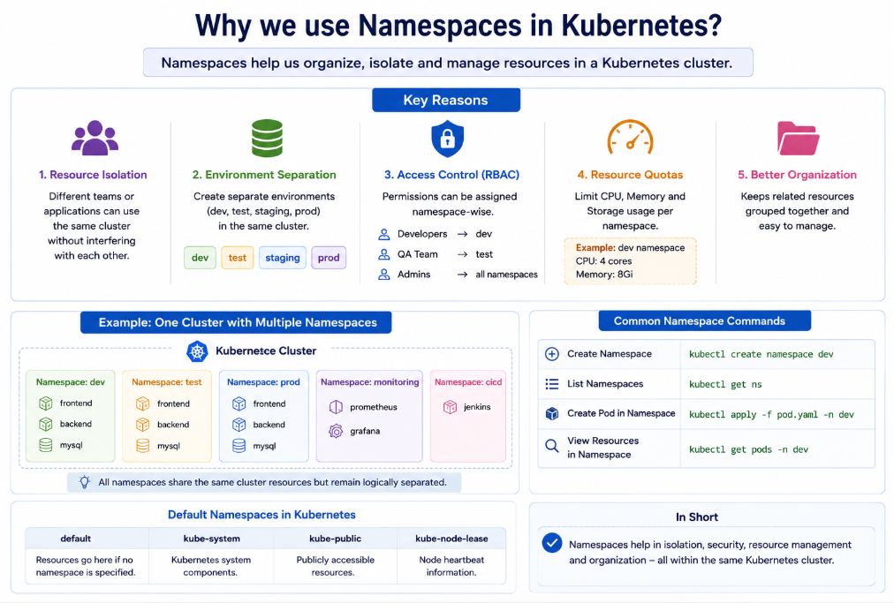

Bhavana@LAPTOP-E0A1LIKM MINGW64 ~/Downloads/Bhavana Work/AWS Devops/AWS-Devops_MC_B17D/Kubernetes/practice/3_June (main)
$ cd ..

Bhavana@LAPTOP-E0A1LIKM MINGW64 ~/Downloads/Bhavana Work/AWS Devops/AWS-Devops_MC_B17D/Kubernetes/practice (main)
$ cd 1_june/

Bhavana@LAPTOP-E0A1LIKM MINGW64 ~/Downloads/Bhavana Work/AWS Devops/AWS-Devops_MC_B17D/Kubernetes/practice/1_june (main)
$ ll
total 5
-rw-r--r-- 1 Bhavana 197121 342 Jun 2 11:46 1_pod.yaml
-rw-r--r-- 1 Bhavana 197121 455 Jun 2 11:59 2_pod.yaml
-rw-r--r-- 1 Bhavana 197121 343 Jun 2 12:34 3_multicont_pod.yaml
-rw-r--r-- 1 Bhavana 197121 612 Jun 2 13:04 4_rs.yaml
-rw-r--r-- 1 Bhavana 197121 218 Jun 2 13:45 5_pod.yaml

Bhavana@LAPTOP-E0A1LIKM MINGW64 ~/Downloads/Bhavana Work/AWS Devops/AWS-Devops_MC_B17D/Kubernetes/practice/1_june (main)
$ kubectl apply -f 1_pod.yaml
pod/fb-pod created

Bhavana@LAPTOP-E0A1LIKM MINGW64 ~/Downloads/Bhavana Work/AWS Devops/AWS-Devops_MC_B17D/Kubernetes/practice/1_june (main)
$ kubectl get all
NAME READY STATUS RESTARTS AGE
pod/fb-pod 1/1 Running 0 13s

NAME TYPE CLUSTER-IP EXTERNAL-IP PORT(S) AGE
service/kubernetes ClusterIP 10.100.0.1 <none> 443/TCP 5m8s

Bhavana@LAPTOP-E0A1LIKM MINGW64 ~/Downloads/Bhavana Work/AWS Devops/AWS-Devops_MC_B17D/Kubernetes/practice/1_june (main)
$ kubectl apply -f 1_pod.yaml
pod/fb-pod unchanged

Bhavana@LAPTOP-E0A1LIKM MINGW64 ~/Downloads/Bhavana Work/AWS Devops/AWS-Devops_MC_B17D/Kubernetes/practice/1_june (main)
$ kubectl describe pod fb-pod
Name: fb-pod
Namespace: default
Priority: 0
Service Account: default
Node: ip-192-168-17-129.ec2.internal/192.168.17.129
Start Time: Thu, 04 Jun 2026 07:27:02 +0530
Labels: app=fb-app
env=prod
Annotations: <none>
Status: Running
IP: 192.168.10.111
IPs:
IP: 192.168.10.111
Containers:
fb-container:
Container ID: containerd://c180268d2862ebe1111dc14fb28e1f6b761d1e1640803f1a2217e1e13666388f
Image: tomcat
Image ID: docker.io/library/tomcat@sha256:f8d2287df1bb2bf9b75a6acfc6d25a75b3a9044429906ff04e01533cfbafa028
Port: 8080/TCP
Host Port: 0/TCP

Events:
Type Reason Age From Message
---- ------ ---- ---- -------
Normal Scheduled 3m7s default-scheduler Successfully assigned default/fb-pod to ip-192-168-17-129.ec2.internal
Normal Pulling 3m7s kubelet spec.containers{fb-container}: Pulling image "tomcat"
Normal Pulled 3m1s kubelet spec.containers{fb-container}: Successfully pulled image "tomcat" in 6.01s (6.01s including waiting). Image size: 154491880 bytes.
Normal Created 3m1s kubelet spec.containers{fb-container}: Created container: fb-container
Normal Started 3m kubelet spec.containers{fb-container}: Started container fb-container

Bhavana@LAPTOP-E0A1LIKM MINGW64 ~/Downloads/Bhavana Work/AWS Devops/AWS-Devops_MC_B17D/Kubernetes/practice/1_june (main)
$ kubectl create namespace dev
namespace/dev created

Bhavana@LAPTOP-E0A1LIKM MINGW64 ~/Downloads/Bhavana Work/AWS Devops/AWS-Devops_MC_B17D/Kubernetes/practice/1_june (main)
$ kubectl create namespace qa
namespace/qa created

Bhavana@LAPTOP-E0A1LIKM MINGW64 ~/Downloads/Bhavana Work/AWS Devops/AWS-Devops_MC_B17D/Kubernetes/practice/1_june (main)
$ kubectl create namespace prod
namespace/prod created

Bhavana@LAPTOP-E0A1LIKM MINGW64 ~/Downloads/Bhavana Work/AWS Devops/AWS-Devops_MC_B17D/Kubernetes/practice/1_june (main)
$ kubectl get ns
NAME STATUS AGE
default Active 115m
dev Active 34s
kube-node-lease Active 115m
kube-public Active 115m
kube-system Active 115m
prod Active 15s
qa Active 22s

Bhavana@LAPTOP-E0A1LIKM MINGW64 ~/Downloads/Bhavana Work/AWS Devops/AWS-Devops_MC_B17D/Kubernetes/practice/1_june (main)
$ kubectl apply -f 1_pod.yaml -n qa
pod/fb-pod created

Bhavana@LAPTOP-E0A1LIKM MINGW64 ~/Downloads/Bhavana Work/AWS Devops/AWS-Devops_MC_B17D/Kubernetes/practice/1_june (main)
$ kubectl apply -f 1_pod.yaml -n dev
pod/fb-pod created

Bhavana@LAPTOP-E0A1LIKM MINGW64 ~/Downloads/Bhavana Work/AWS Devops/AWS-Devops_MC_B17D/Kubernetes/practice/1_june (main)
$ kubectl get po -n qa
NAME READY STATUS RESTARTS AGE
fb-pod 1/1 Running 0 37s

Bhavana@LAPTOP-E0A1LIKM MINGW64 ~/Downloads/Bhavana Work/AWS Devops/AWS-Devops_MC_B17D/Kubernetes/practice/1_june (main)
$ kubectl get po -n dev
NAME READY STATUS RESTARTS AGE
fb-pod 1/1 Running 0 26s

Bhavana@LAPTOP-E0A1LIKM MINGW64 ~/Downloads/Bhavana Work/AWS Devops/AWS-Devops_MC_B17D/Kubernetes/practice/1_june (main)
$ kubectl get po --all-namespaces
NAMESPACE NAME READY STATUS RESTARTS AGE
default fb-pod 1/1 Running 0 6m16s
dev fb-pod 1/1 Running 0 63s
kube-system aws-node-6r6l9 2/2 Running 0 111m
kube-system aws-node-ggcmz 2/2 Running 0 111m
kube-system aws-node-kdnr6 2/2 Running 0 111m
kube-system aws-node-v2fjh 2/2 Running 0 111m
kube-system aws-node-zvl5f 2/2 Running 0 111m
kube-system coredns-566b9b9d-8wdkw 1/1 Running 0 114m
kube-system coredns-566b9b9d-dphxl 1/1 Running 0 114m
kube-system kube-proxy-6nxzw 1/1 Running 0 111m
kube-system kube-proxy-mmhxq 1/1 Running 0 111m
kube-system kube-proxy-prt69 1/1 Running 0 111m
kube-system kube-proxy-rqhg5 1/1 Running 0 111m
kube-system kube-proxy-x5bbv 1/1 Running 0 111m
kube-system metrics-server-694dffc97b-q89rw 1/1 Running 0 109m
kube-system metrics-server-694dffc97b-xtqjr 1/1 Running 0 109m
qa fb-pod

---
apiVersion: v1
kind: Pod
metadata:
name: fb-pod #pod name
labels:
app: fb-app # this is the label of the pod, we can use this label to select the pod.
namespace: prod

spec:
containers:
- name: fb-container #container name used in the pod
image: tomcat
ports:
- containerPort: 8080 # tomcat server port.

kubectl apply -f pod.yaml

Verify
Check namespaces:
kubectl get ns
Check pods in prod namespace:
kubectl get pods -n dev
Expected output:
NAME READY STATUS RESTARTS AGE
nginx-pod 1/1 Running 0 1m

