**Integrating GitHub with Azure DevOps Repos**

**Step 1: Create a Project**

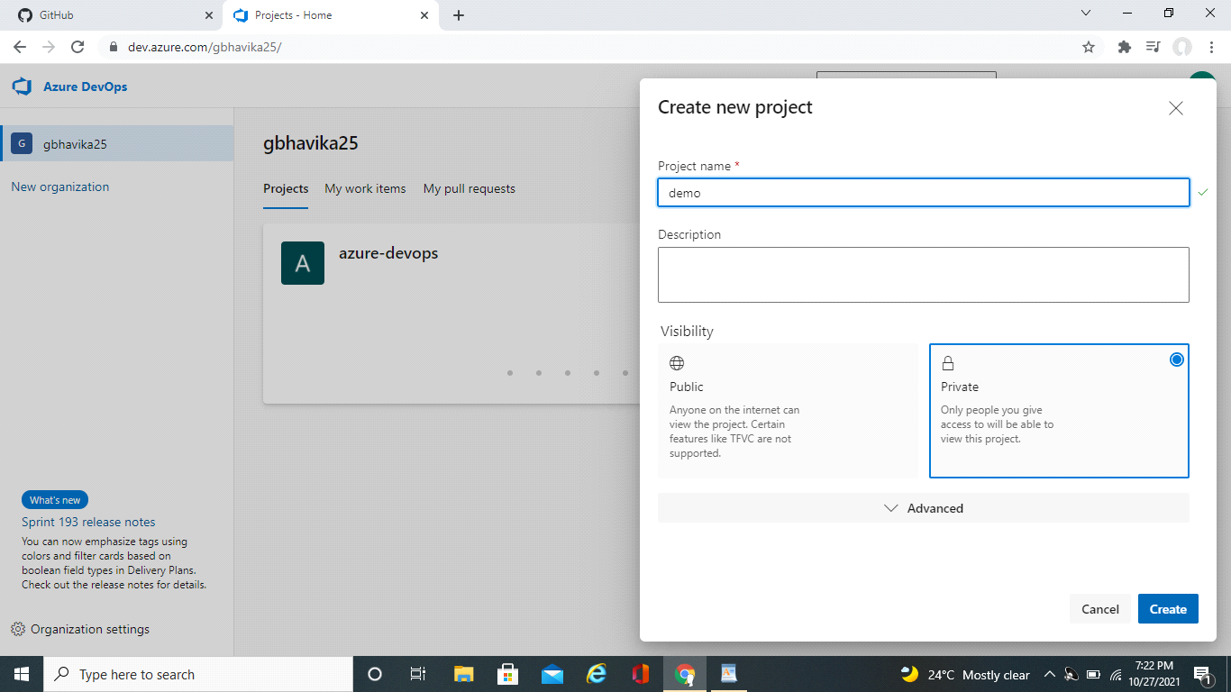

**Step 2 : Importing GitHub repo**

Now we can navigate to the repo's section of our project and import our existing GitHub repo.

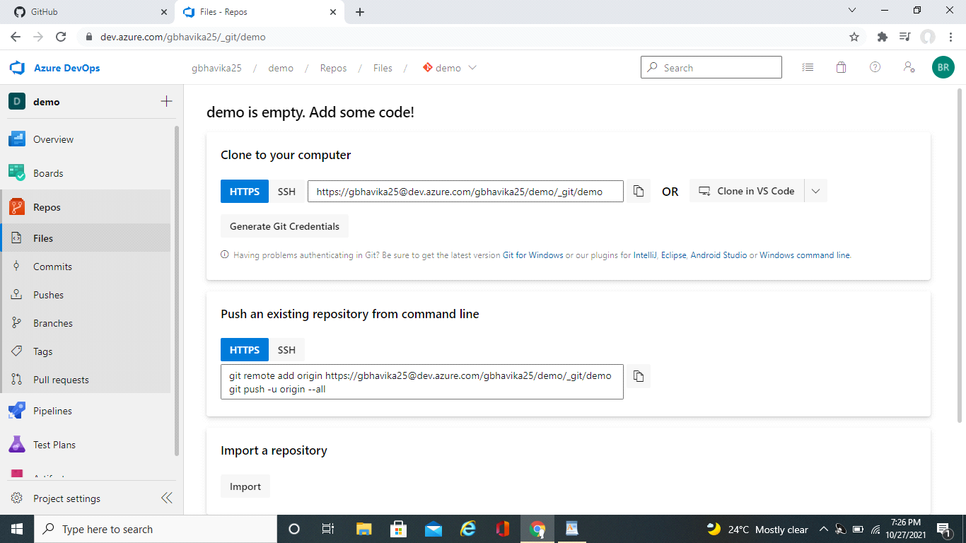

On this screen we can click on the import button.That will open a popup that asks where the source repo is located.From here you should select :"Git" as the source type,and paste in your clone URL from GitHub.If it's a private GitHub repo you will need to check the authorization box and enter your credentials.

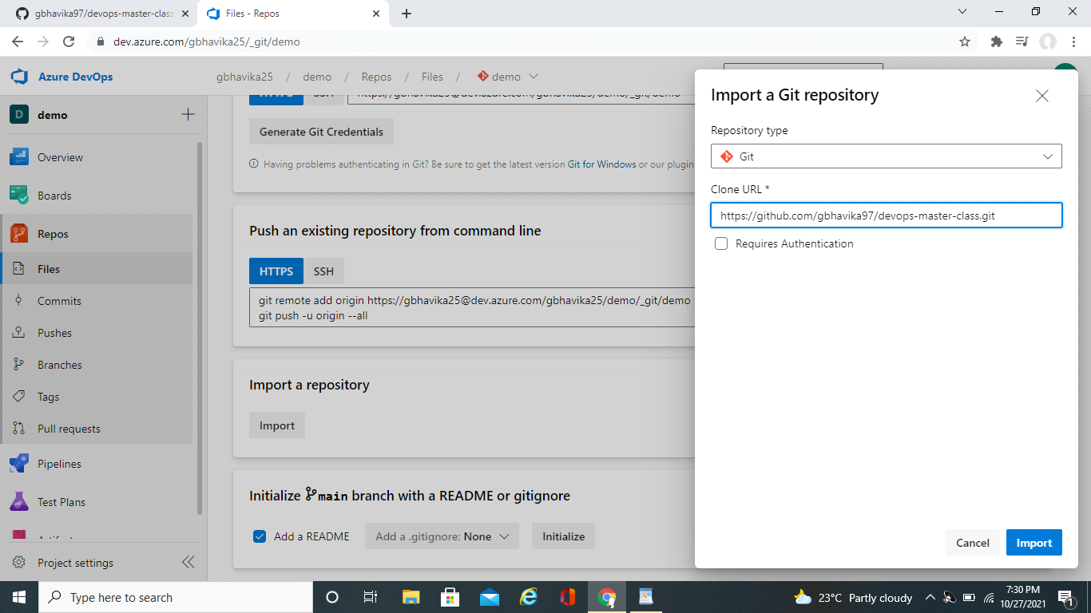

After being redirected it displays all the GitHub repos

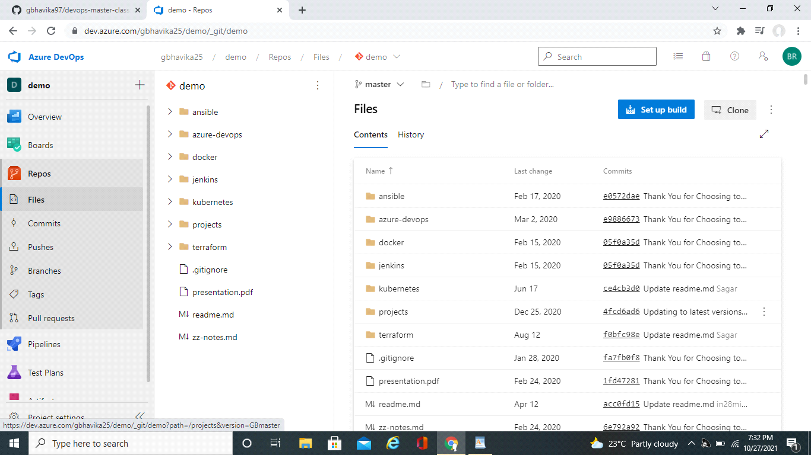

Any changes made to this files can reflect simultaneously in GitHub and viceversa.