* + - 1. 報告標題:lab11
      2. 組別、姓名:no.60 呂旻翰 郭忠明
      3. 程式執行流程、記憶體（暫存器）狀態截圖

Code1:

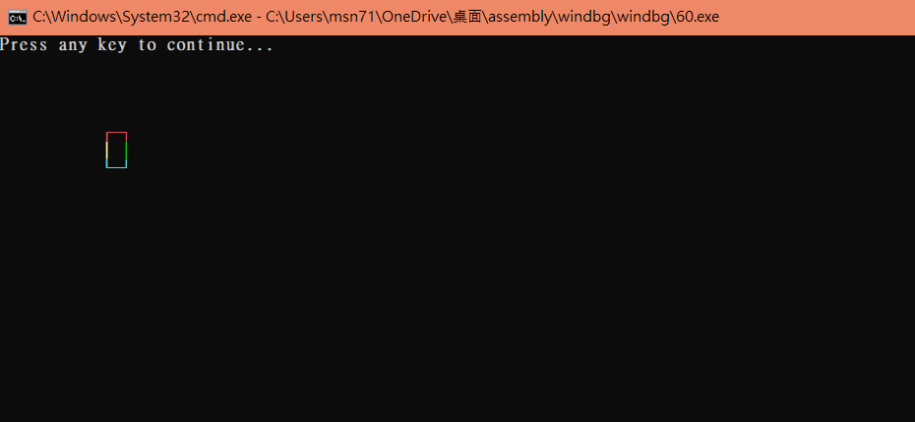

* + - 1. 截圖說明、程式碼說明

INCLUDE Irvine32.inc

main EQU start@0

BoxWidth = 3

BoxHeight = 3

.data

boxTop BYTE 0DAh, (BoxWidth - 2) DUP(0C4h),0BFh

boxBody BYTE 0B3h, (BoxWidth - 2) DUP(' '),0B3h

boxBottom BYTE 0C0h, (BoxWidth - 2) DUP(0C4h),0D9h

outputHandle DWORD 0

bytesWritten DWORD 0

count DWORD 0

xyPosition COORD <10,5>

cellsWritten DWORD ?

attributes0 WORD BoxWidth DUP(0Ch)

attributes1 WORD (BoxWidth-1) DUP(0Eh),0Ah

attributes2 WORD BoxWidth DUP(0Bh)

.code

main PROC

INVOKE GetStdHandle, STD_OUTPUT_HANDLE ; Get the console ouput handle

mov outputHandle, eax ; save console handle

call Clrscr

; 畫出box的第一行

INVOKE WriteConsoleOutputAttribute,

outputHandle,

offset attributes0,

lengthof attributes0,

xyPosition,

offset cellsWritten

INVOKE WriteConsoleOutputCharacter,

outputHandle, ; console output handle

offset boxTop, ; pointer to the top box line

lengthof boxTop, ; size of box line

xyPosition, ; coordinates of first char

offset Count ; output count

inc xyPosition.y ; 座標換到下一行位置

mov ecx, BoxWidth-2 ; number of lines in body

L1: push ecx ; save counter 避免invoke 有使用到這個暫存器

INVOKE WriteConsoleOutputAttribute,

outputHandle,

offset attributes1,

lengthof attributes1,

xyPosition,

offset cellsWritten

INVOKE WriteConsoleOutputCharacter,

outputHandle, ; console output handle

offset boxBody, ; pointer to the top box line

lengthof boxBody, ; size of box line

xyPosition, ; coordinates of first char

offset Count

inc xyPosition.y ; next line

pop ecx ; restore counter

loop L1

INVOKE WriteConsoleOutputAttribute,

outputHandle,

offset attributes2,

lengthof attributes2,

xyPosition,

offset cellsWritten

INVOKE WriteConsoleOutputCharacter,

outputHandle, ; console output handle

offset boxBottom, ; pointer to the top box line

lengthof boxBottom, ; size of box line

xyPosition, ; coordinates of first char

offset Count

call WaitMsg

call Clrscr

exit

main ENDP

END main

* 解釋: 大致上的過程 就是將方形拆成三個部分 頂部用兩個括號 與要得長度-2的直線數去組成 然後中間為身體的部分 由兩個直線中間隔長度-2個空格 將執行長度-2的次數 最後 底部與頂部差不多 剩的就是讓顏色參數去對好就可以了

6.心得:這次好難 幾乎都要用通靈的 寫code靠通靈 真的 一堆參數要幹嘛都不知道 所以我也不知要打啥 只能坐等大大幫