How to View the Content of File in Linux | cat Command

The cat command in Linux is more than just a simple tool; it’s a versatile companion for various file-related operations, allowing users to view, concatenate, create, copy, merge, and manipulate file contents. Let’s delve into the details of some frequently used cat commands, understanding each example along the way.
Table of Content
Basic Syntax of `cat` Command
The basic syntax of the ‘cat’ command is as follows:
cat [OPTION] [FILE]
Here,
[OPTION] : represents various command-line options.
[FILE] : the name of the file(s) to be processed. Let’s explore some of the common uses of ‘cat’ along with examples.
Practical Examples of Cat Command in Linux
1. How to View the Content of a Single File in Linux
The most basic use of ‘cat’ is to display the contents of a file on the terminal. This can be achieved by simply providing the filename as an argument:
Syntax:
cat file_name
Example: If our file_name = jayesh.txt
cat jayesh.txt
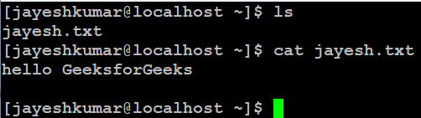
cat jayesh.txt
Note: `ls` command is used to display all files and directories in the current location.
2. How to View the Content of Multiple Files in Linux
Syntax:
cat file_name1 file_name2
Example: If we have two files , file1 and file2.
cat file1 file2
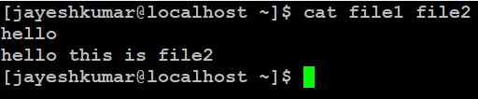
cat file1 file2
3. How to View Contents of a File preceding with Line Numbers in Linux
Adding the -n option to cat introduces line numbers, making it convenient to identify and reference specific lines within the file.
Syntax:
cat -n file_name
Example: If our file_name is file2.
cat -n file2
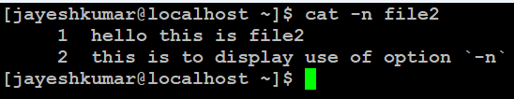
cat -n file2
Here, the cat command, used with the redirection (>), allows you to create a new file named “jayesh1” and input content directly into it. The subsequent ls command lists all files in the current location.
4. How to Create a file and add content in Linux Using `cat` Command
If you want to create a new file or overwrite an existing file with new content, you can use ‘cat’ with the output redirection (`>`):
Syntax:
cat > newfile_name
Example: If we want to create a newfile_name = jayesh1.
cat > jayesh1
ls
This will allow you to type text directly into the terminal, and when you press Ctrl + D, the entered text will be saved to new_file.txt.
`ls` command is used to display all files and directories in the current location.
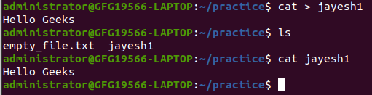
creating file using cat command in linux
5. How to Copy the Contents of One File to Another File in Linux
As the name suggests, ‘cat’ can concatenate multiple files into a single file.This example illustrates how to copy the entire content of “file1” into “file2” using the cat command along with redirection (>).
Syntax:
cat file1.txt file2.txt > merged_file.txt
This command combines the content of file1.txt and file2.txt into a new file named merged_file.txt.
6. Cat command can suppress repeated empty lines in output
The -s option comes in handy when dealing with files containing repeated empty lines. It suppresses these repetitions, providing a cleaner output.
Syntax:
cat -s file_name
Output
Will suppress repeated empty lines in output
7. How to Append the Contents of One File to the End of Another File
If you want to add the content of one file to another, ‘cat’ can be used along with the append (>>) operator:
Syntax:
cat file_name1 >> file_name2
Example:
cat file1 >> file2
This will append the content of `file1` to the end of `file2`
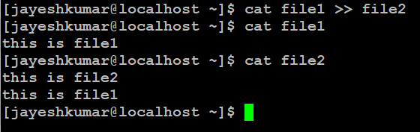
8. How to Display Content in Reverse Order Using `tac` Command in Linux
The ‘tac’ command is the reverse of ‘cat’ and is used to display the content of a file in reverse order. The syntax is simple:
Syntax:
tac file_name
Example:
This command will print the content of ‘file2’ in reverse order, displaying the last line first, followed by the second-to-last line, and so on.
tac file2
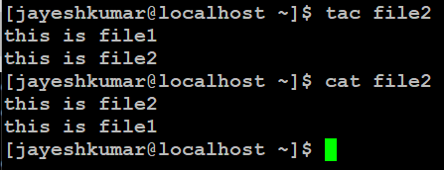
tac file2
9. How to Highlight the End of Line in Linux
The ‘-E’ option in the ‘cat’ command is used to highlight the end of each line.
Syntax:
cat -E "filename"
Output:
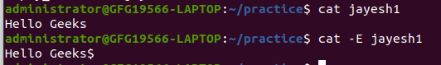
Displaying $ in the end of line
This will display the content of ‘jayesh1’ with a ‘$’ character at the end of each line, indicating the line’s terminate.
10. `-A` Command Line Option in `cat` Command in Linux
The ‘-A’ option allows you to combine the effects of ‘-v’, ‘-E’, and ‘-T’ options. Instead of writing ‘-vET’ in the command, you can use ‘-A’:
Syntax:
cat -A "filename"
This will display the content of ‘filename’ with non-printing characters visible, line endings highlighted, and tabs displayed as ‘^I’.
11. How to Open Dashed Files in Linux Using `cat` Command
To open a file with a dash at the beginning of its name, use the ‘–‘ option:
Syntax:
cat -- "-dashfile"
Example:
cat -- "-jayesh2"
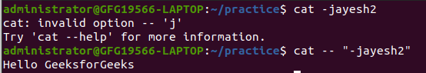
displaying content inside a file starting with `-`
This will display the content of a file named “-jayesh2”
12. Cat command if the file has a lot of content and can’t fit in the terminal.
Syntax:
cat "filename" | more
Output:
Will show that much content, which could fit in terminal and will ask to show more.
13. Merge Contents of Multiple Files Using `cat` Command
To merge the contents of multiple files into a single file, use the redirection (‘>’)
Syntax:
cat "filename1" "filename2" "filename3" > "merged_filename"
Example:
cat "file1" "file2" "file3" > "merged123"
This will concatenate the contents of “file1” “file2” “file3” into “merged123”.
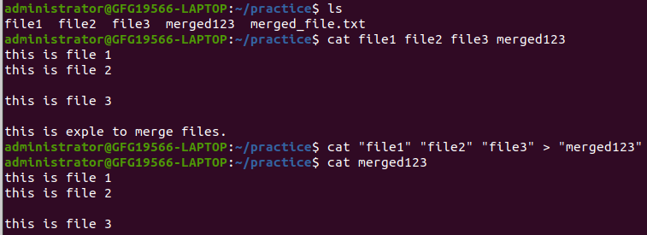
merging content of multiple files into single file
14. Display Content of All Text Files in a Folder Using `Cat` Command
To display the content of all text files in a folder, use the wildcard (‘*.txt’):
Syntax:
cat *.txt
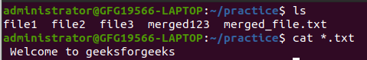
Displaying all file with extension “.txt”
Will show the content of all text files present in the folder.
15. Cat Command to Append to an Existing File:
To append text to an existing file, use the ‘>>’ operator along with ‘cat’:
Syntax:
cat >> geeks.txt
The newly added text.

