George Biehl

August 8, 2020

IT FDN 110 A Su 20: Foundations of Programming: Python

Assignment05

# Lists and Dictionaries

## Assignment Overview

This program reads a file into memory, stores the information in a particular manner, responds to user choices for viewing and altering the information, and finally saves the information back to the original file.

Reading a text file into memory assumes the file exists and consist of lines of data. Each line holds a “task” and a “priority” separated by a comma and each line ends with a carriage return. As each line is read from the file, a new dictionary pair is created. In addition, the comma and carriage return are removed. When the reading process is finished, memory holds a list of dictionary pairs which can be conveniently thought of as a table (each pair forming one row).

Once this table is created the user is presented with a menu of choices – display the table, add an entry, remove an entry, save the table back to the file (overwriting the original in the process), and to exit.

## Creating the Text File

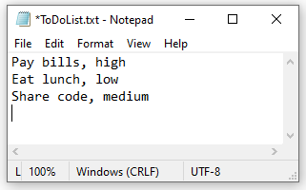The text file I used was named ToDoList.txt and is shown in Figure 1. While this seemed trivial, I did get caught at file by not have a carriage return at the end of the third line.

Figure 1: Text file

## Building on the Assigment05_Starter.py File

The assignment simulated receiving a stub program with the requirement to add code only in the indicated locations. I first ran the given stub program to be sure that it contained no errors. I then began to work on each of the “Add Code here” requirements in order.

As an example, the first “Add Code here” occurred in Assigment05_Starter.py on line 25 as shown in Figure 2. At this early stage I focused on simply making sure I was actually reading the file (!) so I didn’t worry about the getting it into the correct format in memory. It worked as shown in Figure 3. Later, I came back and re-coded this section so that the correct list of dictionary pairs was created in memory along with stripping off the commas and carriage returns (Figure 4)

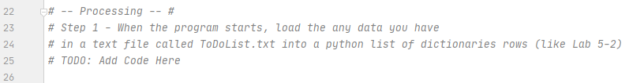Figure 2: First occurrence of “Add Code here”

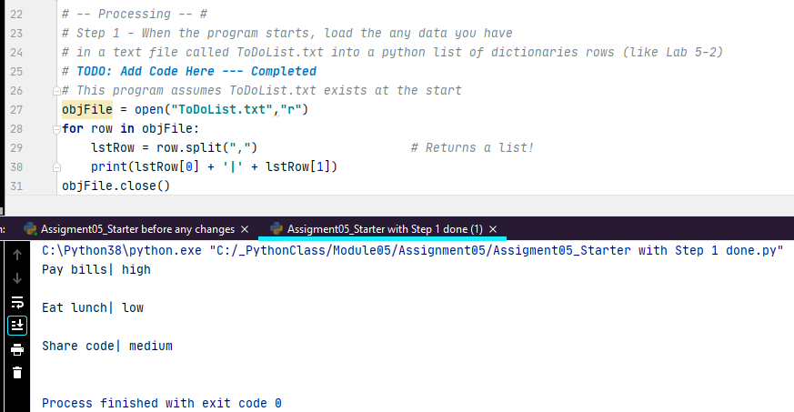

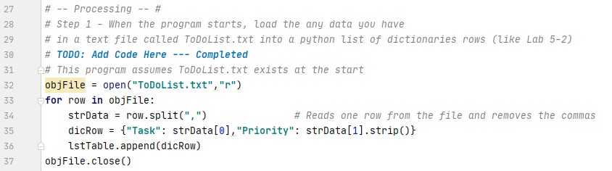Figure 3: First attempt at reading from the file and printing data

Figure 4: Rewritten code to create required list of dictionary pairs

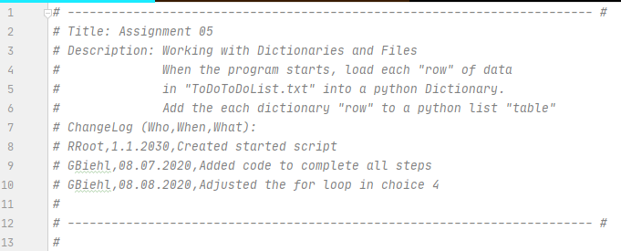After completing each of the “Add Code here” parts my program was completed as shown in Figures 5-7.

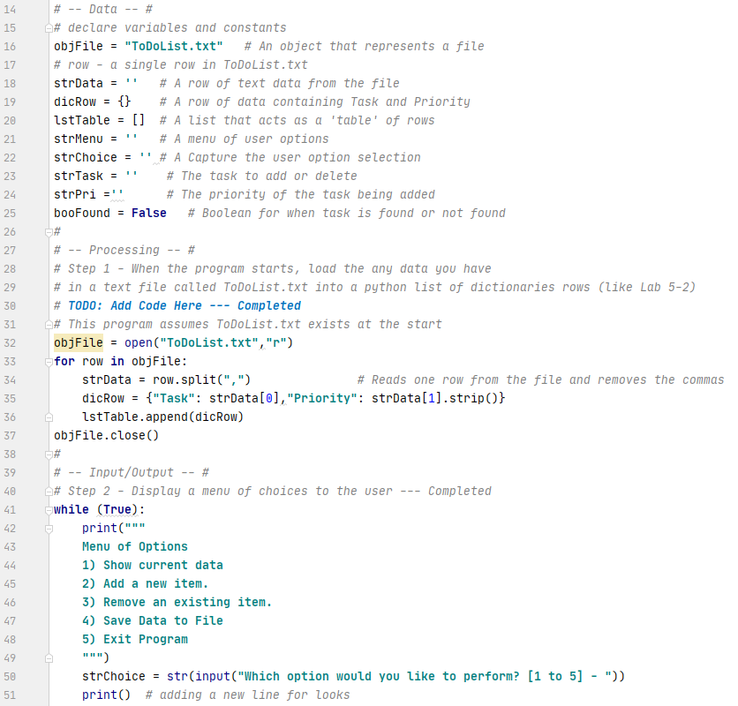Figure 5: Program header

Figure 6: Code sections which read the file and present options

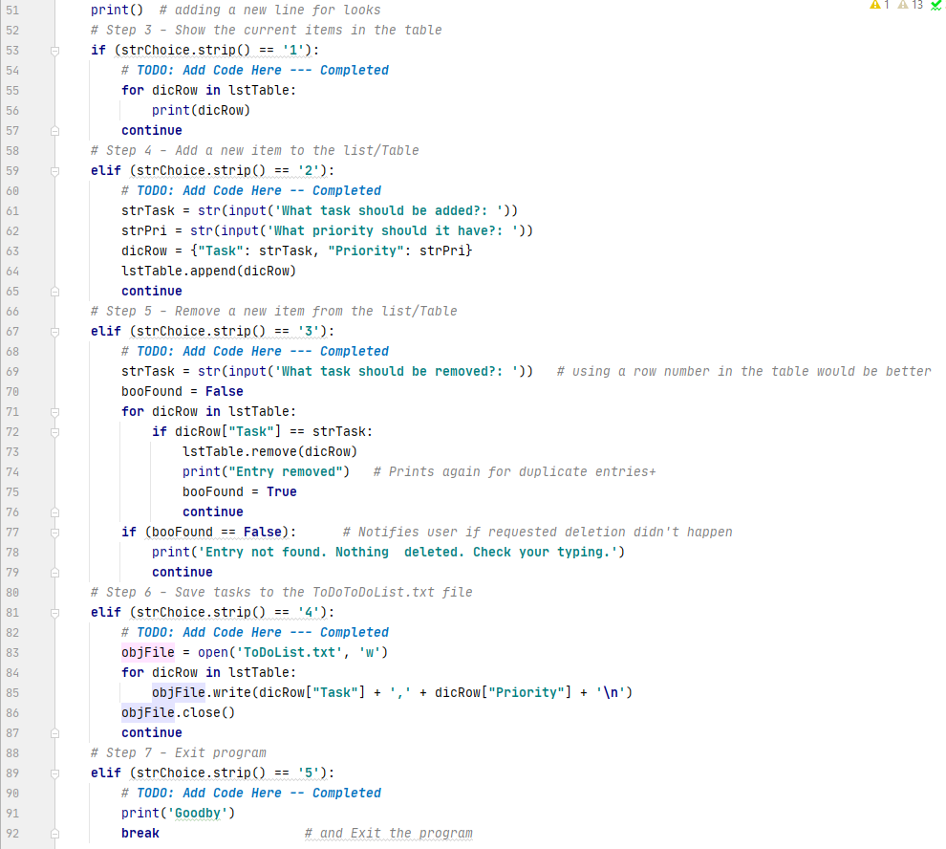Figure 7: Code sections which respond to menu choices 1-5

## Demonstrating Program Operation

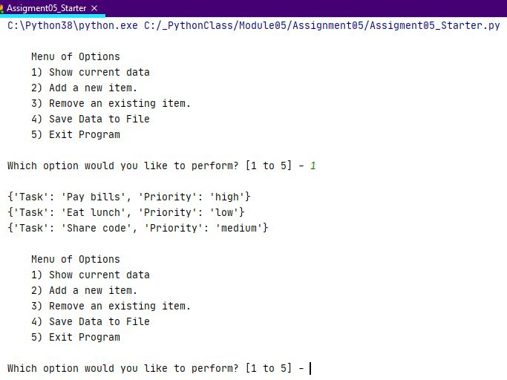Figures 8-15 show the results of testing each menu option using the ToDoList.txt shown in Figure 1.

Figure 8: Python – Show Current Data

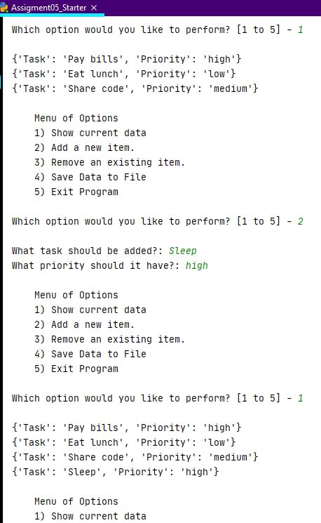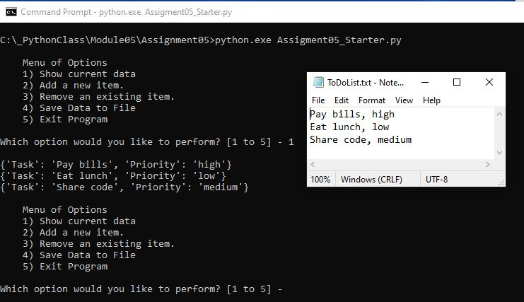Figure 9: Command Line – Show Current Data

Figure 10: Python – Add a new item

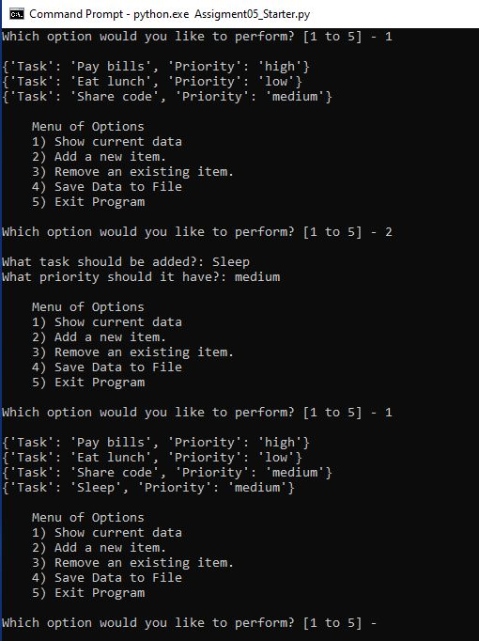

Figure 11: Command Line – Add a new item

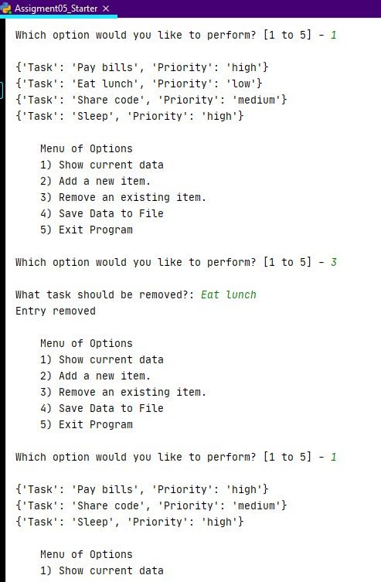Figure 12: Python – Remove an item

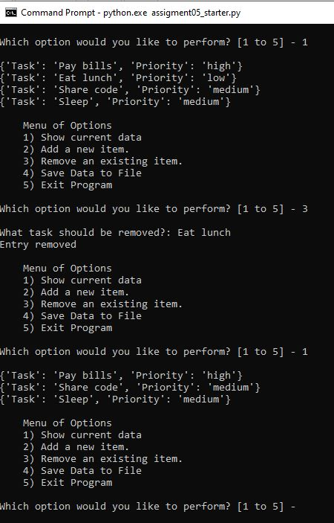Figure 13: Command Line – Remove an item

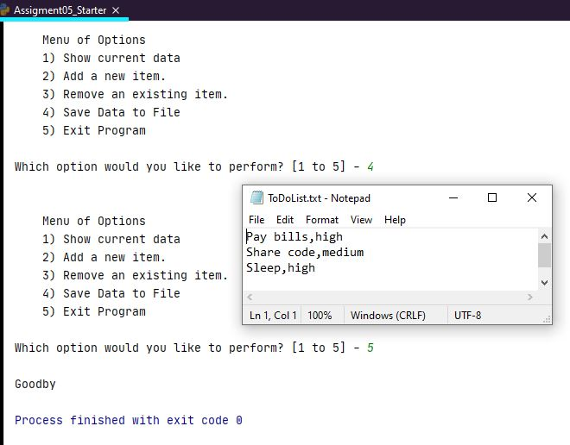Figure 14: Python – Save data to file and Exit

## 

Figure 15: Command Line - Save file (insert shows saved file) and Exit

## Summary