Supplemental materials for Effects of a Passive Upper-Body Exoskeleton during Prolonged Multi-Activity Construction Work
This file contains the supplementary tables and figures that support the main text of the manuscript. Table S1 summarizes previous studies, Tables S2 and S3 give APDF results for all 30 sEMG models, Table S4 gives discomfort and fatigue values, Figure S1 shows trunk and thigh activation, Figure S2 shows lower-body discomfort, and Figure S3 shows perceived fatigue.

Summary of previous studies
Table S1 compares previous passive exoskeleton studies of construction-related tasks with the present study, and it supports Figure 1 of the main text.

Table S1: Summary of passive exoskeleton studies that evaluated construction-related tasks, compared with the present study.
Study | Passive exoskeleton | Construction task(s) | Setting | Activity duration | Cycles or repetitions | Outcome or muscle reduction | Continuous multi-task workflow
Bosch et al. (2016) | Laevo | Forward-bending simulated assembly and static holding | Laboratory | 10 min | 10 work cycles (assembly), continuous hold (static task) | Assembly reductions were ESI 38%, ESL 35%, TA 44%, and BF 20%. Static holding reductions were ESI 44%, ESL 37%, TA 50%, and BF 24%. | ✗
Afolabi et al. (2025) | EksoVest (passive shoulder-support) | Painting | Laboratory | 2 min per subtask | NR | Median EMG (%MVC). Upper-level reductions were 5–32% in all muscles except RLD (↑22%), with LWF ↓32% significant. Ceiling-level reductions were 5–41% except LLD (↑6%), with RUT ↓41% and LUT ↓36% significant. Bending results were mixed, with RUT ↓12%, RTB ↓22%, LTB ↓11%, LWF ↓16%, LUT ↑33%, and RWF ↑38% (RWF significant). ROM change was minimal (1–3%). | ✗
Kim et al. (2019) | Arm-support and back-support | Interview study | NA | NA | NA | Qualitative results. 85% expected reduced MSD, 77% flagged cost, 69% flagged usability and training, 54% flagged catch or snag, and 39% flagged durability and trialability. | ✗
Du et al. (2024) | Hilti EXO-01 (2 kg passive shoulder) | Overhead work | Field | 2 workdays per participant | NR | 66% would likely or very likely adopt if employer-provided. 83% preferred the device for effort in overhead work, and 75% preferred the usual method for maneuverability. The device was helpful for sustained overhead work and unhelpful below shoulder level or in tight spaces. | ✗
Bennett et al. (2023) | HeroWear Apex (back-support exosuit), Hilti EXO-01 and Ekso EVO (arm-support) | Material handling | Field | Task 2, 25–31 min per condition | 10–15 cycles | Reduced pelvis tilt and reduced shoulder flexion and abduction range (motion constraint). Small task-time reduction. HR ↑ in Task 1 (n.s. in Task 2). Conflicting worker opinions. | ✗
Garosi et al. (2022) | HNSE (head and neck supporting exoskeleton) | Overhead fastening and unfastening nut task | Laboratory | Variable, self-terminated | 12 cycles | Perceived discomfort ↓ neck 23.19% (p = 0.009), R shoulder 16.55% (p = 0.05), L shoulder 15.36% (p = 0.02). EMG R SCM ↓53.16% (p = 0.005), L SCM ↓41.81% (p = 0.01), R trapezius ↑48.57% (p = 0.04), L trapezius ↑45.80% (p = 0.05). Other recorded muscles n.s. | ✗
de Vries et al. (2021) | Shoulder-support exoskeleton | Plastering (wall and ceiling) | Laboratory | 2–7 min per task | Single execution of each of 6 tasks | Agonists fell with the device, with MD and trapezius lower in all tasks (P50 and P90), AD lower in most tasks, and BB lower at P50 only. | ✗
Antwi-Afari et al. (2021) | BackX | Manual material handling, cable duct positioning | Laboratory | 2 min (2.7 h total data collection per participant) | Repeated cycles | LES fell by 11% to 33% MVC (32.71% at 25 kg load). TES, LES, RA, and EO fell with the device. Lower-back discomfort fell by 42.40%. | ✗
Gonsalves et al. (2021) | BackX | Simulated rebar work | Laboratory | 100 to 150 s | 4 cycles | LD fell by 3% to 11%. Lower-back discomfort fell by more than 100%, and chest discomfort rose by 383%. | ✗
Baltrusch et al. (2024) | Skelex 360 | Ceiling construction | Laboratory | 20 min | 3 trials | Shoulder muscle activity fell by up to 58%. | ✗
Pentenga et al. (2025) | HAPO Front (arm-support) | Overhead nailing | Field | Multiple repetitions | Multiple repetitions | Trapezius fell by 26–30%, and deltoid fell by 10–56%. | ✗
Alabdulkarim and Nussbaum (2019) | FORTIS, SuitX ShoulderX, Fawcett Exovest + zeroG2 | Overhead drilling | Laboratory | About 18 min | 6 repetitions | Peak, median, and static EMG were 21.6%, 5.0%, and 1.1% MVC (mean). The shoulder design reduced AD and MD. Full-body and arm designs increased ILL (low back). | ✗
Mänttäri et al. (2024) | Passive shoulder exoskeleton (Skelex 360) | Authentic construction work with arm elevation | Field | NR | NR | MD 46.2%, AD 32.2%, WF 24.4%, and TB 13.0% reduction, with reductions of 15.8% and 4.7% in two other recorded muscles. | ✗
Gonsalves et al. (2025) | BackX | Pipeline installation | Field | 45 min per session | NR | Subjective norm predicted intention to use (r = 0.61–0.72, p < 0.05). Worker attitude (SUS) and the perspectives of peers and supervisors were not significant. | ✗
Kang et al. (2025) | Passive waist-assist exoskeleton (Wirobotics) | Material handling | Laboratory | NR per trial | 20 cycles | Lifting results were TES ↓11.3% and LES ↓9.2% (L2), and TES ↓12.5%, LES ↓11.6%, and MF ↓ (L3). Lowering results were TES and LES ↓11.5–15.5% (L2 and L3). | ✗
Liu et al. (2024) | Passive back-support exoskeleton | Material handling | Laboratory | 5 min per session | 10 rounds per scenario | REBA ergonomic risk fell by 31.7% through trunk and knee posture correction. | ✗
Zheng et al. (2024) | Exo1, Exo2, Exo3 | Masonry block-laying (turn, place on wall) | Laboratory | NR | 16 trials | MedDeltoid was lower for Exo2 and Exo3 than Exo1 (p < 0.01, not versus NoExo). UppTrapezius was lower for Exo2 than NoExo and Exo3 (p < 0.05). Biceps, triceps, and AntDeltoid were n.s. Balance worsened in several measures versus NoExo (p < 0.05 to 0.001). | ✗
Musso et al. (2024) | Skelex 360 | Overhead assembly, bricklaying, and box moving | Laboratory | NR | 3 cycles | AD ↓27.64% (dominant) and ↓45.46% (non-dominant), MD ↓38.77% and ↓33.92%, PD ↓28.03% and ↓22.11%, BB ↓15.96% and ↓23.4%, PM ↓20.20% and ↓37.34% (all p < 0.05). | ✗
Present study | Skelex 360 | Drywall lifting, carrying, positioning, overhead fastening, sandbag lifting, carrying, and placement | Laboratory simulation | 30 continuous work cycles (about 180 min including standardized rest periods) | 30 cycles (7 sequential activities per cycle) | Holm-adjusted reductions were right AD P90 20.9%, right BB P10 31.0% and P50 33.8%, and left BB P90 22.2%. Shoulder and upper-arm discomfort rose more slowly with the device. | ✓
AD is anterior deltoid, BB is biceps brachii, BF is biceps femoris, ESI and ILL are iliocostalis lumborum, ESL is longissimus thoracis, LD is latissimus dorsi, LES is lumbar erector spinae, MF is multifidus, TES is thoracic erector spinae, WF is wrist flexor, MD is medial deltoid, PD is posterior deltoid, PM is pectoralis major, SCM is sternocleidomastoid, TA is tibialis anterior, TB is triceps brachii, UT is upper trapezius, MVC is maximum voluntary contraction, EMG is electromyography, ROM is range of motion, REBA is Rapid Entire Body Assessment, NR is not reported, NA is not applicable, and n.s. is not statistically significant. A prefix of L or R shows the left or right side.

APDF results for all sEMG models
Table S2 gives the descriptive values, relative change, test results, and Cohen's d for each of the 30 sEMG models, and Table 2 of the main text repeats the results that remained significant after Holm correction.
Table S2: APDF muscle activation and condition effects for the 30 sEMG models.
Muscle | Side | APDF | Exo (%MVC) | NoExo (%MVC) | Change (%) | F(1,19) | p | Holm p | d
AD | R | P10 | 3.8 ± 2.1 | 4.2 ± 1.8 | 9.5 | 4.38 | 0.050 | 0.052 | −0.47
AD | R | P50 | 14.0 ± 7.2 | 17.0 ± 6.9 | 18.0 | 5.81 | 0.026 | 0.052 | −0.54
AD | R | P90 | 39.5 ± 18.8 | 50.0 ± 18.6 | 20.9 | 9.77 | 0.006 | 0.018 | −0.70
AD | L | P10 | 2.7 ± 1.0 | 3.3 ± 1.3 | 20.3 | 6.48 | 0.020 | 0.060 | −0.57
AD | L | P50 | 10.7 ± 5.3 | 13.6 ± 5.5 | 21.4 | 4.97 | 0.038 | 0.060 | −0.50
AD | L | P90 | 32.9 ± 15.1 | 43.2 ± 16.1 | 23.8 | 6.05 | 0.024 | 0.060 | −0.55
BB | R | P10 | 5.8 ± 2.6 | 8.4 ± 3.2 | 31.0 | 7.49 | 0.013 | 0.026 | −0.63
BB | R | P50 | 18.2 ± 7.1 | 27.5 ± 9.3 | 33.8 | 13.02 | 0.002 | 0.006 | −0.83
BB | R | P90 | 51.4 ± NR | 55.9 ± NR | 8.1 | 0.28 | 0.603 | 0.603 | −0.12
BB | L | P10 | 6.9 ± 2.9 | 7.4 ± 3.1 | 6.8 | 0.13 | 0.725 | 1.000 | −0.08
BB | L | P50 | 24.3 ± 8.8 | 25.9 ± 9.4 | 6.2 | 0.33 | 0.574 | 1.000 | −0.13
BB | L | P90 | 44.6 ± 16.2 | 57.3 ± 13.8 | 22.2 | 7.96 | 0.011 | 0.033 | −0.65
BR | R | P10 | 7.1 ± 3.0 | 8.9 ± 1.7 | 20.2 | 0.70 | 0.415 | 0.830 | −0.19
BR | R | P50 | 25.5 ± 3.0 | 25.2 ± 6.8 | −1.1 | 0.00 | 0.948 | 0.948 | +0.01
BR | R | P90 | 50.6 ± 9.5 | 56.9 ± 7.5 | 11.1 | 6.19 | 0.022 | 0.066 | −0.56
BR | L | P10 | 6.4 ± 6.6 | 8.9 ± 5.6 | 28.1 | 4.45 | 0.049 | 0.090 | −0.48
BR | L | P50 | 17.9 ± 4.1 | 27.3 ± 8.7 | 34.5 | 6.19 | 0.022 | 0.066 | −0.56
BR | L | P90 | 42.4 ± 6.7 | 53.6 ± 8.8 | 20.8 | 4.56 | 0.045 | 0.090 | −0.49
TES | R | P10 | 9.1 ± 3.3 | 9.0 ± 3.1 | −1.2 | 0.06 | 0.812 | 1.000 | +0.05
TES | R | P50 | 26.1 ± 9.1 | 26.1 ± 8.4 | −0.1 | 0.00 | 0.980 | 1.000 | +0.01
TES | R | P90 | 58.9 ± 18.7 | 55.5 ± 17.7 | −6.1 | 1.38 | 0.255 | 0.765 | +0.26
TES | L | P10 | 9.4 ± 3.8 | 9.3 ± 3.6 | −1.1 | 0.13 | 0.727 | 0.727 | +0.08
TES | L | P50 | 27.3 ± 10.4 | 28.9 ± 10.2 | 5.4 | 1.17 | 0.292 | 0.584 | −0.24
TES | L | P90 | 58.1 ± 20.3 | 63.0 ± 21.5 | 7.8 | 2.61 | 0.123 | 0.369 | −0.36
RF | R | P10 | 4.2 ± 1.8 | 4.0 ± 2.2 | −5.5 | 16.00 | 0.001 | 0.003 | +0.91
RF | R | P50 | 13.0 ± 5.2 | 17.0 ± 3.0 | 23.5 | 6.68 | 0.018 | 0.018 | −0.58
RF | R | P90 | 41.8 ± 8.4 | 48.8 ± 6.0 | 14.3 | 11.05 | 0.004 | 0.008 | −0.75
RF | L | P10 | 4.7 ± 1.7 | 5.6 ± 3.1 | 16.1 | 5.14 | 0.036 | 0.108 | −0.51
RF | L | P50 | 16.5 ± 5.2 | 19.0 ± 8.3 | 13.2 | 4.38 | 0.050 | 0.108 | −0.48
RF | L | P90 | 37.6 ± 9.5 | 44.4 ± 6.0 | 15.3 | 2.11 | 0.163 | 0.163 | −0.32
AD is anterior deltoid, BB is biceps brachii, BR is brachioradialis, TES is thoracic erector spinae, RF is rectus femoris, R is right, L is left, and NR is not reported. Values are mean ± SD, and a positive change shows lower activation under the Exo condition. Holm correction used three percentiles within each muscle and side.
Table S3 gives the mean difference between conditions, its 95% confidence interval, and the partial eta squared value for each of the 30 sEMG models. A negative mean difference shows lower activation under the Exo condition, and each interval follows from the mean difference and the F value.
Table S3: Mean differences, 95% confidence intervals, and effect sizes for the 30 sEMG models.
Muscle | Side | APDF | Mean difference (%MVC) | 95% CI (%MVC) | F(1,19) | p | Holm p | η²_{p}
AD | R | P10 | −0.41 | −0.82 to 0.00 | 4.38 | 0.050 | 0.052 | 0.19
AD | R | P50 | −3.06 | −5.72 to −0.40 | 5.81 | 0.026 | 0.052 | 0.23
AD | R | P90 | −10.46 | −17.47 to −3.46 | 9.77 | 0.006 | 0.018 | 0.34
AD | L | P10 | −0.67 | −1.22 to −0.12 | 6.48 | 0.020 | 0.060 | 0.25
AD | L | P50 | −2.91 | −5.65 to −0.18 | 4.97 | 0.038 | 0.060 | 0.21
AD | L | P90 | −10.27 | −19.00 to −1.53 | 6.05 | 0.024 | 0.060 | 0.24
BB | R | P10 | −2.60 | −4.59 to −0.61 | 7.49 | 0.013 | 0.026 | 0.28
BB | R | P50 | −9.30 | −14.69 to −3.91 | 13.02 | 0.002 | 0.006 | 0.41
BB | R | P90 | −4.50 | −22.30 to 13.30 | 0.28 | 0.603 | 0.603 | 0.01
BB | L | P10 | −0.50 | −3.40 to 2.40 | 0.13 | 0.725 | 1.000 | 0.01
BB | L | P50 | −1.60 | −7.43 to 4.23 | 0.33 | 0.574 | 1.000 | 0.02
BB | L | P90 | −12.70 | −22.12 to −3.28 | 7.96 | 0.011 | 0.033 | 0.30
BR | R | P10 | −1.84 | −6.45 to 2.78 | 0.70 | 0.415 | 0.830 | 0.04
BR | R | P50 | +0.28 | −8.59 to 9.15 | 0.00 | 0.948 | 0.948 | 0.00
BR | R | P90 | −6.30 | −11.60 to −1.00 | 6.19 | 0.022 | 0.066 | 0.25
BR | L | P10 | −2.50 | −4.98 to −0.02 | 4.45 | 0.049 | 0.090 | 0.19
BR | L | P50 | −9.43 | −17.37 to −1.49 | 6.19 | 0.022 | 0.066 | 0.25
BR | L | P90 | −11.15 | −22.08 to −0.22 | 4.56 | 0.045 | 0.090 | 0.19
TES | R | P10 | +0.11 | −0.84 to 1.06 | 0.06 | 0.812 | 1.000 | 0.00
TES | R | P50 | +0.03 | −2.44 to 2.50 | 0.00 | 0.980 | 1.000 | 0.00
TES | R | P90 | +3.40 | −2.66 to 9.46 | 1.38 | 0.255 | 0.765 | 0.07
TES | L | P10 | +0.10 | −0.48 to 0.68 | 0.13 | 0.727 | 0.727 | 0.01
TES | L | P50 | −1.57 | −4.61 to 1.47 | 1.17 | 0.292 | 0.584 | 0.06
TES | L | P90 | −4.89 | −11.22 to 1.45 | 2.61 | 0.123 | 0.369 | 0.12
RF | R | P10 | +0.22 | 0.11 to 0.33 | 16.00 | 0.001 | 0.003 | 0.46
RF | R | P50 | −4.00 | −7.24 to −0.76 | 6.68 | 0.018 | 0.018 | 0.26
RF | R | P90 | −7.00 | −11.41 to −2.59 | 11.05 | 0.004 | 0.008 | 0.37
RF | L | P10 | −0.90 | −1.73 to −0.07 | 5.14 | 0.036 | 0.108 | 0.21
RF | L | P50 | −2.50 | −4.99 to −0.01 | 4.38 | 0.050 | 0.108 | 0.19
RF | L | P90 | −6.80 | −16.60 to 3.00 | 2.11 | 0.163 | 0.163 | 0.10
AD is anterior deltoid, BB is biceps brachii, BR is brachioradialis, TES is thoracic erector spinae, RF is rectus femoris, R is right, L is left, and CI is confidence interval.

Discomfort and fatigue values
Table S4 gives the mean ratings at each assessment time under both conditions, together with the condition by time interaction for each outcome. The shoulder and upper-arm rows show the two significant interactions, and pairwise results for these regions appear in the main text.
Table S4: Mean discomfort and ROF ratings at each assessment time and the condition by time interaction.
Outcome | Condition | Baseline | Cycle 10 | Cycle 20 | Cycle 30 | F | p | η²_{p}
Neck | Exo | 0.9 | 3.1 | 4.5 | 5.5 | 0.74 | 0.533 | 0.04
 | NoExo | 0.8 | 2.0 | 3.6 | 5.1
Shoulders | Exo | 0.6 | 2.1 | 3.2 | 4.1 | 5.92 | 0.001 | 0.24
 | NoExo | 0.7 | 2.3 | 4.3 | 5.8
Upper back | Exo | 1.1 | 3.2 | 5.2 | 6.3 | 1.28 | 0.290 | 0.06
 | NoExo | 0.9 | 2.2 | 4.0 | 5.8
Lower back | Exo | 1.2 | 3.5 | 5.3 | 6.8 | 0.96 | 0.418 | 0.05
 | NoExo | 1.0 | 2.6 | 4.2 | 6.2
Upper arms | Exo | 0.6 | 1.9 | 2.9 | 3.9 | 4.83 | 0.005 | 0.20
 | NoExo | 0.6 | 2.0 | 3.4 | 5.2
Forearms | Exo | 0.8 | 2.6 | 4.3 | 5.4 | 0.81 | 0.494 | 0.04
 | NoExo | 0.7 | 1.9 | 3.3 | 4.9
Thighs | Exo | 0.6 | 1.9 | 3.2 | 4.5 | 0.62 | 0.605 | 0.03
 | NoExo | 0.6 | 1.9 | 3.2 | 4.6
Lower legs | Exo | 0.5 | 1.6 | 2.9 | 4.2 | 0.54 | 0.657 | 0.03
 | NoExo | 0.5 | 1.6 | 2.9 | 4.3
ROF | Exo | 1.0 | 3.9 | 5.7 | 6.4 | 1.88 | 0.143 | 0.09
 | NoExo | 1.0 | 4.2 | 5.5 | 7.0
All interactions used df (3,57) for the 20 participants.

Trunk and thigh activation
Figure S1 shows activation of the thoracic erector spinae and rectus femoris, which were the non-target muscles of the device.
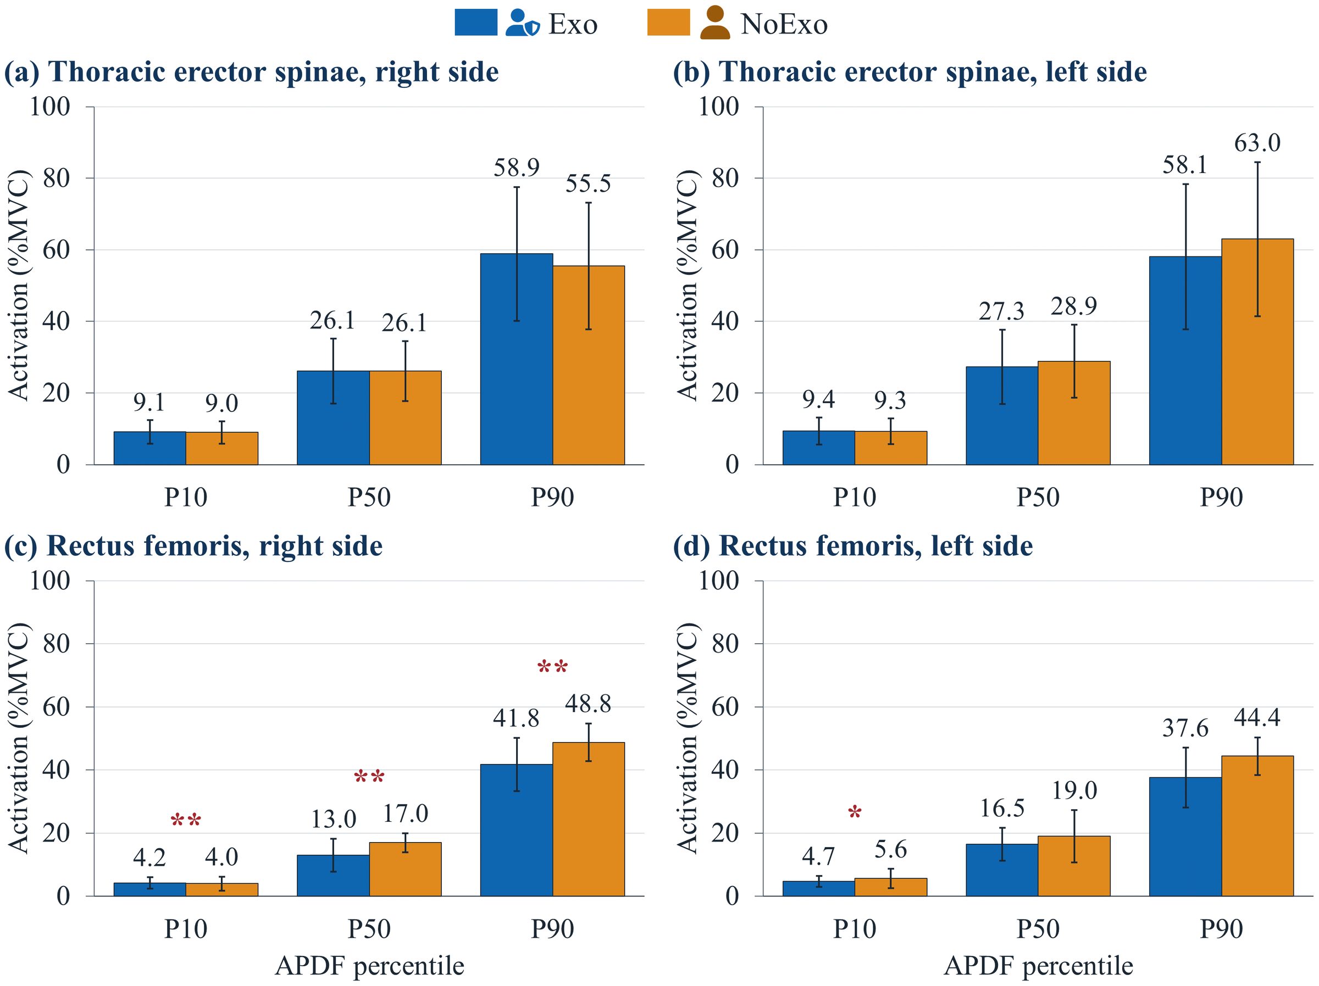
Figure S1: APDF activation of the thoracic erector spinae and rectus femoris under the Exo and NoExo conditions. Bars show means and error bars show SD. One asterisk marks p < 0.05 before correction, and two asterisks mark Holm-adjusted p < 0.05.

Lower-body discomfort
Figure S2 shows thigh and lower-leg discomfort, because the trajectories were nearly identical between conditions and did not need space in the main text.
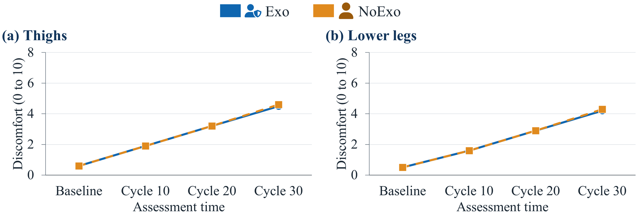
Figure S2: Mean discomfort in the thighs and lower legs across the assessment times under the Exo and NoExo conditions.

Perceived fatigue
Figure S3 shows mean ROF scores, because the two conditions did not differ significantly and Table S4 and the main text give the values.
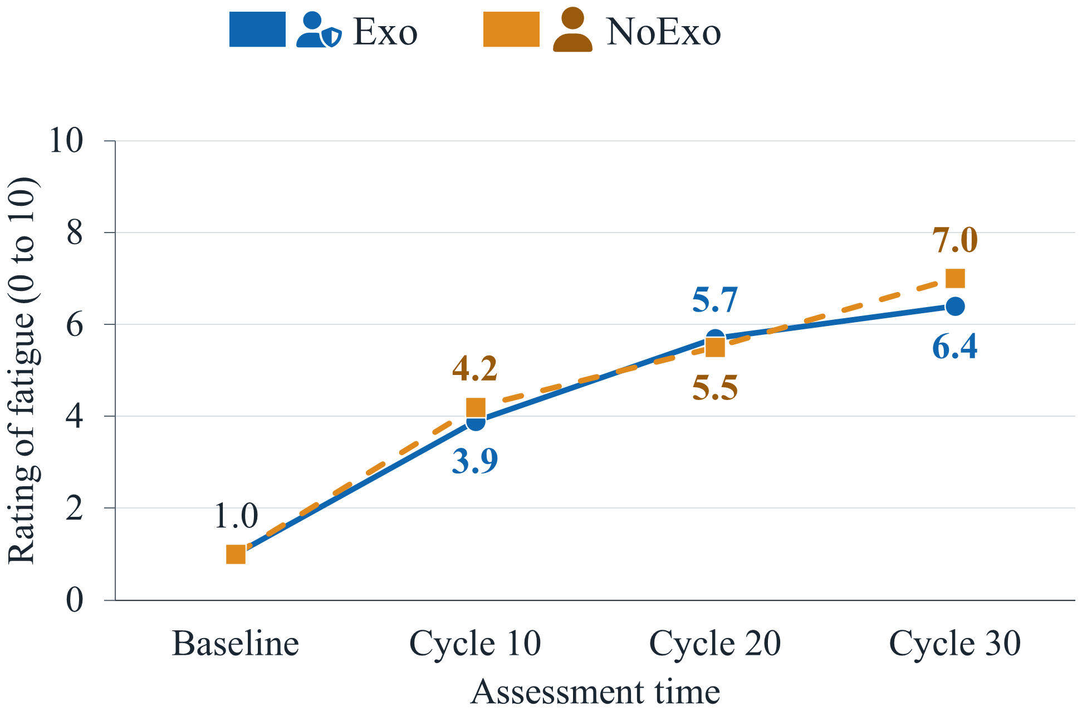
Figure S3: Mean ROF scores across the assessment times under the Exo and NoExo conditions.

References
Afolabi, A., A. Yusuf, and A. Akanmu. 2025. “Effect of a passive shoulder-support exoskeleton on muscle activity, range of motion, discomfort, and exertion during painting tasks.” J. Constr. Eng. Manage. 151 (5): 04025027. https://doi.org/10.1061/JCEMD4.COENG-15348.
Alabdulkarim, S., and M. A. Nussbaum. 2019. “Influences of different exoskeleton designs and tool mass on physical demands and performance in a simulated overhead drilling task.” Appl. Ergon. 74: 55–66. https://doi.org/10.1016/j.apergo.2018.08.004.
Antwi-Afari, M. F., H. Li, S. Anwer, D. Li, Y. Yu, H. Y. Mi, and I. Y. Wuni. 2021. “Assessment of a passive exoskeleton system on spinal biomechanics and subjective responses during manual repetitive handling tasks among construction workers.” Saf. Sci. 142: 105382. https://doi.org/10.1016/j.ssci.2021.105382.
Baltrusch, S. J., F. Krause, A. W. de Vries, and M. P. de Looze. 2024. “Arm-support exoskeleton reduces shoulder muscle activity in ceiling construction.” Ergonomics 67 (8): 1051–1063. https://doi.org/10.1080/00140139.2023.2280443.
Bennett, S. T., W. Han, D. Mahmud, P. G. Adamczyk, F. Dai, M. Wehner, D. Veeramani, and Z. Zhu. 2023. “Usability and biomechanical testing of passive exoskeletons for construction workers: A field-based pilot study.” Buildings 13 (3): 822. https://doi.org/10.3390/buildings13030822.
Bosch, T., J. van Eck, K. Knitel, and M. de Looze. 2016. “The effects of a passive exoskeleton on muscle activity, discomfort and endurance time in forward bending work.” Appl. Ergon. 54: 212–217. https://doi.org/10.1016/j.apergo.2015.12.003.
de Vries, A. W., F. Krause, and M. P. de Looze. 2021. “The effectivity of a passive arm support exoskeleton in reducing muscle activation and perceived exertion during plastering activities.” Ergonomics 64 (6): 712–721. https://doi.org/10.1080/00140139.2020.1868581.
Du, B. B., K. G. Somasundram, A. Johnston, P. Bigelow, M. Abdoli-Eramaki, K. H. Jordan, M. Yung, and A. Yazdani. 2024. “Skilled workers’ perspectives on utilizing a passive shoulder exoskeleton in construction.” Appl. Sci. 14 (19): 8971. https://doi.org/10.3390/app14198971.
Garosi, E., A. Mazloumi, A. H. Jafari, A. Keihani, M. Shamsipour, R. Kordi, and Z. Kazemi. 2022. “Design and ergonomic assessment of a passive head/neck supporting exoskeleton for overhead work use.” Appl. Ergon. 101: 103699. https://doi.org/10.1016/j.apergo.2022.103699.
Gonsalves, N., A. Afolabi, and A. A. Akanmu. 2025. “Impact of social influence on construction workers’ intention-to-use exoskeletons.” Smart Sustainable Built Environ. 14 (4): 1073–1090. https://doi.org/10.1108/SASBE-06-2023-0153.
Gonsalves, N. J., O. R. Ogunseiju, A. A. Akanmu, and C. A. Nnaji. 2021. “Assessment of a passive wearable robot for reducing low back disorders during rebar work.” J. Inf. Technol. Constr. 26: 936–952. https://doi.org/10.36680/j.itcon.2021.050.
Kang, J. S., B. R. Jeong, E. P. Hong, B. M. Lim, B. J. Choi, Y. B. Lee, and Y. H. Chang. 2025. “EMG and usability assessment of adjustable stiffness passive waist-assist exoskeletons for construction workers.” Int. J. Precis. Eng. Manuf. 26 (1): 227–238. https://doi.org/10.1007/s12541-024-01059-8.
Kim, S., A. Moore, D. Srinivasan, A. Akanmu, A. Barr, C. Harris-Adamson, D. M. Rempel, and M. A. Nussbaum. 2019. “Potential of exoskeleton technologies to enhance safety, health, and performance in construction: Industry perspectives and future research directions.” IISE Trans. Occup. Ergon. Hum. Factors 7 (3–4): 185–191. https://doi.org/10.1080/24725838.2018.1561557.
Liu, Y., A. Ojha, and H. Jebelli. 2024. “Vision-based ergonomic risk assessment of back-support exoskeleton for construction workers in material handling tasks.” In Computing in Civil Engineering 2023, 331–339. Reston, VA: ASCE. https://doi.org/10.1061/9780784485248.040.
Mänttäri, S., A.-P. Rauttola, J. Halonen, J. Karkulehto, P. Säynäjäkangas, and J. Oksa. 2024. “Effects of upper-limb exoskeleton on muscle activity in tasks requiring arm elevation: Part II – In-field experiments in construction industry settings.” Work 79 (2): 753–763. https://doi.org/10.3233/WOR-230218.
Musso, M., A. S. Oliveira, and S. Bai. 2024. “Influence of an upper limb exoskeleton on muscle activity during various construction and manufacturing tasks.” Appl. Ergon. 114: 104158. https://doi.org/10.1016/j.apergo.2023.104158.
Pentenga, H. M., P. Coenen, M. A. Huysmans, and E. M. Speklé. 2025. “The effects of working with a passive arm-support exoskeleton on objective and self-reported measures during field tasks – A randomised cross-over study.” Ergonomics 68 (7): 1094–1112. https://doi.org/10.1080/00140139.2024.2392785.
Zheng, L., C. Pan, L. Wei, H. Bahreinizad, S. Chowdhury, X. Ning, and F. Santos. 2024. “Shoulder-assist exoskeleton effects on balance and muscle activity during a block-laying task on a simulated mast climber.” Int. J. Ind. Ergon. 104: 103652. https://doi.org/10.1016/j.ergon.2024.103652.

