BIODIVERSITY INFORMATION FOR DEVELOPMENT

Concept Note Template

Concept notes must be emailed to [BID@gbif.org](mailto:BID@gbif.org) by 09 April 2017, Midnight CET / 11:00pm UTC/GMT.

# Submission checklist

Please confirm the following by checking the box provided:

☐ Statement of endorsement from a GBIF representative (when a partner institution is located in a GBIF Participant country) is provided as an email attachment

# 1. Project title

[Insert your text here...]

# 2. Project category

Indicate the grant type for this proposal (select ONE):

☐ Small ☐ National

Indicate the main project activities (select AT LEAST ONE):

☐ Content mobilization ☐ Capacity enhancement

☐ Establishing national/regional biodiversity information facility

Indicate any major thematic links addressed by the project (select AT LEAST ONE):

☐ Invasive Alien Species ☐ Protected Areas ☐ Threatened Species

# 3. What are the issues that this project seeks to address?

*Explain why this project is needed and the problems it aims to solve (max. 250 words)*

# 4. Who will collaborate on the project?

*List ONE lead partner (“YES” in final column) and all other institutions expected to partner in the project – add rows for additional partners (“NO” in final column) as required*

|  |  |  |  |
| --- | --- | --- | --- |
| **Country/territory** | **Institution (name and address)** | **Contact (name, role email, telephone)** | **Lead partner (yes/no)** |
|  |  |  | YES |
|  |  |  | NO |

# 5. What activities will be included in the project?

*Explain the activities proposed for this project – what will each partner do? (max. 500 words)*

# 6. Why are these the right activities to address the issues?

*Explain how the activities listed under question 5 are expected to address the issues listed under question 3? Identify any risks and explain how these will be addressed. (max. 400 words)*

# 7. What will the project deliver?

*Explain the deliverables expected to result from the project. BID projects are expected to deliver lasting results in one or more of these areas (max. 400 words):*

* *Data on species in the region made freely accessible online via GBIF.org*
* *Increased capacity for biodiversity information management*
* *Establishment of national/regional biodiversity information facilities*

# 8. How much funding will be required?

*Indicate how much funding will be required from the BID Programme and how much co-funding will be provided by each partner. Co-funding must be cash or in-kind resources (e.g. salary cost) contributing directly and exclusively to the project*

|  |  |  |
| --- | --- | --- |
| **Partner institution** | **Funding requested (see limits in call documents)**  **(amount in Euro)** | **Co-funding offered (amount in Euro)** |
|  |  |  |
|  |  |  |

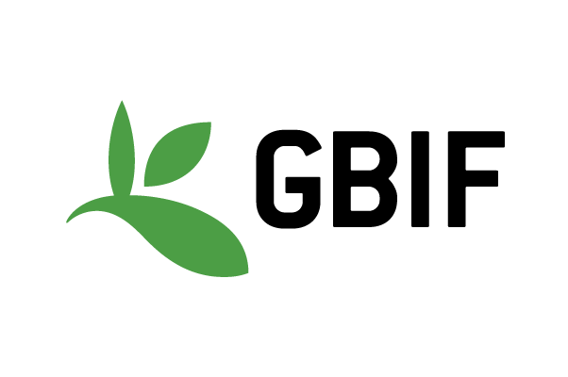

GBIF leads the Biodiversity Information for Development programme, or **BID**, a multi-year, €3.9 million programme funded by the European Union. The programme aims to increase the availability and use of biodiversity information in the [‘ACP’ nations](http://sable.madmimi.com/c/45524?id=9520.526.1.240298b9eca413ec8bb01ce56bc1b973) of sub-Saharan Africa, the Caribbean and the Pacific

This project is funded by the [European Union](http://europa.eu)