**TigerEats User Guide**

Ishan Sinha, Paulo Frazao, Gabriel Birman, Jamison Mercurio

**Overview of the system**

TigerEats is the name of a mobile nutrition app that Ishan is making independently of COS 333; our project is the companion nutritionist portal website for this mobile app.

A user would download the TigerEats mobile app, and provide their height, age, weight, gender, activity levels, and fitness goals. The app uses this information and the recognized Harris-Benedict formula to determine a daily <calorie, protein (g), carbs (g), fats (g)> goal for the user. When a user plans to eat, he navigates to the menu for the dining hall at which he wants to eat for that meal, can view menu items and their nutrition facts, and selects what he wants to eat. From here, he may either input the portions he think he took of each option he chose, or the app can tell him how many servings he should take of each option he chose to meet his goals and visualize those portions for him on his plate. The user would log the meal, take a photo of his plate, and proceed. In total, the user gives the app information about his physical attributes and what he has eaten for his meals.

Below are key images of the app:

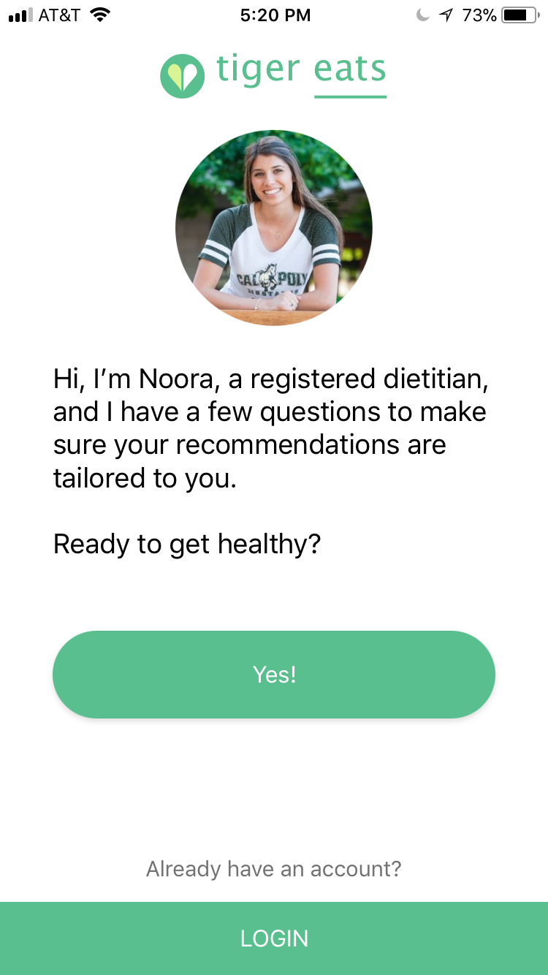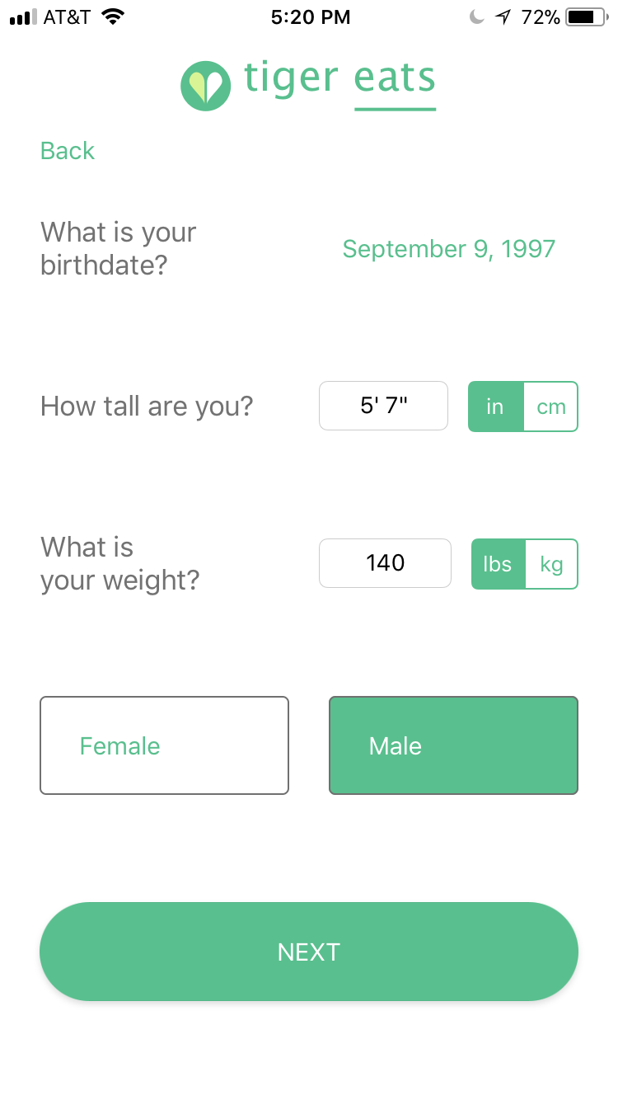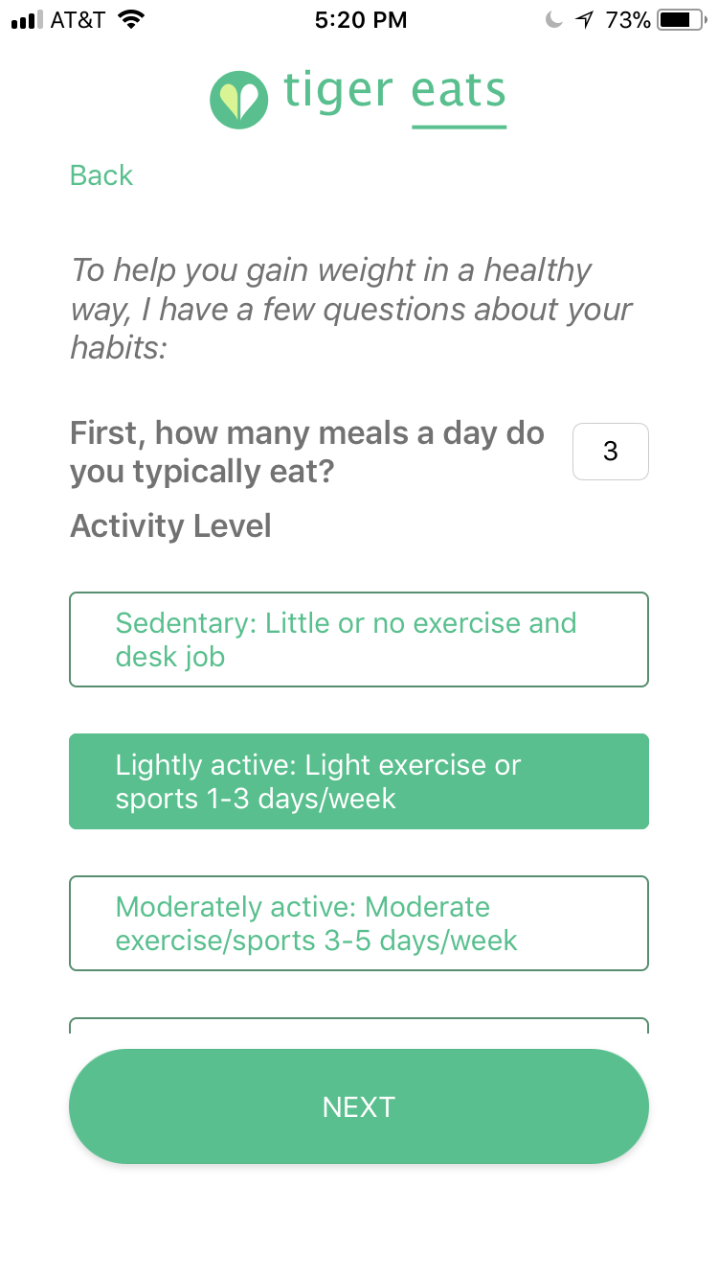

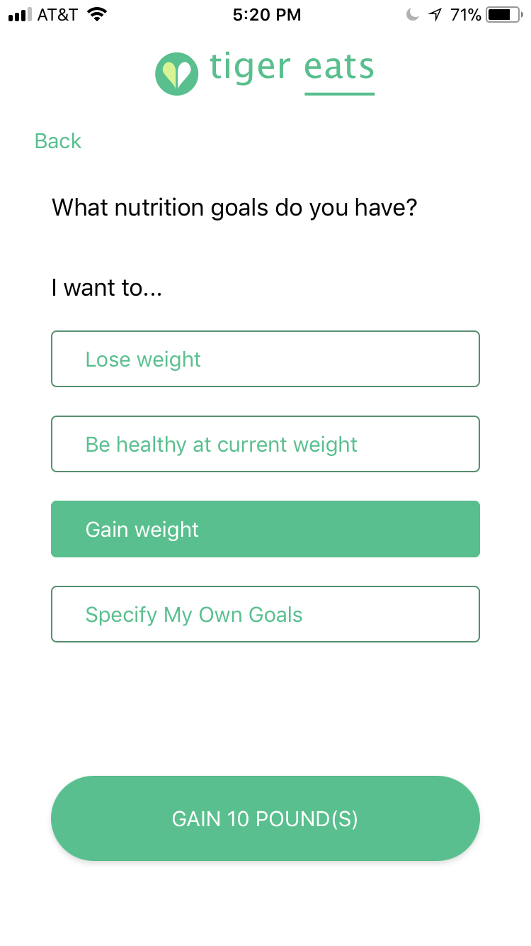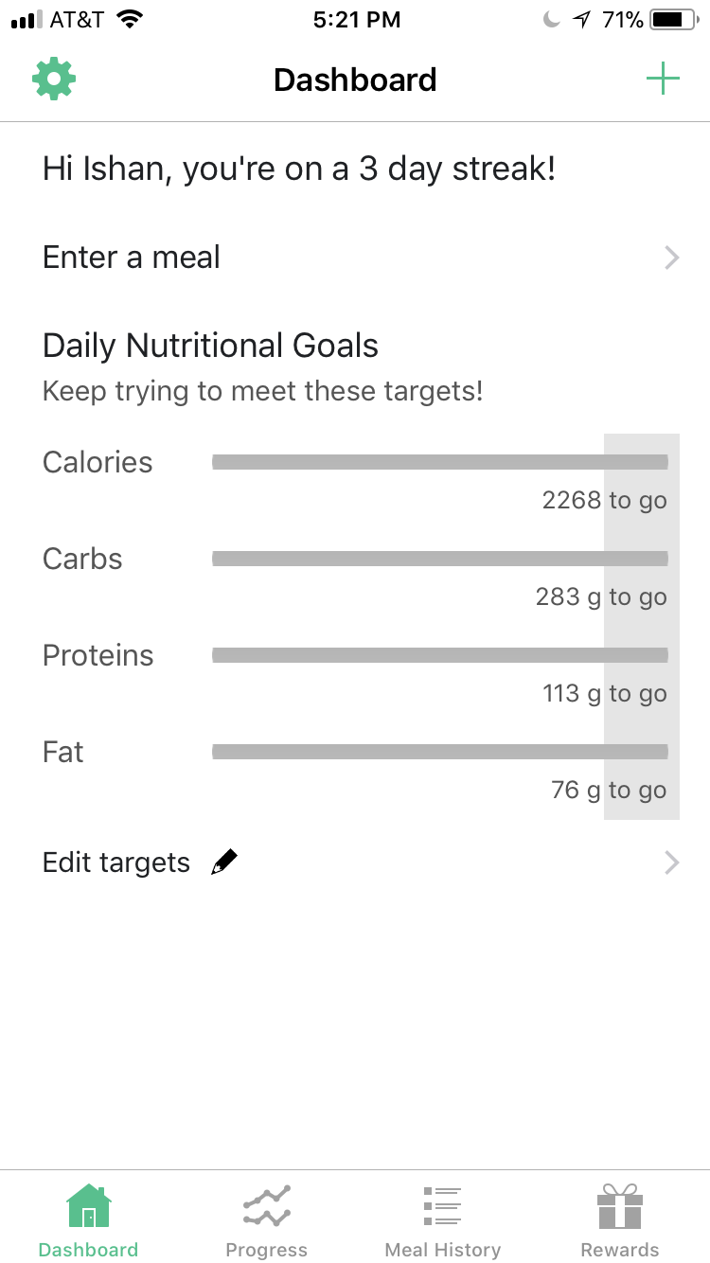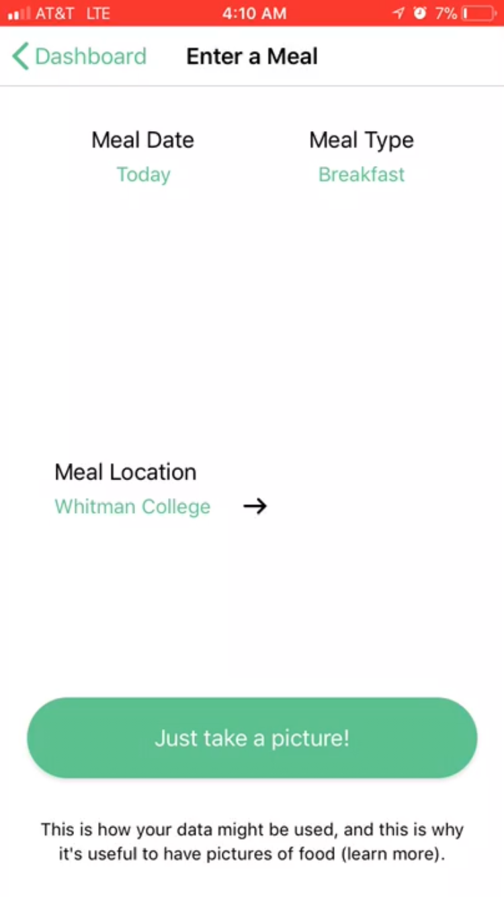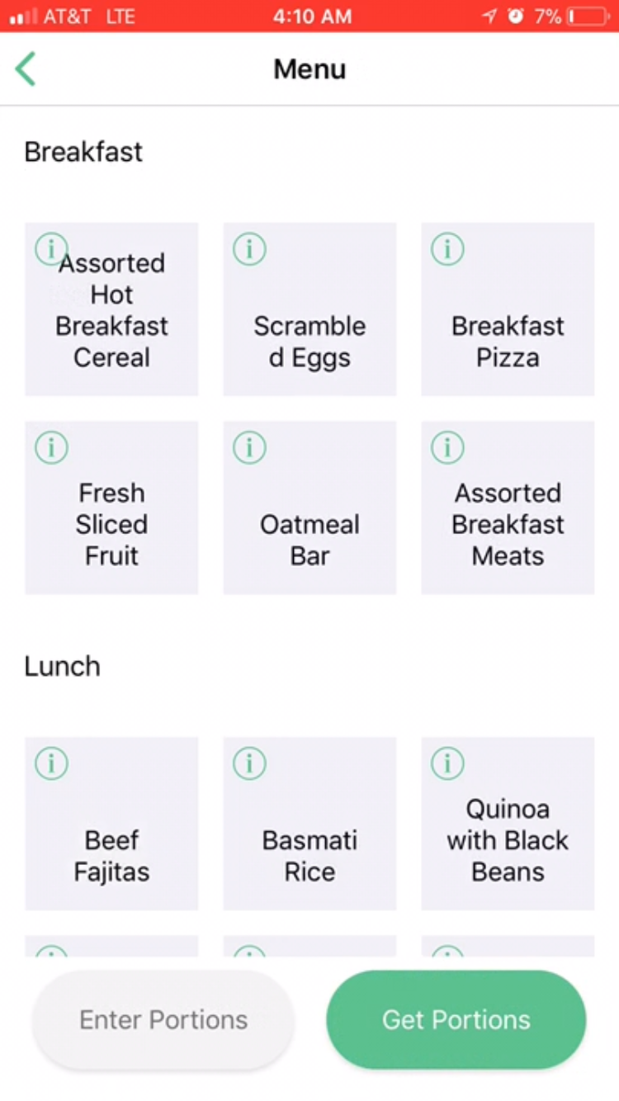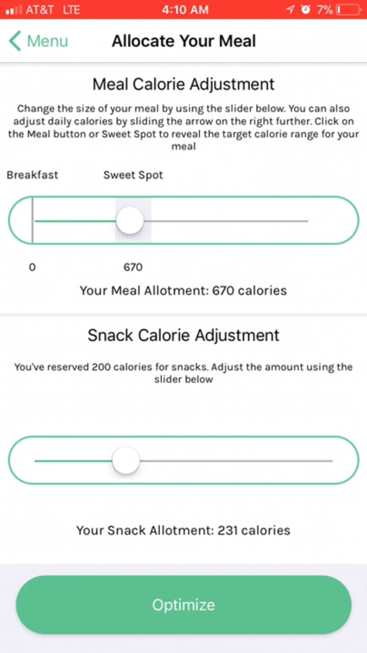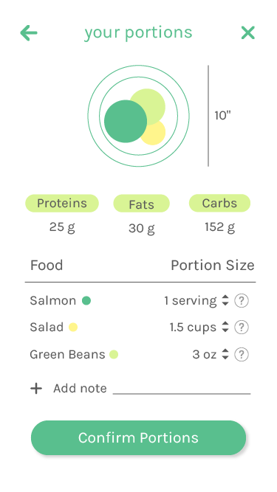

The relationship between the mobile app and the nutritionist portal can be summarized as follows:

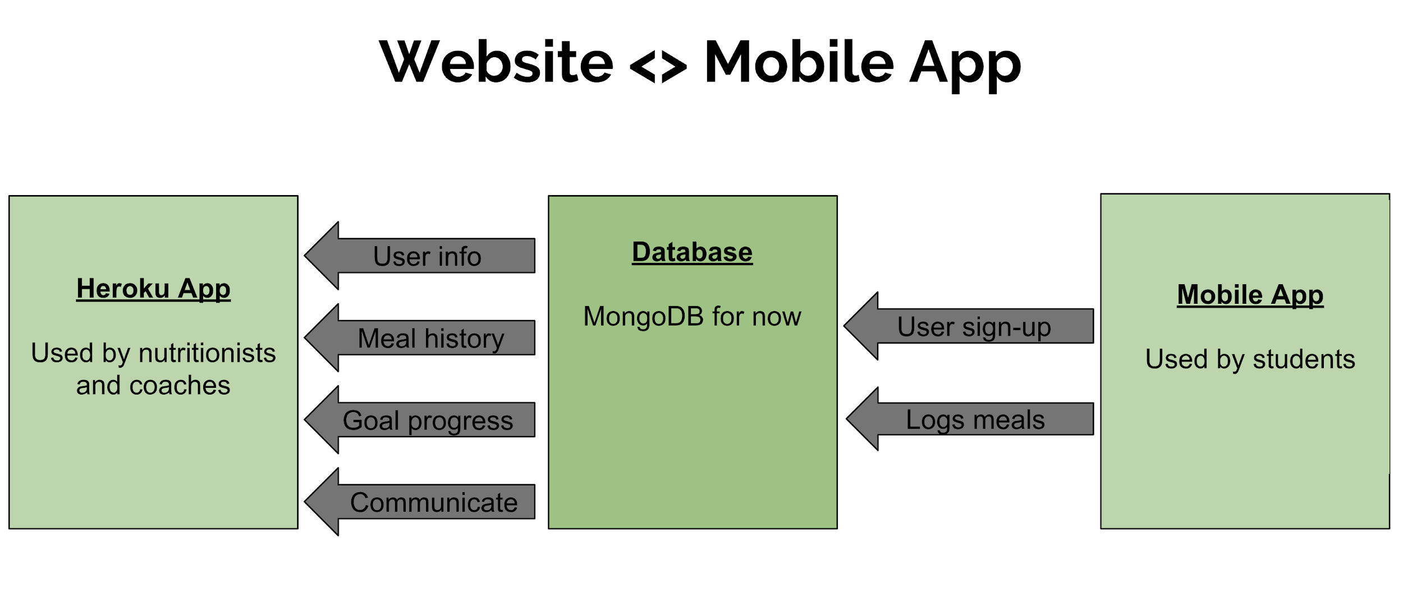

The goal of the companion nutritionist portal we are making in this project is to bridge the gap between campus/sports nutritionists and students. With the plethora of student eating data available through the mobile app, the portal we create can keep nutritionists up-to-date on student progress and help the nutritionist provide support and advice to students along their fitness journeys. The nutritionist portal contains a dashboard with all students in the system, along with these students’ identification points (gender, year, sports team if any, etc.) and fitness goals. The nutritionist can filter the dashboard for students by gender, sports team, and class year, and the nutritionist can put students that they want to pay special attention to on a “watchlist.” The “watchlist” could be used for students who have significant struggles with weight or who have specific eating requirements (like a wrestler). Through the dashboard, nutritionists can view and change users’ daily macronutrient goals, which would then update in their mobile app. Also through the dashboard, nutritionists can directly email students with advice. In future iterations, we would create an in-app messaging interface between students and nutritionists, but that was not feasible for this project. Each student has his own landing page with a detailed glance of his physical attributes, daily goals, and daily summaries of his food consumption. Each student also has his own Progress page that provides detailed time series analyses of the students’ nutrition progress and macronutrient consumption. Nutritionists can analyze this longitudinal information so they can gain insights into how the student is doing in relation to his/her goals, and they can choose to update students’ goals as they see fit.

**Scenarios**

Accessing the System

1. Visit <https://tigereats.herokuapp.com/>
   1. You should see a login page with a single button available to click

Log in to TigerEats

1. Click the “Login with Cas” button
   1. You should be routed to CAS authentication and then, assuming that that validates correctly, to the dashboard
   2. NOTE: If you are not validated in our authorized_users database, you will be bounced to an error page. Only a select subset of the Princeton community is granted access to this page. Normally, this would be Princeton nutritionists and coaches, but if you are a grader, then we should have entered your name in the system already

Filter students by gender: (F [Female])

1. Click on the “Gender” filter tab
2. Press “F” in the dropdown (thereby unchecking it)
   1. Ishan Sinha should no longer appear in the dashboard
3. Press “F” again (thereby re-checking it)
   1. Ishan Sinha should re-appear in the dashboard
4. Click on the “Gender” filter tab again to close it

Filter students by gender: (M [Male])

1. Click on the “Gender” filter tab
2. Press “M” in the dropdown (thereby unchecking it)
   1. Only Ishan Sinha should appear in the dashboard
3. Press “M” again (thereby re-checking it)
   1. All 4 students should once again appear in the dashboard
4. Click on the “Gender” filter tab again to close it

Filter students by team: (Soccer)

1. Click on the “Team” filter tab
2. Press “Soccer” in the dropdown (thereby unchecking it)
   1. Gabriel Birman and Jamie Mercurio should no longer appear in the dashboard
3. Press “Soccer” again (thereby re-checking it)
   1. Gabriel Birman and Jamie Mercurio should re-appear in the dashboard
4. Click on the “Team” filter tab again to close it

Filter students by team: (Football)

1. Click on the “Team” filter tab
2. Press “Football” in the dropdown (thereby unchecking it)
   1. There should be no change
3. Press “Football” again (thereby re-checking it)
   1. There should be no change
4. Click on the “Team” filter tab again to close it

Filter students by team: (Basketball)

1. Click on the “Team” filter tab
2. Press “Basketball” in the dropdown (thereby unchecking it)
   1. Ishan Sinha and Paulo Frazao should no longer appear in the dashboard
3. Press “Basketball” again (thereby re-checking it)
   1. Ishan Sinha and Paulo Frazao should re-appear in the dashboard
4. Click on the “Team” filter tab again to close it

Filter students by class year

1. Click on the “Class Year” filter tab
2. Press “2019” in the dropdown (thereby unchecking it)
   1. There should be no change
3. Press “2019” again (thereby re-checking it)
   1. There should be no change
4. Press “2022” in the dropdown (thereby unchecking it)
   1. Gabriel Birman should no longer appear in the dashboard
5. Press “2020” in the dropdown (thereby unchecking it)
   1. The dashboard should now be empty
6. Press “2022” and “2020” again (thereby re-checking them)
   1. All 4 students should once again appear in the dashboard
7. Press “2021” in the dropdown (thereby unchecking it)
   1. There should be no change
8. Press “2021” again (thereby re-checking it)
   1. There should be no change

Filter students by multiple criteria: (Players on the Women’s Basketball Team; Players on any Basketball Team; Players on any team)

1. Click on the "Gender” filter tab and uncheck “M”
2. Click on the “Team” filter tab and uncheck “Soccer” and “Football”
   1. Only Ishan Sinha should appear in the dashboard
3. Click on the "Gender” filter tab and re-check “M”
   1. Paulo Frazao should reappear in the dashboard
4. Click on the “Team” filter tab and re-check “Soccer” and “Football”
   1. Jamie Mercurio and Gabriel Birman should reappear

Filter students by multiple criteria: (Soccer players graduating in the Class of 2020)

1. Click on the “Team” filter tab and uncheck “Football” and “Basketball”
   1. Paulo Frazao and Ishan Sinha should disappear from the dashboard
2. Click on the “Class Year” filter tab and uncheck “2019,” “2021,” and “2022”
   1. Gabriel Birman should disappear from the dashboard; only Jamie Mercurio should remain
3. Click on the “Team” filter tab and re-check “Football” and “Basketball”
   1. Paulo Frazao and Ishan Sinha should reappear in the dashboard
4. Click on the “Class Year” filter tab and re-check “2019,” “2021,” and “2022”
   1. Gabriel Birman should reappear in the dashboard
   2. All 4 students should now be present in the dashboard

Filter students by searching for their names

1. Type “Jam” into the “Search for Students…” entry field in the dashboard
   1. Only Jamie Mercurio should remain in the dashboard (the others should have disappeared upon typing ‘J’)
2. Type “James Harden” into that same entry field
   1. The dashboard should now be empty (Jamie should have disappeared after “Jame” was entered)
3. Delete the full text within the entry field (i.e. delete “James Harden”)
   1. All 4 students should now be present in the dashboard

Send a student an email from the Dashboard

1. On Paulo Frazao’s row in the dashboard, click the envelope icon under the “Send Email” column header
   1. The default email app on your computer should open with the email “to” field pre-populated with Paulo’s email ([pfrazao@princeton.edu](mailto:pfrazao@princeton.edu)) and the following subject line present: “[TigerEats] A Message from your nutritionist!”
2. Send him a message (Anything works for the purposes of testing, but something as simple as “Congrats on acing this class!” would be fine)
   1. The email screen should have disappeared, leaving you on the dashboard once again

Navigate to the Change Goals Page

1. From the dashboard, press the “Change Goals” pencil icon in Ishan Sinha’s row
   1. You should have been routed to the Change Goals page (with the header “Change your goals below!” at the top

Change a user’s macronutrient goals by inputting macronutrients (Method 1)

1. Look at the two options for input listed on the page
   1. The first option (“Input daily protein, carbohydrate, and fat goals”) should be selected
   2. Ishan’s existing macronutrient goals (which may differ depending on how beta testers have altered them) should be present as placeholders in the four input fields below
2. Enter 100 in the “Protein / Day” field, 100 in the “Carbs / Day” field, and 10 in the “Fats / Day” field
   1. The value in the “Calories / Day” field should change dynamically as these others change. 890 should be the final value to appear in this field (the reason for this is that there are 4 calories in 1 gram of protein and carbs and 9 calories in 1 gram of fat, and so 890 = 4*100 + 4*100 + 9*10)
   2. You should not be able to alter the value in this field
3. Click “Submit Changes!”
   1. You should be redirected to the Dashboard, and Ishan Sinha’s goals should now be 890 for calories, 100 for protein, 100 for carbs, 10 for fat

Change a user’s macronutrient goals (from the dashboard) by inputting a caloric goal and macronutrient percentage breakdowns

1. From the dashboard, press the “Change Goals” pencil icon in Jamie Mercurio’s row
   1. You should have been routed to the Change Goals page (with the header “Change your goals below!” at the top
2. Press the “Input daily caloric goal and macronutrient breakdown” option
   1. The contents of the body of the page should have changed to include a “Current Goals” section, a “New Caloric Goal and Percentage Breakdown” section, and a “New Goals” section
3. Input 6000 in the “Calories / Day” field
   1. 6000 should have appeared under the subheading of the same name in the “New Goals” section
4. Input 20 for protein, 50% for carbs, 30 for fats
   1. 300.00, 750.00, and 200.00 should have appeared under the corresponding subheadings of the “New Goals” section (these calculations were performed using a variation of the above formula)
5. Click “Submit Changes!”
   1. You should be redirected to the Dashboard, and Jamie Mercurio’s goals should now be 6000 for calories, 300 for protein, 750 for carbs, and 200 for fat

Change a user’s macronutrient goals (from the dashboard) by inputting a caloric goal and (invalid) macronutrient percentage breakdowns

1. From the dashboard, press the “Change Goals” pencil icon in Jamie Mercurio’s row
   1. You should have been routed to the Change Goals page (with the header “Change your goals below!” at the top
2. Press the “Input daily caloric goal and macronutrient breakdown” option
   1. The contents of the body of the page should have changed to include a “Current Goals” section, a “New Caloric Goal and Percentage Breakdown” section, and a “New Goals” section
3. Input 6000 in the “Calories / Day” field
   1. 6000 should have appeared under the subheading of the same name in the “New Goals” section
4. Input 20 for protein, 50 for carbs, 20 for fats
   1. 300.00, 750.00, and 133.33 should have appeared under the corresponding subheadings of the “New Goals” section
5. Click “Submit Changes!”
   1. An alert should have popped up, stating:
      1. Valid values only! - Your macronutrient breakdown percentages must add up to 100%!
6. Press OK
   1. You should return to the Change Goals page with no change to your inputs
7. Change the 20 in the “% Fats” field to -1 and press “Submit Changes!”
   1. An alert should have popped up, stating:
      1. Valid values only! - Values must be numbers between 0 and 15,000 - no negative values allowed!
8. Press OK
   1. You should return to the Change Goals page with no change to your inputs
9. Change the -1 in the “% Fats” field to 30 and the 6000 in the “Calories / Day” field to the character ‘b’ and press “Submit Changes!”
   1. An alert should have popped up, stating:
      1. Valid values only! - You need to enter numbers!
10. Press OK
    1. You should return to the Change Goals page with no change to your inputs
11. Press the “Dashboard” button in the navigation header
    1. You should have been redirected to the dashboard

Navigate to an individual student’s landing page

1. From the dashboard, click anywhere on Jamie Mercurio’s table row
   1. You should have been redirected to his student profile page

Send a student an email from his landing page

1. Click the “Send Message” button under his profile picture
   1. The default email app on your computer should open with the email “to” field pre-populated with Jamie’s email (jamisonm[@princeton.edu](mailto:pfrazao@princeton.edu)) and the following subject line present: “[TigerEats] A Message from your nutritionist!”
2. Send him a message (Anything works for the purposes of testing, but something as simple as “Congrats on acing this class!” would also be fine in this case)
   1. The email screen should have disappeared, leaving you on the student profile once again

View the contents of a student’s prior meal: (Present Day)

1. Scroll down until you see a subsection headed by today’s date (“today” being the date of testing)
   1. This subsection should be the first under “Logged Meals”
2. Consider the contents of the student’s three meals for that day
   1. The student’s breakfast should be shown on the left
   2. The student’s lunch should be shown in the middle
   3. The student’s dinner should be shown on the right
   4. Each meal should have an accompanying set of macronutrient values, contents, and an accompanying image (the reason for there only being eggs and bread is the lack of real-time data from the mobile application)

View the contents of a student’s prior meal: (Two Days Prior)

1. Scroll down until you see a subsection headed by today’s date minus two days (“today” being the date of testing)
   1. This subsection should be the third under “Logged Meals”
2. Consider the contents of the student’s three meals for that day
   1. The student’s breakfast should be shown on the left
   2. The student’s lunch should be shown in the middle
   3. The student’s dinner should be shown on the right
   4. Each meal should have an accompanying set of macronutrient values, contents, and an accompanying image (the reason for there only being eggs and bread is the lack of real-time data from the mobile application)

Navigate to the Change Goals Page

1. From the student profile page, press the “Change Goals” button
   1. You should have been redirected to the Change Goals page
2. Press the Dashboard button on the navigation header, followed by Jamie Mercurio’s table row once again
   1. You should once again have been redirected to his student profile page

Check the ratio of how much the user has eaten today to his macronutrient goals

1. Scroll to the top of the student profile page
   1. Macronutrient ratios as well as 4 bars (one for each macronutrient) should be present in the right-hand corner
2. Observe the ratio of Jamie’s macronutrient intake for that day to his macronutrient goals
   1. The numerators of these ratios should be consistent with the first subsection in the “Logged Meals” section
   2. The bars to the right of these ratios should themselves be consistent with the ratios

Add User to the Watchlist

1. Observe the button under the Send Message button
   1. If Jamie is presently on the watchlist, it should read: “Remove from Watch List”
   2. If Jamie is not on the watchlist, it should read: “Add to Watch List”
2. Ensure that Jamie is not on the watch list (by pressing the button if he is, and leaving it alone if not)
   1. The page should not refresh; the text on the button should change upon clicking it
   2. NOTE: You may have to push the “Remove from Watchlist” button twice; this is a known bug
3. Click this “Add to Watch List” button
   1. The text should change to “Remove from Watchlist”
4. Click the Dashboard button in the header
5. Press the “Watchlist” option under “Select user list:”
   1. All the users on the watch list (important: including Jamie) should now be displayed in the table
6. Click anywhere in Jamie’s row to navigate to his student profile page
7. Click “Remove from Watch List”
   1. The text should have changed accordingly
   2. You may need to click “Remove from Watch List” twice -- this is a known bug
8. Once again, return to the dashboard via the header button and then to the list of users on the watchlist
   1. Jamie should no longer appear in this list
9. Click the “All Users” option
   1. You should see all of the users in the table once again

Force an error screen to appear

We are maintaining a list of users (the “nutritionists” for the application) who are authorized to view the application. To that end, any CAS-enabled user who is not on this list will be bounced to an error screen, giving them the option to return to the login screen. Granted, we have authorized Prof. Dondero and all of the TAs, and so it is hard to trigger this error. However, this section will show you the actual error landing page as an example.

1. Click on the dashboard button in the header to return to the dashboard
2. In the browser, change the URL that you are accessing to: “<http://tigereats.herokuapp.com/error>”
   1. You should see an error screen with an element that says “We’re sorry! You aren’t authorized to view this page!” and an accompanying button to redirect you to the Login page
3. Press the button
   1. You should have been redirected back to the login page
4. Log in once again
   1. You should be at the dashboard

Navigate to Progress

1. Navigate to Gabriel Birman’s student profile page
2. Press the “See Progress” button next to the “Change Goals” button
   1. You should have been redirected to the student’s progress page

View the student’s daily macronutrient progress

1. Consider the three viewing options in the top left corner
   1. The “Daily” option should be selected by default
2. Observe the central pane, where the student’s macronutrient goals and progress should be displayed
   1. All 4 macronutrients should be displayed by default
   2. Hovering over any of the bars should display the date associated with that data point at the top right
   3. 4 metrics should be displayed at the left of each of these series:
      1. Min - the minimum value in the time series
      2. Max - the maximum value in the time series
      3. Avg - the average value in the time series
      4. Goal - the current goal for that macronutrient

View the student’s weekly macronutrient progress

1. Select the “Weekly” option in the top left corner instead
   1. Hovering over any of the bars should display the week associated with that data point at the top right

View the student’s monthly macronutrient progress

1. Select the “Monthly” option in the top left corner instead
   1. Hovering over any of the bars should display the month and year associated with that data point at the top right
2. Reset the option to “Daily”

Unselect Calories and Carbs

1. In the selection module at the top, uncheck “Calories” and “Carbs”
   1. The two time series associated with those two macronutrients should disappear from the display
2. Recheck “Calories” and “Carbs”
   1. The two time series should reappear
3. Now you should just see time series data for Carbohydrates and Fats

Attempt to unselect all of the macronutrients

1. In the selection module, uncheck “Calories,” “Carbs,” and “Fat”
   1. Those three time series should disappear
2. Uncheck “Protein”
   1. There should be no change
3. Re-check “Calories,” “Carbs,” and “Fat”

See Gabriel’s macronutrients for a specific day: 1/17/19

1. Bring the cursor into the main display
2. Notice, once again, the date at the top right, indicating the day of the year associated with a given data point
3. Move the cursor onto the protein time series, and then move it right if 1/17/19 is later than the day depicted or left if 1/17/19 is earlier than the day depicted
   1. The values to the right of the 4 time series should be changing as you hover over each new data point, reflecting that day’s corresponding values
4. When you have reached 1/17/19, view Gabriel’s macronutrients at the right
   1. His values should be:
      1. Protein: 410
      2. Fat: 101
      3. Carbs: 650
      4. Calories: 5050

View a smaller date range

1. Click on the help icon on the top right corner of the brush chart (the helper chart below the main time series) for an explanation of how to modify the time range displayed
2. Place the cursor over the right side of the brush (the translucent bar) on the bottom box of the page
3. Click and drag it to the left
   1. You should see the upper bound of the data shown in the display decrease, and that decrease reflected in the horizontal axis of the display
   2. The data displayed should also be reduced accordingly
4. Place the cursor over the center of the brush
5. Click and drag it to the right so that the first date displayed is 12/23
   1. The translucent bar should have moved across the bars on the bottom of the screen accordingly
   2. You should see 12/23/18-2/01/19 now
6. Click and drag the left side of the translucent bar in the bottom bax to the left so the first date displayed is 12/14 again
   1. You should see 12/14/18-2/01/19 now
7. Pan over the rightmost edge of the translucent bar until the mouse turns into a double-ended arrow; click and drag it to the right until the last data displayed (right-most) is 1/17
   1. You should see 12/14/18-1/17/19 now

Logout

1. Click the Logout button in the navigation header
   1. You should have been redirected to the CAS Logout page
   2. In order to go back to the tigereats application, you have to open a new window or tab

Thank you for using our application!