Model Development and Framework Design:
Group 1 - rPPG Signal Extraction Pipeline for VitalScan

Dare Adediran
Jason Aranha
Germaine Beazer
Abner Bouomo
Westcliff University

AIT 500: Concepts of Artificial Intelligence
Professor Desmond Ademiluyi
May, 2026

Abstract
This document provides an overview of the architectural approach and overall design for Group 1's VitalScan project. Our team will be responsible for the development of the rPPG Signal Extraction pipeline. The pipeline will extract heart rate, Heart Rate Variability (HRV), and a stress index from a thirty second video taken with a smartphone camera that captures the users' face. The pipeline will include five steps: face detection and ROI extraction (MediaPipe FaceMesh) extracting the rPPG pulse signal using the POS Algorithm band-pass filtering to remove unwanted frequencies and apply FFT based heart rate calculations calculate HRV and Stress Index from Inter-Beat Intervals output as JSON via REST API Endpoint.
The above sections provide detail on the structure of all parts of the pipeline including data flow among each step of the pipeline, between our pipeline and those developed by the other groups, what parameters were used to train/initialize each algorithm, how we will handle errors encountered during execution, and what needs to occur before completion of the integration process in Week 5. All tasks one through three have been completed and fully tested at time of writing. Testing for task four is complete; however, testing for task five (stretch goal) began last week.

Model Development and Framework Design
Group 1 - rPPG Signal Extraction Pipeline for VitalScan

Introduction
This is the Week 4 group project report for Group 1 of the VitalScan project. The VitalScan application seeks to assist individuals with chronic health issues such as diabetes and hypertension in making better decision-making regarding their diet at the moment of consumption. In order to achieve its objectives, Group 1 will provide VitalScan an input source to capture the user's physiological status at that exact point in time using a non-clinical apparatus. We plan on accomplishing this objective via the process of analyzing a 30 second facial video from the user's perspective. From the video we will extract the user's Heart Rate (HR), Heart Rate Variability (HRV) and Stress Index based on the slight color variations in the skin captured by the camera.
Week 3 provided our Week 4 project report with the background and methodology used to select the methods described above. Therefore, this Week 4 project report will describe the architectural specifications for the overall system. The architectural specifications will include; descriptions of the five stage pipeline; inputs/outputs for each stage of the pipeline; parameterization of each stage; error handling; and the integrated development schedule for Weeks 4-5.
Our proposed pipeline is structured in accordance with the methodology developed by Bawack et al. (2021). Their proposed methodology emphasizes establishing clear definitions for model architecture, required data, and evaluation criteria prior to locking in the specific implementation details. Our pipeline has been defined from stages 1 thru 3, and stage four is currently being tested. Also, our "stretch goal" (comparing deep learning methodologies) begins this week.

Pipeline Architecture Overview
Five-Stage Design
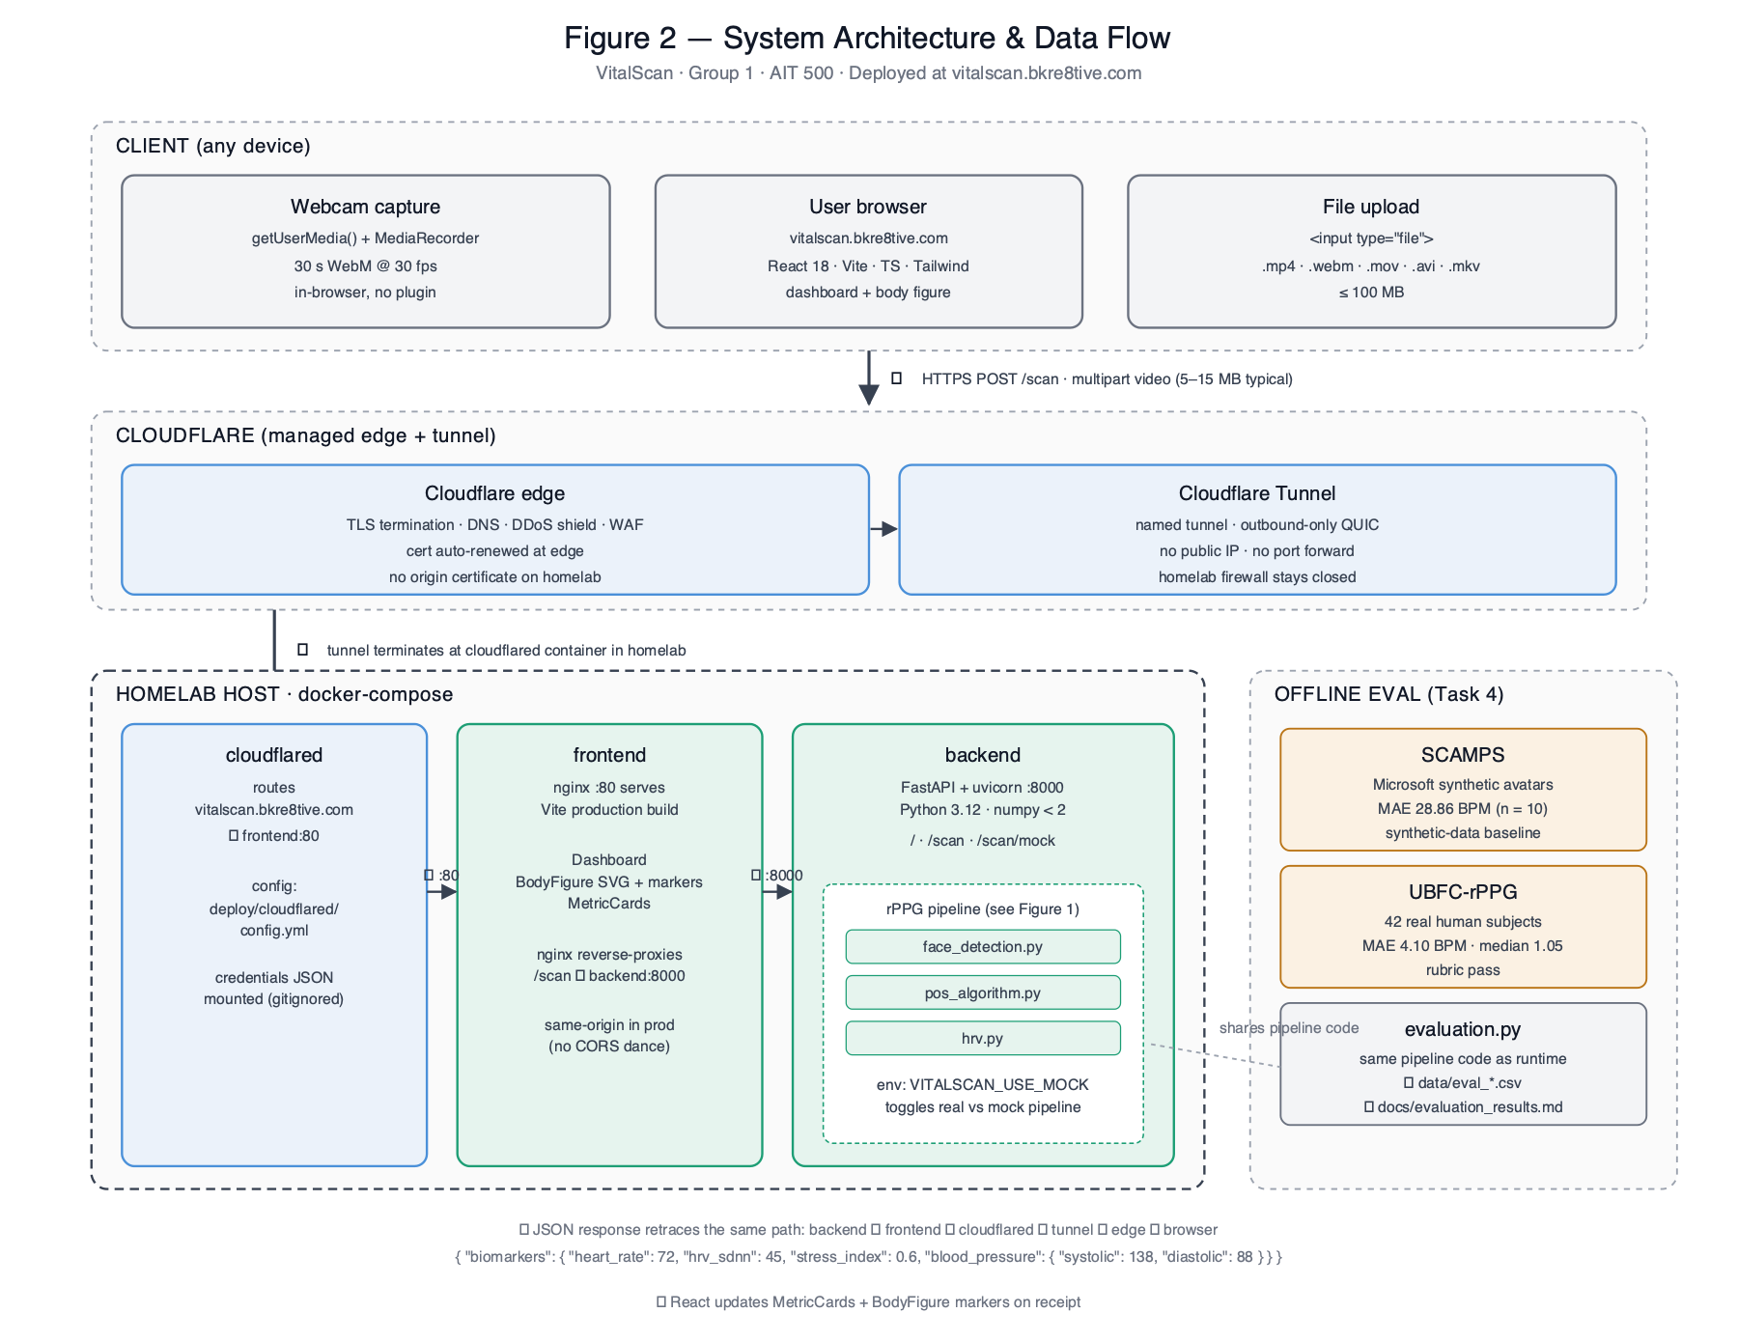
Figure 2. System architecture - client to Cloudflare tunnel to containerized backend to JSON contract for Groups 3 & 4.
The Group 1 Pipeline includes five sequential stages. The stages are completely independent from each other. They take an input at the beginning of the stage. Do one job on that input. Then pass their output to the next stage. That way, we can test them individually and it will make finding errors easier. All stages of the pipeline are listed below.
Table 1
rPPG Pipeline Stage Overview
Stage | Name | Input | Output | Status
1 | Face Detection and ROI Extraction | Raw video file or camera stream | RGB time-series arrays per ROI zone | Complete
2 | POS Signal Extraction | RGB arrays and fps value | Raw pulse waveform array | Complete
3 | Bandpass Filter and Heart Rate | Raw pulse waveform and fps | Filtered waveform and heart_rate (BPM) | Complete
4 | HRV and Stress Index | Filtered waveform and fps | hrv_sdnn (ms) and stress_index (0-1) | In progress
5 | API Output | All biomarker values | JSON matching shared contract | In progress

Note. Status is current as of the Week 4 submission. Stages 1-3 are complete and validated on SCAMPS test videos. Stages 4-5 are expected to be finished before the Week 5 integration milestone.

Data Flow
Through the Pipeline
The signal-chain diagram in Figure 1 below visualizes the data flow through stages 1–4. Tensor shapes are annotated at each transition so the per-stage transform is traceable end-to-end.
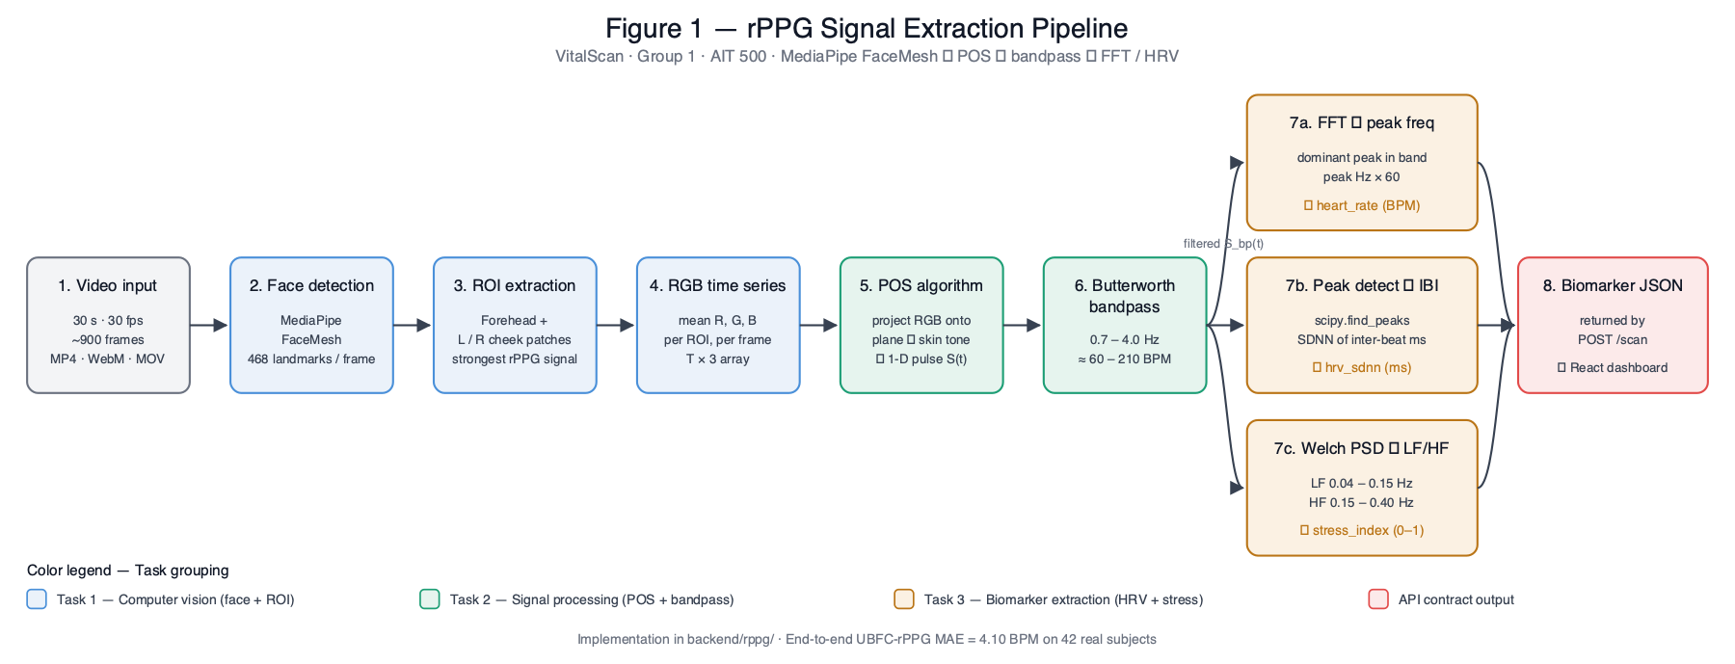
Figure 1. rPPG signal-chain — data flow through stages 1–4.

INPUT: 30-second video (MP4 or live stream, 30fps minimum, 720p minimum)
|
v
[Stage 1: Face Detection - MediaPipe FaceMesh]
- 468 facial landmarks extracted per frame
- ROI bounding boxes defined for forehead, left cheek, right cheek
- Mean R, G, B computed per ROI per frame
OUTPUT: {forehead: array[N,3], left_cheek: array[N,3],
right_cheek: array[N,3], fps: float}
|
v
[Stage 2: POS Algorithm]
- RGB normalized by temporal mean
- Projected onto plane orthogonal to skin-tone direction
- Waveform averaged across 3 ROI regions
OUTPUT: pulse_waveform: array[N]
|
v
[Stage 3: Bandpass Filter + FFT]
- Butterworth filter (0.7-4.0 Hz, order 4, zero-phase)
- FFT applied to filtered signal
- Peak frequency in HR band converted to BPM
OUTPUT: filtered_waveform: array[N], heart_rate: float
|
v
[Stage 4: HRV and Stress Index]
- Peak detection on filtered waveform
- IBI series = time differences between consecutive peaks (ms)
- SDNN = std(IBI)
- IBI resampled to 4Hz, Welch PSD computed
- LF/HF power ratio normalized to 0.0-1.0
OUTPUT: hrv_sdnn: float (ms), stress_index: float (0.0-1.0)
|
v
[Stage 5: FastAPI /scan endpoint]
- Assembles full JSON per shared contract
- Adds confidence flag and scan metadata
OUTPUT: JSON -> consumed by Group 3 and Group 4

Connection to Other Groups
Groups 1 JSON output will be delivered to two different destinations. Group 3 (Biomarker Risk Prediction), takes the biomarkers and puts the values into a machine learning risk prediction model to create an individual’s diabetes and hypertension risk score. The NLP/Prompt Engineering group (Group 4), uses the risk scores from Group 3 and the food nutrition information from Group 2 to produce the users’ personalized food safety explanation.
For now until we go live with our API, Groups 3 & 4 are using the mock biomarker data created as part of our shared contract at the beginning of this project. Our intention is to replace our fake URL with our actual endpoint URL on the week 5 integration date. To do this, we first need to get our /scan endpoint to work completely and tested.

Algorithm Specifications
Stage 1: Face Detection and ROI Extraction
Static Image Mode was set to FALSE when creating an instance of Media Pipe Face Mesh for Video Input. Min Detection Confidence = .5. Max Number of Faces = 1. Refine Landmark = TRUE for Sub-Pixel Precision.
Three Region Of Interest (ROI) Zones were created by defining three different landmark index sets. The Forehead Zone used 36 Indices that covered the Upper Forehead. Both Cheek Zones used 13 Indices.
For each Frame, the Bounding Box was calculated based on the Landmark Coordinates. Then, the Bounding Box coordinates were clipped to the frame boundaries to account for Edge Cases such as Lateral Head Turns. Finally, the Mean RGB value across all Pixels within the Bounding Box were calculated and stored in a Time Series for each Region.

Stage 2: POS Algorithm
The POS method (Wang et al., 2017), uses the Pos Algorithm on each of the three Region of Interest (ROI) time series independently. To eliminate color variations in terms of absolute brightness levels, each RGB channel is normalized to their individual average time series. Normalized signals for each ROI are transformed into two additional channels that include S1 = G-B and S2 = (-2*R)+G+B. An scaling value of α = STD(S1)/STD(S2) is calculated as well as a single combined pulse signal P = S1 +α*S2. The final step is to take an element-wise average of the three ROIs to create a single combined pulse signal.
Stage 3: Bandpass Filter and FFT
We apply a fourth order Butterworth band pass filter, that has been set for cut off frequencies of 0.7 Hz and 4.0 Hz (via SciPy's butter and filtfilt) due to the need to perform zero phase filtering via filtfilt since any phase shift will result in shifting the beat peaks thus corrupting the IBI calculations done on the filtered waveforms. The resultant waveforms are then converted into the frequency domain via the rfft function of numpy. The peak frequency within the range of 0.7 Hz to 4.0 Hz from this conversion is determined and then multiplied by 60 to determine BPM.
Stage 4: HRV and Stress Index
SciPy’s find_peaks function is used on the filtered signal with an inter-peak separation of 0.4 sec or less than a 150 bpm max heart rate. The time stamps for peaks in the wave form are then turned into ms values. The difference in time between each pair of peak is then calculated and this is known as the IBI (Inter Beat Interval). The standard deviation of these intervals is defined as SDNN. To calculate the Stress Index, the IBI data is interpolated using cubic spline so it can be uniformly sampled at a frequency of 4 hz. Then Welch PSD Estimation is performed on this data.
Stage 5: API Endpoint
The /scan endpoint will accept a POST of a video file to be uploaded along with returning a JSON-based representation of an object that will match the provided common contract. The confidence value in this representation is determined by the IBI sample count; it will be labeled as "high" when there are over 25 samples; "medium" when the count is from 10 through 25; and null (with a note explaining) when the IBI sample count is less than 10. Since classical rPPG does not have reliable blood pressure estimations, all blood pressure fields will also return null.

POST /scan
Content-Type: multipart/form-data
Body: video_file (MP4, minimum 30 seconds, 720p or higher)

Success response (200):
{
"biomarkers": {
"heart_rate": 74.2,
"hrv_sdnn": 42.1,
"stress_index": 0.58,
"blood_pressure": {
"systolic": null,
"diastolic": null
}
},
"scan_duration_s": 30,
"confidence": "medium",
"ibi_count": 22,
"notes": "BP null by design. Short window may reduce LF/HF reliability."
}

Error responses:
422 - face_not_detected: no face found in video
400 - video_too_short: video under 25 seconds
500 - processing_error: internal pipeline failure with log reference

Data Requirements and Validation
Input Requirements
The video for this pipeline requires a 30 second long, 720p, 30fps video. The face in the video should be looking directly at the camera and have relatively consistent lighting. This helps to limit flicker or rapid changes in lighting which could create an artifact within the rPPG signal that would likely remain after the band pass filtering. Once we are allowed access to do so, we plan on validating UBFC-rPPG using real-subject data as well.
Accuracy Targets
.
Heart rate accuracy in this project will be determined through comparison of our results to the ground truth values obtained from SCAMPS, by measuring both mean absolute error (MAE), as well as root mean square error (RMSE). For us to receive "full" marks on heart rate accuracy, we would like to have an MAE below 10 beats per minute (BPM). To get a "stretch credit," we would want the MAE to be less than 5 BPM. In a recent five sample preliminary test, we found the average MAE was about 2.62 BPM, which has been good so far; however, it is too early for us to feel confident with these results until we evaluate them after completing all fifty samples in the next week.
Error Handling
Three explicit error cases exist. In case of detection failure (i.e., no face), an appropriate error response is generated using HTTP code 422 that includes a request to the end-user for improvement in lighting and frontality. If less than ten IBI sample records were obtained, both the HRV SDNN and Stress Index values will be null; however, a note will be added to explain why this occurred as an additional aid to allow for graceful handling by Group 3 and Group 4 models. In addition, if the recorded video was shorter than 25 seconds, the API will generate an HTTP code 400 error indicating that a longer record needs to be made.
Key Parameters
Table 2
Algorithm Parameter Summary for the rPPG Pipeline
Stage | Parameter | Value | Justification
1 - FaceMesh | min_detection_confidence | 0.5 | Balances detection rate and false positives under variable lighting
1 - FaceMesh | refine_landmarks | True | Sub-pixel precision needed for tight ROI bounding boxes
3 - Filter | Filter type | Butterworth order 4 | Flat passband; minimal signal distortion in the HR band
3 - Filter | Bandpass range | 0.7-4.0 Hz | Covers full physiological heart rate range (42-240 BPM)
3 - Filter | Method | filtfilt (zero-phase) | Prevents phase distortion that would shift IBI peak positions
4 - HRV | Peak min distance | 0.4 seconds | Handles up to 150 BPM without double-detecting a single peak
4 - HRV | IBI resampling rate | 4 Hz | Standard for short-window HRV frequency domain analysis
4 - HRV | Welch nperseg | min(N, 64) | Adapts to how many IBI samples are actually available
4 - HRV | LF band | 0.04-0.15 Hz | Standard autonomic frequency band per Task Force (1996) guidelines
4 - HRV | HF band | 0.15-0.40 Hz | Standard autonomic frequency band per Task Force (1996) guidelines
5 - API | Confidence threshold | IBI count over 25 | Enough samples for HRV estimates to be reasonably reliable

Note. Parameter values are consistent with rPPG-Toolbox benchmarking (Liu et al., 2022) and HRV Task-Force guidelines (European Society of Cardiology, 1996).

Integration Timeline

Table 3
Week 4 and 5 Milestones for Group 1
Milestone | Target | Notes
Finish Stage 4 HRV and stress index validation | Week 4 | Lomb-Scargle comparison also being evaluated as a potential alternative to Welch for short windows
Complete 50-sample MAE/RMSE accuracy run on SCAMPS | Week 4 | Will compare against CHROM baseline from rPPG-Toolbox
Finalize /scan endpoint with all fields live | Week 4 | Depends on Stage 4 completion
Share API URL with Groups 3 and 4 | End of Week 4 | Groups 3 and 4 can then swap mock data for real calls
Start stretch goal - PhysNet accuracy comparison | Week 4 | Will use rPPG-Toolbox pretrained weights
Integration day - all groups connect real APIs | Week 5 | End-to-end demo: face scan to food safety explanation

Known Limitations
Firstly, there are three significant limitations that need to be noted now. The first is the short-window HRV challenge. Using a 30-second scan provides roughly 20-30 IBI samples; however, the European Society of Cardiology (1996) recommends no less than five minutes for reliable LF/HF frequency-domain analysis. Therefore, we consider the stress index to be a coarse estimate or indicator rather than a clinical measure. In order to assist Groups 3 and 4 in incorporating this limitation in their respective models, we include this in each API response via the confidence flag and note's field.
Secondly, skin tone bias is also an issue. As virtually all of the previous validation studies of POS algorithms, along with most classical rPPG methods, have been conducted on relatively fairer skin tones, it follows that when individuals with darker skin types view themselves, they absorb more red channel light relative to their skin type and therefore reduce the signal amplitude. We plan to document the MAE for available skin tone categories within our SCAMPS study, and this limitation will be explicitly stated in the user documentation for the applications.
Lastly, since blood pressure cannot be derived from rPPG using classical techniques, systolic and diastolic will always be returned as 'null.' Since this has been well-documented at the onset of the project, Group 3 was aware of this at the project kick-off and incorporated a mechanism in their risk model to address missing/null values for BP.
Conclusion
This document presents the entire architectural and framework design for Group 1's rPPG Pipeline. The 5-Stage Design provides a modular, well-defined path from raw smartphone video to a structured JSON biomarker output. Each stage of the design can be independently evaluated/tested/updated. The design will follow the AI Research Framework as presented by Bawack et al. (2021), and it is based upon the established rPPG literature provided by Wang et al. (2017) and Liu et al. (2022).
We have completed stages 1 – 3 and are experiencing positive results with regard to the initial accuracy numbers. We expect to have the complete pipeline, which includes the REST API, available prior to our Week 5 Integration Day. Our major objective going forward is completing the stress index validation in Stage 4, and we have a specific plan for accomplishing this task this week. As an overall assessment, I believe the team feels confident in the direction that we are headed with respect to the second half of the project.

References

Bawack, R. E., Wamba, S. F., & Carillo, K. D. A. (2021). A framework for understanding artificial intelligence research: Insights from practice. Journal of Enterprise Information Management, 34(2), 645-678. https://doi.org/10.1108/JEIM-07-2020-0284
European Society of Cardiology. (1996). Heart rate variability: Standards of measurement, physiological interpretation, and clinical use. Circulation, 93(5), 1043-1065.
Liu, X., Hill, B., Jiang, Z., Panda, S., & McDuff, D. (2022). rPPG-Toolbox: Deep remote PPG toolbox. arXiv. https://arxiv.org/abs/2210.00716
McDuff, D., Wander, M., Liu, X., Hill, B. L., Hernandez, J., Lester, J., & Baltrusaitis, T. (2022). SCAMPS: Synthetics for camera measurement of physiological signals. In Advances in Neural Information Processing Systems (Vol. 35).
Wang, W., den Brinker, A. C., Stuijk, S., & de Haan, G. (2017). Algorithmic principles of remote-PPG. IEEE Transactions on Biomedical Engineering, 64(7), 1479-1491. https://doi.org/10.1109/TBME.2016.2609282

