**JUnit Test Runner**

**Software Requirements Specification**

**CEN 4072 Software Testing, Spring, 2015**

**Modification history:**

|  |  |  |  |
| --- | --- | --- | --- |
| Version | Date | Who | Comment |
| v1.0 | March 1, 2015 | Geoffrey Kuhn | Initial SRS |
| v1.01 | March 3, 2015 | Carly Hessler | Initial SRS modifications |
| V1.02 | March 6, 2015 | Geoffrey Kuhn | Final changes before submission |
| V1.03 | March 9, 2015 | Geoffrey Kuhn | Revision 2 |
| V1.04 | March 12, 2015 | Geoffrey Kuhn | Grammar and sentence structure fixes |

**Team Name:** Kuhn-Hessler

**Team Members:**

* Geoffrey Kuhn, gbkuhn@eagle.fgcu.edu
* Carly Hessler, cahessler3098@eagle.fgcu.edu

**Contents of this Document**

Introduction

* Software to be Produced
* Definition, Acronyms, and Abbreviations

Product Overview

* Assumptions
* Use Case Diagram
* Use Case Descriptions

Specific Requirements

**SECTION 1: Introduction**

Software to be Produced:

* The software being developed is a customized test runner that utilizes JUnit. It allows the user to run a subset of test methods with custom annotations. The user is given the ability to set priorities for each test so important tests will be more likely to run over less prior prioritized tests.

Definitions, Acronyms, and Abbreviations:

* N/A

**SECTION 2:** **Product Overview**

Assumptions:

* Minimum Hardware:
  + Intel i3 1st Generation
  + 20 GB Hard Drive
  + 1 GB RAM
* Input data
  + Annotated methods with the “@” accompanied with custom tag
  + Set priority number for most desirable test cases.

Use Case Diagram:

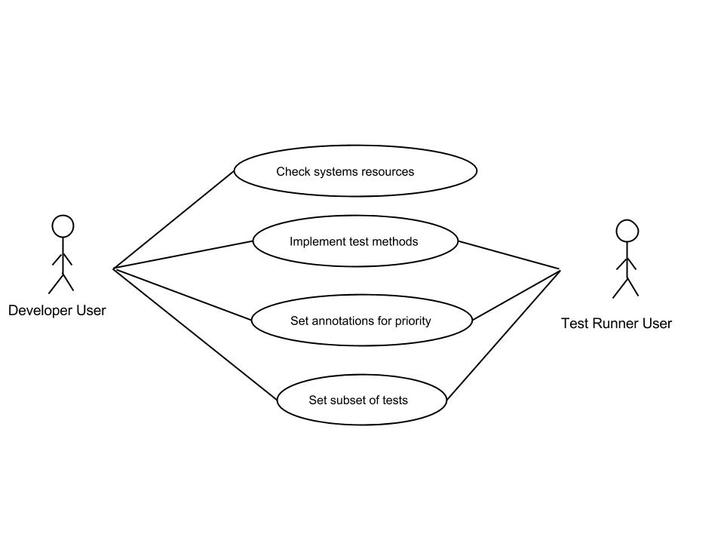

Use Case Descriptions:

|  |  |
| --- | --- |
| **Use Case** | **Description** |
| Check system’s resources | The test runner will analyze the currently free resources to decide is certain tests cases should be running. Desirability rank will also be accounted for in making this decision. |
| Implement | The foundation of the program. These are the test cases that will be run using the Test Runner. |
| Set Annotations for Priority | The ‘@’ symbol with accompanying notation shall be written by the user or developer is set desirability of the test. |
| Set subset of tests | The user and developer have the ability to run a subset of tests. |

**SECTION 3: Specific Requirements**

|  |
| --- |
| **No:** 1 |
| **Statement:** The user shall be able to set annotations for selected test method to designate which tests can and cannot be skipped. |
| **Test Criteria:** Tests will run higher prioritized methods over less prioritized methods and vise versa. |

|  |
| --- |
| **No:** 2 |
| **Statement:** The test runner user shall be able to designate designate a subset of tests. |
| **Test Criteria:** The tests that are designated to run will run independently of others test by the test runner. |

|  |
| --- |
| **No:** 3 |
| **Statement:** The custom annotation of “@desire” and “@must” shall be able to designate the importance of each test. |
| **Test Criteria:** The test runner will run the method in accordance to the custom annotation parameter. |

|  |
| --- |
| **No:** 4 |
| **Statement:** The test runner shall be able to decide on test cases based on currently free system resources. |
| **Test Criteria:** Automated tests will perform only that which the system can manage. |

|  |
| --- |
| **No:** 5 |
| **Statement:** The user shall be able to set how much resources the test runner shall be allowed. |
| **Test Criteria:** The tests have the ability to utilize every resource but the user many disallow it. |

|  |
| --- |
| **No:** 6 |
| **Statement:** The test runner shall be able to notify the user if not all tests can be run. |
| **Test Criteria:** If not all tests can be run the user should know that not all tests were run. |

|  |
| --- |
| **No:** 7 |
| **Statement:** The test runner shall be able to keep a composite average of how many resources previous run tests took. |
| **Test Plan:** The test runner will better be able to determine which tests it can run if it knows how many resources each test takes. |

|  |
| --- |
| **No:** 8 |
| **Statement:** The user shall be able to set whether a test should be run multiple times. |
| **Test Plan:** The test runner shall run designated test multiple times to ensure redundant results. |

Template created by G. Walton ([GWalton@mail.ucf.edu](mailto:GWalton@mail.ucf.edu)) on Aug 30, 1999 and last updated Aug 15, 2000; updated by A. Koufakou, Aug 2014