**Eight Channels Fiber Switch for Laser Mode Diagnosis and Wavelength Measurement**

Guan-Bo Liao

Ph.D Fellowship, Molecular Science Technique Program, TIGP

gbliao0@gmail.com

1. **Introduction**

Single narrow frequency laser is an essential tool in several important research fields such as high resolution spectroscopy, low temperature atomic physics, and optical frequency synthesis. Scientists usually use a Fabry-Perot cavity and a wavelength meter to diagnose laser’s mode condition and to check their wavelength. In this simple experiment, multiple laser beams will be sent into a fiber switch (8 channels input; one output). This fiber switch decides which channel will be switched on by a TTL voltage control signal. The final end is a high precision wavelength meter, which also provides Fabry-Perot cavity function. This platform allows me measure multiple laser beams by scanning different channels.

1. **Purchasing List**

1. Anamorphic Prism Pairs (Thorlabs PS871-B):

Because the laser diode beam is elliptical, I used anamorphic prism pairs to reshape the laser beam by magnifying the elliptical beam in one dimension.

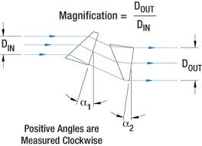

1. (b)

**Fig. 1** (a) A real picture of an anamorphic prism pairs. (b) A schematic diagram of beam shaping concept.

1. Broadband Dielectric Mirrors (Thorlabs, BB1-E02): Reflection rate larger than 99%, coating range from 400nm to 900 nm.

3. Faraday Isolator(Thorlabs, IO 3-780-HP):

In order to prevent unwanted feedback laser beam into our laser diode, I used several Faraday Isolators (also known as optical isolator) to isolate the reflection laser beam. Faraday isolator is made of three parts: an input polarizer, a rotator, and an output polarizer.

The principle of isolation is polarization effect. First of all, light traveling in the forward direction will be polarized in the vertical direction. Second, the light beam will be rotate 45 degree by a rotator. Finally, the polarization degree of the light beam will be output without power loss. One the contrary, the backward laser beam will be rotate 45 degree and perpendicular to the initial polarization condition without power throughput.

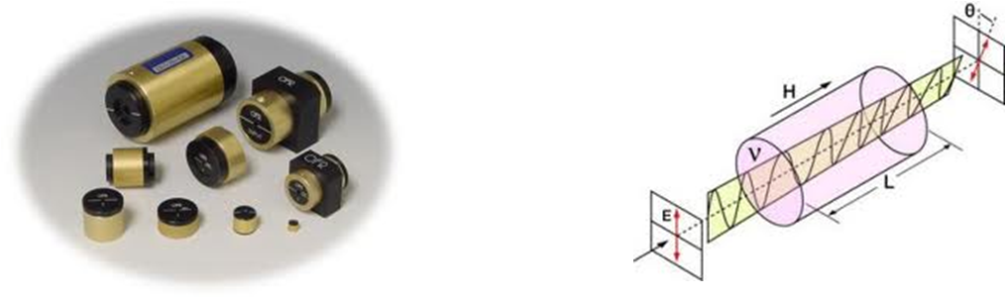

1. (b)

**Fig. 2** (a) Real pictures of optical isolators. (b) A schematic diagram of polarization effect concept.

1. Half-wave plate (Thorlabs,WPMQ05M-780)and Polarization Beam Splitter Prism(CM1-4E):

A half-wave plate and a polarizer beam splitter cube were used to control the laser power.

1. Fiber Switch (Lightwave Link 1X8/ 8X1)

This fiber switch has 8 input channels and 1 output channel, which channel will be switched on decided by a set of electrical voltage signal.

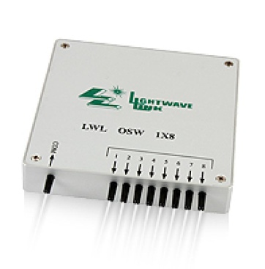

**Fig. 3** A real picture of fiber switch.

1. Wavelength Meter (HighFinesse,WS-7)

This wavelength meter is designed for precision measurement. It also provides

Fabry-Perot cavity function. I used it to diagnosis my laser’s mode condition and

measure its wavelength.

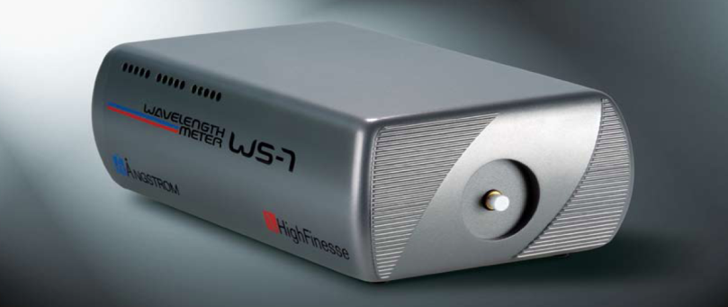

**Fig. 4** A real picture of super-precision wavelength meter.

1. **Experimental Setup**

My experimental setup was schematically illustrated in Fig. 5. Two linearly polarized laser beams from diode lasers were my optical sources. Laser power was controlled by a half-wave plate (/2) in conjunction with a polarized beam splitter (PBS). Laser beams sent into a fiber switch (8 channels into; one output). This fiber switch decided which channel could be switched on by voltage signal.

**Fig. 5** A top view diagram of the experimental system.

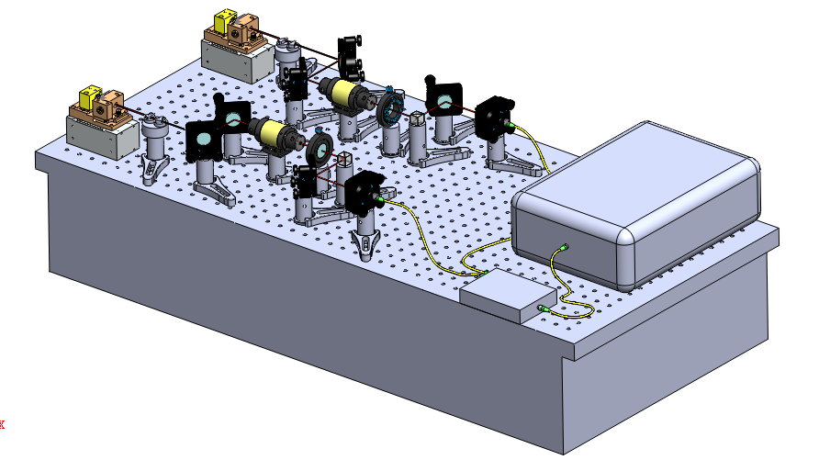

**Fig. 6** A side view of the experimental system.

1. **Experimental Result**

Experimental result is shown in Fig. 7. The experimental system can selectively measure each single channel, or to scan multichannel by program command.

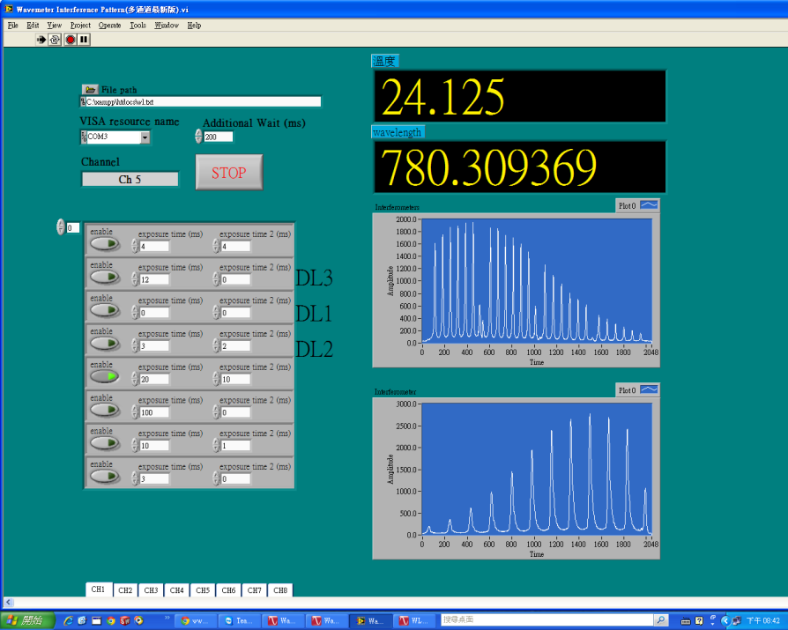

**Fig. 7** Control Program Interface

|  |  |  |
| --- | --- | --- |
|  |  |  |

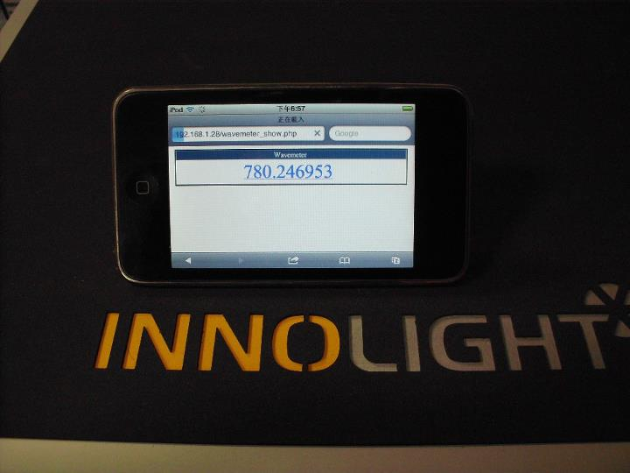

**Fig. 8** Internet Interface