Supplementary Figure 1.
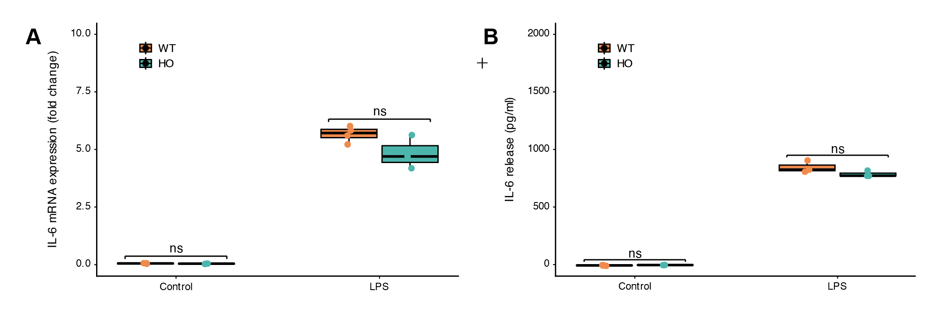
(a) qPCR analysis of transcriptional priming markers in primary peritoneal macrophages at the indicated time points following LPS stimulation, comparing WT and EphB1-deficient cells.
(b) Cytokines release in supernatants from primary peritoneal macrophages following LPS priming and NLRP3 activation with increasing doses of nigericin, comparing WT and EphB1-deficient cells.
Data are presented as mean ± SD unless otherwise indicate. n denotes biologically independent samples. For panels (a,b), n ≥ 3 per group, and results were reproduced in ≥3 independent experiments; Statistical significance was assessed using two-tailed unpaired t-tests. In panels (a), transcript levels were normalized to GAPDH and expressed relative to unstimulated controls; in panel (b), ELISA signals were background-subtracted and normalized to cell number. *P < 0.05, **P < 0.01, ***P < 0.001; ns, not significant.

Supplementary Figure 2.
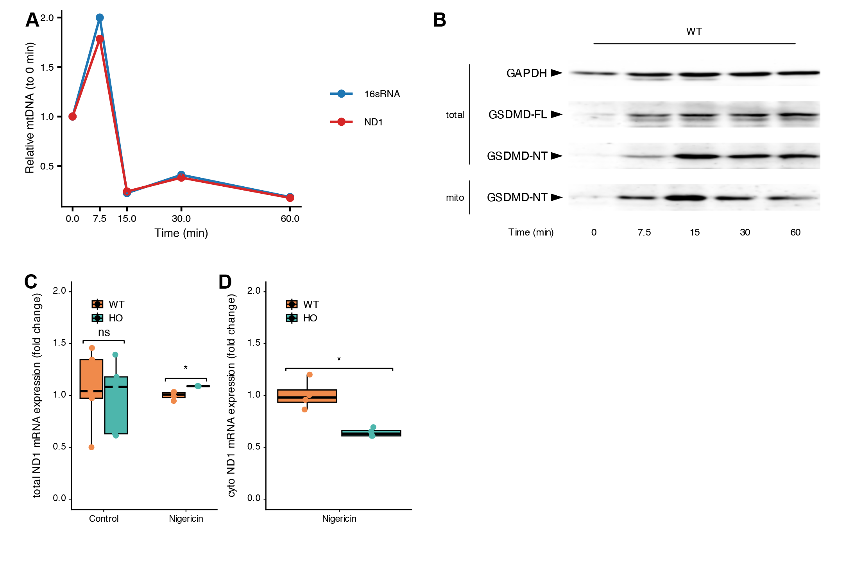
(a) Cytosolic mtDNA abundance measured by subcellular fractionation followed by qPCR in primary peritoneal macrophages at the indicated time points during NLRP3 inflammasome activation.
(b) GSDMD abundance in mitochondrial fractions and total lysates from primary peritoneal macrophages at different time points during NLRP3 inflammasome activation.
(e) GSDMD-NT abundance in mitochondrial fractions and total lysates from primary peritoneal macrophages at the indicated early time points during NLRP3 inflammasome activation, comparing WT and EphB1-deficient cells. Mitochondrial abundance controls were assessed in parallel.
(c,d) Cytosolic mtDNA abundance measured by subcellular fractionation followed by qPCR in primary peritoneal macrophages at the indicated time points during NLRP3 inflammasome activation, comparing WT and EphB1-deficient cells.
Data are presented as mean ± SD unless otherwise indicate. n denotes biologically independent samples. For panels (a–g), n ≥ 3 per group, and results were reproduced in ≥3 independent experiments. Statistical significance was assessed using two-tailed unpaired t-tests. In panels (a,b), transcript levels were normalized to GAPDH and expressed relative to unstimulated controls; in panel (c), ELISA signals were background-subtracted and normalized to cell number; and in panels (e–g), lysate and supernatant or soluble and insoluble fractions were analyzed in parallel. *P < 0.05, **P < 0.01, ***P < 0.001; ns, not significant.

Supplementary Figure 3.
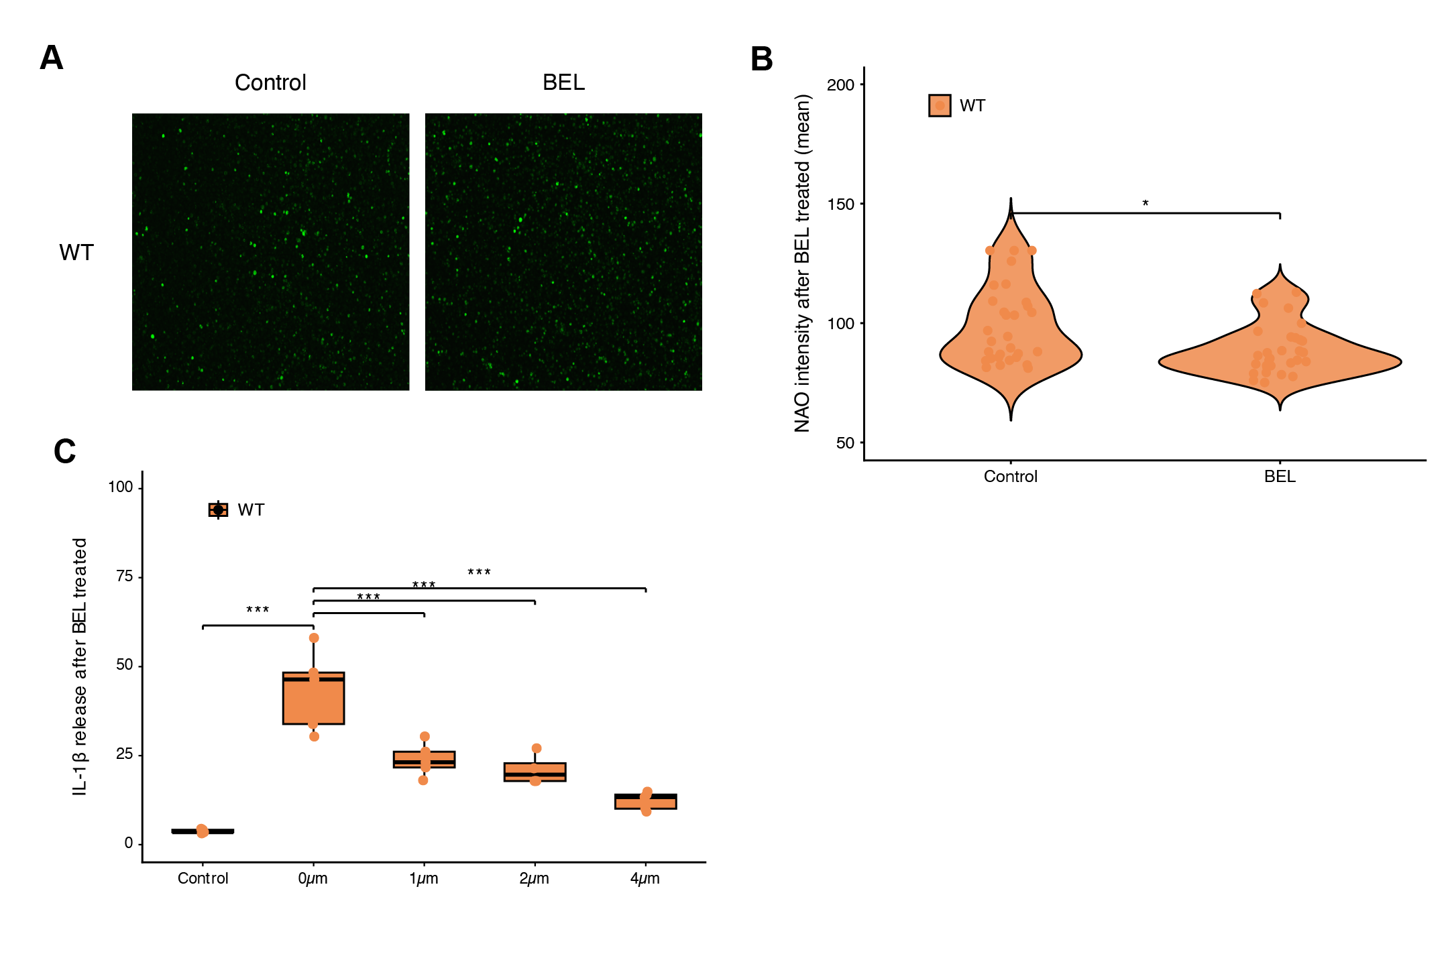
(a) NAO-associated fluorescence measured by fixed-exposure imaging and time-resolved plate-reader analysis in primary peritoneal macrophages under unstimulated conditions, comparing WT and EphB1-deficient cells.
(b) Pharmacological inhibition of iPLA2 with BEL reduces NAO-associated fluorescence and collapses genotype-dependent differences in WT and Ephb1-deficient primary peritoneal macrophages.
(c) IL-1β release in culture supernatants from primary peritoneal macrophages following AD pretreatment, LPS priming, and nigericin stimulation, comparing WT and EphB1-deficient cells across the indicated doses and treatment durations.
Data are presented as mean ± SD unless otherwise indicate. n denotes biologically independent samples. For panels (a–g), n ≥ 3 per group, and results were reproduced in ≥3 independent experiments. Statistical significance was assessed using two-tailed unpaired t-tests. In panels (a,b), transcript levels were normalized to GAPDH and expressed relative to unstimulated controls; in panel (c), ELISA signals were background-subtracted and normalized to cell number; and in panels (e–g), lysate and supernatant or soluble and insoluble fractions were analyzed in parallel. *P < 0.05, **P < 0.01, ***P < 0.001; ns, not significant.

