10.1002/oby.24270

脂肪组织末端补体级联调控的免疫-代谢双重功能

Abstract：

白色脂肪组织中先天免疫防御作用

脂肪组织储存病原体
白色脂肪组织是多种病原体及其产物（如脂多糖）的储存库。
White adipose tissue (WAT) is a reservoir for various pathogens and their products, such as lipopolysaccharides.

脂肪组织需具备先天免疫防御
因此脂肪组织必须具备与先天免疫激活相联系的防御机制。
Therefore, it must be equipped with a defense mechanism connected with the activation of innate immunity.

脂肪细胞补体成分表达与激活

脂肪细胞表达经典与旁路补体成分
脂肪细胞表达经典和替代补体途径的成分，即使在缺乏机会性病原体的情况下也可被激活。
This explains the phenomenon that adipocytes express components of the classical and alternative complement pathways, which can be activated even in the absence of opportunistic pathogens.

末端补体通路的细胞裂解作用

膜攻击复合物形成并可裂解病原或脂肪细胞
补体途径的末端阶段与膜攻击复合物的生成相关，因此既可裂解病原体，也可导致宿主脂肪细胞的自溶，从而调控脂肪组织的细胞数量。
Terminal stages of the complement pathway are related to the production of membrane attack complexes and, thus, can cause lysis of pathogens, as well as autolysis of host adipocytes, contributing to the regulation of the cellularity in WAT.

细胞防御机制抵消补体诱导的自溶
补体诱导的脂肪细胞自溶被多种细胞防御机制所对抗。
Complement-induced autolysis of adipocytes is counteracted by a number of cellular defense mechanisms.

补体调控的生理与病理适应性

激活与抑制的多样性提供生理适应性
这种激活与抑制过程的多样性使脂肪组织能在从肥大性WAT到脂肪营养不良的多种生理情境中广泛适应。
This versatility of activation and suppression processes enables a broad range of adaptability to physiological contexts, ranging from the development of hypertrophic WAT to lipodystrophy.

病原激活补体与纤维化

病原激活补体诱导促纤维化表型
病原诱导的补体途径激活可在脂肪组织中诱导促纤维化表型。
Pathogen-induced activation of the complement pathway in WAT also induces a profibrotic phenotype.

与代谢调控的联系

补体过程可能调控胰岛素抵抗
这些过程还可能参与调控脂肪细胞的胰岛素抵抗。
These processes may also be involved in the regulation of insulin resistance in adipocytes.

免疫-代谢双重作用

补体通路在脂肪组织中的双重功能
补体通路既是免疫应答的组成部分，又在生理和病理条件下显著参与脂肪组织体积与细胞性的调控。
This explains the dual immune/metabolic role of the complement pathway in WAT: the pathway is an integral part of the immune response but also potently involved in the control of volume and cellularity of WAT under both physiological and pathological conditions.

Introduction：

白色脂肪组织的免疫与代谢双重特性

白色脂肪组织功能转变

由储能器官向主动内分泌器官转变
大量研究进展使人们认识到，白色脂肪组织不再只是甘油三酯的被动储存仓和哺乳动物的主要能量库，而是一个主动器官，表达多种促炎与抗炎脂肪因子，并通过旁分泌和内分泌方式作用于其他组织。
Enormous progress in the understanding of physiological and pathological processes in WAT gradually transformed this tissue from a passive storage compartment for triglycerides and the main energy reservoir in mammals into an active organ expressing different pro- and anti-inflammatory adipokines and demonstrating paracrine and endocrine effects on other tissues.

脂肪组织作为病原储库需具备防御机制
同时，人们发现白色脂肪组织是多种病原体的长期储库，因此必须配备与先天免疫激活相联系的防御机制。
At the same time, it became clear that WAT is a long-term reservoir for the accumulation of various pathogens and, therefore, must be equipped with a defense mechanism connected with the activation of innate immunity.

脂肪细胞补体通路表达

经典与旁路补体成分表达
这可以解释一个已确立的现象：脂肪细胞表达经典补体途径成分（C1q、C1r、C1s）以及替代途径成分（C3、CFB、CFD），这些成分可在无机会性病原的情况下被激活，但不引发末端级联。
This can explain the well-established phenomenon that adipocytes express some components of the classical complement pathway, such as C1q, C1r, and C1s, as well as the components of the alternative complement pathway, such as C3, factor B (CFB), and factor D (CFD, also known as adipsin) that can be activated in the absence of opportunistic pathogens but without triggering the terminal part of the cascade.

旁路激活反映快速应答能力
白色脂肪组织中旁路激活反映了该组织能快速应对入侵病原或内源性激活的病原产物（如脂多糖）。
Activation of the alternative pathway in WAT reflects the ability of this tissue to quickly react to invading pathogens, as well as to endogenously activated pathogens or their products, such as lipopolysaccharides (LPS).

体外与组织中激活需求不同
值得注意的是，在体外培养的脂肪细胞中实现旁路全激活需要细胞因子额外刺激，而在白色脂肪组织外植体中则无需这种额外刺激，表明需要特定炎症微环境来触发旁路的完全激活。
Remarkably, there is the potential for the full activation of the alternative pathway in adipocytes cultured in vitro, where the cascade requires additional stimulation with cytokines, as well as in WAT explants, for which such additional stimulation is not necessary.

性别与年龄对补体途径的影响

性别差异
健康高加索人群中经典途径活性无性别差异，但旁路及其末端级联活性在男女间有显著不同。
No sexual dimorphism was observed for the classical pathway activity in a healthy Caucasian population; however, significant differences between male and female individuals were revealed in the activity of the alternative pathway and its terminal cascade.

不同成分的性别差异
女性的C3水平较低、CFD水平较高，而C5、C7、C8、C9等末端级联成分在女性中显著少于男性。
Female individuals were shown to have lower C3 and higher CFD levels compared with age-matched male individuals, whereas other components of the terminal cascade, such as C5, C7, C8, and C9, were much less prevalent in female compared with male individuals.

年龄相关变化
经典途径、旁路及末端级联活性随年龄增长而增加，但CFD水平则相反，随年龄增长逐渐下降。
Whereas the activities of the classical pathway, the alternative pathway, and the terminal cascade generally increase with aging, CFD is the exception and demonstrates the opposite behavior, progressively decreasing in aging individuals.

末端补体激活与细胞自溶

MAC介导的细胞裂解
替代途径末端激活可通过形成膜攻击复合物（MAC或C5b-9）产生补体依赖的细胞毒性，形成跨膜孔洞，在脂肪组织病理状态下不仅裂解病原，也可诱导脂肪细胞自溶。
Activation of the terminal stages of the alternative pathway can lead to the production of complement-dependent cytotoxicity through the formation of the membrane attack complex (MAC or C5b-9), which under pathological conditions in WAT can induce not only the lysis of pathogens but also the autolysis of host cells, including adipocytes.

生理条件下的抑制机制
在生理条件下，脂肪细胞产生补体因子不会导致自溶，主要由于C3转化酶C3bBb半衰期较短。但在存在C3肾小球因子（C3Nef）时，该因子与C3bBb结合并与补体因子P（properdin）协同，稳定C3bBb，从而诱导裂解。
Under physiological conditions, the production of complement factors by adipocytes does not lead to autolysis, mainly because of the short half-life of the C3 convertase C3bBb. However, such lysis can be induced, for example, in the presence of the C3 nephritic factor (C3Nef), which binds to C3bBb and increases its stability through cooperation with complement factor P (CFP, properdin).

properdin的来源与调控作用
Properdin不仅由中性粒细胞产生，也由单核细胞、巨噬细胞、树突状细胞、脂肪细胞和肥大细胞产生。其下游包括CD36（脂肪酸转运蛋白）与C5L2（C5a受体），Properdin缺失小鼠在高脂饮食下脂肪质量增加超过50%，提示脂肪细胞自溶可能是维持脂肪细胞数量平衡的组成部分。
Properdin is primarily expressed by neutrophils but can also be produced by monocytes, macrophages, dendritic cells, adipocytes, and mast cells. Downstream molecules include CD36 and C5L2; properdin knockout mice on a high-fat diet show more than a 50% increase in relative fat mass, suggesting adipocyte autolysis may help maintain adipocyte number balance.

皮肤白色脂肪组织(dWAT)的防御作用

dWAT的位置与特征
真皮脂肪细胞构成真皮内一薄层，位于真皮-皮下交界处，具有对病原入侵的强烈应答能力。
Dermal adipocytes constitute a thin layer in the dermis located around the dermal-hypodermal junction and have the ability to mount a strong response to invading pathogens.

反应性脂肪生成与抗菌肽表达
dWAT可通过诱导反应性脂肪生成（快速且大量增加细胞数）和表达抗菌肽如cathelicidin来应对病原。
They respond through reactive adipogenesis and expression of antimicrobial peptides such as cathelicidin.

Ⅱ型免疫与脂解调控
近期发现Ⅱ型免疫（如IL-4、IL-5、IL-9、IL-13相关细胞因子）参与调控dWAT功能，尤其与脂解相关。脂生成受损的脂肪营养不良小鼠在皮肤中的免疫反应减弱。
Recent observations suggest type 2 immunity is involved in regulation of dWAT function, especially in lipolysis, and lipodystrophic mice with impaired adipogenesis have reduced immune reactions in the skin.

dWAT的转录组特征
转录组分析显示，dWAT中抗菌肽cathelicidin (Camp)和趋化因子Ccl4的表达最高，提示先天免疫与脂肪细胞生理状态密切相关。
Transcriptomic analysis revealed cathelicidin (Camp) and chemokine Ccl4 are most abundantly expressed in dermal adipocytes, highlighting innate immunity’s strong connection to adipocyte physiology.

段落概念短语
白色脂肪组织由储能器官向免疫内分泌器官转变
脂肪细胞表达并调控补体途径成分
性别与年龄影响补体活性
末端补体激活可诱导脂肪细胞自溶
properdin在脂肪细胞数量平衡中的作用
dWAT在皮肤病原防御中的特殊作用

总概念短语
白色脂肪组织通过补体级联实现免疫与代谢功能的综合调控

Result

白色脂肪组织中的补体系统

不同脂肪相关疾病中的CFD表达差异

肥胖与脂肪营养不良中的CFD变化
全身性肥胖与多种脂肪营养不良通常分别与脂肪细胞中CFD表达的增强或降低相关。
Generalized obesity and different forms of lipodystrophy are normally associated with either enhanced or reduced expression of CFD in adipocytes, respectively.

脂肪水肿中的CFD下调
转录分析显示，在脂肪水肿（特点是近端肢体皮下脂肪异常对称沉积）中，CFD基因下调近两倍。
Transcriptional analysis revealed an almost twofold downregulation of the CFD gene in lipedema compared to controls.

Barraquer-Simons综合征中的CFD升高
与其他脂肪营养不良不同，在Barraquer-Simons综合征（获得性部分脂肪营养不良，表现为头尾向皮下脂肪丧失）中，血清CFD水平显著升高。
CFD levels in serum were found to be significantly increased in Barraquer-Simons syndrome.

家族性混合高脂血症的补体通路上调
在轻度超重伴家族性混合高脂血症的个体皮下脂肪组织中，补体系统是转录水平上调最显著的通路之一，提示代谢应激状态下的脂肪细胞亦可激活补体通路。{}
The complement system was identified as the transcriptionally most upregulated pathway in subcutaneous WAT of individuals with marginal overweight with familial combined hyperlipidemia, indicating significant activation of the complement pathway in metabolically stressed adipocytes.

补体激活与低度炎症及代谢紊乱

补体激活引发低度炎症
补体通路激活与受累白色脂肪组织中低度炎症的诱导相关，从而推动代谢异常的发生。
Activation of the complement pathway is connected to the induction of low-grade inflammation in the affected WAT and to the development of metabolic conditions.

低水平MACs的信号效应
低水平膜攻击复合物（MACs）的表达可激活多种信号转导途径与转录因子，同时抑制细胞凋亡。
A sublytic expression of MACs induces stimulatory effects on different signal transduction pathways and transcription factors while also inhibiting apoptosis.

CFB在脂肪细胞分化中的作用
CFB反映替代途径的早期阶段，可能参与脂肪细胞分化后期及脂滴形成。
CFB reflecting an early phase of the alternative pathway may be involved in the late phase of adipocyte differentiation and lipid droplet formation.

脂肪细胞体积与补体途径的相关性
脂肪细胞体积与早期/末端补体通路分别呈正/负相关。
Adipocyte volumes demonstrate a positive/negative correlation with early/terminal complement pathways.

补体在凋亡碎片清除中的作用
补体通路可能参与白色脂肪组织中凋亡碎片的清除。
It has been suggested that the complement pathway can be involved in the clearance of apoptotic debris in WAT.

补体激活对邻近组织的影响

CFD引发邻近组织炎症
补体通路在白色脂肪组织中的作用不仅限于基质，脂肪细胞产生的CFD还可在邻近组织（如炎性关节炎中）诱发炎症反应。
The production of CFD by adipocytes can induce inflammatory reactions in adjacent tissues, as demonstrated for inflammatory arthritis.

补体与脂肪细胞状态的关联
这些结果进一步表明，先天免疫与脂肪细胞生理状态及形态之间存在密切联系，但其潜在机制仍需进一步明确。
These results point further to an interconnection between innate immunity and the physiological state of adipocyte physiology and its morphology, although the underlying mechanisms remain to be better defined.

段落概念短语
脂肪相关疾病中补体途径的多样性调控
补体激活与低度炎症、代谢状态和脂滴形成的关联
补体途径对邻近组织炎症反应的外溢影响

总概念短语
病理状态下白色脂肪组织的补体系统失衡与炎症代谢互作

白色脂肪组织中MAC介导的细胞更新与平衡

免疫与代谢在WAT中紧密耦合

补体通路在低度炎症下的免疫-代谢双重作用
补体通路在WAT中的免疫/代谢双重作用，可归因于先天免疫反应与WAT的代谢和形态改变在低度炎症背景下共享相同细胞靶点。
The dual immune/metabolic role of the complement pathway in WAT can be rationalized by the fact that innate immune reactions and metabolic/morphological modifications in WAT are tightly interconnected with a low-grade level of inflammation in the tissue, sharing the same cellular targets.

TLR4对LPS和脂肪酸的共同感受
脂肪细胞主要的促炎受体TLR4既可被LPS激活，也可被脂肪酸激活，但尚不清楚免疫与代谢哪一方是主因。
One of the main proinflammatory receptors in adipocytes, TLR4, can be stimulated by both LPS and fatty acids; however, it is unclear whether immune or metabolic aspects are primary.

补体激活与巨噬细胞募集

先启动补体，后募集巨噬
理论上启动先天免疫只需激活WAT中的巨噬细胞，这些细胞与单核、树突细胞共同提供经典和替代补体途径因子，主要用于清除死亡脂肪细胞。然而巨噬细胞浸润被认为是补体激活后的下游过程，由C3a、C5a等过敏毒素驱动。
Macrophage infiltration into WAT is considered a downstream process of complement pathway activation caused by anaphylatoxins such as C3a and C5a.

补体作为巨噬募集第一步
因此，激活替代补体途径似乎是巨噬细胞募集的第一步。
Activating the alternative complement pathway appears to be the first step toward macrophage recruitment into WAT.

巨噬细胞异质性与脂肪细胞死亡

肥胖WAT中巨噬细胞的双重特性
肥胖时WAT中存在表型不同的巨噬群体，冠状结构外的巨噬细胞具促脂肪生成特性，冠状结构内的则富脂且促炎。
In obesity, WAT contains different macrophage populations: those outside crown-like structures are proadipogenic, while those in crown-like structures are lipid-laden and proinflammatory.

肥大脂肪细胞的NLRP3依赖性死亡
高度肥大的脂肪细胞在冠状结构形成前即发生退化与死亡，NLRP3依赖的caspase-1活化在此过程中诱导失控炎症和焦亡。
Highly hypertrophic adipocytes degenerate and die before crown-like structures form, with NLRP3-dependent caspase-1 activation inducing uncontrolled inflammation and pyroptosis.

焦亡通路与MAC作用

经典与非经典焦亡途径
caspase-1为焦亡经典途径，caspase-4、-5、-11及caspase-3介导非经典途径。中度焦亡可清除胞内病原，过度则致自身免疫。
Caspase-1 represents the canonical pathway, while caspase-4/5/11 and caspase-3 mediate noncanonical pathways; moderate pyroptosis clears pathogens, excessive pyroptosis induces autoimmunity.

GsdmD裂解与膜孔形成
焦亡依赖于GsdmD裂解，其成熟片段转运至膜，形成孔洞并释放IL-1β、IL-18等炎性因子。
Pyroptosis is connected with cleavage of GsdmD, which forms membrane pores and releases IL-1β and IL-18.

MAC促进NLRP3活化与GsdmD裂解
MAC内吞可激活NLRP3并促进GsdmD裂解，从而在巨噬细胞中启动焦亡级联。
MAC internalization activates NLRP3 and promotes GsdmD cleavage, initiating pyroptosis in macrophages.

多种Gasdermin介导焦亡
焦亡不一定涉及NLRP3，但在所有情况下都依赖Gasdermin家族的裂解。
Pyroptosis can, but does not have to, involve NLRP3, but it is always gasdermin-dependent.

CFD与脂肪生成的调控

CFD对脂生成的双向调控
体外前脂肪细胞中抑制CFD可减少脂滴积累，而过表达CFD则促进脂肪细胞分化，提示免疫反应或为补体双重功能的起始信号。
Suppression of CFD in preadipocytes inhibits lipid accumulation, whereas overexpression stimulates adipocyte differentiation, suggesting immune responses may trigger complement’s dual role.

反应性脂肪生成是病原感染的次级应答
高免疫反应性的真皮脂肪细胞在分化过程中表达最高水平抗菌因子，但成熟后不再表达，这表明病原诱导的反应性脂肪生成是由先天免疫触发的次级应答。
Highly immune-reactive dermal adipocytes express highest antibacterial factors during differentiation but not as mature cells, indicating reactive adipogenesis is a secondary response triggered by innate immunity.

段落概念短语
免疫-代谢互作背景下MAC的调控作用
补体激活先于巨噬细胞募集
巨噬细胞异质性与肥大脂肪细胞焦亡
MAC与GsdmD介导的焦亡级联
CFD调控脂生成并参与免疫-代谢双重功能

总概念短语
MAC通过补体激活与焦亡调控脂肪组织细胞更新及免疫-代谢平衡

白色脂肪组织中抵御自溶的自我防御机制

通过补体通路调控脂肪组织体积和细胞平衡

生理状态下MAC诱导自溶被抑制

MAC内吞触发NLRP3炎症小体
脂肪细胞内NLRP3炎症小体的生成通常在MAC被内吞后诱导。
The intracellular production of the NLRP3 inflammasomes in adipocytes is typically induced after endocytosis of MACs.

病理与生理的区别
补体系统的自溶效应在脂肪营养不良等病理情况下明显，但其参与脂肪细胞生理更新的可能性仅最近被提出。
The autolytic effects of an activated complement system are apparent in pathological cases such as lipodystrophy; however, its involvement in physiological turnover was only recently proposed.

多重自我防御机制
在生理条件下，脂肪细胞通过多种机制减少自溶，包括：膜上孔道装配抑制因子（CD46、CD55、CD59）、膜攻击复合物的脱落（MMP14等介导）或CAV1依赖的内吞。
Autolysis is reduced through inhibitors (CD46, CD55, CD59), shedding of MACs (e.g., MMP14), or CAV1-dependent endocytosis.

CD59抑制MAC装配

CD59在肥胖中的上调
CD59在前脂肪细胞中较低，在肥胖者的成熟肥大脂肪细胞中显著上调；同卵双胞胎研究亦显示，BMI较高者CD59上调。
CD59 is low in preadipocytes but significantly upregulated in hypertrophic adipocytes; monozygotic twin studies confirmed CD59 upregulation in heavier co-twins.

CD59保护作用与糖化损伤
CD59上调提供保护，防止MAC形成与自溶；其在K41位点的糖化会导致MAC沉积增加并引发病理反应（如糖尿病患者）。
CD59 protects against MAC formation; glycation at K41 leads to increased MAC deposition and pathological responses.

MMP14介导C3b脱落

MMP14抑制补体激活
MMP14可从细胞表面脱落C3b，抑制末端补体通路激活。
MMP14 sheds C3b from the cell surface, suppressing terminal complement activation.

MMP14对脂肪细胞形态的影响
MMP14在小鼠WAT中过表达导致脂肪细胞肥大；Mmp14⁻/⁻小鼠脂肪细胞显著缩小并呈现脂肪营养不良样表型。
Overexpression of MMP14 causes hypertrophy; Mmp14⁻/⁻ mice show small adipocytes and lipodystrophy-like phenotype.

MMP14与免疫因子关联
MMP14可被补体C5a和抗菌肽cathelicidin上调，提示其在先天免疫应答中有作用。
MMP14 is upregulated by C5a and cathelicidin, linking it to innate immune reactions.

CAV1介导MAC内吞

CAV1与DNM2协同调控
CAV1与DNM2共同调控MAC的内吞；肥大脂肪细胞中CAV1表达显著增加。
CAV1 and DNM2 regulate MAC endocytosis; CAV1 is increased in hypertrophic adipocytes.

CAV1缺失与脂肪营养不良
Cav1⁻/⁻小鼠对高脂饮食不敏感并出现脂肪营养不良和细胞死亡易感；人类CAV1突变也导致严重脂肪营养不良。
Cav1⁻/⁻ mice are resistant to HFD-induced obesity but develop lipodystrophy; human CAV1 mutations cause severe lipodystrophy.

EHD2稳定CAV1功能
EHD2调控CAV1在膜上的稳定；Ehd2⁻/⁻小鼠在高脂饮食下累积肥大脂肪细胞，CAV1与PPARγ表达降低，肥胖模型和患者WAT中EHD2下调。
EHD2 stabilizes CAV1; Ehd2⁻/⁻ mice accumulate hypertrophic adipocytes with reduced CAV1/PPARγ, and EHD2 is downregulated in obesity.

自我防御机制与PPARγ/GsdmD平衡

自我防御与肥胖状态
CD59、MMP14、CAV1三大自我防御因子在肥胖时显著上调，缺失则表现为脂肪营养不良样表型。
All three defense factors are upregulated in obesity, while their depletion leads to lipodystrophy-like phenotypes.

PPARγ的抗炎作用
PPARγ可直接抑制NLRP3炎症小体，通过阻断caspase-1与IL-1β成熟，发挥抗炎效应；PPARγ与GsdmD表达呈强烈负相关。
PPARγ attenuates NLRP3 activation, blocking caspase-1 and IL-1β; PPARγ and GsdmD show a strong negative correlation.

MAC内吞与PPARγ通路
少量MAC的CAV1介导内吞可启动PPARγ通路，促进脂生成与WAT扩张；而自我防御缺失、补体过度激活则诱发焦亡和脂肪营养不良。
CAV1-mediated endocytosis of few MACs activates PPARγ, stimulating adipogenesis, whereas deficiency of defense leads to complement overactivation, pyroptosis, and lipodystrophy.

段落概念短语
多重机制协同抵御MAC诱导自溶
CD59调控MAC装配保护脂肪细胞
MMP14通过C3b脱落抑制补体激活
CAV1/EHD2调控MAC内吞维持脂肪平衡
PPARγ与GsdmD互作参与免疫-代谢调控

总概念短语
脂肪细胞通过CD59、MMP14、CAV1等自我防御网络抵御MAC诱导自溶并维持白色脂肪组织稳态

脂肪细胞抵御补体系统诱导自溶的自我防御机制（图1）
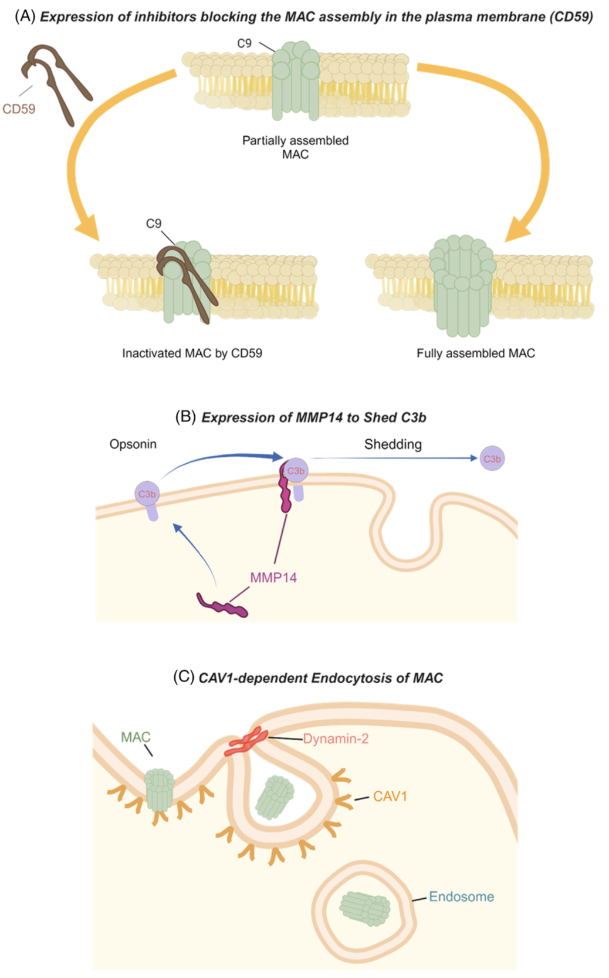

通过多层次机制抑制MAC导致的自溶

早期抑制因子阻断MAC装配
CD59的保护作用
脂肪细胞表达早期阶段的抑制因子CD59，可阻断膜攻击复合物（MAC）在质膜上的装配，防止补体介导的孔道形成与自溶。
Expression of early-stage inhibitors (CD59) blocks MAC assembly in the plasma membrane.

MMP14脱落C3b
减少补体沉积
脂肪细胞通过表达基质金属蛋白酶14（MMP14），将调理素C3b从质膜表面剪切脱落，从而抑制补体末端通路的持续激活。
Expression of MMP14 sheds the opsonin C3b from the plasma membrane of adipocytes.

CAV1依赖的MAC内吞
内吞移除MAC
脂肪细胞利用Caveolin-1（CAV1）依赖的内吞作用，将MAC内吞至胞内，减少其在膜上的破坏作用。
CAV1-dependent endocytosis internalizes MAC from the plasma membrane.

总概念短语
CD59、MMP14 与 CAV1 三大防御机制协同作用，保护脂肪细胞免受补体系统活化所致的自溶。

补体系统在脂肪细胞增生、肥大与死亡中的调控（图2）
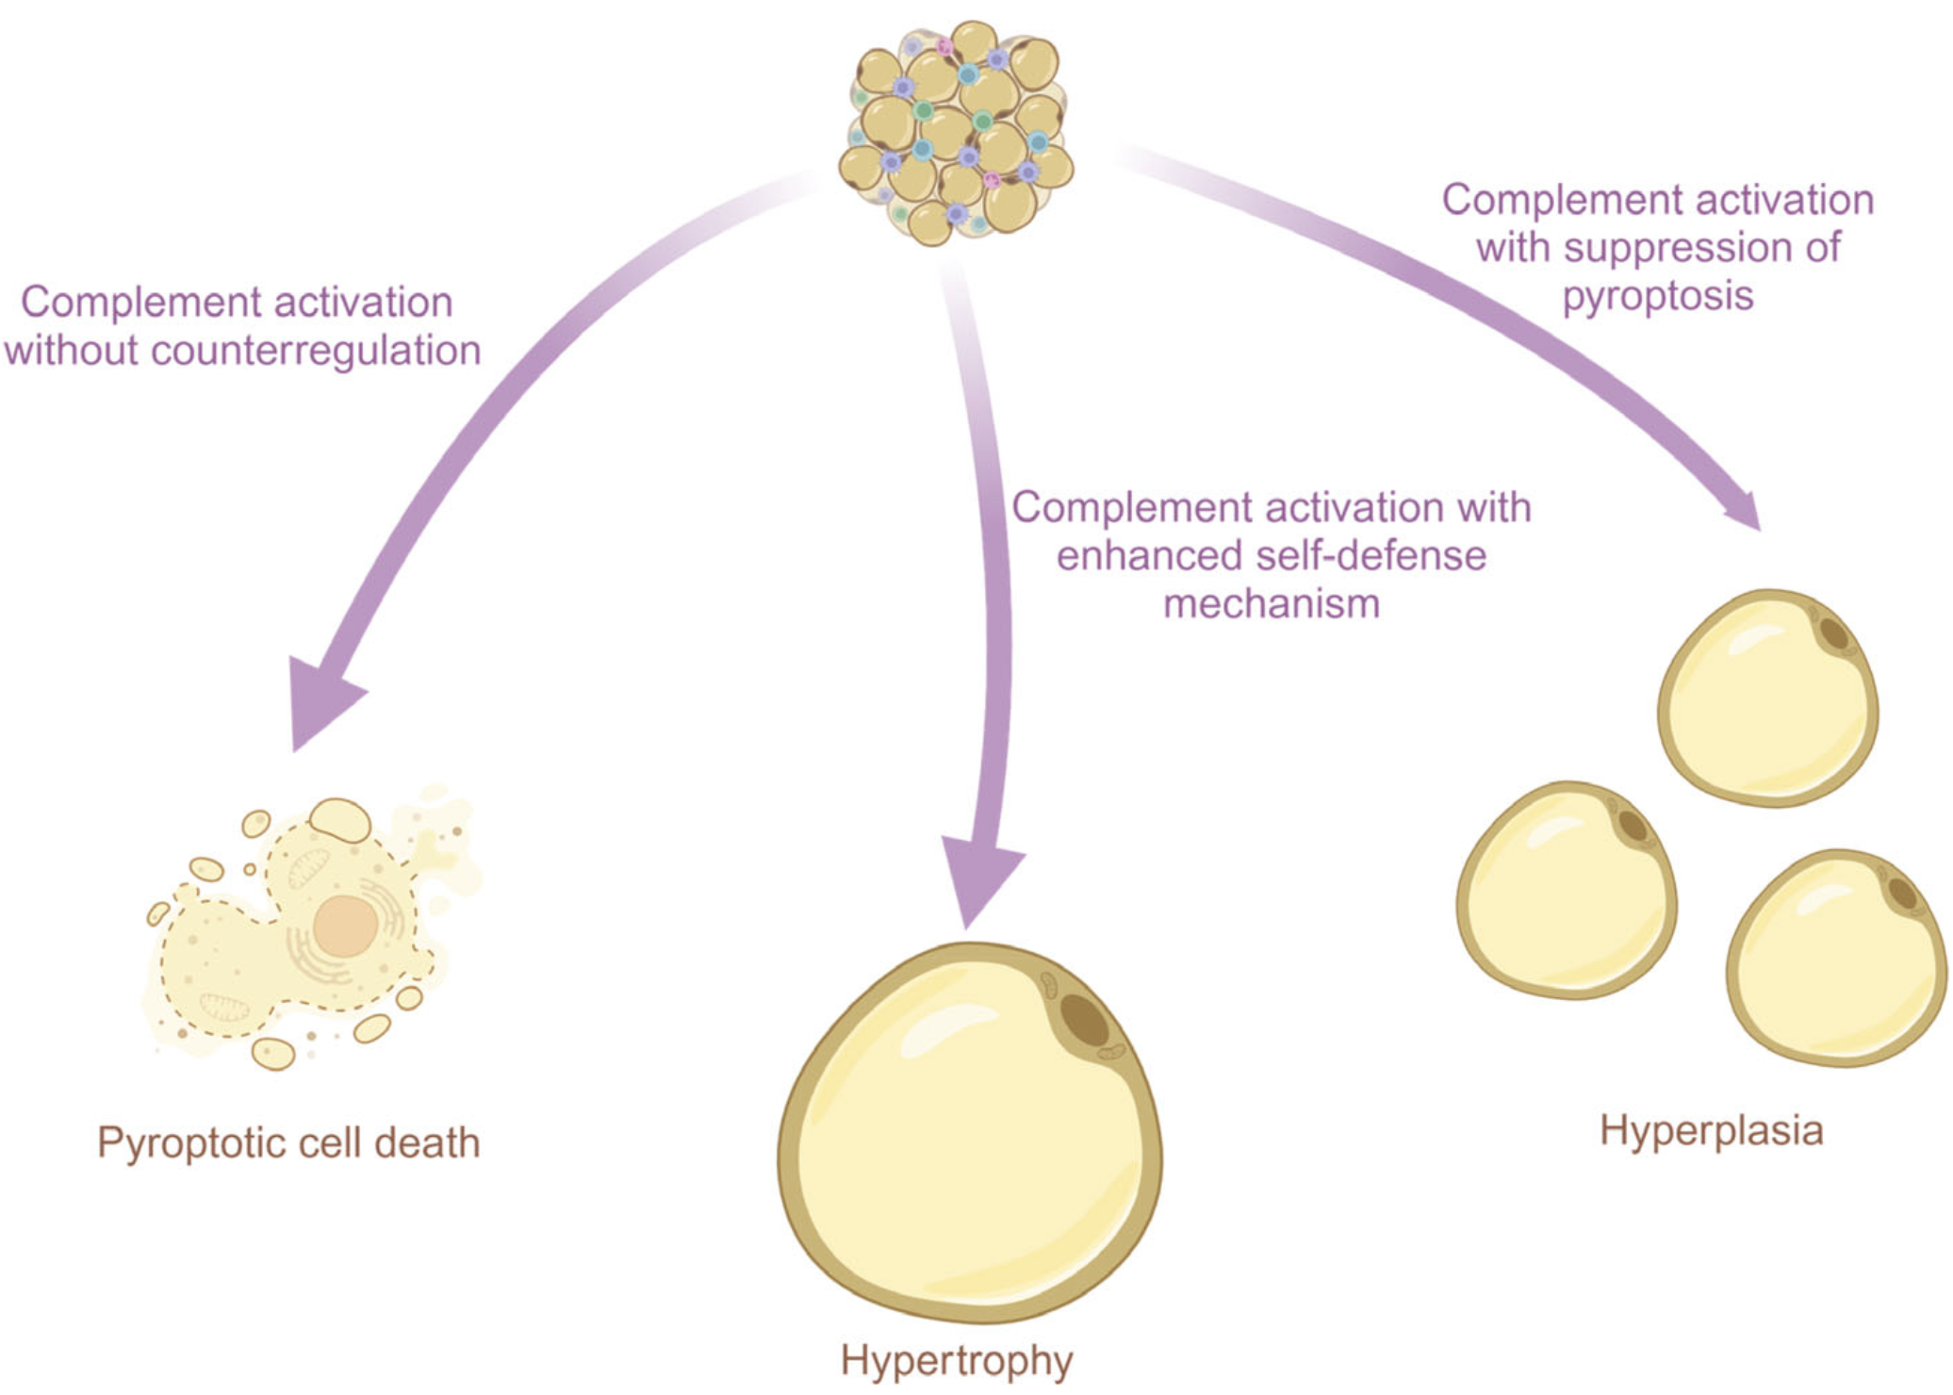

左侧分支：无对抗调控的补体激活
- 结果：焦亡性细胞死亡
当补体活化缺乏调控与防御机制时，MAC过度形成，诱导脂肪细胞发生焦亡性细胞死亡（pyroptotic cell death）。

中间分支：增强自我防御下的补体激活
- 结果：脂肪细胞肥大
补体激活时若伴随CD59、MMP14、CAV1等自我防御机制的增强，脂肪细胞免于死亡，但体积持续增大，表现为肥大（hypertrophy）。

右侧分支：抑制焦亡的补体激活
- 结果：脂肪细胞增生
补体激活的同时抑制了焦亡通路，局部脂生成增加，脂肪细胞数量增多，表现为增生（hyperplasia）。

总概念短语
补体系统通过不同的调控与防御状态，决定脂肪细胞在焦亡死亡、肥大或增生之间的命运平衡。

白色脂肪组织中补体通路在纤维化中的主动作用

补体通路与脂肪组织纤维化的病理关联

WAT纤维化与代谢紊乱

纤维化导致肥胖相关代谢病
WAT纤维化与脂肪组织的不健康扩张密切相关，被认为是胰岛素抵抗、肝脂肪变性和2型糖尿病等多种肥胖相关代谢紊乱的主要原因。
WAT fibrosis is tightly connected to the unhealthy expansion of adipose tissue and is actually considered to be the main reason for various obesity-related metabolic disorders such as insulin resistance, hepatic steatosis, and type 2 diabetes.

不同组织纤维化中的补体证据

MAC诱导肾脏成纤维因子表达
MAC形成增加可诱导Col4及其分子伴侣HSP47的产生，促进肾脏纤维化。
Increased MAC formation induces the production of collagen IV and HSP47, promoting profibrotic processes in the kidney.

亚溶解水平MAC诱导炎性因子
低剂量MACs可诱导IL-6和TGF-β1表达，C1、C3增加促进肾纤维化，C3缺失或巨噬清除则抑制炎症与纤维化。
Sublytic MACs induce IL-6 and TGF-β1; increased C1 and C3 promote kidney fibrosis, while C3 deletion or macrophage ablation prevents it.

C3a/C5a在肺纤维化中的作用
C3a、C5a及其受体在特发性肺纤维化中显著升高，阻断其受体或TGF-β1信号可抑制纤维化。
C3a and C5a with their receptors are increased in idiopathic pulmonary fibrosis; blocking them suppresses fibrosis.

MAC在硬皮病和皮肤病灶中的积聚
系统性硬化症患者皮损及未受累皮区均检测到C5aR和MAC积聚，且CD46下调；CFD水平与皮肤纤维化严重度正相关。
Enhanced MACs and C5aR are detected in systemic sclerosis lesions; CD46 is reduced and serum CFD correlates with fibrosis severity.

补体在WAT纤维化中的潜在作用

Col6α3剪切与内毒素蛋白
WAT纤维化被认为与缺氧及MMP14介导的Col6α3裂解产生的endotrophin相关；Col6α6在多种皮肤炎症与黑色素瘤中上调，这些病变均伴补体激活。
Fibrosis in WAT is linked to hypoxia and endotrophin from Col6α3 cleavage; Col6α6 is upregulated in skin inflammation and melanoma, conditions with complement activation.

MAC抑制因子与纤维化关联
CD59在肥胖WAT中上调，伴随纤维化结构；CD59在肺纤维化患者中亦升高。
CD59 is upregulated in obese WAT with fibrosis and in pulmonary fibrosis patients.

MMP14在WAT纤维化中的双相作用

MMP14缺失与皮肤纤维化样表型
Mmp14⁻/⁻小鼠表现出皮肤纤维化样表型。
Mmp14⁻/⁻ mice show a fibrosis-like phenotype in skin.

MMP14过表达时机的不同效果
在已形成肥胖的WAT中诱导MMP14加剧纤维化；在早期肥胖阶段同步诱导MMP14则改善纤维化和炎症，并改善代谢。
MMP14 induction in established obesity worsens fibrosis, while early induction improves fibrosis, inflammation, and metabolism.

补体活化水平决定MMP14分配
成熟肥胖时补体活化较高，更多MMP14用于保护脂肪细胞免于MAC，减少用于降解周细胞外纤维；早期肥胖时则相反。
In established obesity, more MMP14 is used to prevent MAC, less for fibrosis digestion; in early obesity, more is available for collagen cleavage.

CAV1水平与纤维化的负相关

CAV1缺失与Col6α6增加
CAV1低表达常见于纤维化等高增殖状态；Cav1⁻/⁻小鼠Col6α6显著升高，提示CAV1缺失允许补体末端通路强烈激活，直接促进WAT纤维化。
Low CAV1 is typical in fibrosis; Cav1⁻/⁻ mice show increased Col6α6, indicating CAV1 deficiency enhances complement activation and fibrosis.

CAV1过表达抗纤维化
CAV1过表达阻断博莱霉素诱导的肺纤维化，呈现抗纤维化作用。
CAV1 overexpression blocks bleomycin-induced fibrosis.

MMP14与CAV1调控互补
MMP14与CAV1对终末补体级联的调控均显示类似的促/抗纤维化作用。
MMP14 and CAV1 both show pro/antifibrotic effects through complement regulation.

EMT与补体的交互作用

补体激活促进EMT
补体通过C3aR促进EMT，同时提高CD59表达以抵抗补体依赖性细胞毒性；抑制CD59恢复补体裂解敏感性但不改变EMT标志物。
Complement promotes EMT via C3aR while increasing CD59 to resist cytotoxicity; CD59 inhibition restores lysis sensitivity without altering EMT markers.

MMP14/CAV1诱导EMT
MMP14与CAV1均可诱导多种细胞EMT，提示补体通路激活通过EMT促进组织纤维化。
MMP14 and CAV1 can induce EMT, suggesting complement activation promotes fibrosis through EMT.

综合模型

补体介导WAT纤维化的三重机制
1）病原或LPS激活WAT补体途径；
2）上调CD59、MMP14、CAV1等MAC防御因子；
3）MMP14介导Col6裂解促进纤维化。
These mechanisms together suggest complement-dependent regulation of WAT fibrosis, pending further experimental verification.

段落概念短语
补体在多组织纤维化中的作用证据
MMP14与CAV1双向调控WAT纤维化
EMT通路连接补体激活与纤维化
补体通路在WAT纤维化形成中的三重机制

总概念短语
补体通路通过MAC防御调节与胶原代谢双向作用，主动参与白色脂肪组织纤维化形成

图3 补体通路在WAT纤维化中的作用
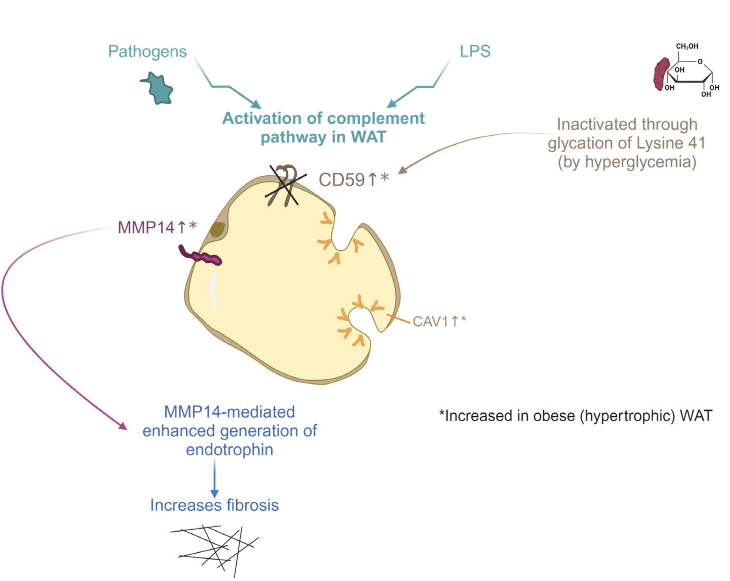

补体激活的起点
- 病原与LPS诱导
病原或脂多糖（LPS）可激活白色脂肪组织（WAT）中的补体通路。

三大防御机制在肥胖WAT中的变化
- CD59↑
肥胖（肥大性WAT）中CD59显著上调，用以阻断MAC形成。
但在高血糖条件下，CD59会因赖氨酸41位点糖基化而失活。G
- MMP14↑
肥胖中MMP14表达增强，可脱落C3b，避免细胞死亡；
但同时MMP14促进endotrophin生成，进一步增加WAT纤维化。
- CAV1↑
肥胖中CAV1表达增强，通过内吞MAC保护细胞；
但CAV1上调可在某些细胞中诱导上皮–间充质转化（EMT），促进纤维化。

纤维化形成的综合结果
- 防御与病理双重作用
在肥胖WAT中，CD59、MMP14、CAV1均上调以对抗自溶；
当CD59失活时，MMP14与CAV1防御加强，但其副作用（endotrophin积累、EMT激活）会进一步导致WAT纤维化。

总概念短语
肥胖WAT中补体激活与自我防御机制交织，MMP14与CAV1虽保护细胞，却通过endotrophin与EMT促进纤维化。

白色脂肪组织的生理与病理维持

补体通路调控WAT体积、细胞性及代谢的动态平衡

MAC水平与自我防御强度决定WAT应答

MAC低水平：稳态凋亡与脂生成
低水平MAC形成呈现“准生理状态”，细胞死亡主要由凋亡维持；亚溶解剂量的MAC经CAV1依赖内吞可诱导NLRP3炎症小体，进而促发焦亡；若NLRP3被PPARγ上调所抑制，则焦亡概率降低，局部脂生成增强。
A low-level production of MACs corresponds to a steady-state with apoptosis; sublytic MACs internalized via CAV1 activate NLRP3 and pyroptosis, but PPARγ induction reduces pyroptosis and induces adipogenesis.

MAC缺失：脂肪组织病理性扩张
补体系统低活化（缺乏MAC激活）可导致WAT持续扩张，如脂肪水肿。
A downregulated complement system without MAC activation may lead to pathological expansion in lipedema.

MAC高水平：脂肪组织丢失
高水平MAC（病原或防御缺陷引起）致脂肪细胞大量死亡，无法由脂生成补偿，驱动部分脂肪营养不良（如Barraquer-Simons综合征）。
High-level MAC activation leads to widespread adipocyte death without compensation, driving partial lipodystrophies.

MAC相关多种死亡途径的调控

MAC诱导凋亡、焦亡与坏死性凋亡
末端补体途径产物MAC不仅能诱导焦亡，还可诱导caspase依赖的凋亡或坏死性凋亡。
MACs can lead to pyroptosis, apoptosis, or necroptosis.

CD59双重作用
CD59阻断MAC形成、降低焦亡概率，但重组CD59可促进凋亡；CD59降低伴随caspase-3增加、BCL-2减少。
CD59 blocks MAC formation and reduces pyroptosis; its downregulation increases apoptosis.

CAV1表达水平与死亡方式
CAV1内吞MAC促进NLRP3活化与焦亡；CAV1转基因降低炎症小体表达，CAV1缺失细胞易凋亡，而CAV1过表达可保护细胞免于凋亡。
CAV1 levels modulate death pathways: overexpression reduces inflammasomes, deficiency enhances apoptosis.

PAQR4与脂肪组织重塑

PAQR4上调导致脂肪营养不良
PAQR4过表达引起小鼠部分脂肪营养不良、高胰岛素血症和高血糖；PAQR4敲除改善肥胖条件下的脂肪重塑和葡萄糖稳态。
Enhanced PAQR4 expression leads to lipodystrophy and metabolic dysfunction; deletion improves remodeling and glucose homeostasis.

PAQR4通过神经酰胺影响CAV1
PAQR4提升神经酰胺水平，置换膜筏中的胆固醇，降低CAV1浓度，抑制CAV1依赖的MAC内吞，削弱防御机制，导致细胞死亡增加和脂肪营养不良。
PAQR4 increases ceramides, reduces CAV1, impairs MAC endocytosis, and promotes cell death.

补体通路作为脂肪细胞胰岛素抵抗的调控因子

CD59的作用与失活

CD59阻断MAC而不影响IR
CD59调控MAC装配，不影响脂肪细胞膜上胰岛素受体（IR）的状态。
CD59 blocks MAC assembly without influencing IRs.

高糖条件下CD59失活
高血糖可糖化CD59，失活其防御功能，MAC积聚导致病理反应。
CD59 is inactivated by glycation under hyperglycemia, leading to MAC-related pathology.

MMP14与CAV1保护及其代谢代价

MMP14保护与IR剪切
MMP14切除C3b抑制补体通路，但也切除IR胞外结构，产生可溶性片段，其水平与胰岛素抵抗相关；抑制MMP14可改善胰岛素抵抗。
MMP14 sheds C3b and IR ectodomains, correlating with insulin resistance; inhibition improves sensitivity.

CAV1内吞MAC与IR关联
CAV1内吞MAC时，IR与小窝共定位并依赖CAV1；MAC内吞使IR解离或与MAC共同内吞，减少膜上IR数量，导致胰岛素抵抗。
CAV1-dependent MAC endocytosis dissociates or internalizes IRs, reducing surface IRs and inducing insulin resistance.

段落概念短语
MAC水平与防御机制共同决定WAT细胞命运
CD59、CAV1、MMP14调控MAC相关死亡途径
PAQR4通过CAV1调控脂肪组织生理与病理
补体防御机制失衡与胰岛素抵抗发生关联

总概念短语
补体通路通过MAC与自我防御机制协同调节白色脂肪组织的生理稳态、病理变化及胰岛素敏感性

图4 补体通路在脂肪细胞胰岛素抵抗中的作用

高血糖条件下CD59失活
- CD59原本阻断MAC装配
在正常情况下，CD59可阻断膜攻击复合物（MAC）的形成，保护细胞膜。
- 高血糖诱导赖氨酸41糖基化
高血糖使CD59失活，无法再抑制MAC激活，补体破坏风险增加。

其他自我防御机制的代偿激活
- MMP14作用
MMP14表达增强，除剪切C3b减弱补体激活外，还会剪切胰岛素受体（IR）胞外结构，产生可溶性受体片段，其水平与糖尿病患者胰岛素抵抗相关。
药理学抑制MMP14可改善胰岛素抵抗。
- CAV1作用
CAV1依赖的内吞途径清除MAC时，会同时内吞与小窝共定位的IR，使膜上IR数量减少，从而削弱胰岛素信号。

结果：胰岛素抵抗形成
- 补体与代谢交织
CD59失活后，MMP14和CAV1的代偿性防御虽减少MAC损伤，却导致IR片段释放和IR内吞，最终促成脂肪细胞胰岛素抵抗。

总概念短语
高血糖下CD59失活促使MMP14与CAV1代偿防御增强，伴随IR丢失与片段释放，共同诱导脂肪细胞胰岛素抵抗。

图4 补体通路在脂肪细胞胰岛素抵抗中的作用
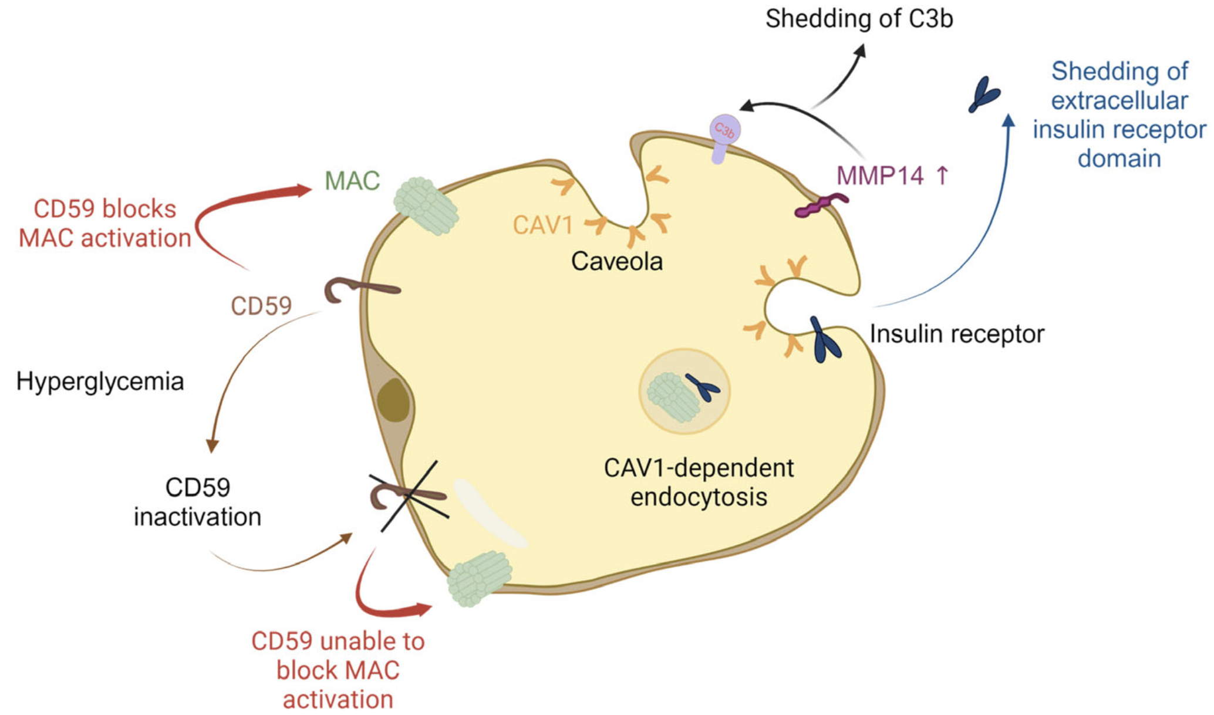

高血糖条件下CD59失活
- CD59原本阻断MAC装配
在正常情况下，CD59可阻断膜攻击复合物（MAC）的形成，保护细胞膜。
- 高血糖诱导赖氨酸41糖基化
高血糖使CD59失活，无法再抑制MAC激活，补体破坏风险增加。

其他自我防御机制的代偿激活
- MMP14作用
MMP14表达增强，除剪切C3b减弱补体激活外，还会剪切胰岛素受体（IR）胞外结构，产生可溶性受体片段，其水平与糖尿病患者胰岛素抵抗相关。
药理学抑制MMP14可改善胰岛素抵抗。
- CAV1作用
CAV1依赖的内吞途径清除MAC时，会同时内吞与小窝共定位的IR，使膜上IR数量减少，从而削弱胰岛素信号。

结果：胰岛素抵抗形成
- 补体与代谢交织
CD59失活后，MMP14和CAV1的代偿性防御虽减少MAC损伤，却导致IR片段释放和IR内吞，最终促成脂肪细胞胰岛素抵抗。

总概念短语
高血糖下CD59失活促使MMP14与CAV1代偿防御增强，伴随IR丢失与片段释放，共同诱导脂肪细胞胰岛素抵抗。

Conclution：补体通路在白色脂肪组织中的双重调控作用

补体通路在WAT中的关键作用

低度炎症与补体活化
补体通路的活化通常与病原或其产物（如LPS）引起的低度炎症相关，在WAT中发挥重要作用。
The complement pathway, the activation of which is connected to low-grade inflammation in affected tissues mainly caused by pathogens or their products such as LPS, plays an important role in WAT.

末端通路与MAC形成
补体通路的末端阶段与MAC形成相关，可裂解病原体，也可导致宿主脂肪细胞自溶。
Terminal stages of this pathway are related to the production of MACs and can thereby cause lysis of pathogens, as well as autolysis of the host adipocytes.

多重自我防御机制

抑制MAC形成的早期因子
脂肪细胞通过上调CD59抑制MAC早期形成，抵御自溶。
This process is counteracted by different cellular defense mechanisms, including enhanced expression of inhibitors of the early stages of MAC formation (CD59).

MMP14介导C3b脱落
MMP14通过膜表面C3b的脱落减少MAC形成。
Shedding of the opsonin C3b from the plasma membrane by MMP14.

CAV1依赖内吞与PPARγ通路
CAV1依赖的MAC内吞可诱导NLRP3炎症小体的表达，继而激活脂生成主调控因子PPARγ，带来抗炎作用。
CAV1-dependent endocytosis of MACs induces expression of NLRP3 inflammasomes that triggers activation of PPARγ with anti-inflammatory properties.

广泛适应的生理与病理情境

从肥大到脂肪营养不良
激活与抑制的多样性使WAT在肥大到脂肪营养不良等多种情境下保持广泛适应性。
This versatility of activation and suppression processes enables many different scenarios and a broad range of adaptability to physiological contexts, ranging from the development of hypertrophic WAT to lipodystrophy.

纤维化表型的诱导
病原诱导补体活化及CD59/MMP14/CAV1防御机制的激活可促进WAT的促纤维化表型。
Pathogen-induced activation of the complement pathway in WAT accompanied by induction of CD59/MMP14/CAV1-dependent defense against autolysis can also induce a profibrotic phenotype.

胰岛素抵抗的调节
这些过程还可能参与脂肪细胞胰岛素抵抗的调控。
These processes may also be involved in the regulation of insulin resistance in adipocytes.

综合作用

免疫应答与体积细胞调控
补体通路在WAT中既是免疫应答的重要组成，又深度参与体积与细胞性的调控。
This may explain the dual role of the complement pathway in WAT: it is an integral part of the immune response but also potently involved in the control of volume and cellularity of WAT under both physiological and pathological conditions.

