Fig. 1. EphB1 loss constrains inflammasome-triggered pyroptosis and IL-1β release
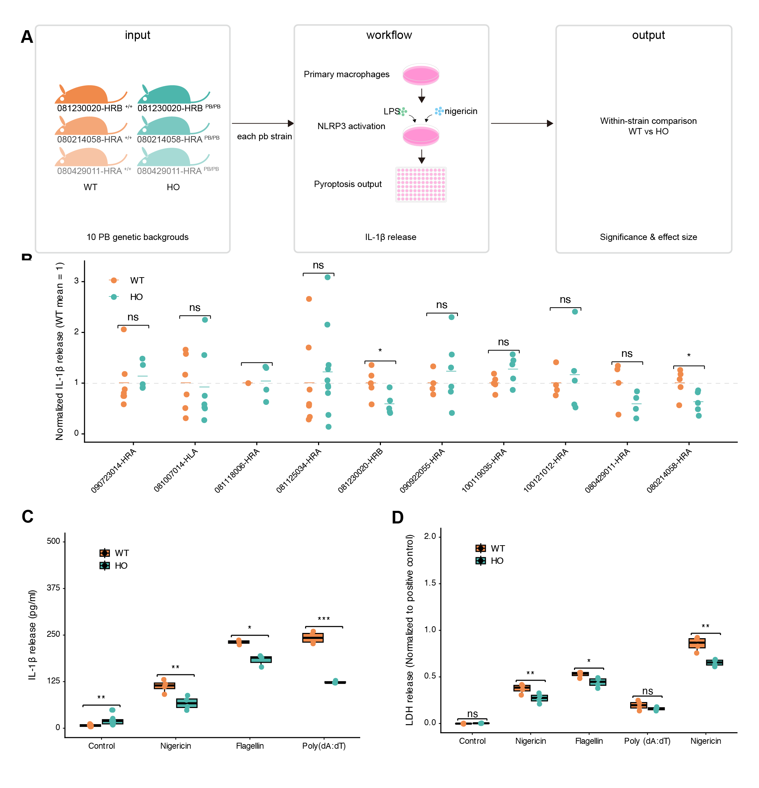
(a) Schematic overview of the genetic screening strategy used to identify regulators of inflammasome-associated pyroptotic output.. (b) Normalized IL-1β release across multiple pb genetic backgrounds following nigericin-induced inflammasome activation, highlighting strains with pronounced genotype-dependent differences.. (c) IL-1β release from primary peritoneal macrophages following activation of distinct inflammasome pathways via different secondary stimuli.. (d) LDH release from WT and EphB1-deficient primary peritoneal macrophages following activation of NLRP3, NLRC4, or AIM2 inflammasomes under the indicated conditions..

Fig. 2. EphB1 loss preserves upstream NLRP3 activation yet constrains GSDMD pore–driven execution
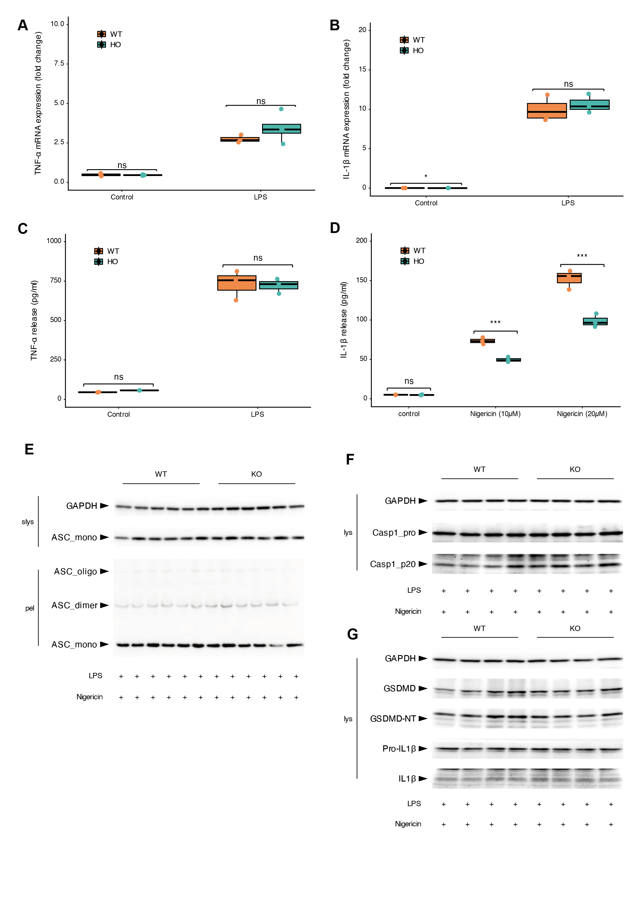
(a,b) TNF-α and IL-1β Transcriptional priming responses to LPS stimulation in WT and EphB1-deficient primary peritoneal macrophages.. (c) TNF-α and IL-1β secretion from WT and EphB1-deficient primary peritoneal macrophages following LPS stimulation at defined time points.. (d) IL-1β release from WT and EphB1-deficient primary peritoneal macrophages following NLRP3 activation with increasing doses of nigericin.. (e) ASC oligomerization in WT and EphB1-deficient primary peritoneal macrophages following NLRP3 inflammasome activation.. (f) Pro-caspase-1 and cleaved caspase-1 p20 levels in total cell lysates from WT and EphB1-deficient primary peritoneal macrophages following NLRP3 inflammasome activation.. (g) GSDMD and IL-1β processing in total cell lysates from WT and Ephb1−/− primary peritoneal macrophages following NLRP3 inflammasome activation..

Fig. 3. EphB1 loss diminishes GSDMD-NT engagement and enrichment on mitochondria
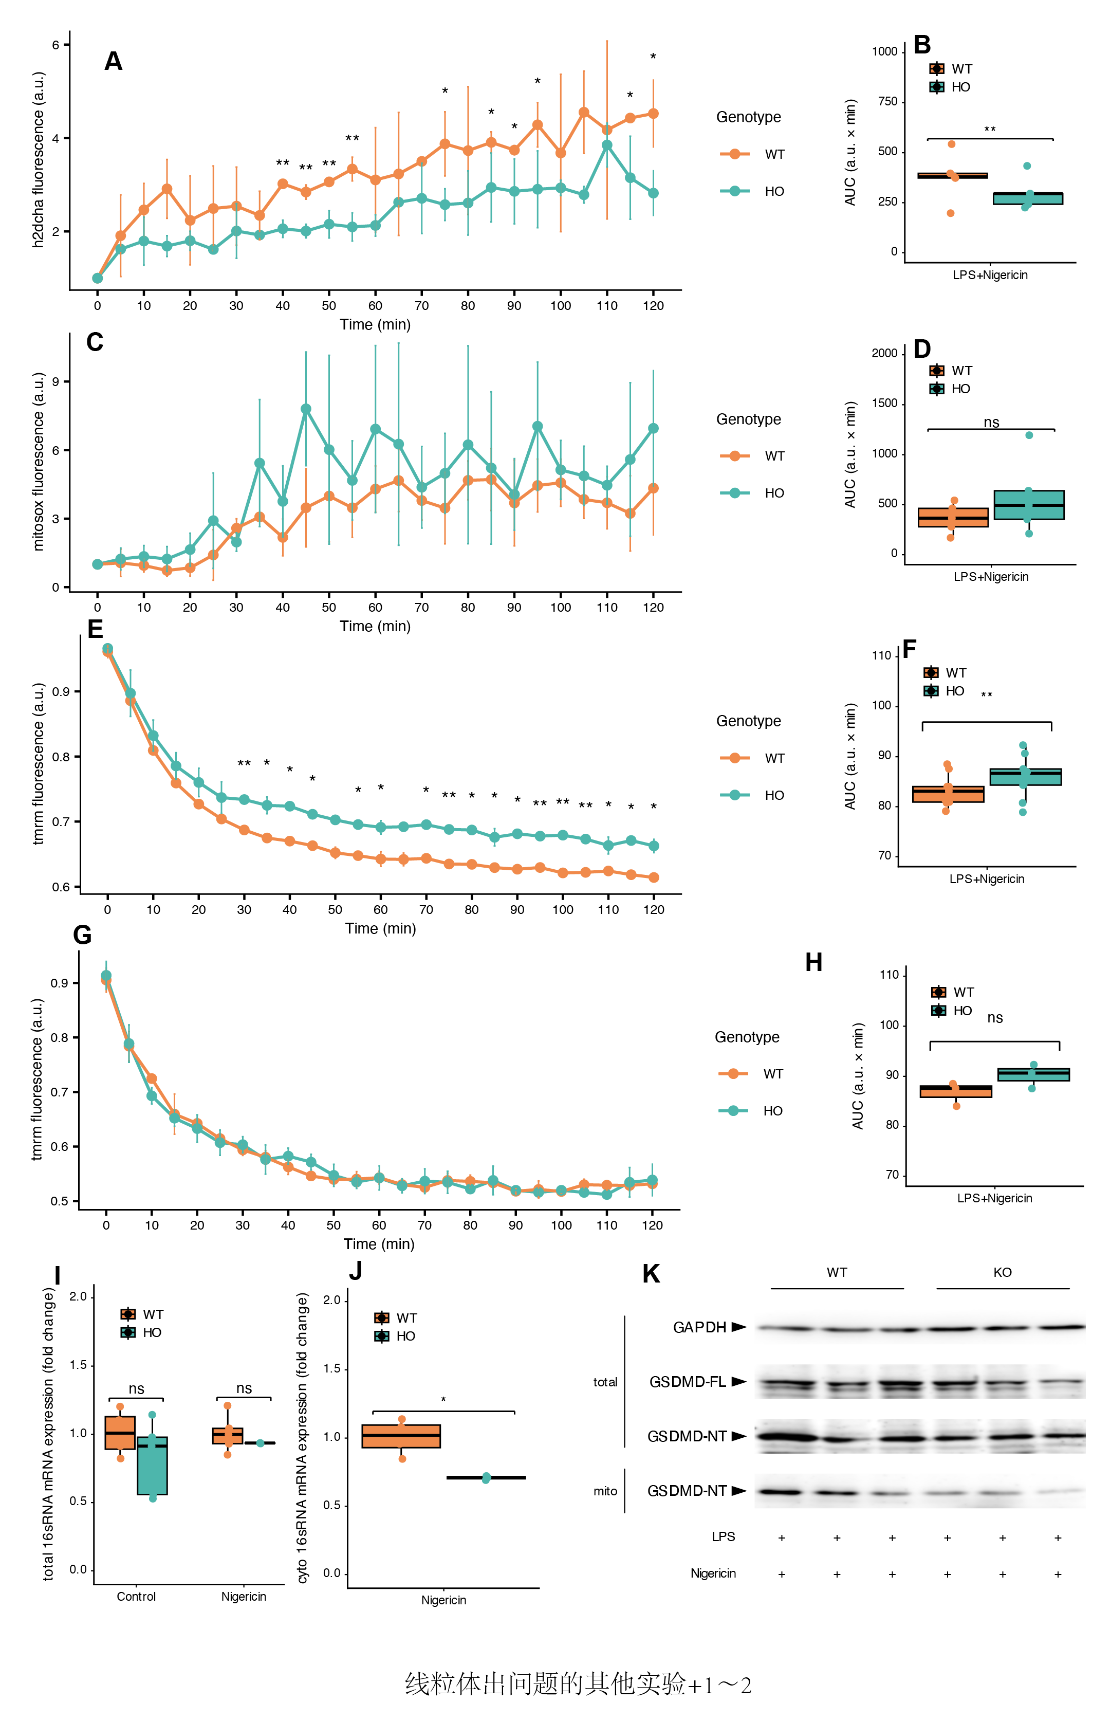
(a,b,c,d,e,f,g,h) Time-resolved changes in cytosolic ROS, mitochondrial ROS, and mitochondrial membrane potential in WT and EphB1-deficient primary peritoneal macrophages during NLRP3 inflammasome activation and under unstimulated baseline conditions.. (i,j) Cytosolic mtDNA release dynamics in WT and EphB1-deficient primary peritoneal macrophages following NLRP3 inflammasome activation, quantified by rapid subcellular fractionation and qPCR.. (k) Early mitochondrial enrichment of GSDMD-NT during NLRP3 inflammasome activation in WT and Ephb1−/− primary peritoneal macrophages, with mitochondrial abundance controls assessed in parallel..

Fig. 4. Cardiolipin availability mediates EphB1-dependent limitation of inflammasome output
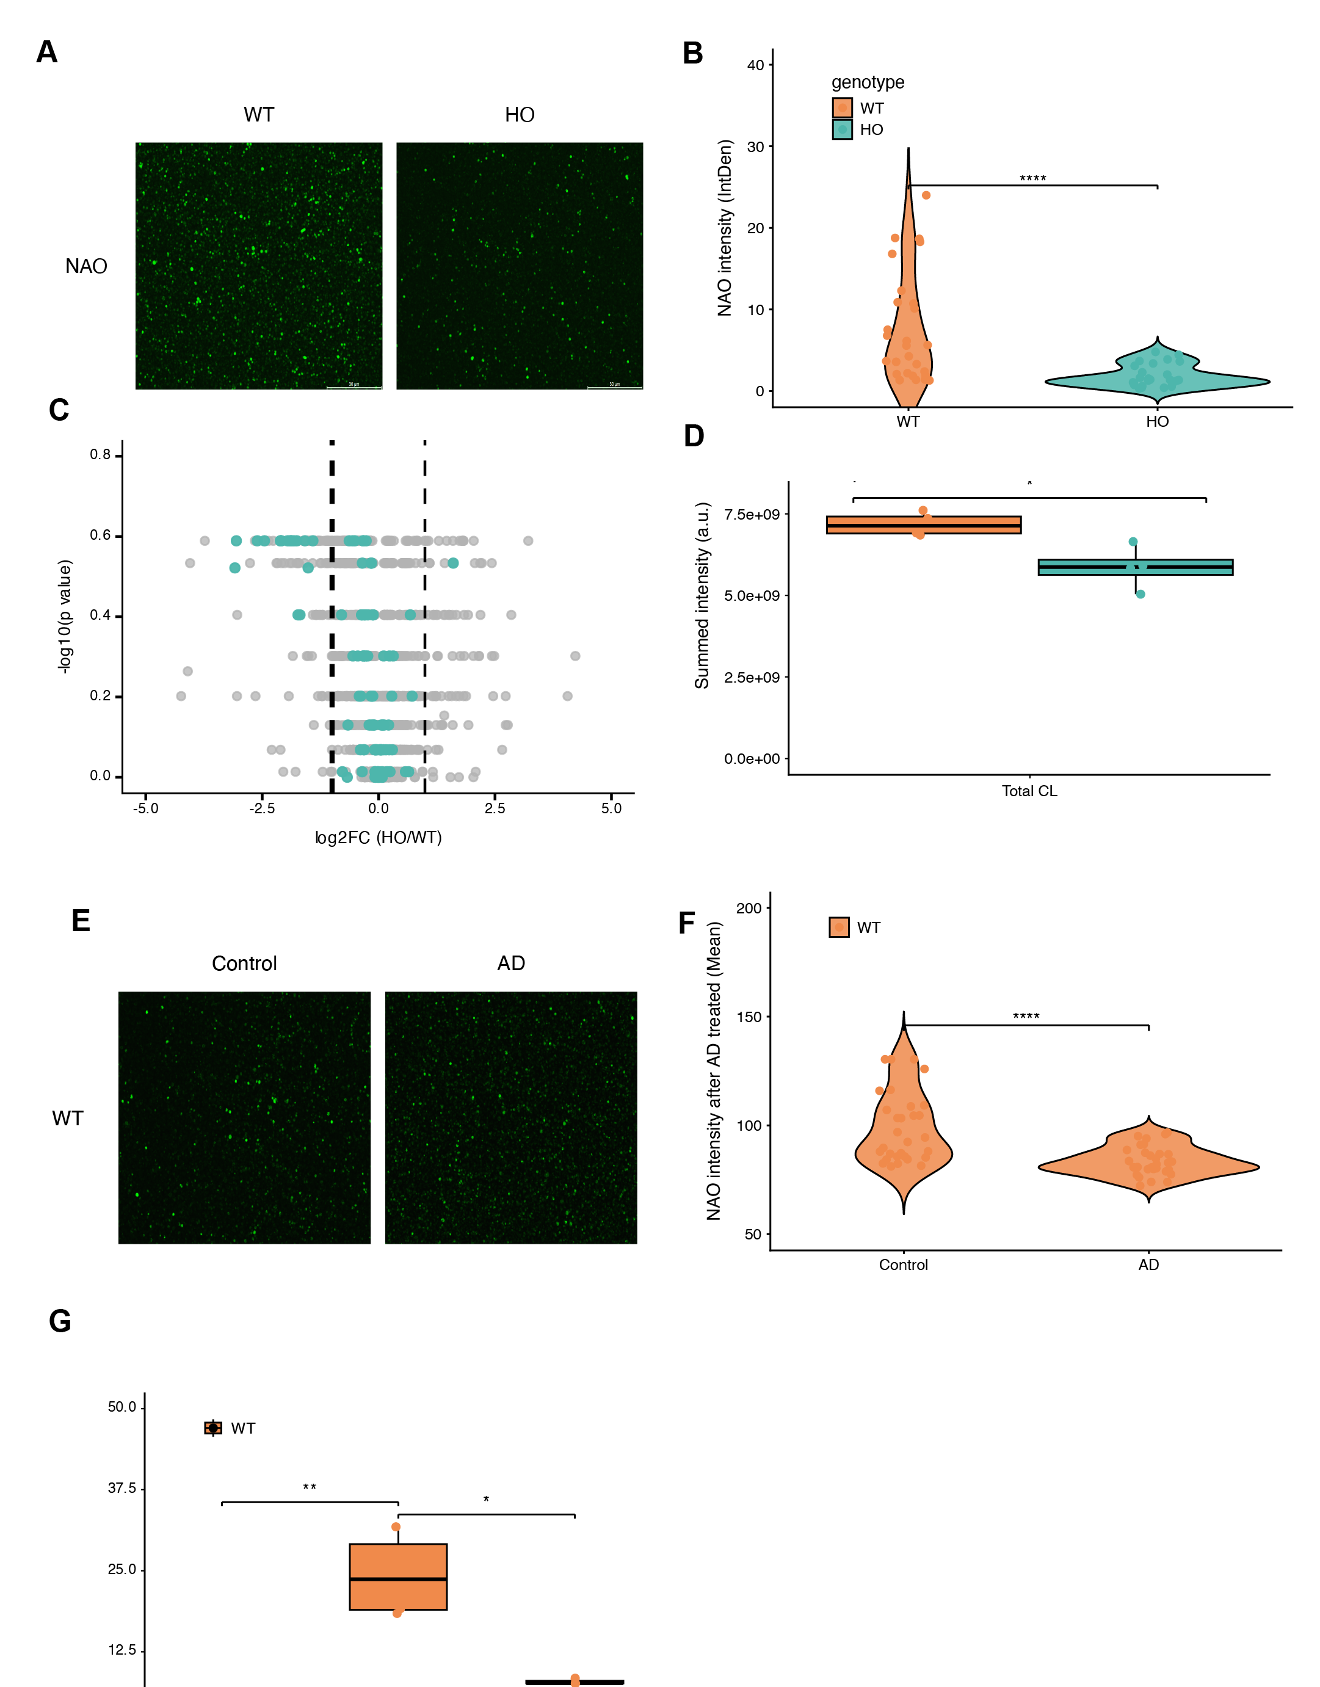
(a,b) Pharmacological inhibition of iPLA2 with BEL reduces NAO-associated fluorescence and collapses genotype-dependent differences in WT and Ephb1−/− primary peritoneal macrophages.. (c,d) LC–MS/MS lipidomics quantification of total cardiolipin abundance and molecular species composition in resting WT and Ephb1−/− primary peritoneal macrophages.. (e,f) Pharmacological inhibition with alexidine dihydrochloride (AD) reduces NAO-associated fluorescence and collapses genotype-dependent differences in WT and Ephb1−/− primary peritoneal macrophages.. (g) IL-1β release from WT and Ephb1−/− primary peritoneal macrophages following LPS and nigericin stimulation in the presence of increasing doses and durations of alexidine dihydrochloride (AD).. (s4c) IL-1β release from WT and Ephb1−/− primary peritoneal macrophages following LPS and nigericin stimulation under increasing doses and durations of BEL treatment..

Fig. 5. Multi-omics integration prioritizes the membrane-context axis as the dominant perturbation
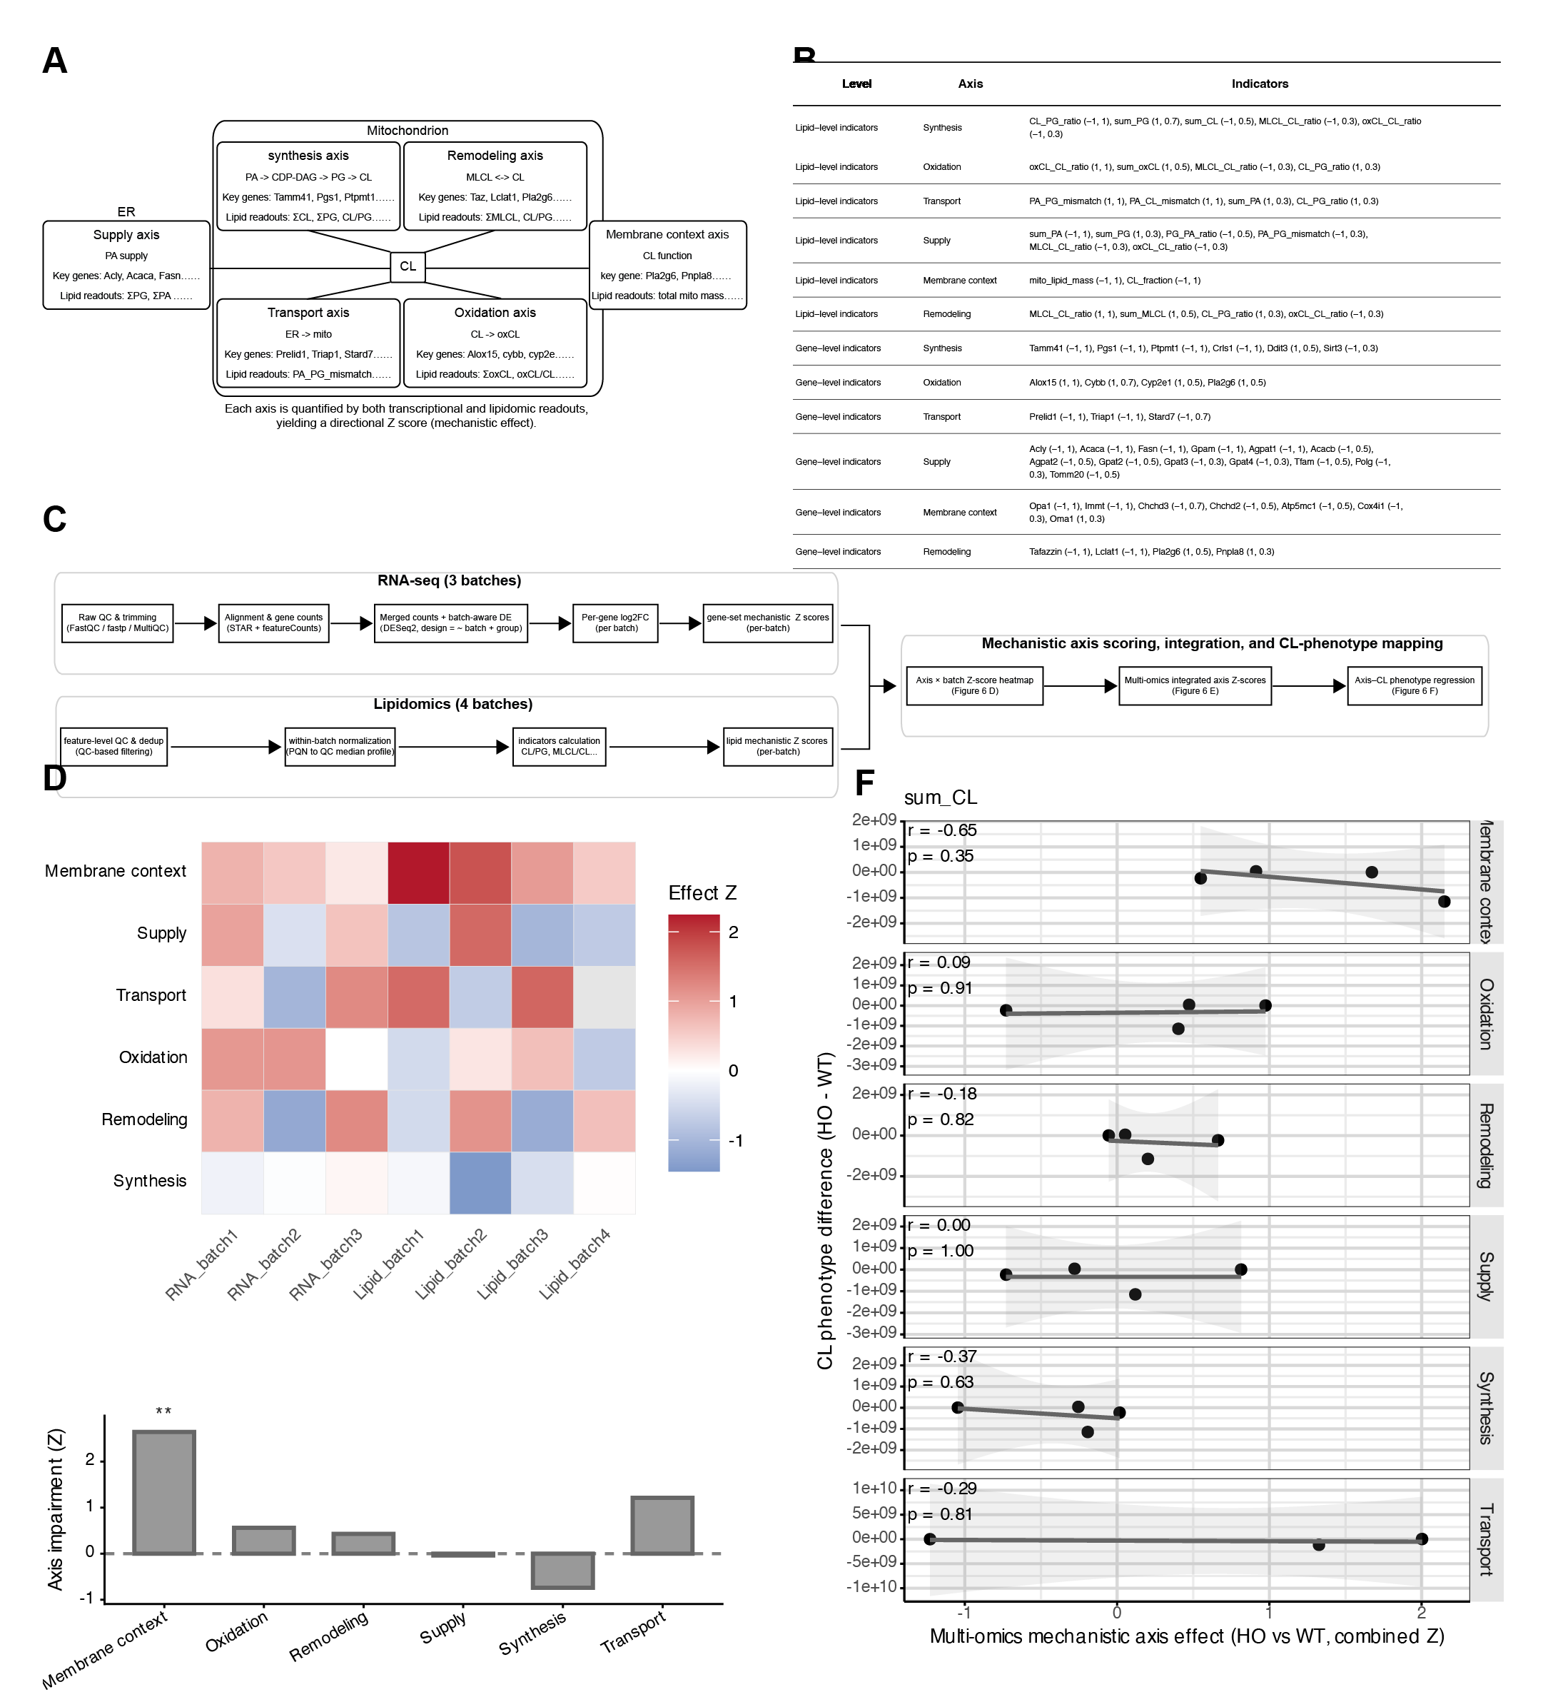
(a) Conceptual diagram illustrating six mechanistic axes of cardiolipin metabolism and their organization into an ER–mitochondria–centered framework used to interpret EphB1-dependent multi-omics changes.. (b) Curated table of representative lipid readouts and key genes mapped to six cardiolipin-related mechanistic axes, including explicit directionality conventions (bottleneck_sign) and within-axis weights to support axis-level scoring and interpretation.. (c) Integrated workflow summarizing how multi-batch RNA-seq, untargeted lipidomics, and targeted cardiolipin panel datasets were quality-controlled, normalized, batch-modeled, and compressed into mechanistic axis Z scores and cardiolipin-related indicators for downstream multi-omics integration.. (d) Batch-level effect_z matrix summarizing the direction and magnitude of EphB1 deficiency–associated changes across six mechanistic axes in RNA-seq and lipidomics datasets.. (e) Overall multi-omics Z scores summarizing Ephb1−/− versus WT effects across six predefined mitochondrial-related mechanistic axes by Stouffer meta-analysis of RNA-seq and lipidomics batches.. (f) Cross-batch linear regression linking mechanistic axis combined Z scores (HO–WT) to batch-matched HO–WT differences in total cardiolipin abundance (sum_CL) to test whether axis-level effects predict cardiolipin content at the batch level..

Fig. 6. An RNA X–M–Z framework prioritizes EphB1-linked pathways with orthogonal lipid alignment
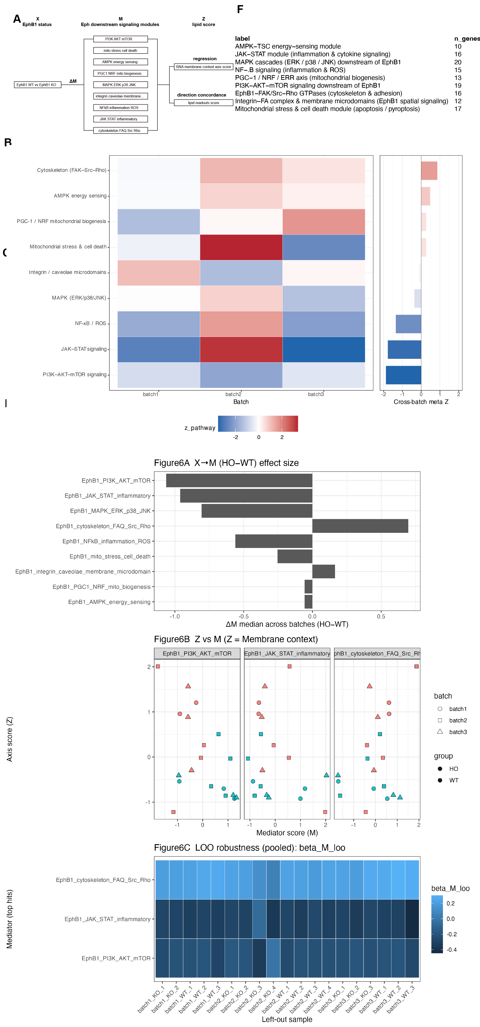
(a) Conceptual diagram illustrating an RNA-first X–M–Z framework that links EphB1 status (X), downstream signaling modules (M), and an RNA membrane context axis (Z), with independent lipid phenotypes used for directional concordance validation.. (b) Curated table defining EphB1 downstream signaling modules (gene sets) and mapping each module to the cardiolipin mechanistic axes it is expected to influence.. (c) Pathway-level transcriptional response scores for curated EphB1 downstream signaling modules in WT and Ephb1−/− primary peritoneal macrophages across three independent RNA-seq batches, summarized as per-batch z_pathway shifts and cross-batch meta Z effects.. (d) Cross-batch ranking of EphB1 downstream signaling modules by genotype-associated transcriptional shifts (ΔM) and assessment of their coupling robustness with the Membrane context axis using within-batch regression and pooled leave-one-out refitting.. (e) Mediation analyses testing whether EphB1-dependent changes in five lipid indicators are transmitted through RNA-seq–derived downstream signaling pathway scores, summarized as pathway-specific indirect effects (a×b) with bootstrap confidence intervals..

