As of Tuesday 4/17/18 (older notes below)

Problems:

1. Image not showing up in jumbo area:

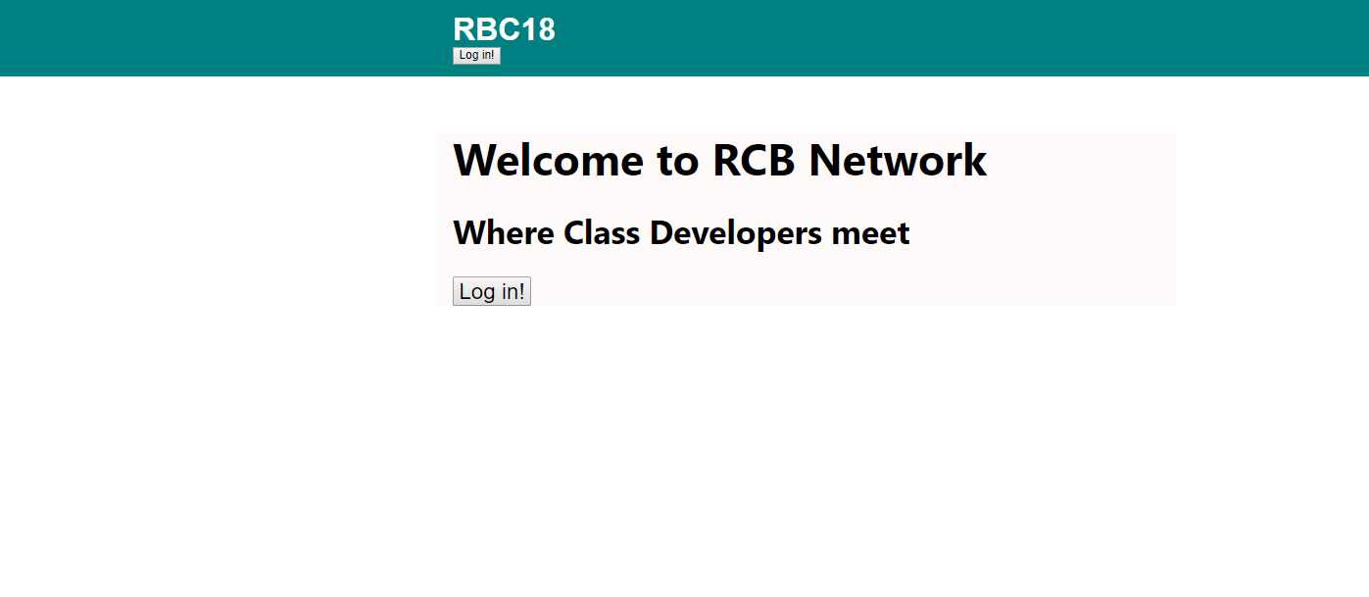

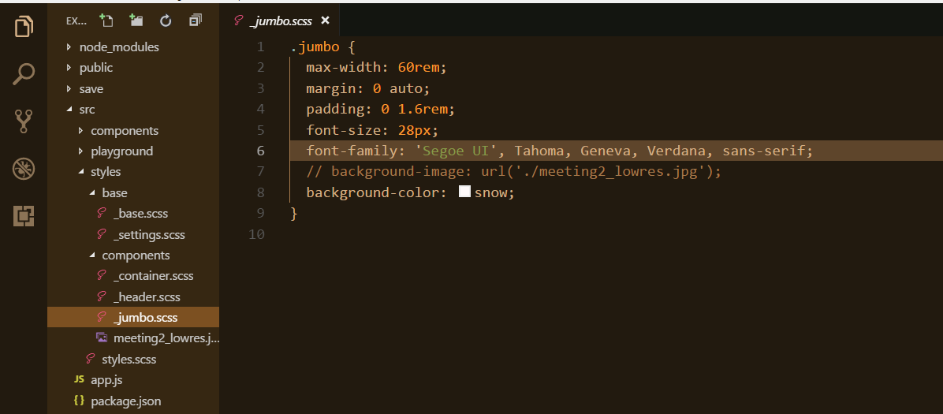

1. Sign in button in jumbo area is still rendering the header’s login button and resulting form - rather than the jumbo’s sign-up button and form: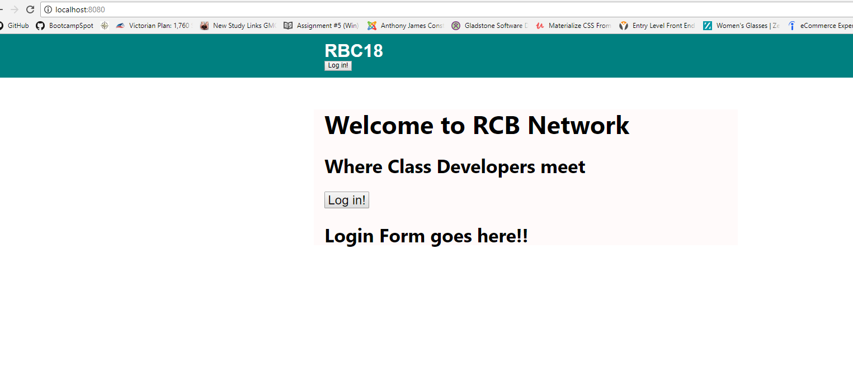 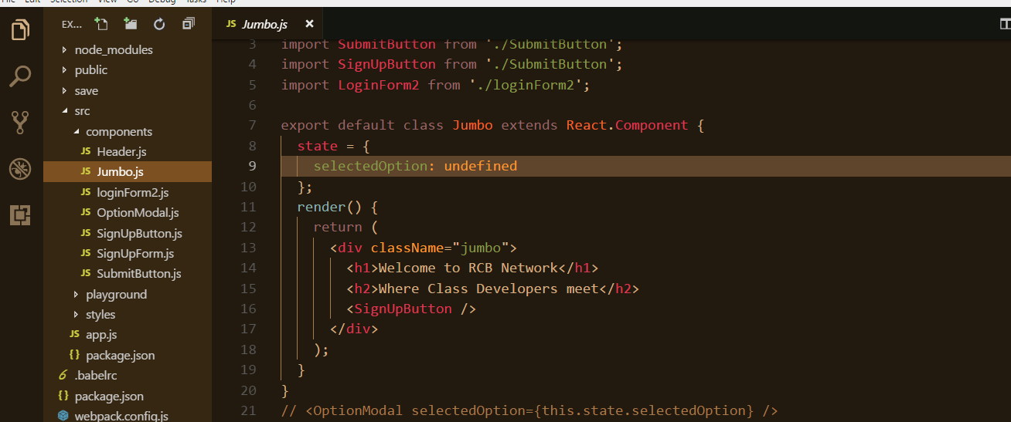

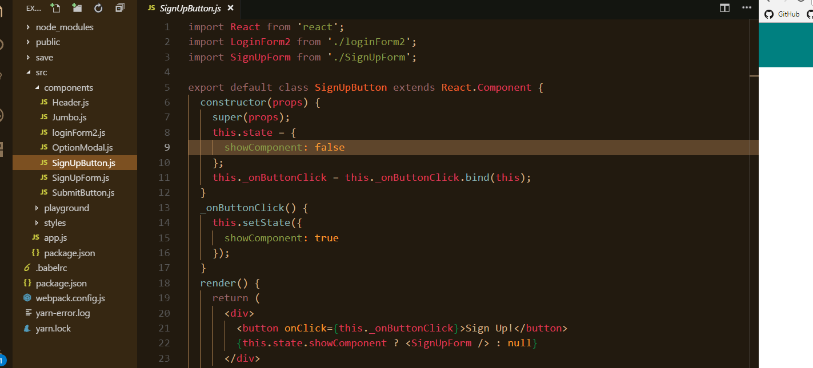

OLDER NOTES:

Start the application at:

/src/app.js

It renders the page described in:

Public/index.html

Changes on Thursday 4/12/18

Start at app.js

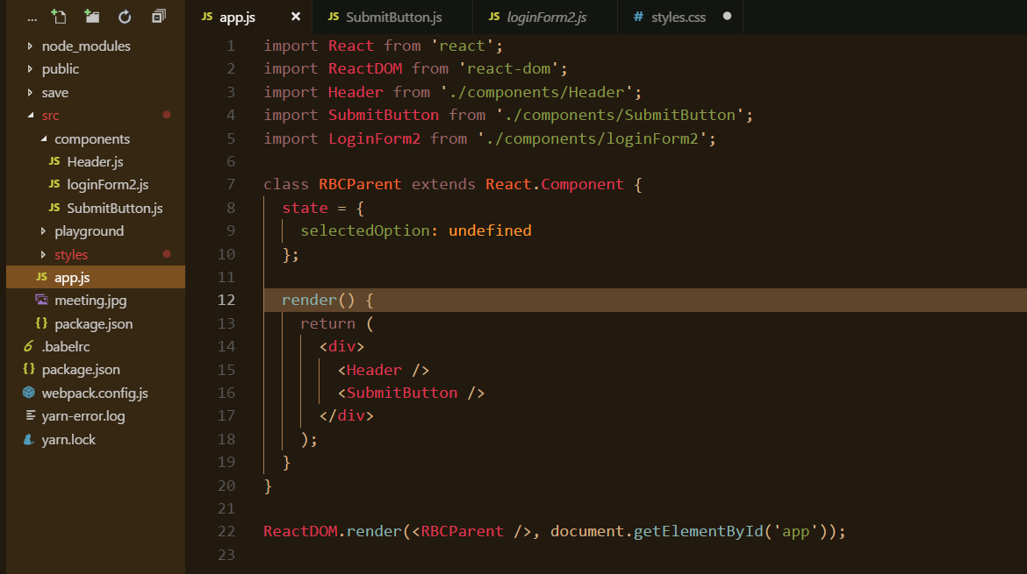

Next to ./component/header

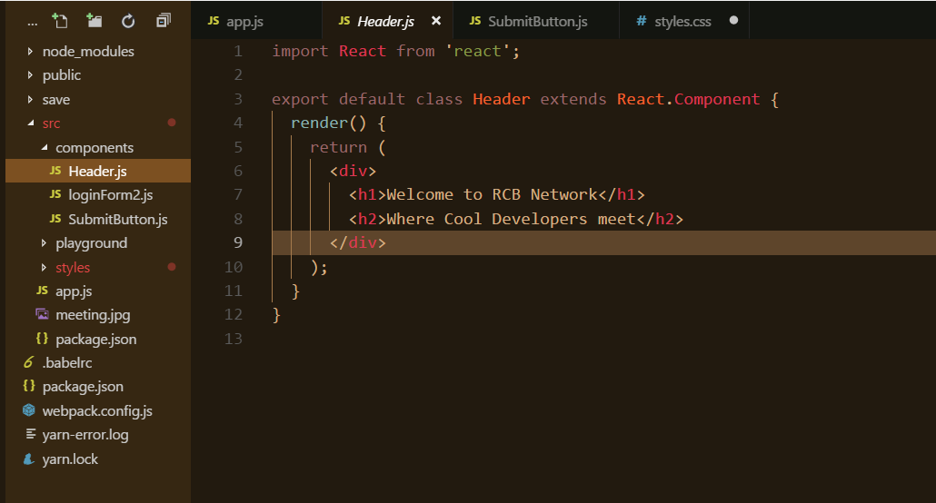

Then to ./components/submitButton.js

Which when it’s clicked, renders “Login Form goes here” - have to make an actual form/ submit button