The gprof does not work with multiple threads. So we see that profiling is done only with the main file in gprof.
In main file most of the time is taken in reading the range file ( very less amount of time is taken to read the data file.
The gprof is adding the time taken by all threads to readRanges that is why we see the time for more than actual time taken for read ranges (0.86 sec) whereas the actual time taken is 0.35 sec.

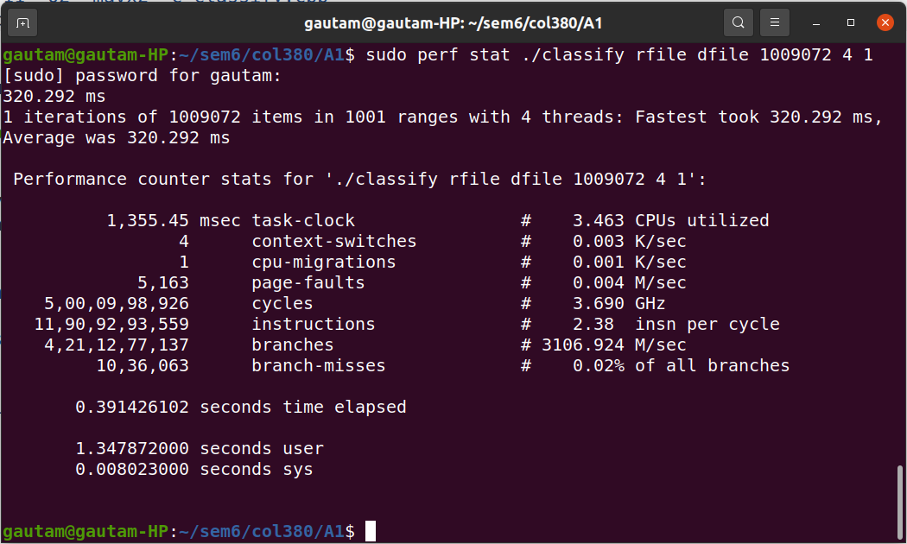
Original code perf stats

Heap profiling of original code

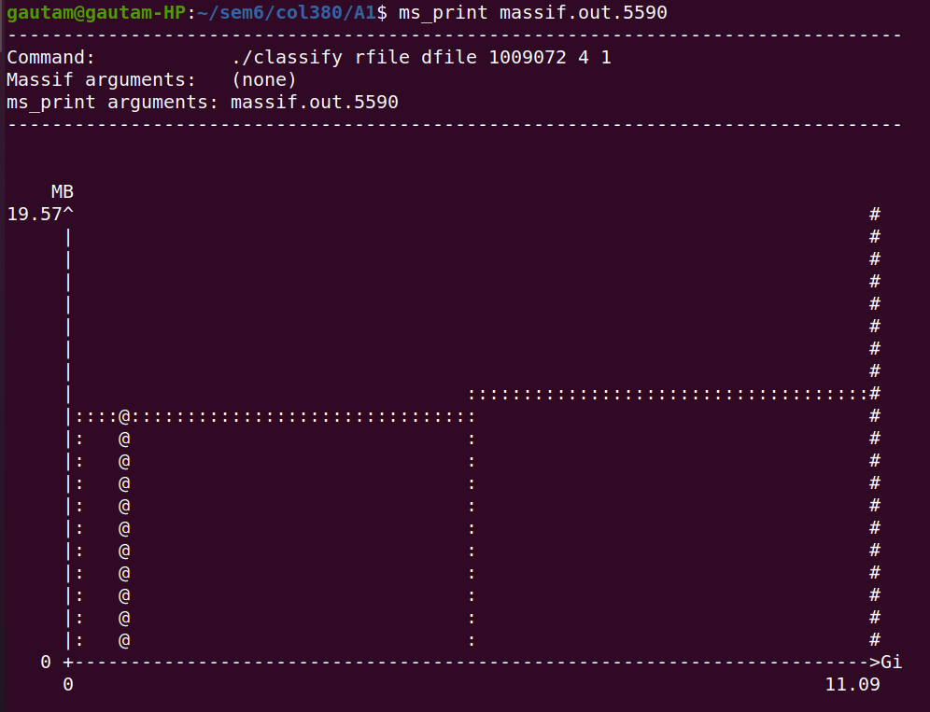
The heap profile shows an intial increase which corresponds to the reading of range and data files.
Then at ‘@’ the classify is called and range values are assigned to the data items.
The increase in the middle corresponds to the making of new data array.

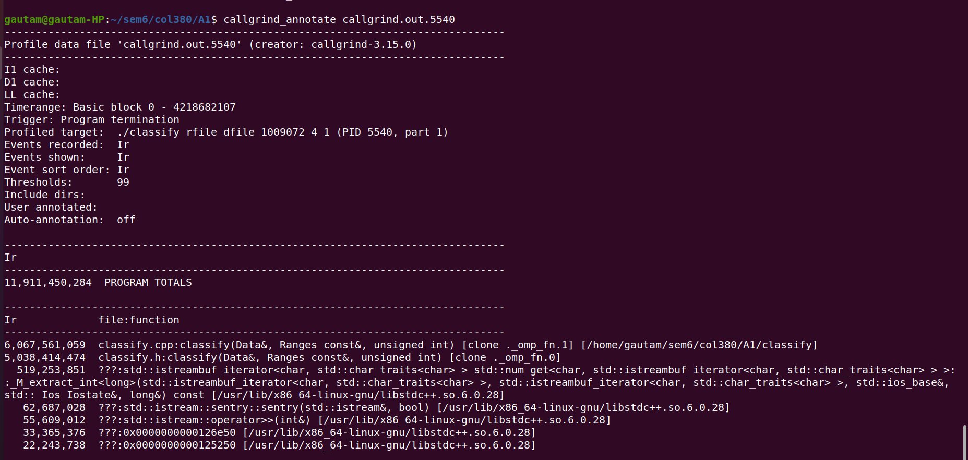
Callgrind shows that most of the clock cycles are spent in classify.cpp and classify.h.
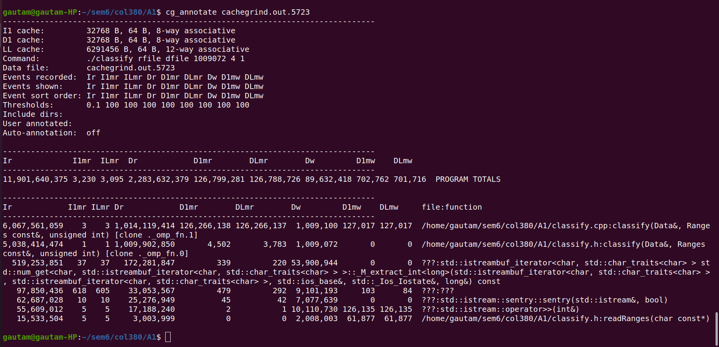
There are about a billion D cache reads in classify function. 100 million D cache read misses.
Similarly 89 million D cache writes, 702 thousand D cache write misses in classify.

Means about 10% of reads and writes to D cache are misses.

