This presentation is about visualizing some findings in the International Standard Classification of Education dataset and its changes across the last few years. This system of classification documents the „Expenditures by educational institutions on students by country and educational sector in US dollars with converted purchasing power parity”. I have used the online available ISCE databases to understand some of the main characteristics of international trends. The dataset is standardized and maintanined by the UNESCO as a project of organizing information on education globally, however the entries are not representing all countries in the world and not every year is documented in the given time frames. The ISCED was designed in the early 70s, the first version known as ISCED 1976 being approved by the International Conference on Education (Geneva, 1975), the second major revision of this classification was done in 1997, I have used the data available from 1997.

The data columns used here are are „low education 0-2”, „medium education 3-4” and „high education 5-8” for most European countries with a yearly average, and 20 other, mostly OECD countries are also included in this dataset. In certain cases the data is missing or not available, I decided to keep all rows as it might be fascinating to see the irregularities based on the results of some odd years.

I have used Tableau (see link at the end of the document) and filtered the values for each illustration to highlight what I wanted to point out. First I mapped all countries with the yearly values visible from primary to tertiary education, which is 12 plus 3 plus 2 plus years, and as you can see on the outlier values it was obvious which trends to focus on later. I have used horizontal bars to display all countries available with color intensity indicating the numerical values.

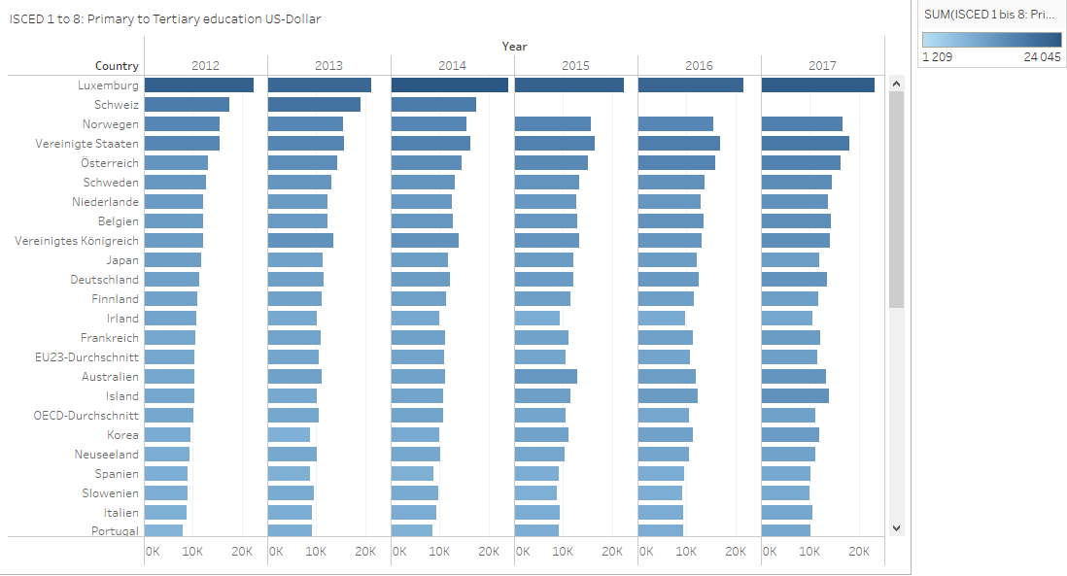By visualizing the values calculated for each country [FIG 1] we can clearly see the dispersion is often significantly larger over time, however interpreting the data is not always obvious just by looking at the numerical values because the education systems vary in structure, curriculum and many other aspects. Within the EU some countries tend to spend significantly more over the years and some of the countries spend an outstanding amount, comparatively speaking, which is easy to see notice on this diagram and the mapped data. I would like to illustrate the extremes from the dataset in the time range of [Fig 2] and [Fig 3]

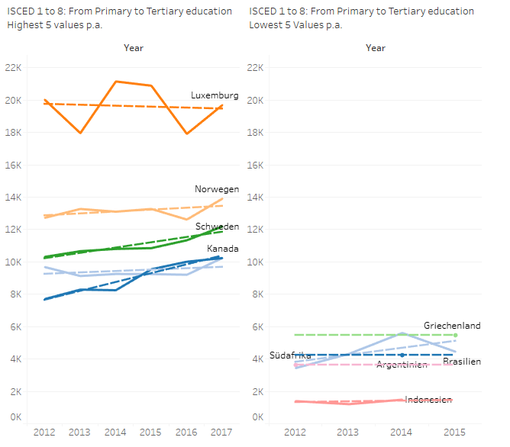Within the EU until post-secondary education, after that United states and Canada roughly speaking twice as much – as a trend the amount spent is highly correlated with GDP per capita and other economic predictors, presumably many political changes left their mark and explain the changes. This change over the years in the summarized dataset that is calculated with a purchasing power parity can be attributed to many factors which is approximately a 30% difference between the median of summarised spending. Thw OECD average 38 member countries and EU average are almost identical in the 6 years documented between 2011-2017 while North American countries tend to spend approximately 40% more on higher education (they are members of the OECD) [Fig 4].

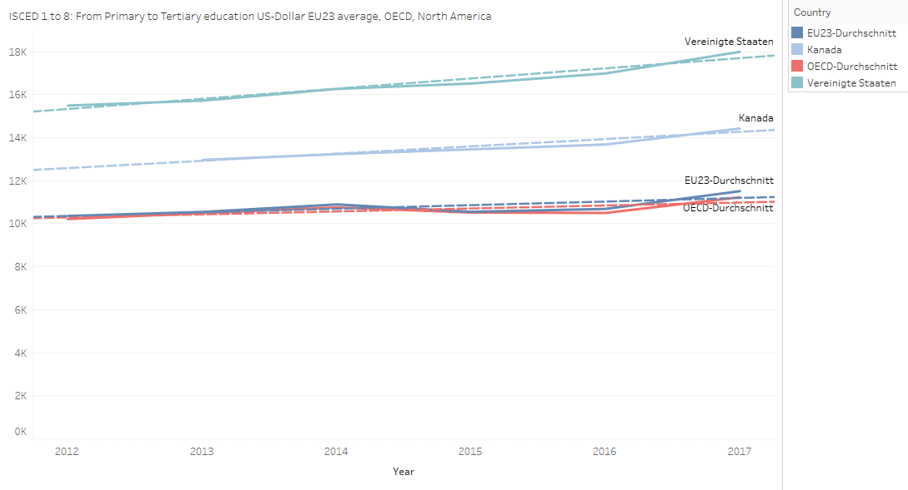This difference can mostly be attributed to the standardization of the higher education as Bologna system since 1999.

Mapping all the listed countries with the standard deviation on a ’box and whisker’ plot we can have a good overview how the aggregated values changed between 1997 and 2004. I included the accumulated values of tertiary education as the outlier countries had the most visibly different data points from [Fig 5]. The countries that decided to spend the most money on higher education on average probably had a traditionally different higher education system

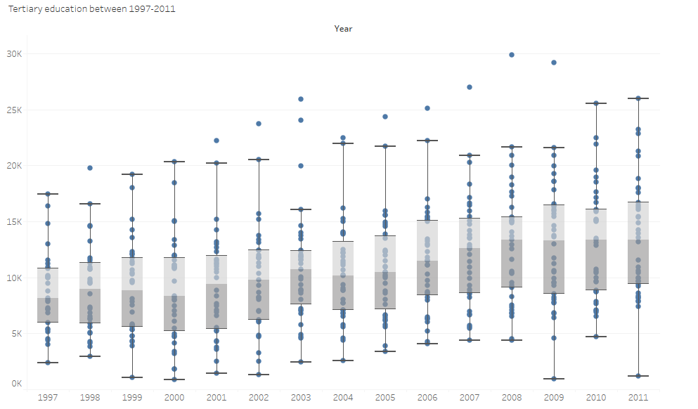As a conclusion we can say that structural variances and many other factors could contribute to differences among countries, and the yearly comparison can indicate how pervasive these differences actually are over time. Part of the reason why the ISCED was designed to have data categores instead more precise and specific educational statistics was to even out the effect of individual practices across contries, educational structures and changes over time.

The dataset doesn’t explain the reasons why some of the values deviate drastivally, it might be due to standardization differences or it can actually indicate how much difference is there between the average amount of money one person indirectly gets out of the system, but the data is well documented enough to accurately describe which values are outstanding and do research to see economic and any other reasons, and get a comprehensive overview.

<https://trello.com/b/WO5LepHv/data-project-1>

https://public.tableau.com/app/profile/gell.rt.bodork.s/viz/Primaryandtertiaryeducation/Sheet82