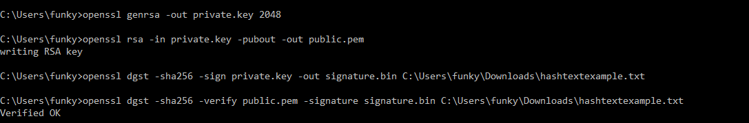
Using openssl, the private and public keys are generated in the first two lines. Then the second command uses the private key to sign the file for future verification. Finally, the public key is used to verify that the file has been signed by the private key where the last line confirms the it is verified by the private key.

