Gabriel Borges

Yufeng Wu

CSE 3500 – Programming Assignment

3/23/16

Programming Assignment Write-Up

**Settings:** For this assignment, I’m running the program on my MacBook Pro, with a 2.4Ghz i5 and 8GB 1600Mhz RAM.

**Results:**

|  |  |  |
| --- | --- | --- |
| FileName | BruteForce Runtime (in seconds) | BinarySearch Runetime (in seconds) |
| listNumbers-10.txt (1) | 6.37199E-4 | 6.82965E-4 |
| listNumbers-10.txt (2) | 0.00401796 | 0.002959525 |
| listNumbers-100.txt (1) | 0.002218045 | 8.74264E-4 |
| listNumbers.100.txt (2) | 0.01269465 | 0.006410437 |
| listNumbers-1000.txt (1) | 0.026166509 | 0.001715684 |
| listNumbers-1000.txt (2) | 0.067301876 | 0.011900116 |
| listNumbers-10000.txt (1) | 0.335328108 | 0.010119315 |
| listNumbers-10000.txt (2) | 2.629364564 | 0.025217425 |
| listNumbers-100000.txt (1) | 41.075098774 | 0.028160041 |
| listNumbers-100000.txt (2) | 265.087019675 | 0.088976959 |
| listNumbers-1000000.txt (1) | 2944.801408131 | 0.198014289 |
| listNumbers-1000000.txt (2) | 25950.726119835 | 0.329783723 |

**Conclusion:**

The choice of algorithm becomes painfully clear as the sample size for a given set of data becomes larger. Although the difference in time is apparent for smaller sample sets, the perceived time elapsed is not particularly large. However, when the program is run for the sets of 100,000 and 1,000,000 sized lists, the time difference between the bruteforce algorithm and the binarysearch algorithm become more apparent, and the faster algorithm becomes the only logical option.

An interesting observation is that for small data sets, the algorithm choice does not seem to matter if the input size is also small. Looking at the difference between, as an example, the numberset 1 runtime to the numberset2 runtime for the sample size of 10, the only reason that the binarySearch algorithm runs faster is the new numberset has a significantly larger amount of inputs to check (i.e. 100 vs. 10). If the number set was still small, as it is for the first run through (listNumbers-10.txt (1)), the brute force algorithm is actually more efficient (although this may have been due to the luck of the arrangement). In both sample sets, however, as the amount of data becomes larger, the binarysearch algorithm becomes painstakingly more efficient to use. For example, the first data set for 1,000,000 numbers to check, the bruteForce algorithm took approximately 49 minutes to complete versus .2 seconds. There’s not a question that binary search is more efficient.

**Code:** Source Code is included in submission as .java file. GitHub public repository for the project: <https://github.com/gborges0727/CSE3500-ProgrammingAssignment>

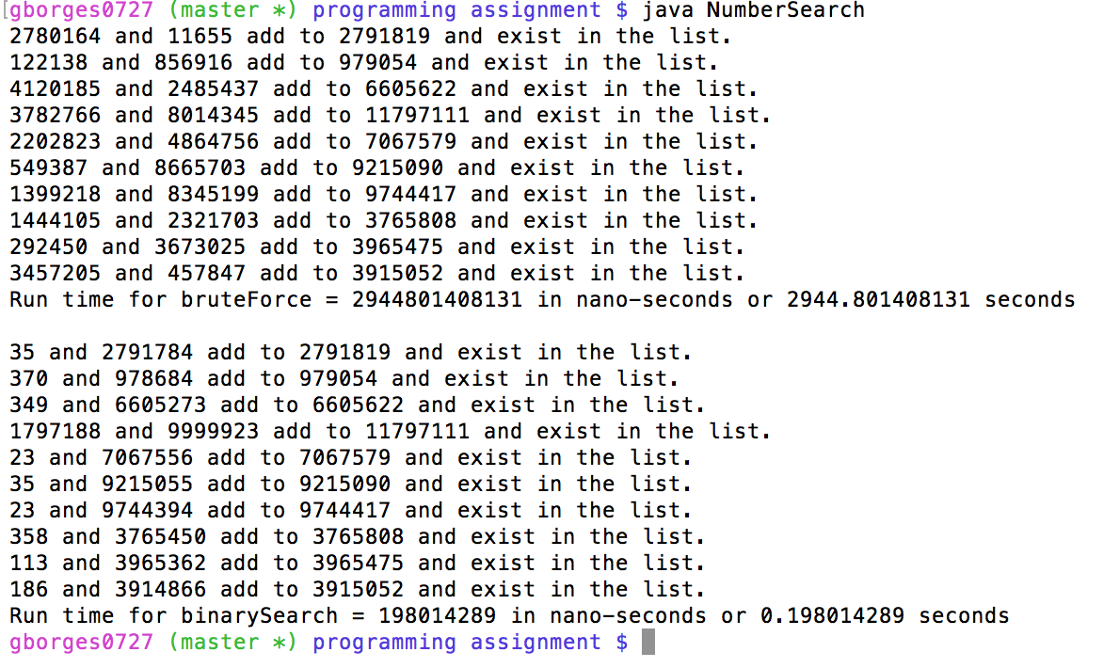 Example Output (for listNumbers-1000000.txt (1)):