Homework Assignment -- Mathematics + Written Expression
Student: Mila | Subject: Mathematics + Written Expression | Session: 2026-08-15
Due: 2026-08-19 | Estimated time: ~25 minutes

Complete all questions in your workbook. Show your working for every maths question. For the writing question, write a full PEEL paragraph in your workbook.
Reverse Percentages [Core]
1. A bike helmet costs $136 after a 15% discount was applied. What was the original price before the discount?
[2 pts] ~1m 00s

160

2. A skateboard costs $153 after a 10% discount was applied. What was the original price before the discount?
[2 pts] ~1m 00s

170
3. Mila's savings balance grew by 12% to reach $224. What was the balance before the increase?
[2 pts] ~1m 00s

200

Two-Step Compound Percentages [Stretch]
4. A price is increased by 20%, then decreased by 10% of the new price. The final price is $270. What was the original price?
[3 pts] ~1m 30s

250

5. A price is decreased by 25%, then increased by 20% of the new price. The final price is $360. What was the original price?
[3 pts] ~1m 30s

400

Border Geometry [Core]
6. A rectangular lawn is 12 m long and 7 m wide. A path of uniform width 2 m is built all the way around the outside. What is the total area of the path?
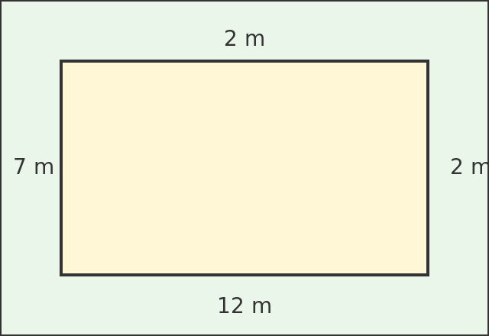
[2 pts] ~1m 00s

92

Border Geometry -- Finding the Side [Stretch]
7. A square garden has a path 2 m wide built all the way around it. The total area of the path is 96 m². What is the side length of the garden?
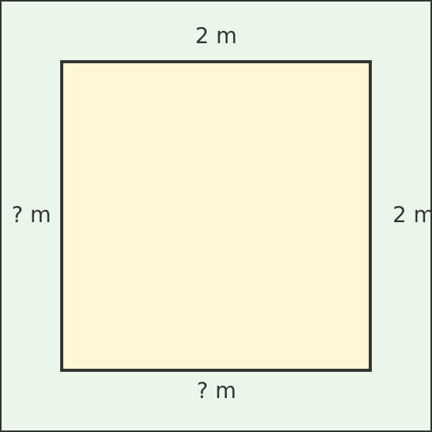
[4 pts] ~2m 00s

10

Spaced Review: Number Patterns and Equations [Core]
8. What is the next number in the pattern: 2, 6, 18, 54, ?
[2 pts] ~0m 45s

162

9. Solve for x: 3x − 4 = 20
[2 pts] ~1m 00s

8

Written Expression: PEEL Paragraph [Core]
10. Write one PEEL paragraph answering this prompt: Should students wear school uniforms? Make a clear point, back it with a reason, explain your thinking, and link back to your point at the SAME strength. No invented statistics. 4-6 sentences.
[5 pts] ~2m 00s

Uniforms offer a great deal of protection, as they allow students to roam free without the fear of not being found if lost. Many students on excursions eventually get lost because they either roam around and don’t follow their group or they weren’t focusing, with uniforms students can easily find their group with the bold colours and identifiable logo. Many students that don’t wear a school uniform gets lost more easily and has high chances of not being found. Getting lost is likely when on excursion especially when you aren’t wearing one. This is very unfortunate as students can’t have the freedom they could if they wore school uniforms. It shows how important uniforms is to a child’s safety and how they should wear them.

