**Exercise 2: Digit Recognizer task**

**Task**

In this assignment we had to experiment with different classification algorithms and setting to decide on the model achieving the best performance on the MNIST ("Modified National Institute of Standards and Technology") dataset.

**Data Analysis**

Before we begin experimenting with different classification methods and settings, we performed a preliminary data analysis.

The dataset we used, consists of 42000 observations and 784 features for each observation. Each observation is an image of a handwritten digit and each feature is the value of a pixel of this image.

Each image is 28 pixels in height and 28 pixels in width, for a total of 784 pixels in total. This pixel-value is an integer between 0 and 255, inclusive.

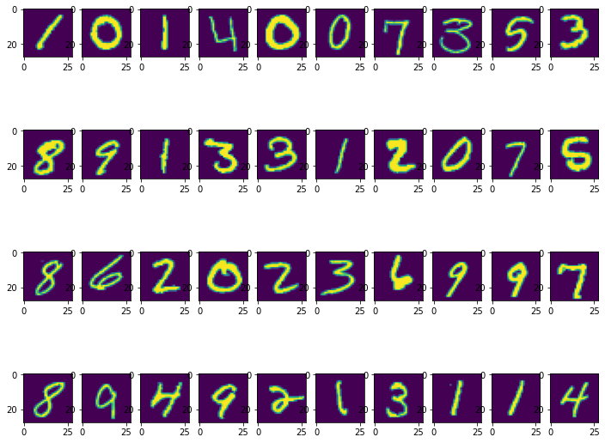

The frequency of each digit is depicted in the following plot:

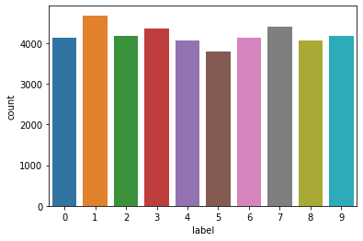

As we can observe the distribution of the observations in the 10 classes is balanced.

**Method**

We decided to initially experiment with some linear classifiers to investigate if a linear combination of the features is able make the right classification decision. In particular, we tried a logistic regression classifier and a SVM classifier with linear kernel. The results ..

Afterwards, we tried some non-linear classifiers., in particular Random Forest and SVM with RBF kernel. The results…

Finally, we also tried an ensemble non-linear classifier, namely Random Forest. The results...

**Feature Selection and Reduction**

**Evaluation metrics**

**Results**

Here we report the macro-average results for each class and each evaluation metric.

TABLE

**Conclusions**

From the results reported above we can observe: WITH OR WITHOUT FETURE SELECTION

LINEAR VS NON LINEAR ALGORITHMS