Vanier College

Computer Science Department

**TIVI - A Productivity Application**

**User Manual**

Giuliana Bouzon (1940108)

Chilka Joy Libut Castro (2030864)

Jiahui Xia (2044092)

420‐331‐VA : Application Development (Sec‐01)

Teacher: Syed Naseem Afzal

Thursday, December 09, 2021

Table of Contents

**Introduction:** 3

**Interactive Features:** 3

**Graphical User Interface:** 4

**Basic UI:** 4

**Application Features:** 5

**Log In page** 5

**Exception Handling in log in page:** 5

**Exception Handling in sign up page:** 7

**Menu page** 8

**Calendar page** 9

**Exception Handling in Calendar page:** 11

**To do list page** 12

**Exception Handling in Calendar page:** 14

**Stopwatch page** 15

**Finance page** 17

**Exception in Budging page** 18

**Countdown page** 20

**Notes page** 23

**Additional software required to support project application software** 24

# **Introduction:**

The TIVI is a GUI application that serves as a productivity app. In this program, the user will be able to keep track of personal schedule, task and budget. The user can also use the calculator, stopwatch, countdown and notes to easier manage their daily event and time. This user’s manual will provide a detailed explanation of all features included in this productivity application.

# **Interactive Features:**

In recent years, productivity applications have become more and more popular since people can clearly see and manage their schedules through these apps. TIVI- productivity application makes time management easier and provides tools to help enhance productivity. Some of the major features of this applications include:

* **Calendar:** display and updated each month’s events and tasks
* **To do list:** display the task of user need to do and update it if user finish and delete the task
* **Stopwatch:** measure the amount of time
* **Finance:** display and update the daily expenses of user
* **Countdown:** a virtual clock that counts down form the time of user set
* **Notes:** display the notes taken by user

# **Graphical User Interface:**

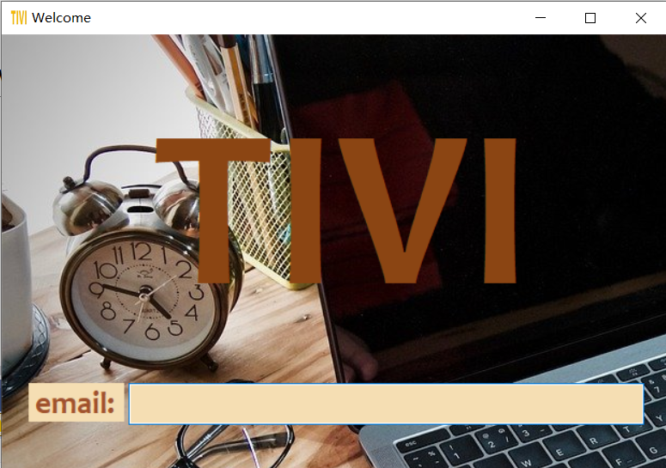

# **Basic UI:**

This application is programmed using the C# language and comes with a very simple user interface and has a light design. The user can log in with their email. If it’s the user’s first time using our application, they will be prompted to create an account which will then be added to our database. If the user has already registered, a welcome page will open following email validation through our database.

# **Application Features:**

## **Log In page**

In the **Log In** page: the user has to enter a unique email in order to access his or her

account. Once the information has been entered, the user can press “**Enter”** to login**.** At the same time **“Enter”** willverify if the entered data is valid. If the email is not valid, an error message will be displayed. If the email is valid but not found in our database, the user will be prompted to create an account.

## **Exception Handling in log in page:**

* The email must be a valid email
  + If the email is invalid, a message box will display the warning “Please enter a valid email!”

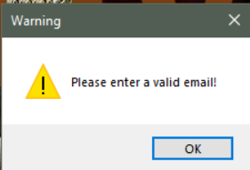

**Sign up page**

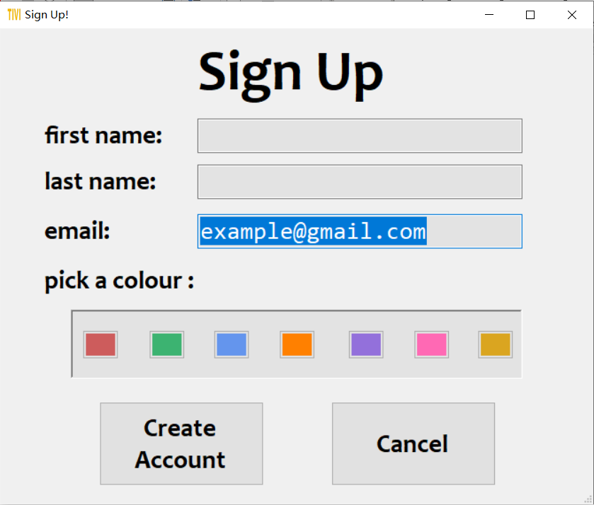

If it is the user’s first time using our application with entered email, the user will jump to sing up page. In the sign-up page, it will automatically save the email entered during login page. The user can pick the color he/she prefers as the background color of the application. The default color is white.

If the user does not want to sign up, he/she can click “**Cancel**” button to exit the application. When the user has entered valid information and clicked “**Create Account**” button, he/she will be redirected to the application menu, or “Welcome” page.

**Exception Handling in sign up page:**

* The first name cannot be empty

* The last name cannot be empty

## **Menu page**

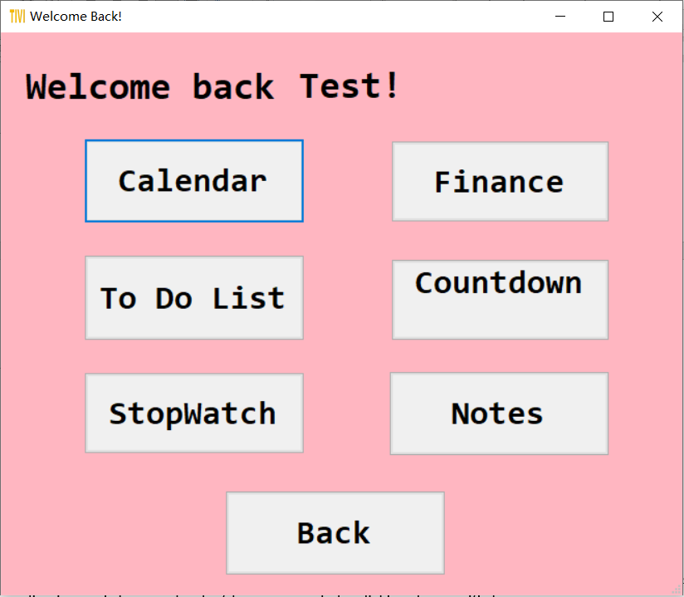

In the menu page, it will display the user’s first name and the user can see all the function in this application and choose what he/she wants to do by clicking the specific button.

Clicking “**Back**” button to go back to login page.

## **Calendar page**

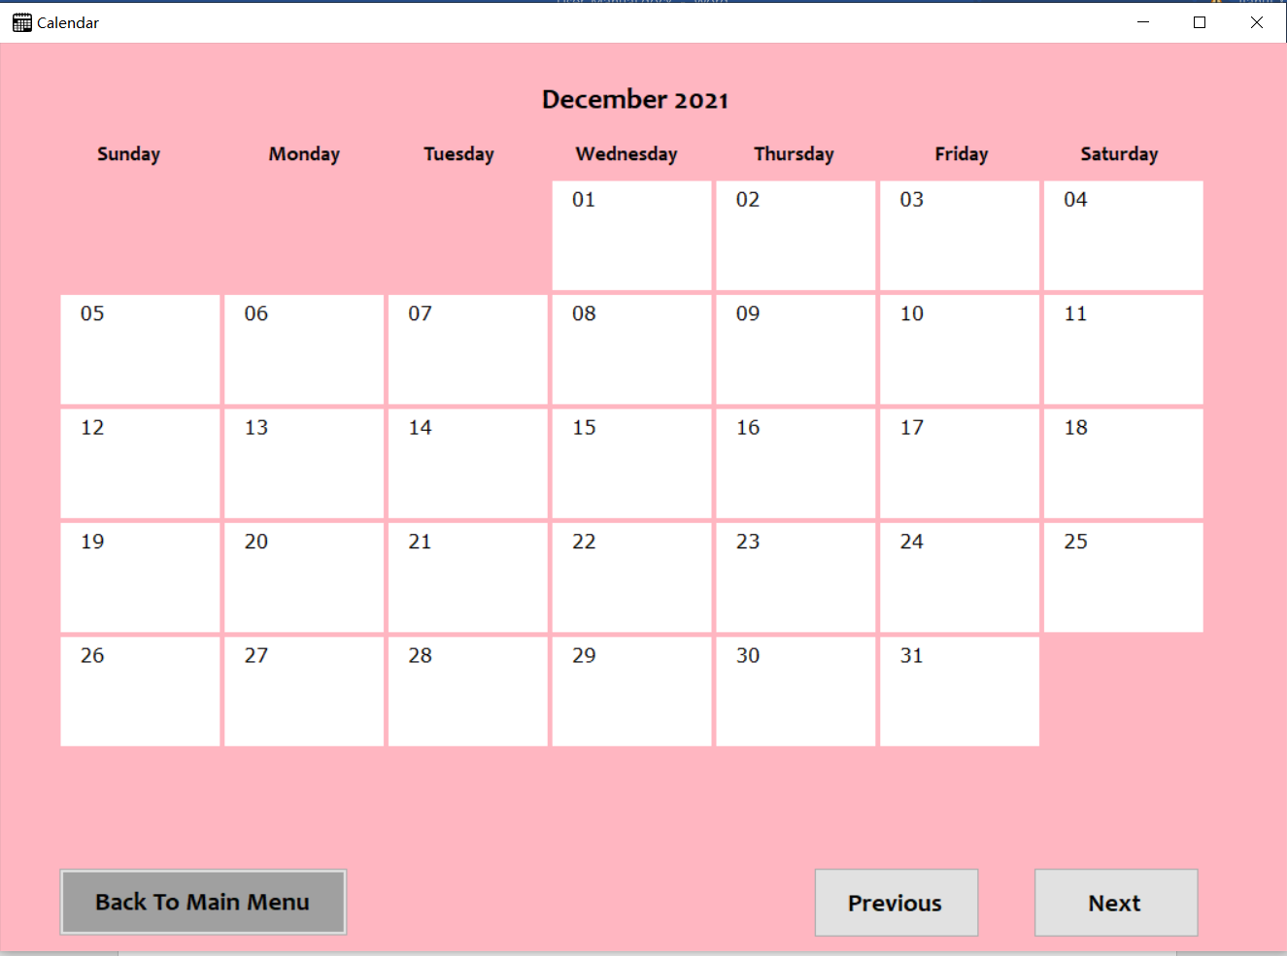

In the calendar page, it will display and updated each month’s events and tasks. The user will go back to the menu page when clicks the “Back To Main Menu” button. The “Previous” and “Next” button will display the previous month and next month. When use clicks the day, he/she can add the event or task. The add event page will be displayed.

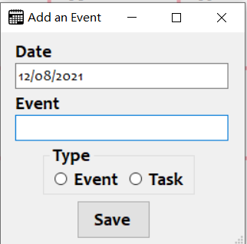

The user can choose it is an event or task by clicking Radio Button.

When user clicked “save” button”, the popup message will display saved. The events and tasks will be display on the calendar.

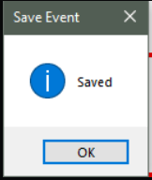

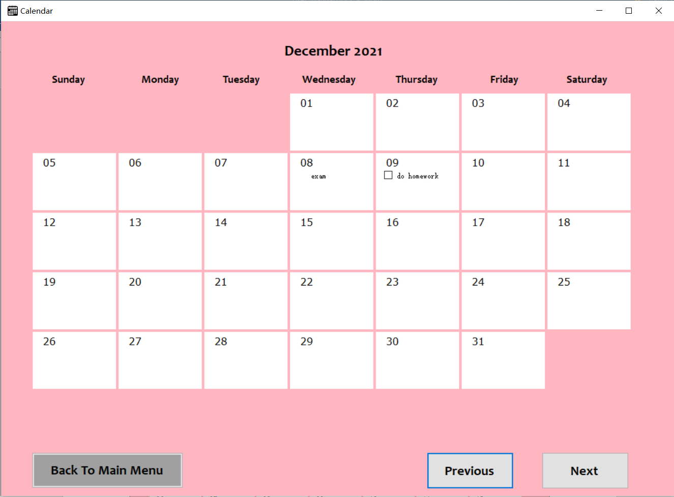

## **Exception Handling in Calendar page:**

* The user cannot input empty when add an event or task

## **To do list page**

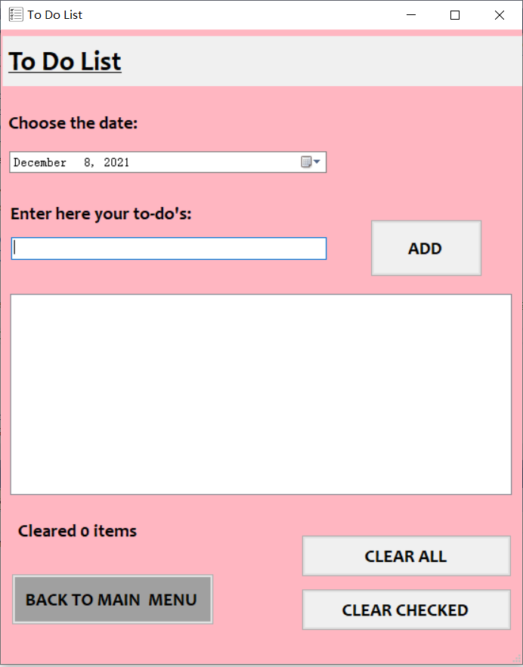

In to do list page, the user can choose the date of the task and add the task, remove the tasks that have been completed and remove all the tasks. The user will go back to the menu page when the “Menu” button is clicked.

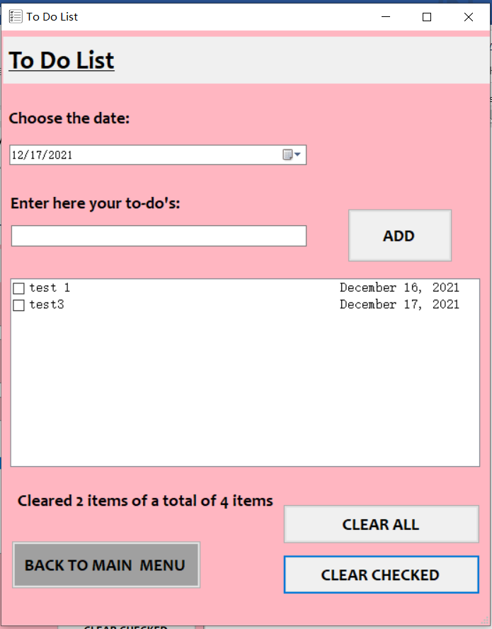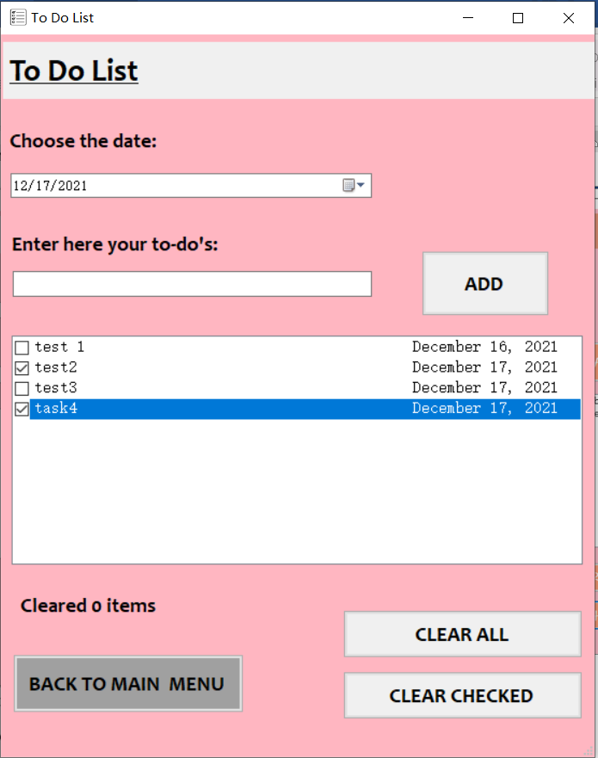The user can choose the date of the task through the data time picker. When the user clicks the “ADD” button, the task will be added and display in the page. The user can remove the finished task by clicking “CLEAR CHECKED” button and the number of tasks to be removed will be displayed. The used can double click the task check the checkbox and click again to uncheck it.

The user can remove all the task by clicking “CLEAR ALL” button.

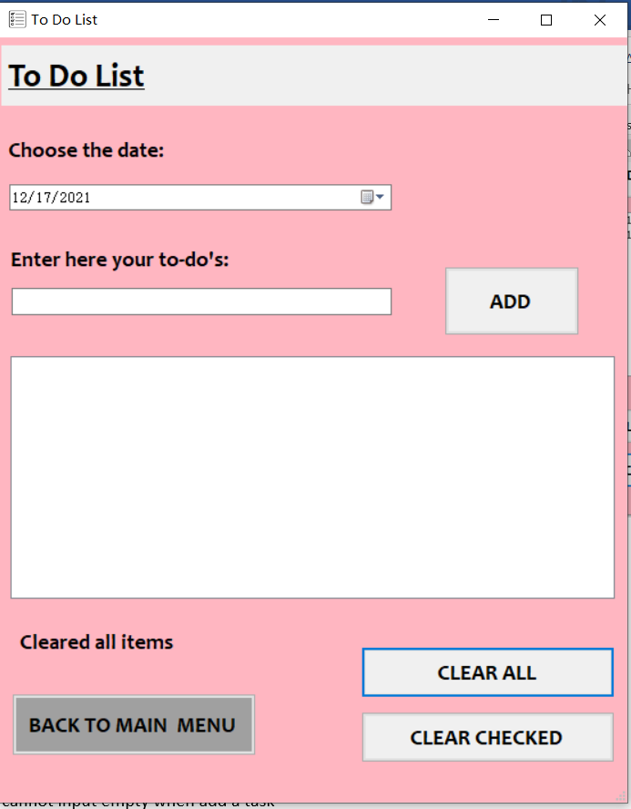

## **Exception Handling in Calendar page:**

* The user cannot input empty when add a task

## **Stopwatch page**

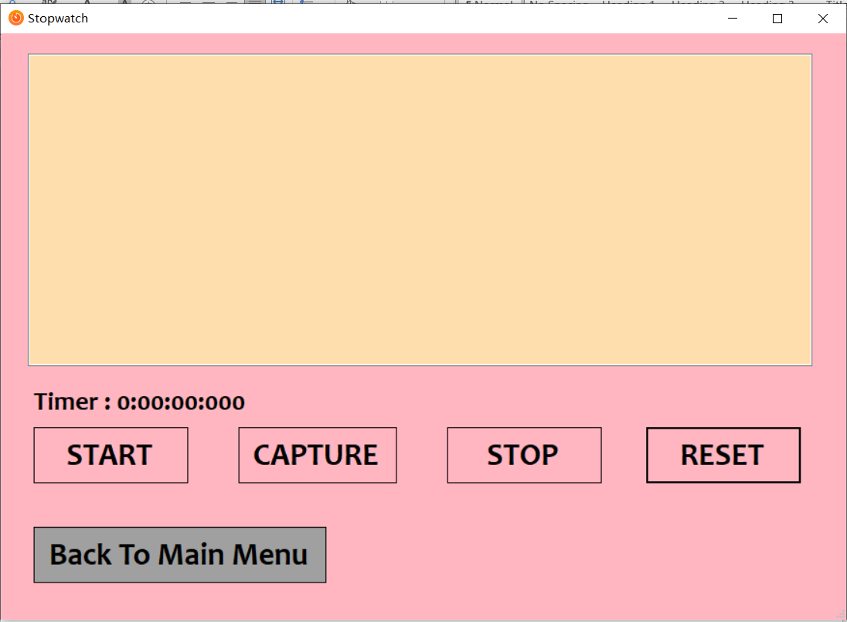

In the stopwatch page, the user can measure the amount of time and capture any time (similar to “lap”). The time of capture will be displayed.

Clicking “**Back To Main Menu**” button to go back to menu page.

Clicking “**START**” button to start measure the time

Clicking “**CAPTURE**” button to get the time of capture and will be displayed

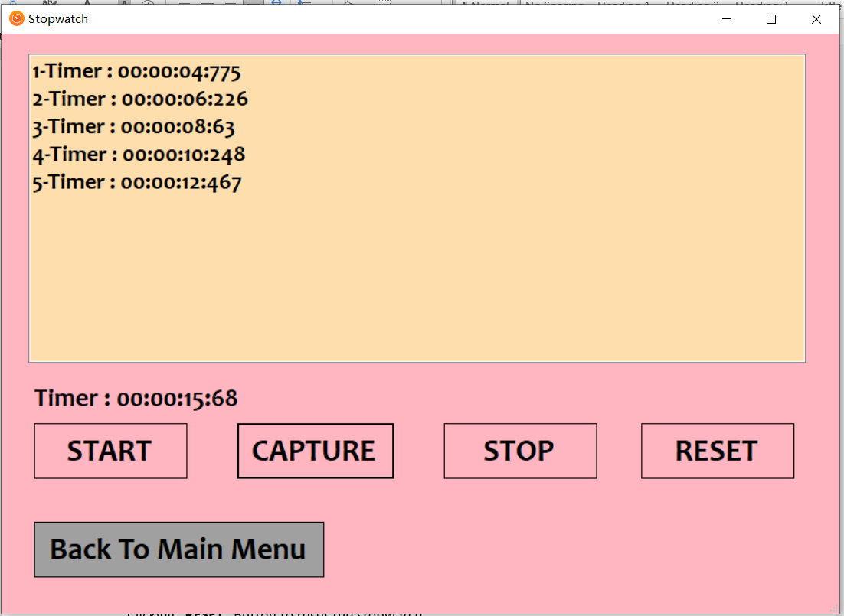

Clicking “**STOP**” button to pause the measure

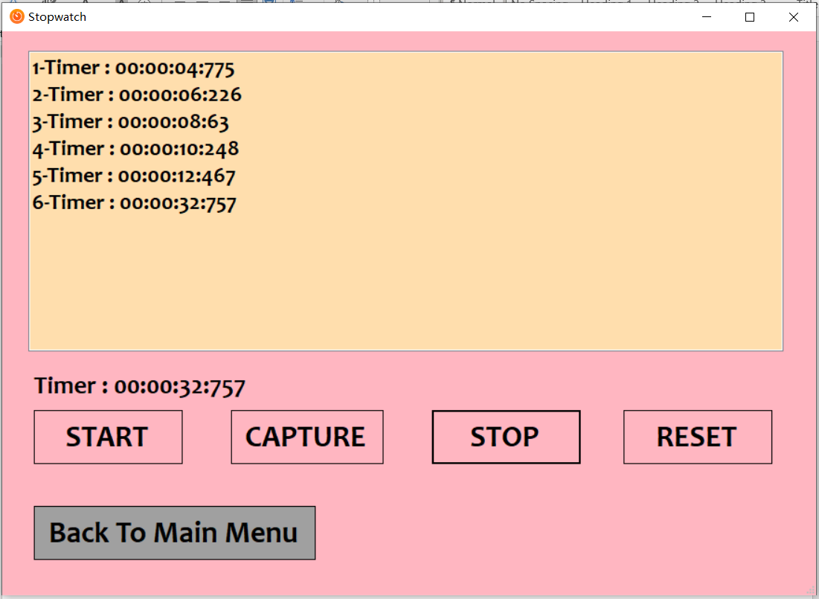

Clicking “**RESET**” Button to clear the capture and reset the stopwatch

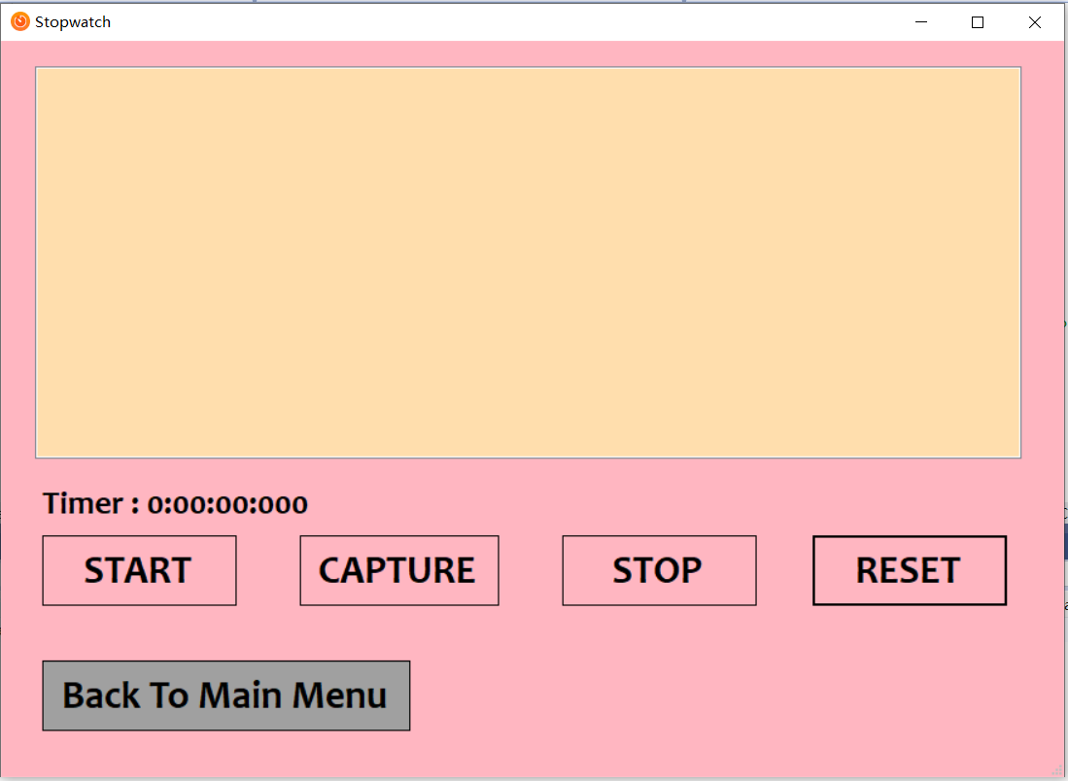

## **Finance page**

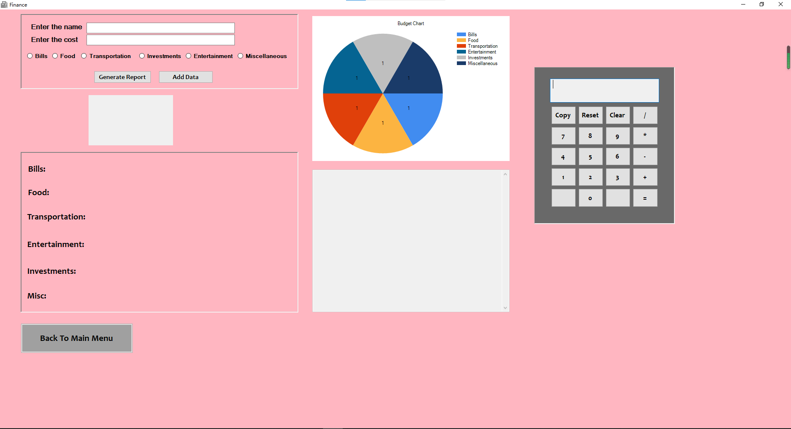In the budgeting page, the user can add his/her expenses and generate the report. The user can choose the type of each expenditure.

Clicking “Add Data” button to add the cost in database.

Clicking “Generate Report” to generate the budget report and display in the page

The user can use Calculate to calculate the cost if he/she want

The user can go back to menu page by clicking “Back To Main Menu” button

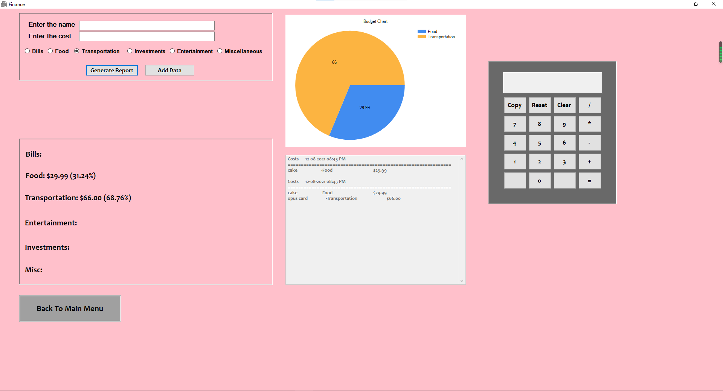

## **Exception in Budgeting page**

* The input data cannot be null

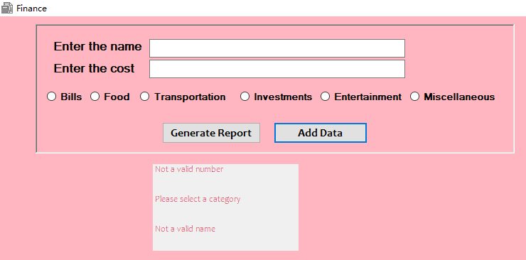

* The cost needs to be a number

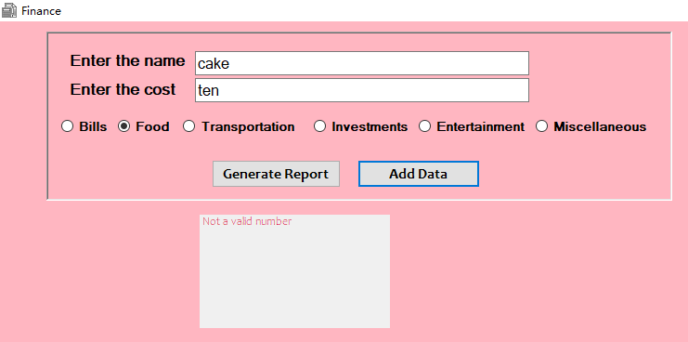

* Must to choose a category

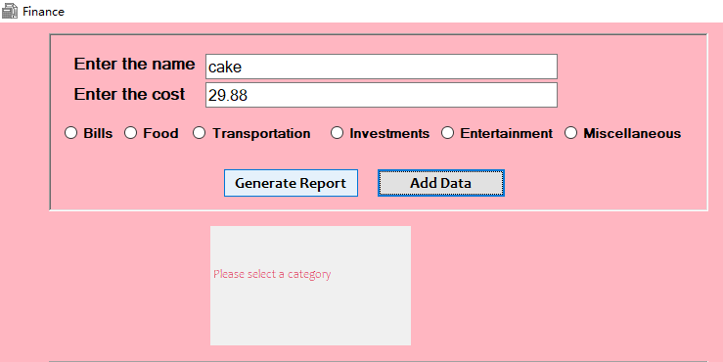

## **Countdown page**

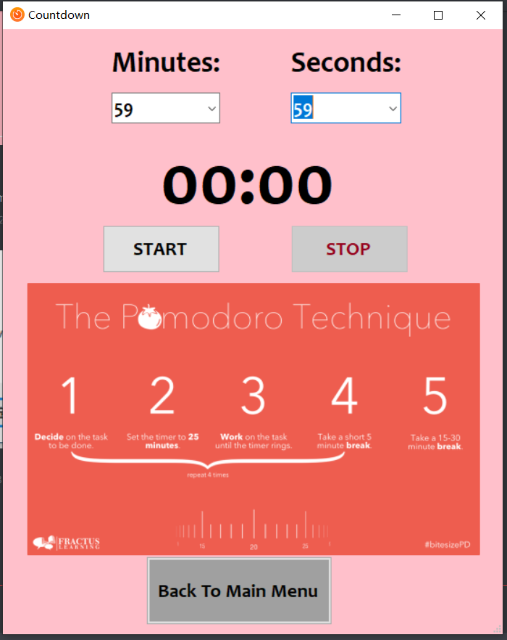

In the countdown page, there is a virtual clock that counts down from the time chosen by the user.

The user can set the time from one second to 59 minutes 59 seconds.

Clicking “**START**” button start to count down

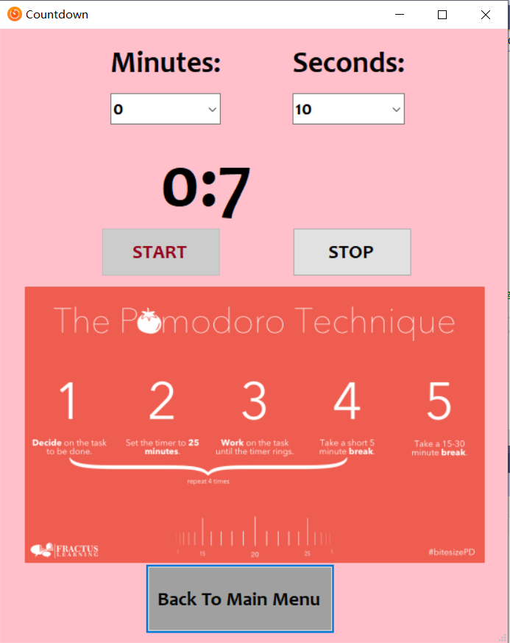

Clicking “**STOP**” button to pause the countdown.

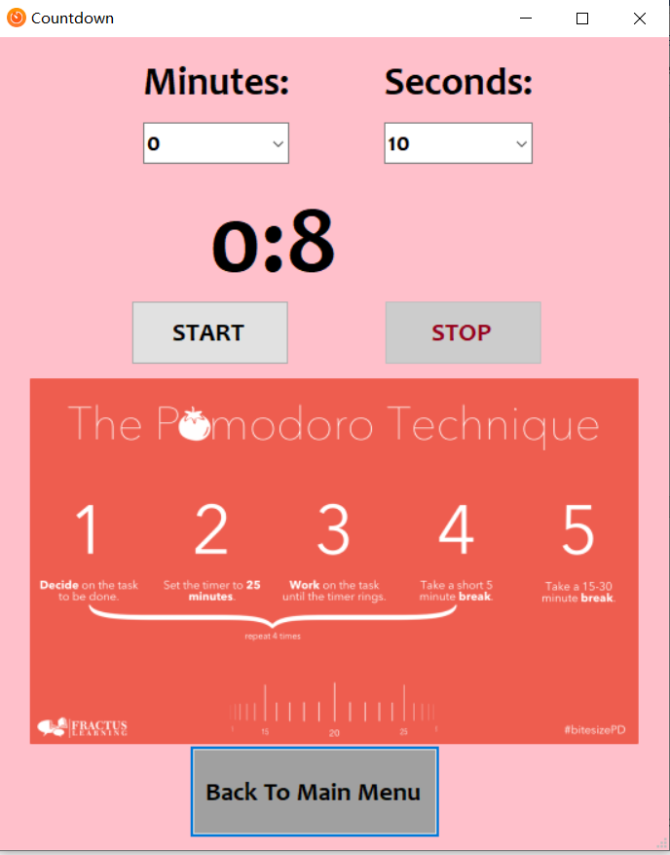

When the time is up, the popup message will display “Time’s up” to remainder the user and play a sound.

## **Notes page**

The user can take notes in this page.

In the notepad page, user can create new file, open an existing file, edit the file, and format the font and color of the text.

**File**

* New – create new note
* Open – open an existing file
* Save – save current note
* Exit – exit the notepad

**Edit**

* **Undo** – reverse the action of an earlier action
* **Redo** – restores any actions that were previously undone using an undo
* **Cut** – removes the currently selected text and places it on the clipboard
* **Copy** – copies the selected text
* **Paste** – paste the copied text
* **Select All** – select all the text
* **Date/Time** – inserts the current date and time

**Format**

**• Font** – the change default font of the text

**• Color** – to change default color of the text

# **Additional software required to support project application software**

Step 1: Download XAMPP from the link:

<https://www.apachefriends.org/download.html>

Step 2: open XAMPP and click on it, open the control panel

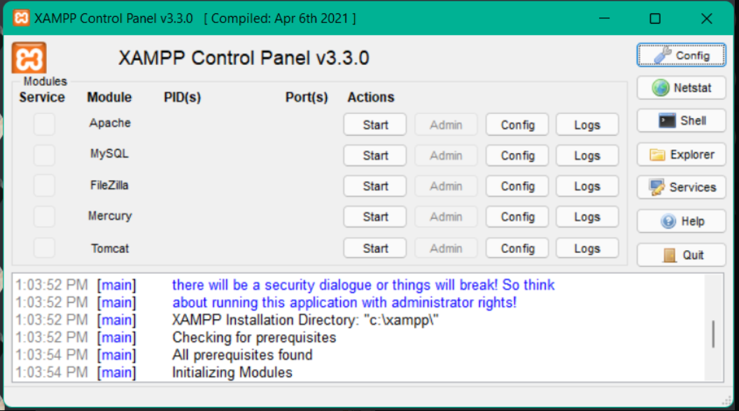

Step 3: start the process for apache and mySQL by clicking “start”

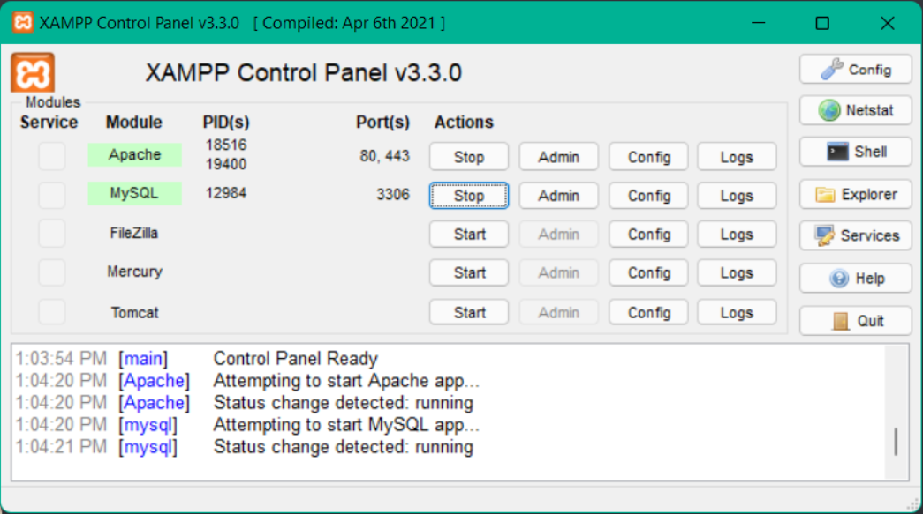

Step 4: open a browser and type <http://localhost/phpmyadmin/>

Then you will get this page

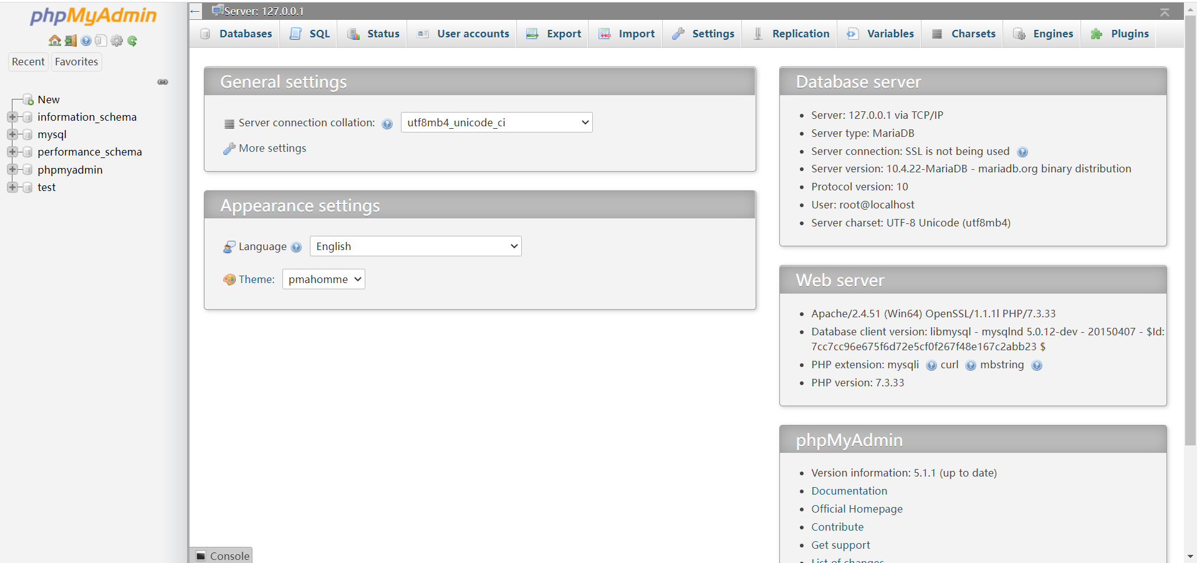

Step 5: click “new” one the left and create a database called “tivi”. Then click “create”

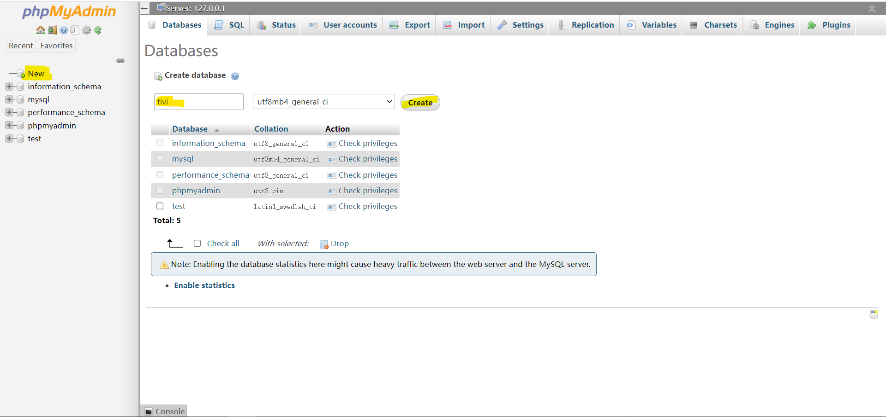

Then you should see “tivi” on the left

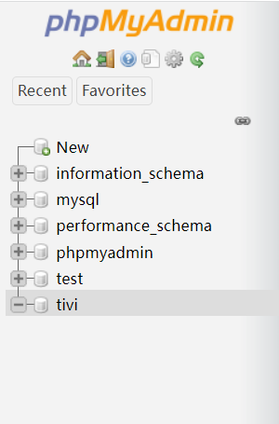

Step 6: click “import”

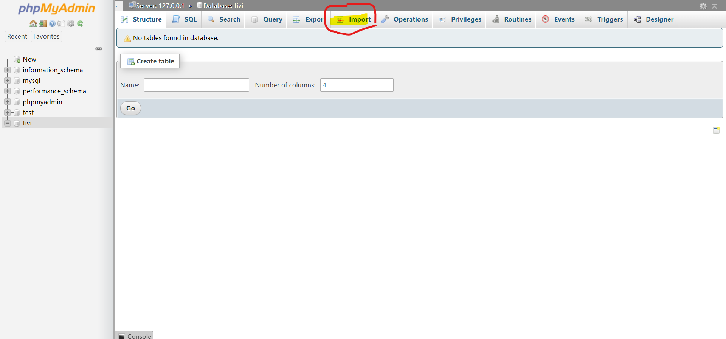

Step 6: then click on browse and choose the sql file

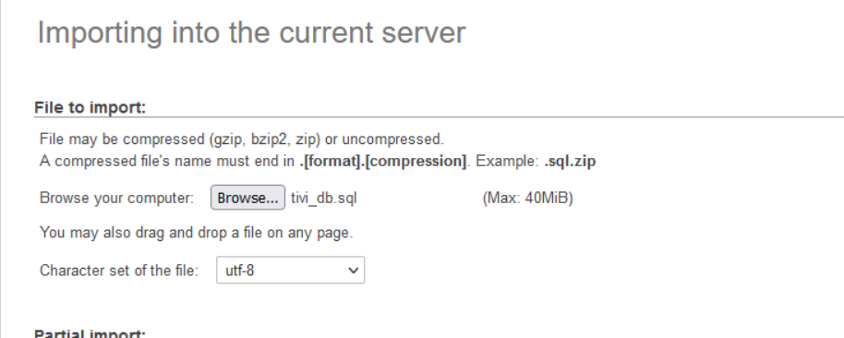

Step 7: now click “Go”

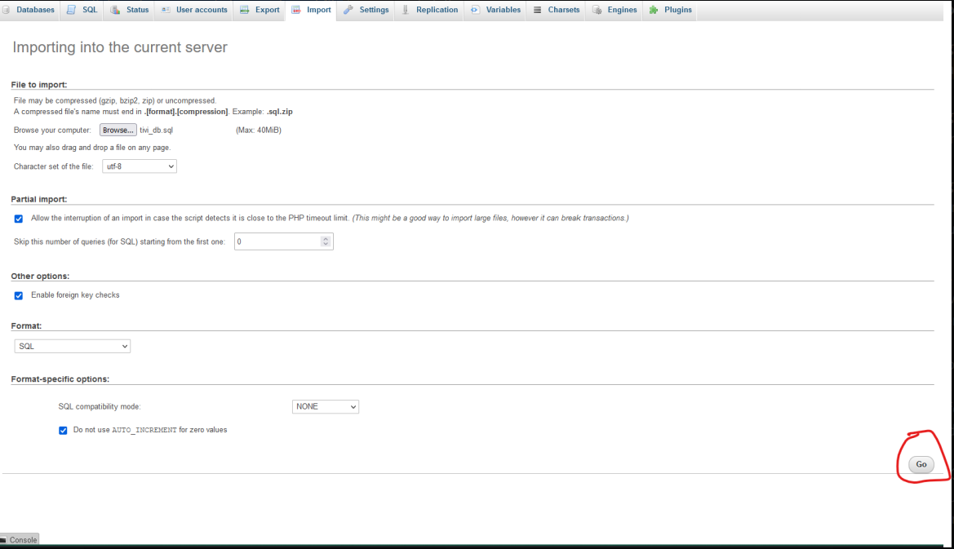

After clicking “Go”, you should see like this

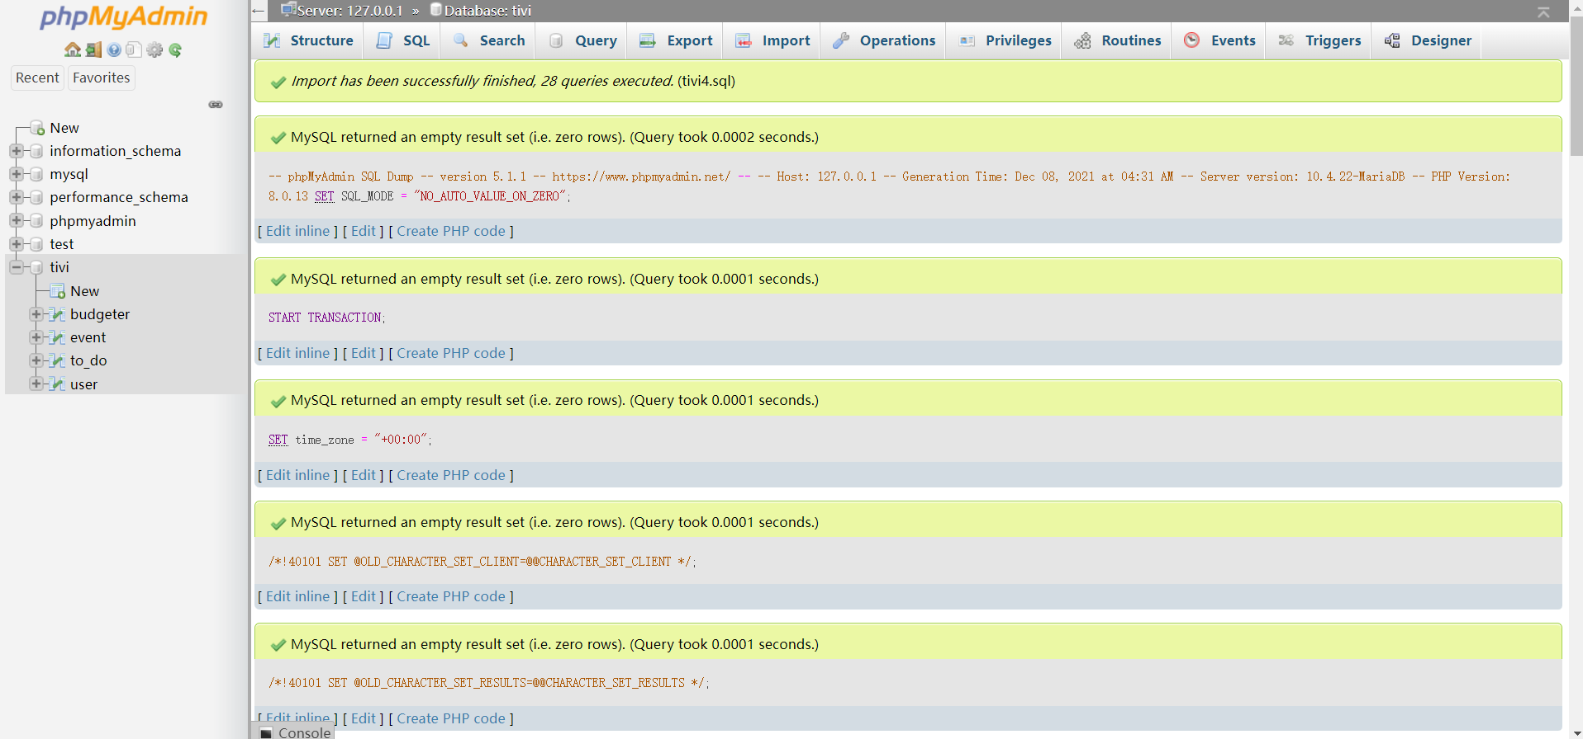

OK. Everything is DONE! You can use the application now!