Euclid MER VIS geometry outcomes summary
Completed local fitting and grouped galaxy review reports
Updated 20 October 2026
All 2777 galaxy cutouts now have an individual PNG report and a place in the grouped PDF collection. The fitting returned 2207 provisional geometry estimates and 570 failures. We have separated reports with detected quality issues so they can be reviewed efficiently before adopting geometry for deprojection.

Fitting outcomes under the original screening policy
Result | Galaxies | Share of sample
Fit with no automatic geometry flags | 546 | 19.7%
Fit with one or more geometry flags | 1661 | 59.8%
Fit failed | 570 | 20.5%
Total | 2777 | 100.0%

A returned fit supplies observed disc PA, observed bar PA and inclination. It remains provisional until the selected light contours have been checked against the image. A failed fit remains visible in the reports, with unavailable geometry rather than zero-valued angles.

The review groups
Group | PNG reports | PDF batches
QI quality issues | 2250 | 38
NoQI no detected issue | 527 | 9
Total | 2777 | 47

The existing QI/NoQI report folders preserve the original screening policy: QI includes any original geometry flag, a failed fit or partial coverage. Its 2250 reports comprise 1661 originally flagged fits, 570 failures and 19 otherwise unflagged partial cases. These stored labels have not been regenerated. Under the revised interpretation used in the PowerPoint, nearly face-on is informational and unstable disc PA is disregarded for face-on galaxies. This gives 601 fits with no counted quality flags and 1606 with counted flags: 963 with one, 466 with two, 176 with three and one with four. Failures remain 570. These revised chart groups differ from the original QI/NoQI file groups.
The 47 PDFs contain 463 pages at six galaxies per page, with at most 60 galaxies per batch. QI and NoQI reports never share a PDF. Each PNG is 2000 × 1750 pixels. The original FITS images and source fitting manifest remain unchanged.

Scope and basis
The sample comprises 2777 Euclid Q1 candidate barred spirals selected from Galaxy Zoo morphology, with cutouts drawn from 309 mosaics. This summary uses the completed fitting run and the verified report collection. Report generation reused the existing ellipse profiles; it did not rerun the scientific fits.

Quality issues and fitting failures
Most detected issues arise from a small selected bar interval, unstable disc orientation or changing outer ellipticity. The table preserves the original run statistics. Nearly face-on is an informational statistic, not a quality issue in itself. Other flags identify specific numerical conditions and may overlap; their counts must not be added to infer a number of affected galaxies.
Original condition or informational statistic | Count | Share of 2207 fits
Bar interval upper bound below 1.5 arcsec | 1210 | 54.8%
Disc PA radial scatter above 10° | 791 | 35.8%
Disc ellipticity span above 0.15 | 573 | 26.0%
Nearly face on q > 0.90 (informational statistic) | 200 | 9.1%
Bar PA radial scatter above 10° | 28 | 1.3%
Median bar ellipticity below 0.25 | 7 | 0.3%

No high-inclination or axis-ratio-below-thickness flags occurred. A small-bar warning indicates sensitivity to resolution and interval selection; its interval boundary is not a measured physical bar length. Disc PA instability warns that the selected outer contours do not share a consistent direction, except that this is expected for nearly circular discs. Changing disc ellipticity makes inclination sensitive to the selected range.

Why 570 galaxies failed
Recorded reason | Galaxies
Too few reliable samples in the selected bar or disc interval | 431
Fewer than ten reliable isophotes overall | 138
Catalogue centre not on a detected component | 1

The 431 interval-selection failures are the largest potential recovery group. A reviewed interval may help when enough suitable light is available, but merely widening an interval until the calculation succeeds does not establish a physical bar or disc. Short profiles may need a better mask, centre, background estimate or a different fitting approach.

Coverage needs a separate check
There are 62 partial requested cutouts, including 51 fitted objects and 19 unflagged fits. The requested box crosses a mosaic boundary; this does not necessarily mean the galaxy is truncated. All 62 reports enter QI, including those already flagged or failed. The 19 unflagged partial cases explain the difference between 546 unflagged fits and 527 NoQI reports.
Nearly face-on discs (200 of 2207 fits, 9.1%) have b/a > 0.90, corresponding to inclination below about 25.8° for a thin circular disc. Their disc PA is poorly constrained because the projected shape is almost circular. This does not make the galaxy or bar measurement poor: little deprojection is needed, and bar analysis can be easier. We therefore exclude this informational marker from revised quality counts and disregard disc PA instability for these 200 galaxies. Of the original 791 unstable disc PAs, 182 are face-on; the revised statistic is 609 of 2007 non-face-on fits (30.3%).

How Codex calculates position angle
Codex fits ellipses to contours of constant brightness using Photutils. Photutils initially measures the ellipse major axis from the positive image x-axis towards the positive image y-axis, counterclockwise in a plot where x increases rightwards and y upwards. This intermediate pixel angle depends on the FITS orientation.
The code then uses the FITS World Coordinate System (WCS) at the galaxy centre to convert that pixel direction into local celestial East and North components. In sky_pa(), the calculation is PA = degrees(atan2(East, North)) modulo 180°. The local matrix stores West and North, so the code passes minus West as the East component. This accounts for image rotation and reflection.

The reported sky convention
Both fitted disc PA and fitted bar PA are measured FROM CELESTIAL NORTH TOWARDS EAST. North–South is 0°, northeast–southwest is 45°, East–West is 90°, and southeast–northwest is 135°. The range is 0° inclusive to 180° exclusive. An ellipse axis has no arrow, so 0° and 180° describe the same direction.
On a North-up, East-left astronomical display the reported North-towards-East direction is COUNTERCLOCKWISE. If East is displayed on the right, it is CLOCKWISE. The thumbnails preserve the deliberately North-up mosaic grid without additional rotation. Across all 2777 galaxy centres, local North differs from pixel vertical by a median 0.141° and a maximum 0.604°, owing to sky projection. WCS conversion accounts for this local difference.
The code calculates an axial mean over reliable isophotes in the selected outer disc interval for disc PA and the selected inner bar interval for bar PA. It doubles angles before averaging and halves the result, so axes near 179° and 1° average near 0°, rather than 90°. These are observed sky angles before deprojection. Inclination is a separate quantity calculated from the disc axis ratio.

How to interpret the 90 degree adjustment
On a North-up, East-left image, the positive x-axis points West and the positive y-axis points North. For an axial orientation, the conversion is sky PA = (image angle measured counterclockwise from +x + 90°) modulo 180°. For example, a horizontal axis has image angle 0° and sky PA 90°; a vertical axis has image angle 90° and sky PA 0°. The perpendicular image and sky reference axes therefore explain a 90° difference between these two angle definitions.
Euclid documents raw POSITION_ANGLE as counterclockwise from image x, SExtractor THETA_IMAGE. Our original WCS conversion already changes that image reference to North towards East. The observed offset is consistent with POSITION_ANGLE being referenced to the detection image’s y-axis rather than the documented x-axis, assuming the same rotation sense and major-axis definition. Interpreting such a y-referenced value as x-referenced would introduce a quarter-turn, which our additional 90° adjustment would cancel modulo 180°. This is a plausible explanation for the additional correction, but has not been confirmed. We retain the tested correction for this Q1 comparison without asserting a documentation or pipeline error. The raw Euclid values and independently fitted Photutils angles remain unchanged.
Code references: fit_MER_VIS_geometry_portable.py, sky_pa() and axial_mean(); MER_VIS_geometry_transforms.py, local_pixel_matrix(). Euclid definition: https://euclid.esac.esa.int/dr/q1/dpdd/merdpd/dpcards/mer_finalcatalog.html#mer-main-catalog-fits

Comparison with Euclid geometry

Adopted position angle adjustment
The adopted project conversion is adjusted Euclid sky PA = (previously converted Euclid sky PA + 90°) modulo 180°. The reports use this adjusted value consistently. It changes the catalogue comparison direction; it does not change the raw catalogue measurement, rotate the FITS image or alter the independently fitted Photutils angles. The adjustment must be applied once only.
Comparison with Photutils | All 2207 fits | 546 unflagged fits
Adjusted detection PA median absolute difference | 7.07° | 3.72°
Adjusted detection PA within 10° | 59.4% | 79.3%
Detection inclination proxy median absolute difference | 4.28° | 2.71°
Single Sérsic inclination proxy median absolute difference | 8.41° | 6.76°

The comparison table retains the original 546-object subset with no original geometry flags, including 19 partial cases. It differs from both the 527 original NoQI reports and the revised 601 fits with no counted quality flags; the comparison statistics have not been recalculated for that revised subset. The completed validation of 51 stable non-diagonal discs supports the adopted PA adjustment, with a median absolute difference of 2.15°.

What the agreement establishes
Euclid detection and single Sérsic shapes describe whole-object light. Our disc geometry comes from a selected outer interval. Differences can therefore be physical or methodological, particularly in galaxies with bulges, bars, rings, arms or neighbours. Agreement supports consistency but does not prove that either measurement gives the true outer-disc geometry.
No independent Euclid bar PA is available for this sample, and separate disc-component axis ratios are unpopulated. The reports explicitly mark the missing bar counterpart. Euclid inclination values are proxies derived from axis ratios under the same circular thin-disc assumption, q₀ = 0, used in the local fit.

Angle and delta conventions
All reported angles use degrees. Sky PA is east of north modulo 180°; inclination is 0° face on and 90° edge on. Deltas are Photutils minus Euclid. PA differences use the shortest signed axial separation in [−90°, 90°), while inclination differences use ordinary subtraction. Display values round to one decimal place after calculating the deltas.

Bar classifications remain separate
The sample selection uses Galaxy Zoo Euclid Q1 morphology from Zenodo record 15106473. Strong and weak bar fractions describe predicted classifications, not a physical torque-based bar strength or a bar PA. The fitting and QI labels should therefore not be interpreted as confirming or rejecting every catalogue bar classification.

Review priorities and use of the reports
Begin with the QI PDFs and use the image and profiles together. Check the centre, neighbouring light and the selected outer interval. Nearly circular contours can have an ill-defined disc PA even when the fit completes. Treat the face-on marker as information rather than a quality defect, and disregard disc PA instability for face-on objects when assessing the revised quality counts. A face-on galaxy may remain useful for bar analysis.
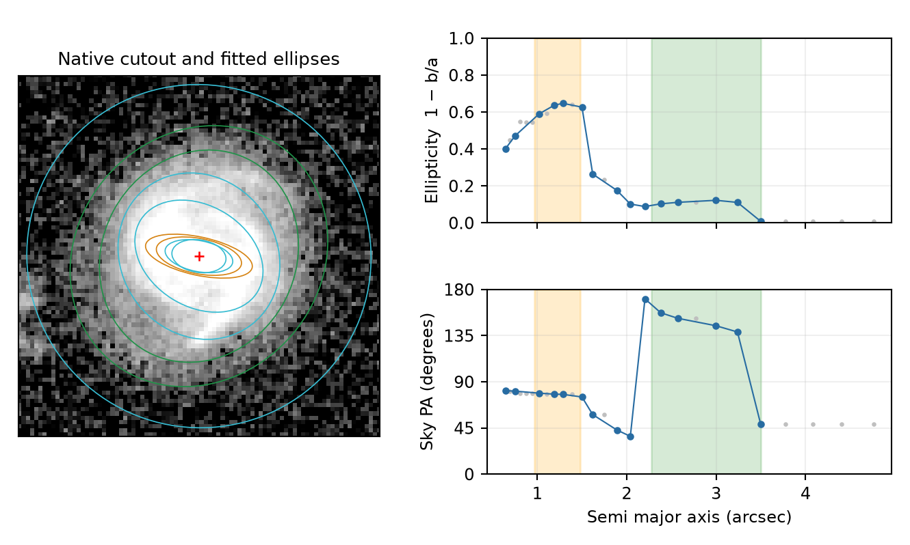
Illustrative QI case −515488559271594427. The outer PA changes markedly across the selected green disc interval. Orange indicates the selected bar interval. A returned mean angle or close Euclid agreement cannot establish stable outer-disc geometry in this case.
Review group | Recommended action
431 interval-selection failures | Inspect profiles and choose defensible bar and disc ranges where the image supports them.
138 short reliable profiles and one centre failure | Inspect signal, masks, catalogue centre and neighbouring light before choosing a recovery method.
Flagged fits and partial cutouts | Review the specific warnings. Keep a usable disc measurement separate from an uncertain bar measurement.
527 NoQI reports | Check the physical component identification before adopting geometry.

Record reviewed centres, masks, radial ranges and accepted values in an adopted-geometry table before generating final deprojected, bar-aligned images. Preserve failed measurements and the reasons for exclusion. A geometry flag is a reason for review rather than an automatic rejection of every quantity.

Finding individual galaxies
Reports are under Euclid/MER_VIS_galaxy_reports/all_2777 in the research data folder. The png_QI and pdf_QI folders contain quality-issue reports, and png_NoQI and pdf_NoQI contain the other reports. MER_VIS_report_review_index.csv identifies each galaxy’s PNG, PDF batch, page and position. The associated metadata retains the exact original flag strings and full-precision values.
Sources: MER_VIS_local_geometry_manifest.csv; MER_VIS_report_summary.json; MER_VIS_report_verification.json; MER_VIS_report_review_index.csv; the completed PA comparison summaries; and the revised Euclid MER VIS galaxy geometry fitting report. Counts and comparisons refer to the completed October 2026 local run.

