Project Specification
Spec-Driven Development Template for Claude

💡 HOW TO USE THIS TEMPLATE Fill in every section below. Be as specific as possible — Claude anchors on what you write.
Insert annotated screenshots directly into the placeholder boxes.
Leave no field blank: write "N/A" or "TBD [reason]" if something is unknown.
When submitting to Claude, paste the whole doc or export as PDF and attach it to the chat.

SECTION 1 — PROJECT OVERVIEW

Project Name | ADACS Team Resource Allocation Tool
Author / Owner | Gregory B. Poole
Date | March 12, 2026
Version | V0.1
Tech Stack | Start the project with the ADACS Django Template which creates a new project with the following tech stack:  Backend  - Python 3.12 with Django 5.2 as the core framework  - Gunicorn as the WSGI application server  - MySQL 8.4 as the database (via mysqlclient)  - Poetry for dependency management  Django Packages  - django-allauth + fido2 for authentication (email/username login with passkey/WebAuthn support), or optionally ADACS SSO for single sign-on  - django-axes for brute-force login protection  - django-recaptcha for bot protection  - django-post-office for email handling  - django-crispy-forms for form rendering  - django-compressor for static asset compression  - django-health-check for service health endpoints  - Optionally: Django REST Framework + django-cors-headers + drf-spectacular (for OpenAPI docs) if API endpoints are needed  Frontend  - Tailwind CSS v4 for utility-first styling  - DaisyUI v5 for component themes (30+ themes to pick from at project creation)  - Optionally: HTMX for dynamic HTML interactions without a JS framework  Infrastructure  - Docker Compose with four services: django, nginx, mysql, and a cron container for mail processing  - Nginx for serving static files and proxying to Gunicorn  Dev Tooling  - ruff, black, flake8 for linting/formatting  - pytest, factory-boy, playwright + adacs-django-playwright for testing  - django-debug-toolbar, nplusone, django-migration-linter for development helpers  - djlint for Django template linting  - GitLab CI configuration included out of the box
Target Platform | Web & Mobile (both iOS and Android)
Deployment | Locally and on a Ubuntu VM on an OpenStack Cloud service

1.1 One-Line Summary
Manage the allocation of the time of a group of software professionals (developers and designers; group of-order 20-50 people) against roughly 20-50 projects on a semesterly basis (2 semesters per year: A semester from Jan 1 to June 30; B semester from July 1 to Dec 31).

1.2 Problem Statement
Making sure that all projects receive the time they have been allocated and all developers have a plan for their time over the next 6 months to a year. Ultimately, actual usage of developer time will be entered by them (on a weekly basis) against projects and tracked, but not in this version.

SECTION 2 — GOALS & SUCCESS CRITERIA

2.1 Goals (what success looks like)
List 3–5 concrete, measurable outcomes. Avoid vague goals like "improve UX."
- Improved timely completion of projects
- Everyone maintains a clear picture of what everyone is doing this semester

2.2 Non-Goals (explicit out-of-scope)
List things Claude should NOT build or address. This prevents scope creep.
- Internationalisation is out of scope for v1
- Developer time logging is out of scope for v1

SECTION 3 — USERS & CONTEXT

3.1 Who are the users?
Primary User | Program manager, technical, clear picture of how the group’s time is allocated across the semester and when projects will be delivered
Secondary Users | Developers, technical, clear picture of what they are working on and when for the semester
User Volume | 50 users accessing on a weekly basis
Access Control | Admin/Program Manager (PM)/Developer (Dev)/Observer

3.2 Key User Journeys
Describe the 2–3 most important flows a user will take through the product.
Journey 1: [Name] — e.g. "New user onboarding"
- Step 1: User arrives at…
- Step 2: User selects…
- Step 3: System responds by…

Journey 1: [Add Single Project]
- Step 1: PM arrives at the project page
- Step 2: PM clicks a “+” button to add a project
- Step 3: System responds by showing a pop-up querying for the information needed to specify the new project
- Step 4: User clicks a button to add the user or a different button to cancel submission.
- Step 5: System returns to the project page with any new projects added to the table
Journey 2: [Add Multiple Projects]
- Step 1: PM arrives at the project page
- Step 2: PM clicks a “Upload TSV” button to upload a list of projects
- Step 3: System responds by showing a pop-up querying whether the user wants to download a template TSV file or upload a file with new projects in it
- Step 4: If download a template is selected, the example TSV is downloaded and the popup remains open.
- Step 5: If upload is selected, then the system queries for a filename, uploads the file, validates its contents (checking that no duplicates are being introduced, columns are all present and formatted correctly, etc.), creates the new projects if file is ok, and reports a clear error with instructions to fix the problem is an error is encountered
- Step 6: System returns to the project page with any new projects added to the table
Journey 3: [Add Single Developer]
- Step 1: PM arrives at the developers page
- Step 2: PM clicks a “+” button to add a developer
- Step 3: System responds by showing a pop-up querying for the information needed to specify the new developer
- Step 4: User clicks a button to add the user or a different button to cancel submission.
- Step 5: System returns to the project page with any new projects added to the table
Journey 4: [Add Multiple Developers]
- Step 1: PM arrives at the developers page
- Step 2: PM clicks a “Upload TSV” button to upload a list of developers
- Step 3: System responds by showing a pop-up querying whether the user wants to download a template TSV file or upload a file with new developers in it
- Step 4: If download a template is selected, the example TSV is downloaded and the popup remains open.
- Step 5: If upload is selected, then the system queries for a filename, uploads the file, validates its contents (checking that no duplicates are being introduced, columns are all present and formatted correctly, etc.), creates the new developers if file is ok, and reports a clear error with instructions to fix the problem is an error is encountered
- Step 6: System returns to the developers page with any new projects added to the table
Journey 5: [Add project phase] — e.g. "New user onboarding"
- Step 1: PM arrives at the Planning page
- Step 2: User drags across the timeline for a specific developer (scrolling if needed)
- Step 3: System responds with a popup with the selected date range and corresponding weeks of allocation shown. This range is editable. The popup allows the selection of a project to allocate the phase against. The project defaults to the last project a phase was allocated to.
- Step 4: The user can either cancel the creation of the phase or click a button to create it.
- Step 5: The system responds by returning to the planning page with any new phases added.

SECTION 4 — FUNCTIONAL REQUIREMENTS

📌 REQUIREMENT FORMAT Number each requirement (e.g. FR-01). Use "MUST", "SHOULD", or "MAY" to indicate priority.
MUST = required for launch | SHOULD = strongly desired | MAY = nice-to-have

4.1 Core Features
FR-01 | [MUST] — Users MUST be able to log in with email and password
FR-02 | [MUST] —There must be the following roles: Admin, Project Manager (i.e. PM), Developer (i.e. dev) and Observer. Each must be associated with a unique and immutable ID, name, email address, organisation and (optionally) an emoji. IDs only ever need to be visible for Admins.
FR-03 | [MUST] – Each developer will have the following additional user information associated with them: tags, colour. For tags, multiple values are allowed and they should be selectable from a list of currently used tags with the option to add a new value. Colours are assigned from a selectable list with defaults cycled to promote differentiation. Developer tags and colours can only be edited by an Admin or PM.
FR-04 | [MUST] – There must be a page where a user can edit their information (e.g. name, email address, emoji).
FR-05 | [MUST] — Throughout the whole application, when discussing and computing intervals of time (either as effort completed by or available from a developer or time allocated to a project), a week is considered 5 work days. One weekday counts for 0.2 weeks and one weekend day counts for 0 weeks.
FR-06 | [MUST] — There must be the concept of a “Semester”. This application will organise work on a semesterly basis. There are 2 semesters per year: the “A” semester from Jan 1 to June 30 and the “B” semester from July 1 to Dec 31. Semesters must be named with a five character code with the format YYYYS, where YYYY is the year and S is “A” or “B”, for the first or second semester of the year. Some application data will be fixed across semesters but some will vary, with different values for different semesters.
FR-07 | [MUST] — There must be the concept of a “Project”. Each project will have the following information associated with it: name, stream, tags, colour. Colours are assigned from a selectable list with defaults cycled to promote differentiation. For tags, multiple values are allowed and they should be selectable from a list of currently used tags with the option to add a new value. Stream provides a way to categorise projects and is a single value from a selectable list of strings with an option to add a new value. All projects are allocated resources in units of weeks of effort. The total number of weeks available for a given semester is the sum of two values: new weeks allocated for the semester and (occasionally) weeks carried over from last semester. There are two scenarios for allocations: most projects are allocated a fixed number of weeks for a small number (usually 1 and generally less than 5) of semesters (there may be gaps in this list with semesters that did not receive time); and 2) some are allocated resources indefinitely, with a per semester time allocation. Projects can change from one type to another (i.e. they can have fixed resources for a specified list of semesters, then indefinitely for a time, and then fixed for another number of semesters, then indefinite, etc.)
FR-08 | [MUST] — Projects may continue from one semester to a subsequent semester with a new name. There may be gaps where there are semesters with the project not receiving a new allocation. There must be a way for admins and PMs to modify project names for a given semester.
FR-09 | [MUST] — For each semester there will be a list of developers (each with a given amount of time available for the semester, in units of weeks) and projects for them to work on (each with a number of weeks of effort allocated to them for the semester, in units of weeks).
FR-10 | [MUST] — There must be a “Developers” page giving a table of developers with: Name, tags, “Effort Available [weeks]” and “Effort Allocated [weeks]”. Effort allocated is the sum of all phases associated with them for the displayed semester. If time allocated exceeds time available, it should be highlighted in an alerting way. This page is visible only to admins, PMs and developers. PMs (and only PMs) can edit developer information here, including effort available.
FR-11 | There must be an “Observers” page giving a table of observers. Each has the following information: Name, email, organisation and access. Access lists projects that the given observer is able to see information about, filtered either by project name or type (all projects is an option as well). Default access is none (or no project access). This page is visible only to admins or PMs.
FR-12 | [MUST] — There must be a “Projects” page giving a table of projects. Each has the following information: Name, type, tags. Also, each is assigned a selectable colour with defaults cycled to promote differentiation. For observers: only those projects they are authorised to view should be shown.
FR-13 | [MUST] — There must be the concept of a period of “Leave”. Each period of leave is associated with a specific developer and each developer may have zero or more periods of leave associated with them. A period of leave is specified for a specific developer by a start and end date (both specific to the day). Periods of leave can cross the boundaries of semesters. Periods of leave can be set by a developer (but only for periods specifying themselves) or a PM (for all developers).
FR-14 | [MUST] — There must be a “Leave” page. When developers visit this page, they can specify a list of date ranges (start and end dates, specified to the day) when they will be on leave and see a table of their pending (or past; filtered-out by default) leave intervals. They must only see their own leave and not be able to see the leave of other developers. When a PM visits this page, they see a list of pending (or past; filtered-out by default) leave intervals for the whole team (default date range is the next month, but that should be changeable). All other roles must not see and must not have access to this page.
FR-15 | [MUST] - There must be the concept of a “Phase”. This is an interval of time when a specific developer is working on a specific project, in a specific semester, for a specific range of dates (specified by a start and end date and bounded by the limits of the semester). Their effort may be fractional during this time, so a number between 0 and 1 (inclusive; default value is 1) must be associated with every phase. Each developer can have zero or more phases associated with them. An amount of effort must be associated with a phase as a number of weeks. When calculating this: periods of leave must be excluded, the rules for intervals described in FR-05 must be obeyed, and the result multiplied by the given fractional effort. This must be reactive to changes in leave, since they can be specified after a phase is instantiated. Only Admins or PMs can add/remove/edit phases.
FR-16 | [MUST] - There must be a “Planning” page giving a timeline (rendered at the resolution of weeks, not days) along the horizontal axis and developers listed vertically with one per row. The axis showing weeks should be sticky at the top and stay on the screen as the table is scrolled up or down. Scrolling horizontally should be possible with the ability to change the range of weeks being shown. The developers shown should be filterable based on tag. The row for each developer should shade-out periods of leave and show existing phases for each developer, colour coded by the colour of the project associated with the phase. PMs and Admins (only) are allowed to highlight ranges of weeks for a given developer. This highlighting should skip over periods of leave for the given developer. Fractional weeks at either end of these phase lines should be reflected by extending these lines a corresponding fraction of the way across. Hovering over a phase line should reveal the project name, effort represented by the phase and key information about the corresponding project. This page is visible only by Admins and PMs.
FR-17 | [MUST] - There must be a “Schedule” page giving a timeline (rendered at the resolution of weeks, not days) along the horizontal axis and projects listed vertically with one per row. All the same horizontal scrolling and date range setting functionality on the Planning page should be available on the schedule page. This page should show the range of weeks over which each project is planned to be worked on as well as the developers schedule to do that work and the amount of effort they will provide.
FR-18 | [SHOULD] — The system should clearly signal when the time available for a dev is inconsistent with the number of weeks in the semester and the amount of leave they are taking

4.2 Data & State
Input Data | TSV files with lists of developers & time available for the semester; TSV files with new projects and time allocated for the semester; indications of when developers will be working on projects (done with a GUI; this may not be all in one contiguous block; fractional weekly time allocations may be involved); devs should be able to input times when they will be on leave (there maybe multiple non-contiguous intervals for each dev)
Output Data | A table of devs; a table of projects; a table of observers (only viewable by admin and PM); a list of all projects with time running horizontally with an indication of when the project is being worked on
Persistent State | Lists of developers, observers and projects. Intervals of activity and leave for each developer. Use a DB for all of this.
External APIs | None

SECTION 5 — NON-FUNCTIONAL REQUIREMENTS

Performance | None
Security | None
Accessibility | None
Browser / OS Support | None
Error Handling | None
Scalability | None

SECTION 6 — UI & VISUAL REFERENCES

📸 SCREENSHOT TIPS Annotate screenshots with arrows, labels, or callouts before pasting.
Include: current UI, Figma mocks, competitor references, or hand-drawn sketches.
Add a caption under each image explaining what Claude should take from it.

6.1 Reference Screenshot 1
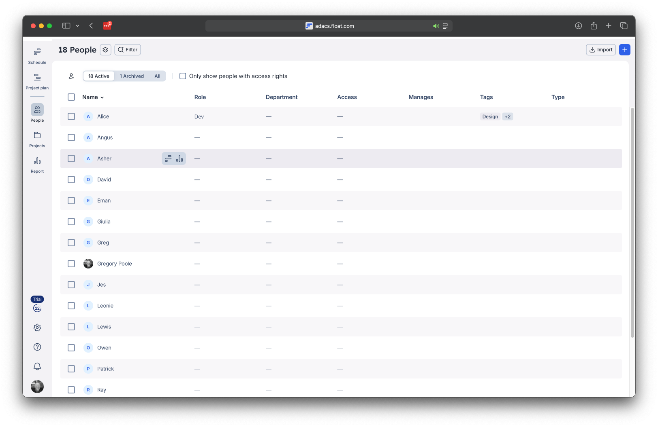
Caption: The developer page, with developers listed in a table, a menubar to select pages on the left, filtering options above the table and buttons to add new developers or import a TSV list on the top right

Key Takeaway | Match this layout for the app and this sort of table formatting for the developers page.
What to Ignore | Specific table headings will differ; Ignore the color scheme — we're using our brand palette

6.2 Reference Screenshot 2
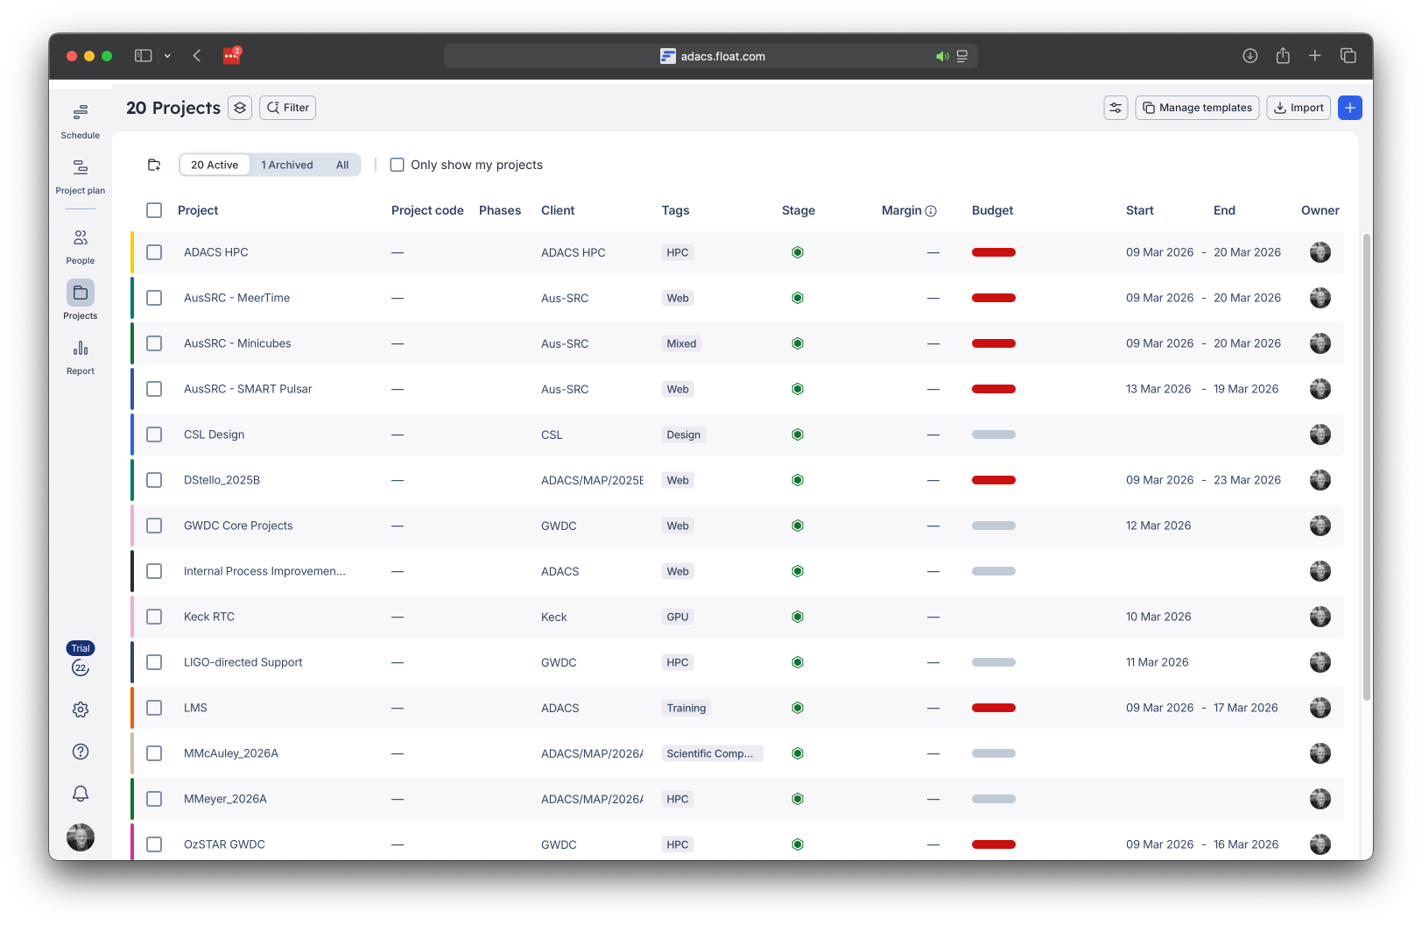
Caption: The projects page, with projects listed in a table, a menubar to select pages on the left, filtering options above the table and buttons to add new projects or import a TSV list on the top right

Key Takeaway | Match this layout for the app and this sort of table formatting for the projects page.
What to Ignore | Specific table headings will differ; Ignore the color scheme — we're using our brand palette

6.3 Reference Screenshot 3
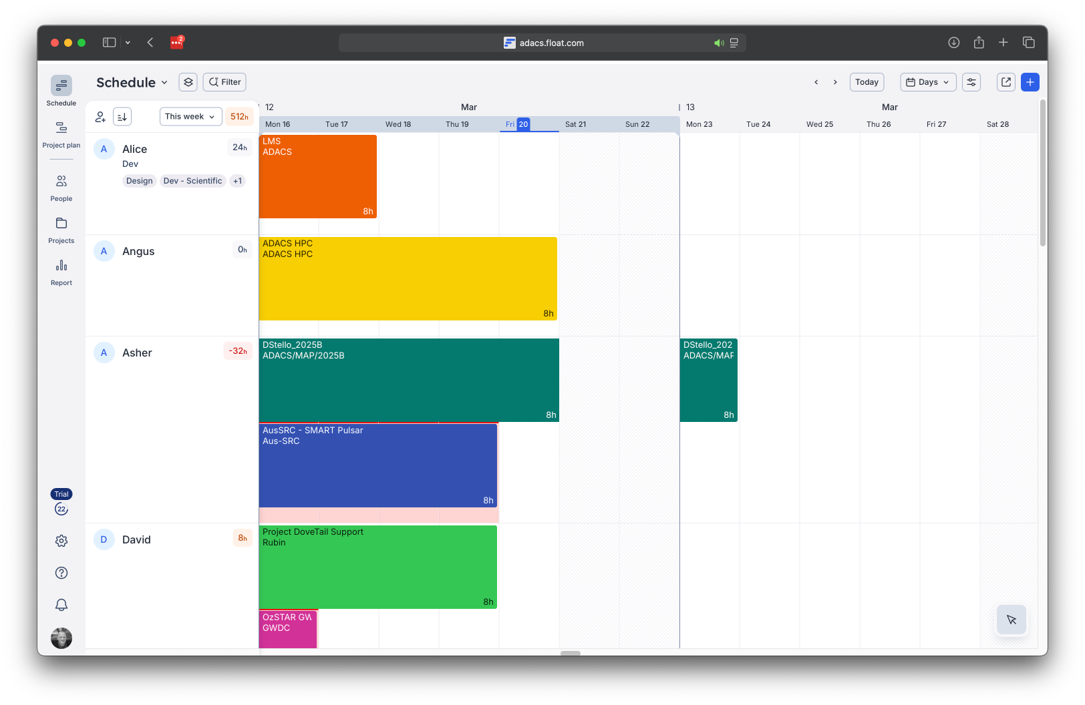
Caption: The planning page with phases shown for each developer

Key Takeaway | Phases are colour coded by their project’s colour. Project name,stream and weeks are shown in the phase. Periods of leave are shaded out the way weekends are shaded out here. Phases skip periods of leave (shown by the phase given here for the user “Asher”)
What to Ignore | We only need to show whole weeks horizontally, not days; Ignore the color scheme — we're using our brand palette

6.4 Reference Screenshot 4
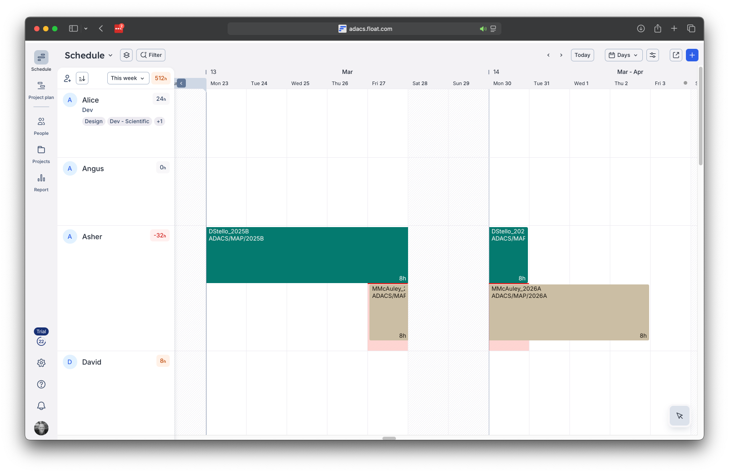
Caption: The planning page with two concurrent phases shown for one developer (“Asher”)

Key Takeaway | When there are concurrent phases for a developer, show them stacked on top of each other.
What to Ignore | We only need to show whole weeks horizontally, not days; Ignore the color scheme — we're using our brand palette

6.5 Reference Screenshot 5
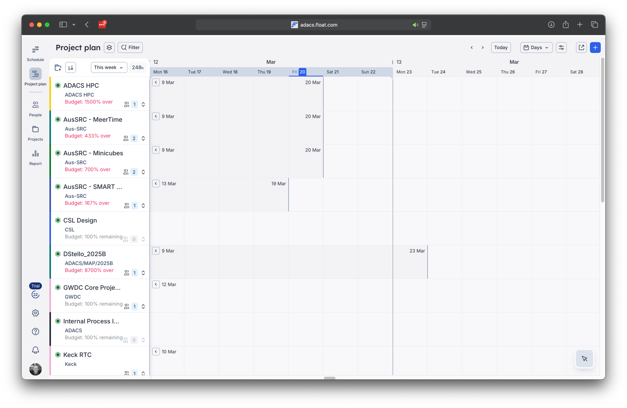
Caption: This is the schedule page showing the range of dates each project is being worked on

Key Takeaway | Show the range of dates each project is being worked on for and the percent of resources allocated for each project in the column on the left with the project names.
What to Ignore | We only need to show whole weeks horizontally, not days; Ignore the color scheme — we're using our brand palette

6.6 Reference Screenshot 6
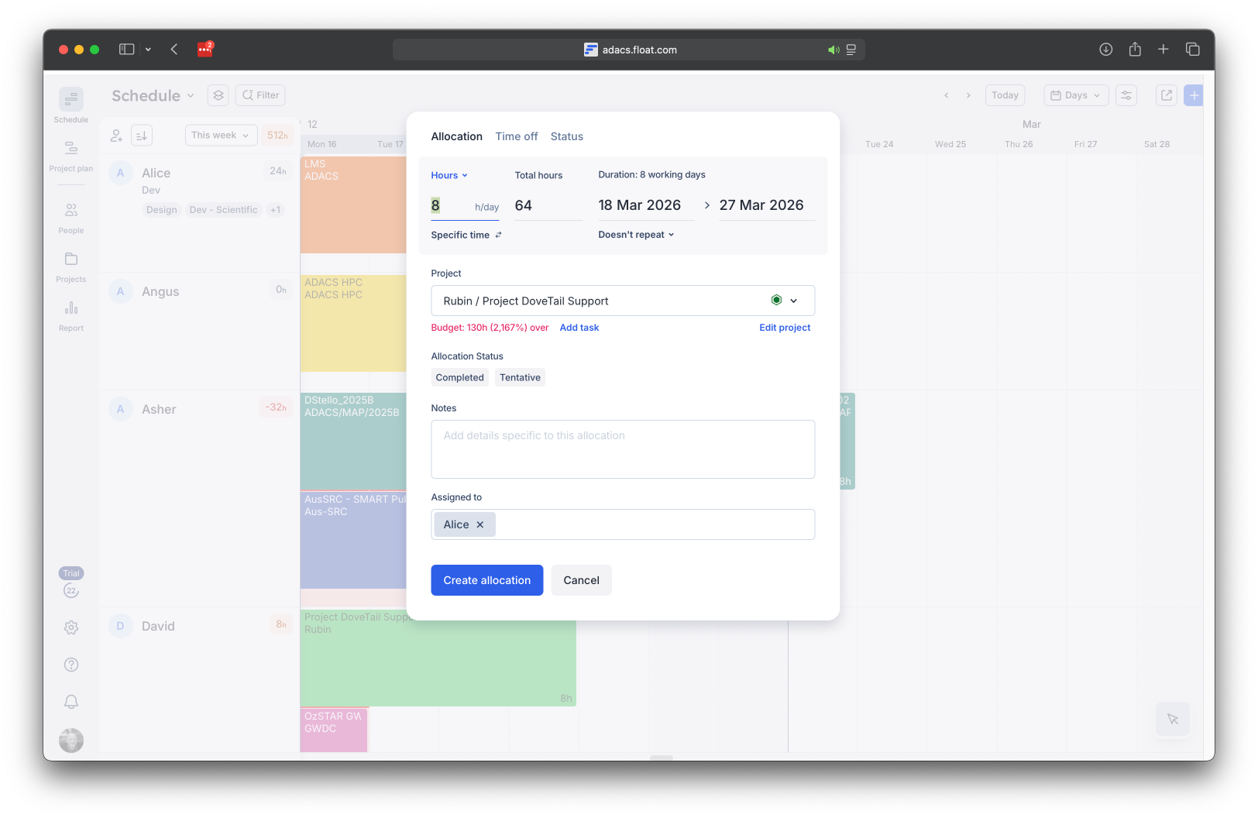
Caption: A pop-up to create a new phase after a range of dates are dragged over by the user

Key Takeaway | A pop-up should appear when a range of dates are selected for a phase on the planning page
What to Ignore | Ignore the color scheme — we're using our brand palette

6.3 Design Constraints
Design System | None
Brand Colors | Colour Design Specification  Brand Colours  Token Role Hex  color-brand-primary Logo mark, CTA buttons, active nav indicators, card accents #8B1A1A  color-brand-accent-teal Highlight: software / computing / data keywords #2A9D8F  color-brand-accent-amber Highlight: expertise / training / support keywords; logo "D" #C97D10  Neutral Colours  Token Role Hex  color-neutral-900 Primary body text, headings #1A1A1A  color-neutral-500 Secondary text, navigation links #666666  color-neutral-0 Page background, card backgrounds #FFFFFF  Semantic Colour Assignments  Navigation  - Link text: color-neutral-500  - Active link underline: color-brand-primary  Hero Heading  - Default text: color-neutral-900  - "software", "high-performance computing", "data": color-brand-accent-teal  - "expertise", "training", "support": color-brand-accent-amber  CTA Button  - Background: color-brand-primary  - Label text: color-neutral-0  Service Cards  - Background: color-neutral-0  - Body text: color-neutral-900  - Card label (e.g. "Expertise", "Training", "Support"): color-neutral-500  - Expertise card — heading & left border: color-brand-accent-amber  - Training card — heading & left border: color-brand-accent-amber  - Support card — heading & left border: color-brand-primary  Usage Rules  - color-brand-primary is reserved for interactive and brand-critical elements only (buttons, active states, logo). Do not use for decorative text.  - color-brand-accent-teal and color-brand-accent-amber are used exclusively for emphasis within typographic contexts. They should not be used for backgrounds.  - All text on white backgrounds must meet WCAG AA contrast minimum (4.5:1 for normal text, 3:1 for large text). Verify color-brand-accent-amber on color-neutral-0 — this pairing is at risk and should be checked before use at small sizes.  - Card border accents must match the card's heading colour.  - No additional colours should be introduced without updating this specification.
Typography | A system-friendly sans-serif stack similar to:  -apple-system, BlinkMacSystemFont, "Segoe UI", Roboto, Oxygen,  Ubuntu, Cantarell, "Open Sans", "Helvetica Neue", Arial, sans-serif
Component Library | Component Library Specification  Framework  Token Value  CSS Framework Tailwind CSS ^4.1.11  Component Library DaisyUI ^5.0.46  Theming  - DaisyUI theming is used for all colour, spacing, and component styling.  - The active theme is set via the data-theme attribute on the <html> element.  - The default theme is selected at project generation time and must be one of the DaisyUI built-in themes.  - All 32 DaisyUI themes are bundled at build time (see styles.css). If bundle size is a concern, this list should be pruned to only the themes required.  Usage Rules  - All UI components must be built using DaisyUI component classes before any custom CSS is considered.  - Custom CSS is only permitted where DaisyUI does not provide a suitable component or modifier.  - Tailwind utility classes may be used to supplement DaisyUI components but must not be used to re-implement components that DaisyUI already provides.  - The colour design specification tokens (e.g. color-brand-primary) must be mapped to DaisyUI CSS custom properties (e.g. --color-primary) in the theme configuration rather than applied as inline Tailwind utilities.
Dark Mode | Not required

SECTION 7 — EDGE CASES & CONSTRAINTS

7.1 Known Edge Cases
- When selecting date ranges to allocate developers to projects, periods of leave must be taken into account (this includes but may not be limited to: those periods must not be counted in time allocated; they must be skipped-over by the selection tool)
- If users edit the same record simultaneously, prefer inputs of PMs over devs

7.2 Hard Constraints
Constraint 1 | No external dependencies beyond what's specified in this document

SECTION 8 — OPEN QUESTIONS & DECISIONS NEEDED

Q1 | n/a

SECTION 9 — INSTRUCTIONS FOR CLAUDE

🤖 HOW CLAUDE SHOULD USE THIS SPEC Implement ONLY what is described here. Do not add unrequested features.
Ask before deviating from any requirement — do not assume.
After implementing, list which requirements were addressed and which remain.
Flag any spec ambiguities before writing code.

9.1 Where to Start
First Milestone | Implement FR-01 to FR-12 and create a test database with 13 developers, 27 projects and 2 observers.
Defer Until Later | Other requirements to be developed incrementally afterwards. None to be deferred until later.
Testing Approach | Write unit tests for all business logic; integration tests for API routes.

9.2 Definition of Done
- All MUST requirements implemented and manually verified
- All edge cases in Section 7.1 handled
- No console errors in browser
- Tests passing

End of Specification Template — Version 1.0

