STEPS TO OPEN AND RUN THE PROGRAM with Database

1. Find folder in which the THON project is located

2. Open THON folder, and then open ".netbeans-derby" folder

3. Copy files from this “.neatbeans-derby” folder (this is the THON database with user credentials)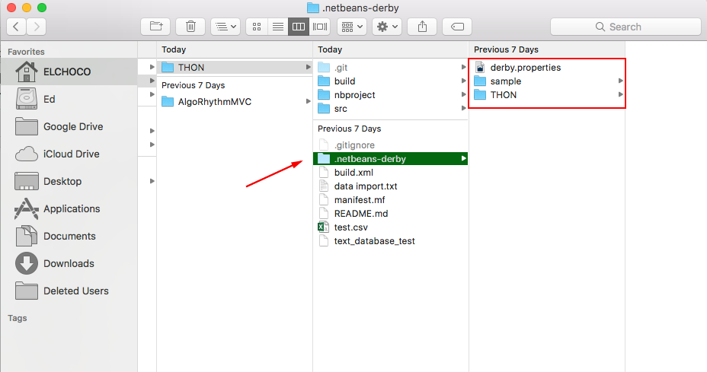4. Search in your User folder for ".netbeans-derby" folder and paste files you copied from previous step — aka ".netbeans-derby" files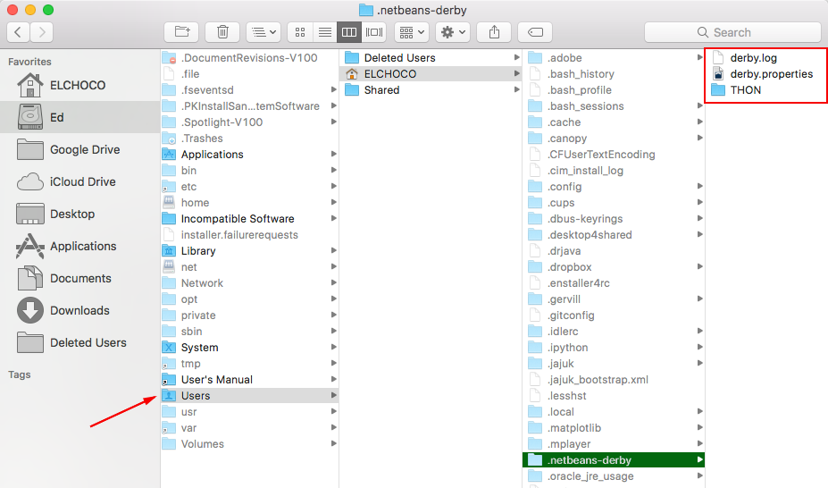

Now that the database is locally in your system. It is time to set up the local database with Netbeans:

6. Open Netbeans

7. On Netbeans top menu, go to Window > Services (which will open the Services tab, next to your Projects tab, typically on the left

8. Click on Databases and then right-click on Java DB to go to Properties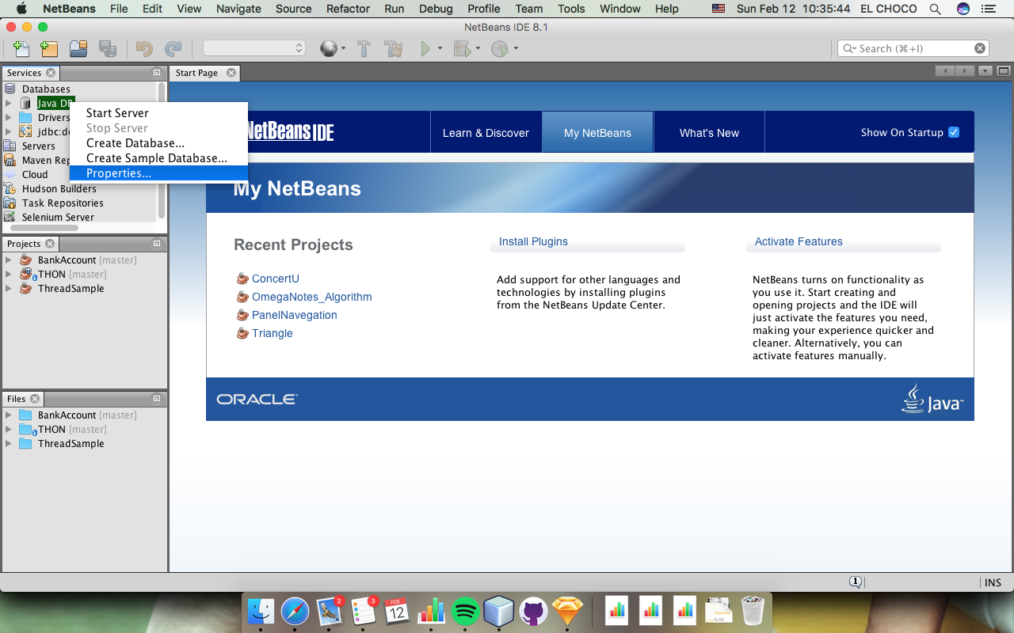

9. You will "Database Location" underneath "Java DB Installation". Make sure that the "Database Location" is YOUR system's ".netbeans-derby" folder.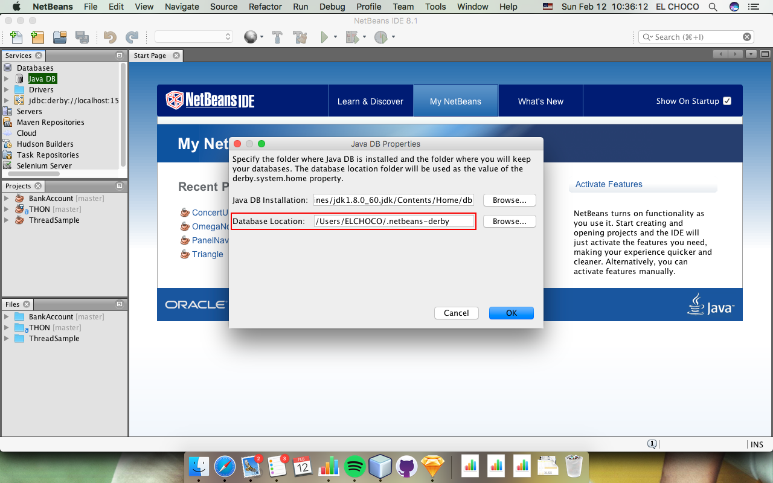

10. ALSO, make sure "Java DB Installation" is located in YOUR system's Java folder. The path should end with "db"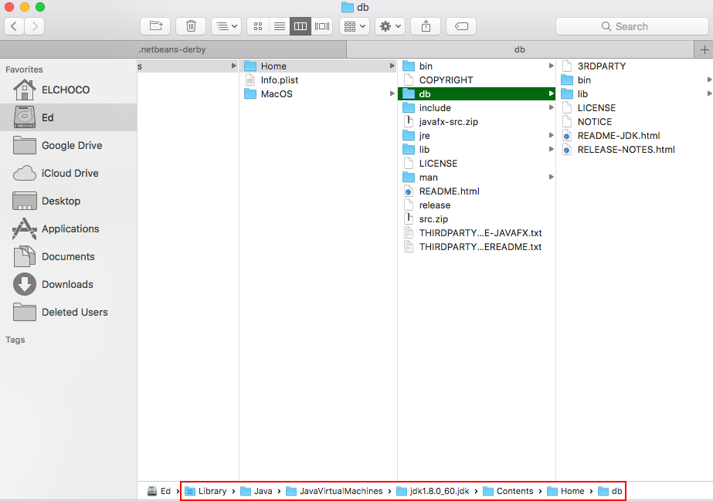

11. Press OK to close in step #9

Now, it is time to start the server and then run the program with the database:

12. Right-click on Java DB and click "Start Server".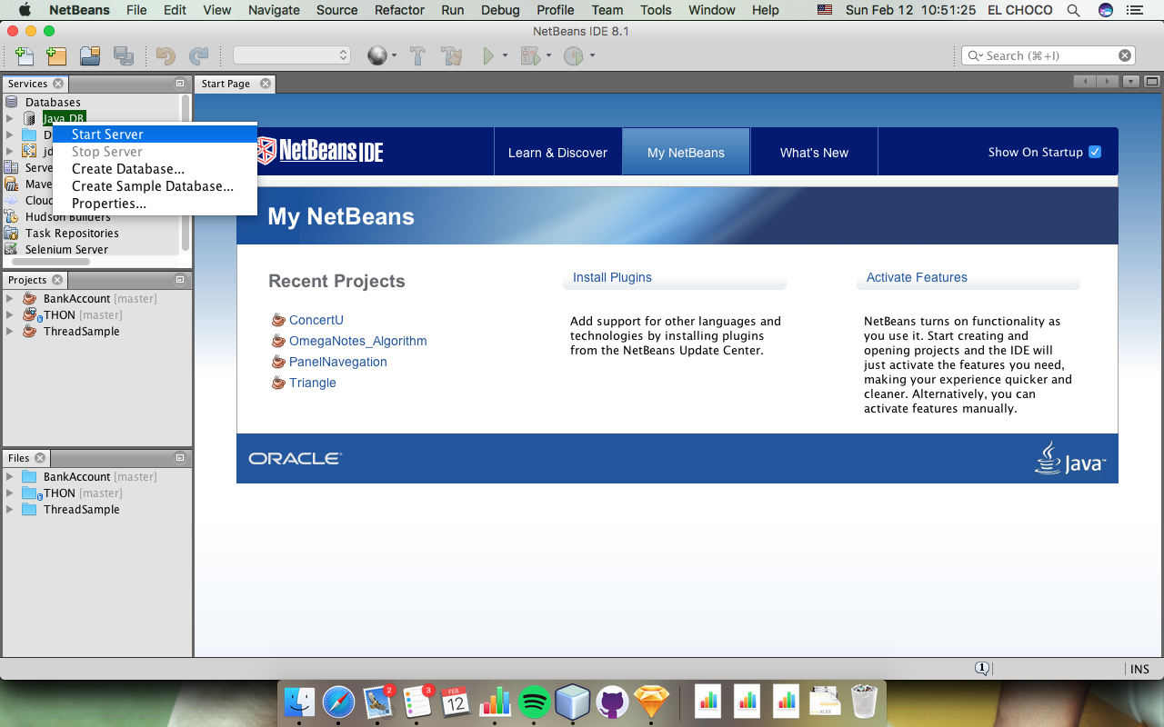

13. Right Click on THON and click "Connect".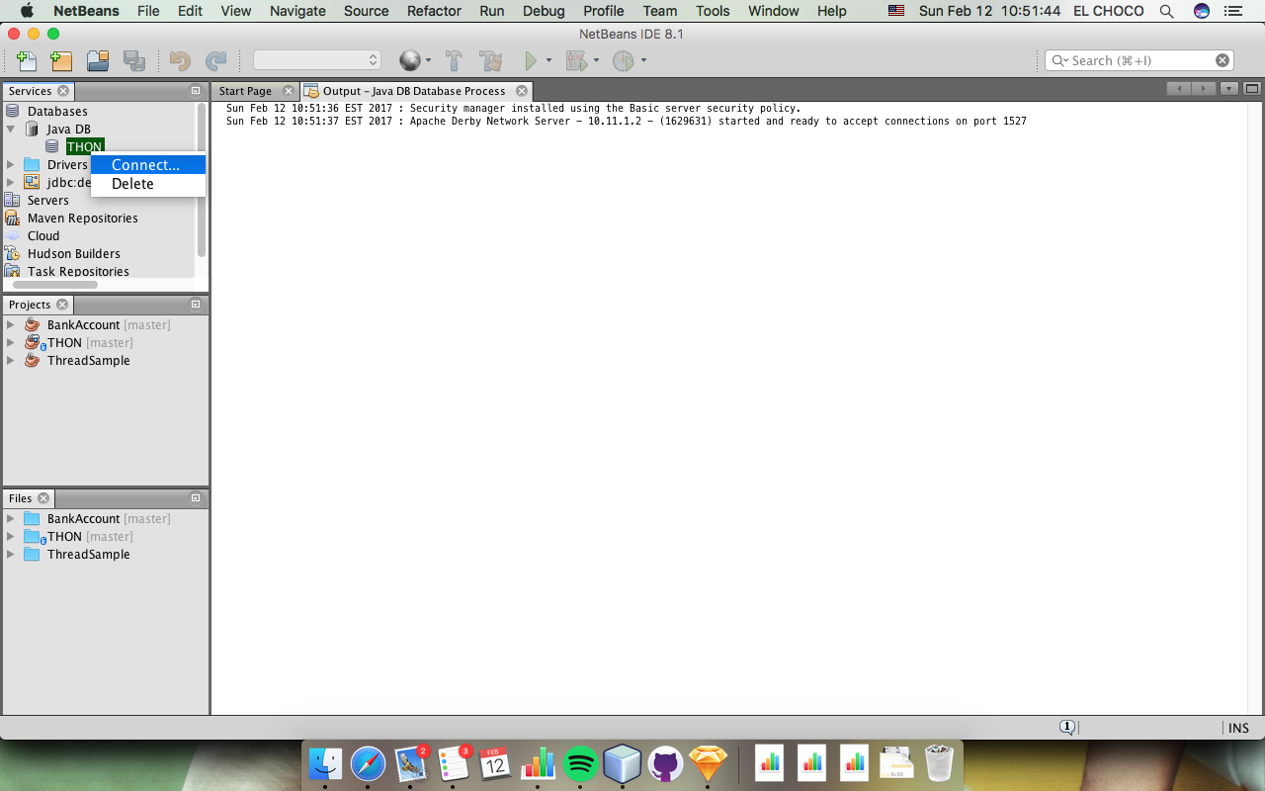

14. The prompt will ask you for the THON database's username and password ("thon" and "123" - don't put those quotes). Enter those credentials.

With this, you should be able to run the server with an output similar to this