STEPS TO OPEN AND RUN THE PROGRAM with Database

**(Figure 1)**

1. Find folder in which the THON project is located

2. Open THON folder

**(Figure 1)**

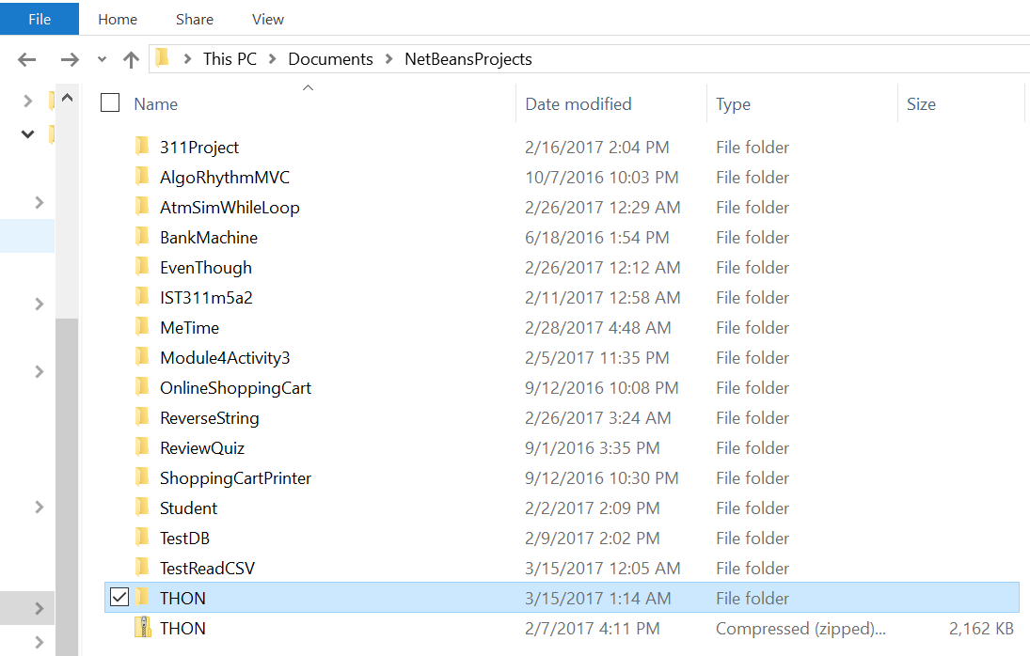

**(Figure 2, 3)**

3. Open ".netbeans-derby" folder

4. Copy files from this “.netbeans-derby” folder (this is the THON database with user credentials)

**(Figure 2)**

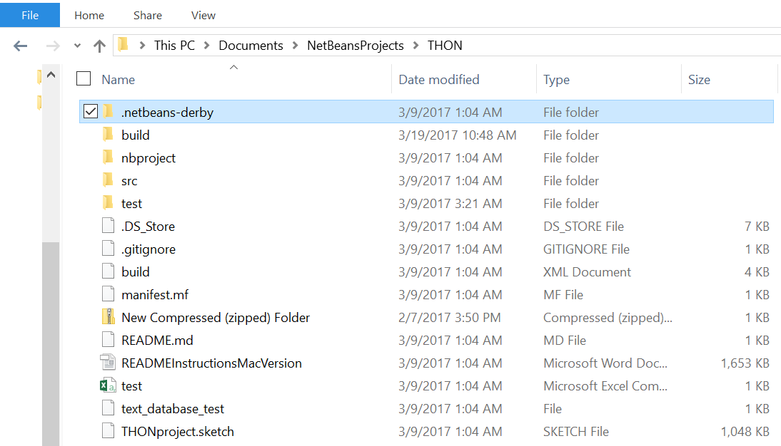

**(Figure 3)**

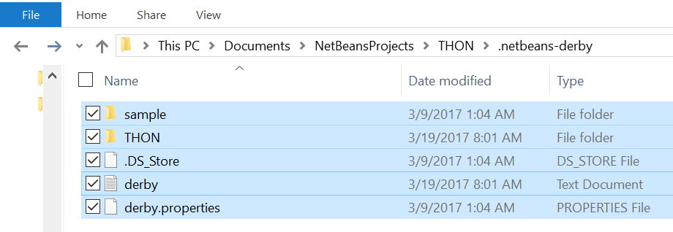

**(Figure 4, 5)**

5. Search in your User folder for ".netbeans-derby" folder and paste files you copied from previous step (".netbeans-derby" files from the THON folder) into your User’s “.netbeans-derby” folder.

**(Figure 4)**

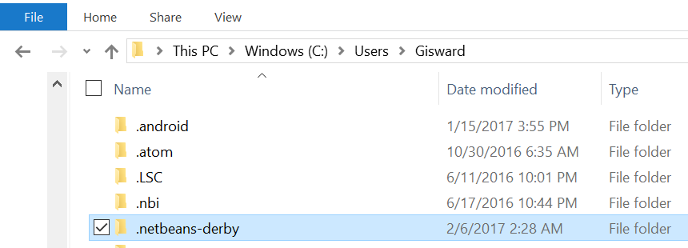

**(Figure 5)**

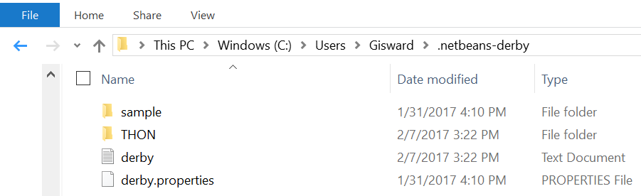

Now that the database is locally in your system. It is time to set up the local database with Netbeans:

**(Figure 6)**

6. Open Netbeans

7. On Netbeans top menu, go to Window > Services (which will open the Services tab, next to your Projects tab, typically on the left

8. Click on Databases and then right-click on Java DB to go to Properties

**(Figure 6)**

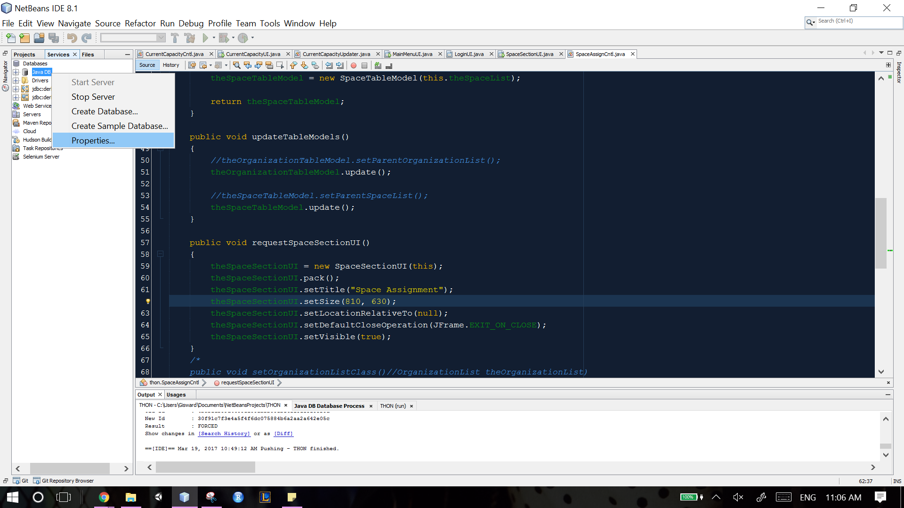

**(Figure 7)**

9. You will "Database Location" underneath "Java DB Installation". Make sure that the "Database Location" is YOUR system's ".netbeans-derby" folder.

**(Figure 7)**

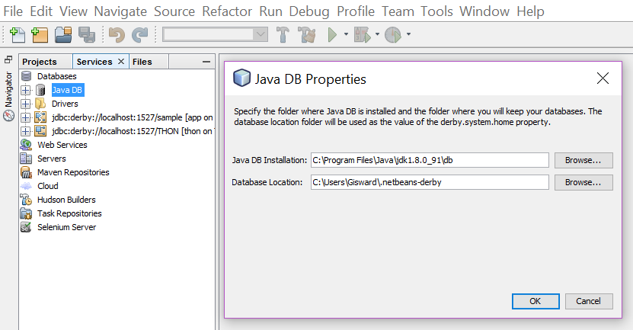

10. Press OK to close.

Now, it is time to start the server and then run the program with the database:

**(Figure 8, 9)**

11. Right-click on Java DB and click "Start Server".

**(Figure 8)**

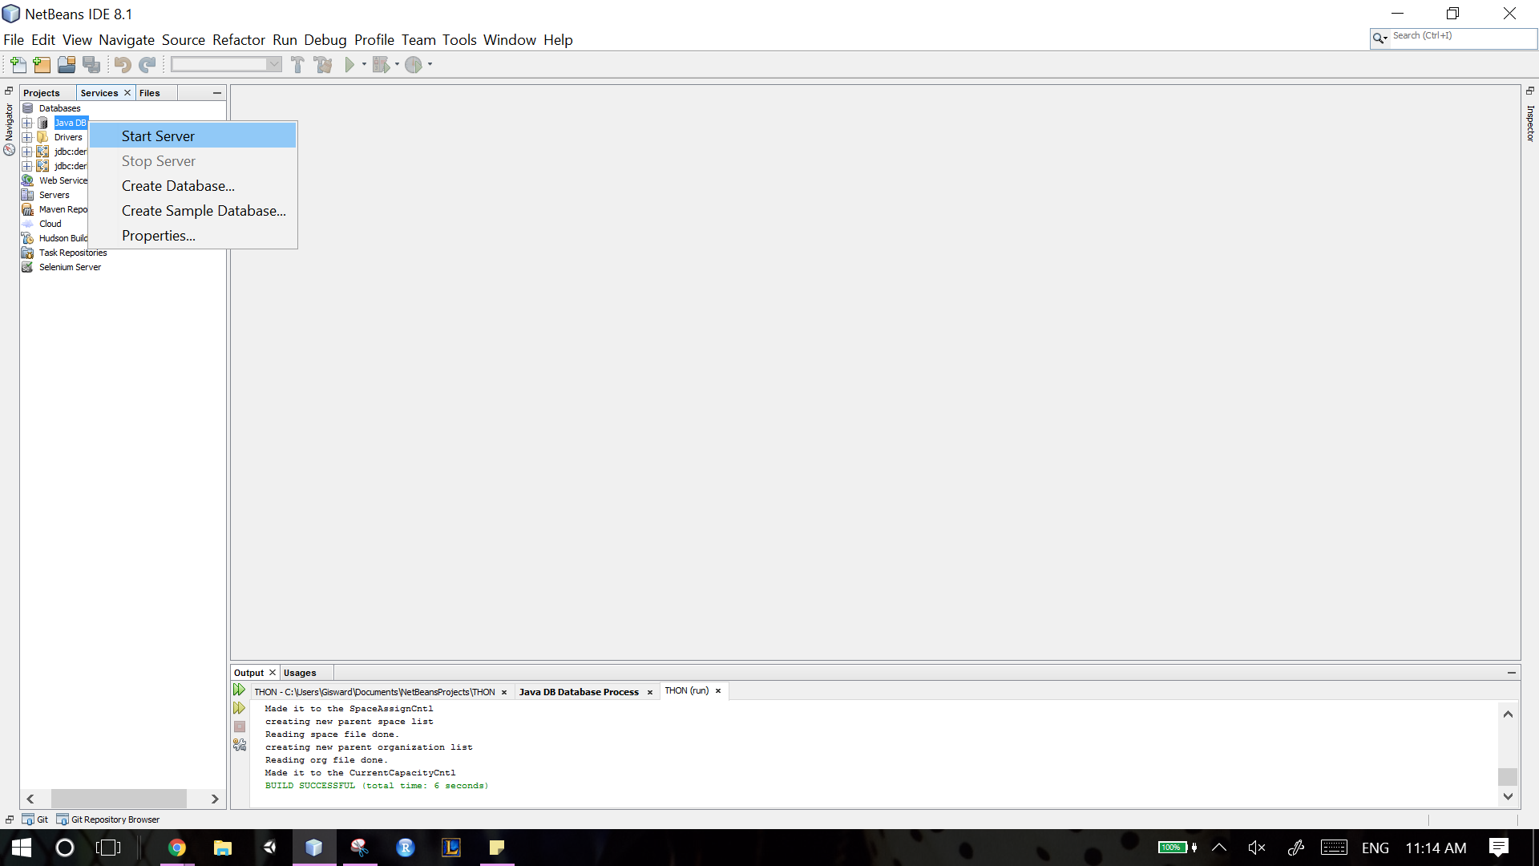

**(Figure 9)**

12. Right Click on THON and click "Connect".

**(Figure 9)**

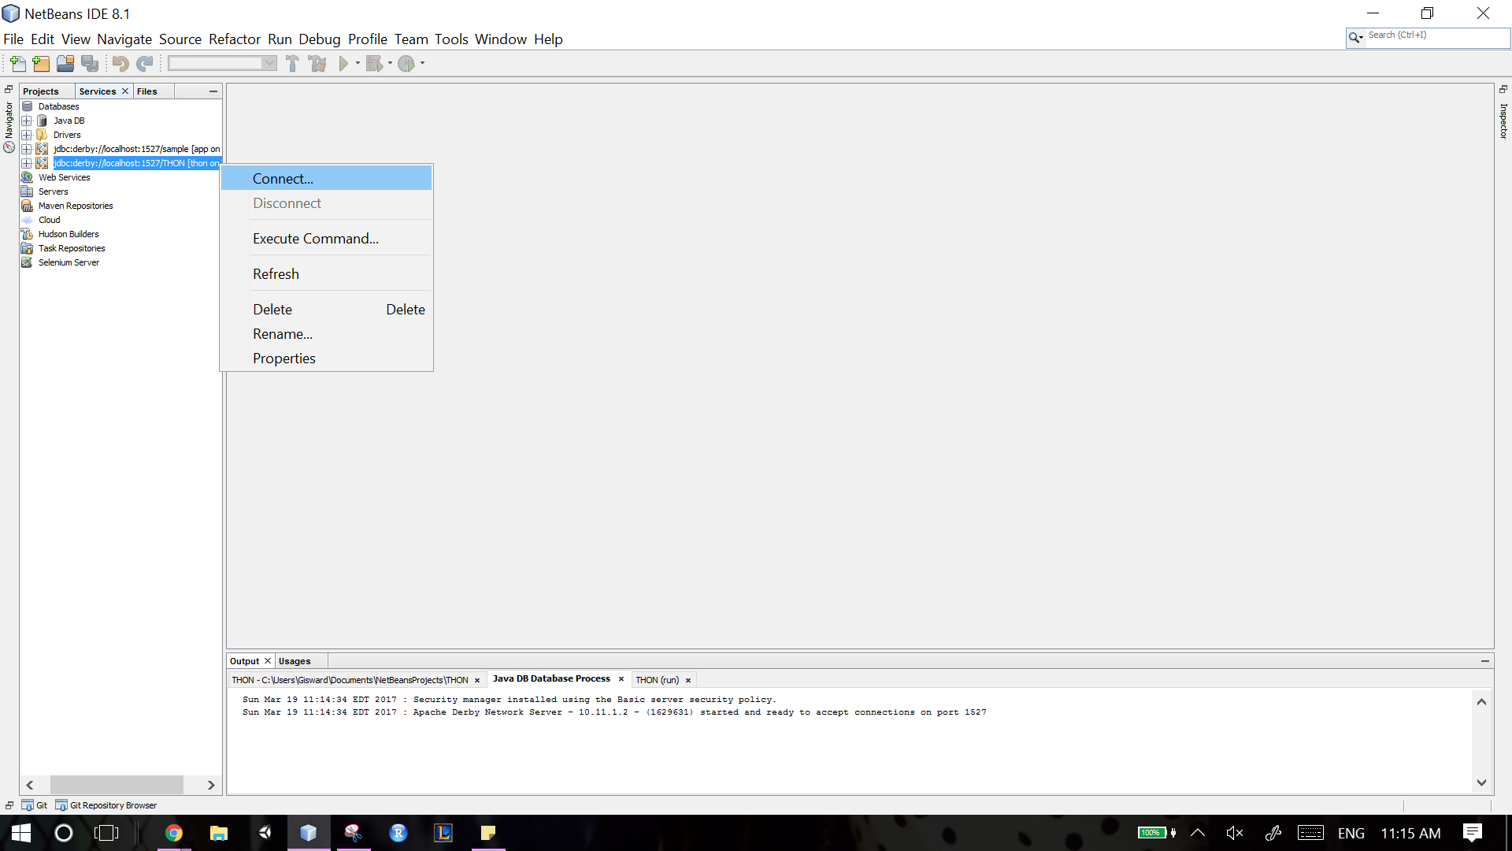

**(Figure 10)**

13. Run the Project by switching to the Projects Tab and Clicking on the “THON” project

**(Figure 10)**

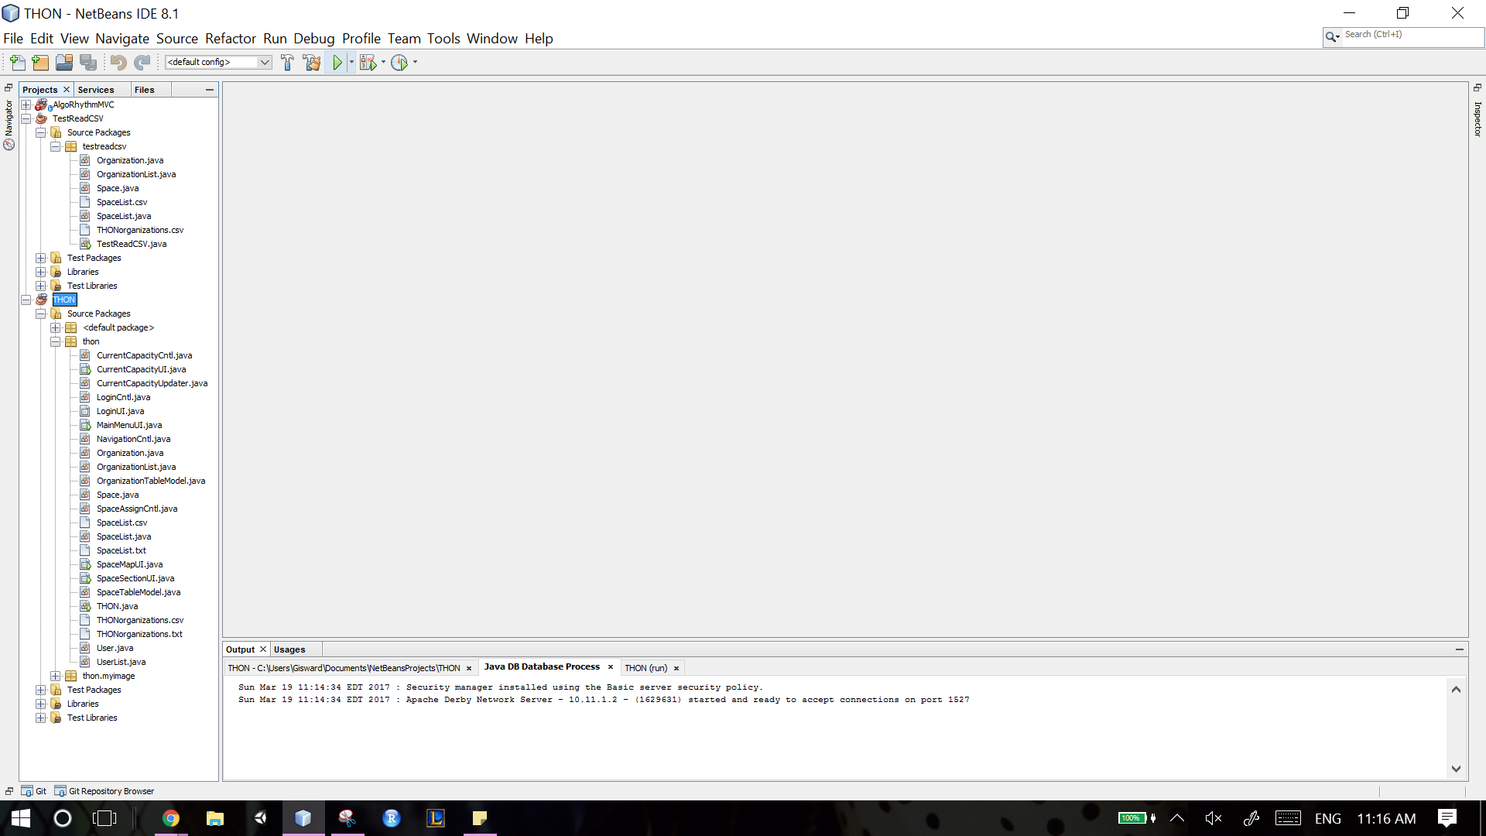

**(Figure 11)**

14. The prompt will ask you for the THON database's username and password ("thon" and "123" - don't put those quotes). Enter those credentials printed out in their Output window.

With this, you should be able to run the server with an output similar to this

**(Figure 11)**

