# Nucleo configuration

* Nucleo F446RE
* X-NUCLEO-IDW01M1: WIFI Serial communication

# Wiring

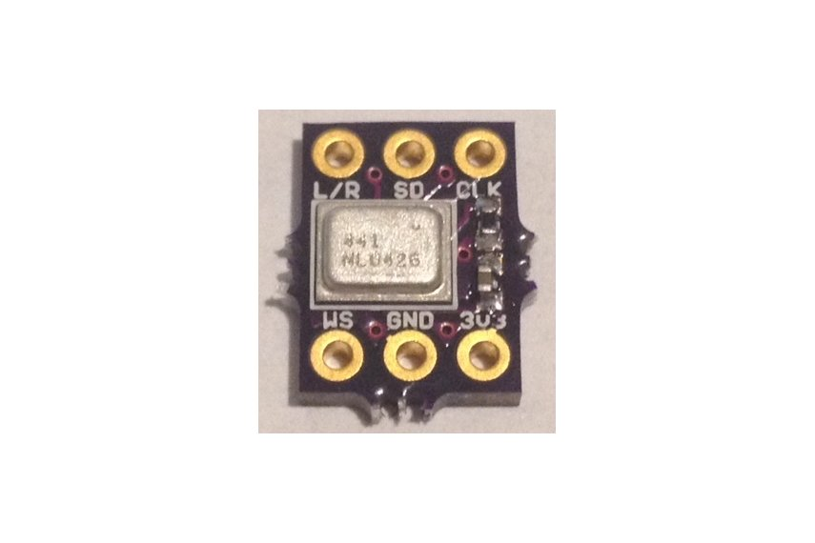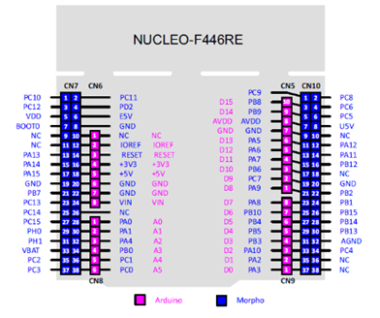

|  |  |  |  |  |  |  |
| --- | --- | --- | --- | --- | --- | --- |
| I2S | Mic Wire | Signal | 446RE | I2S1 446RE | Arduino | Morpho |
| 3v3=VDD | brown | Power |  |  | CN6-4 | CN7-16 |
| L/R | red | Left or Right | L=GND | R=VDD |  |  |
| GND | orange | Ground |  |  | CN6-6  CN6-7 | CN7-20  CN7-22 |
| SD | yellow | Data | PC1  ~~PC3~~ | I2S2_SD | CN8-5 | CN7-36  ~~CN7-37~~ |
| CLK | green | Clock | PB10 | I2S2_CK | CN9-7 | CN10-25 |
| WS | blue | Chip select | PB12 | I2S2_WS |  | CN10-16 |

# ICS-43432 stereo wiring

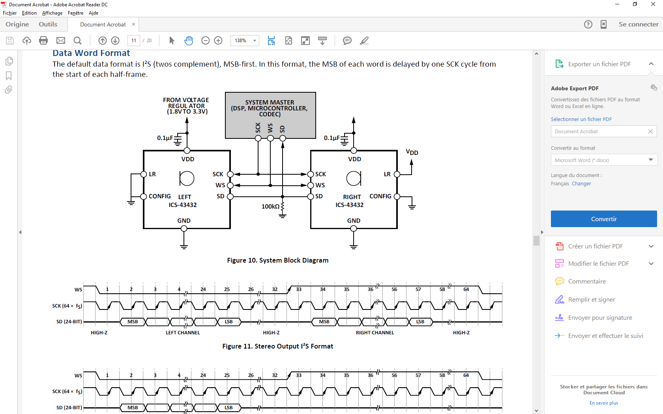

Be careful the upper bit is clocked Hi-Z.



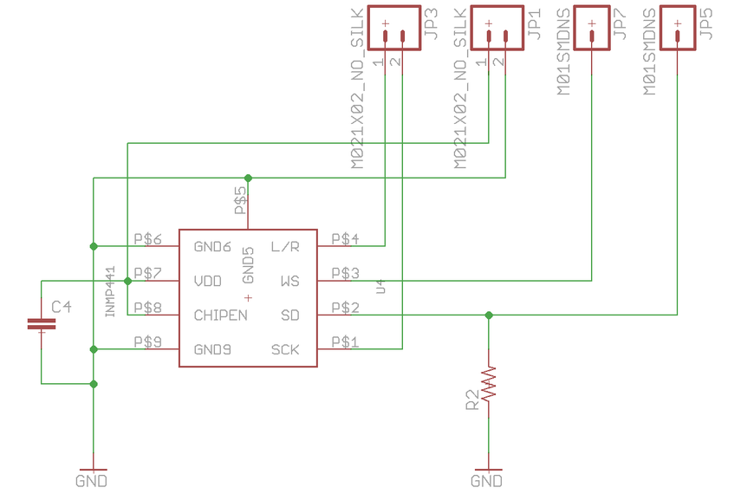



|  |  |  |  |  |  |  |
| --- | --- | --- | --- | --- | --- | --- |
| I2S | Mic Wire | Signal | 446RE | I2S1 446RE | Arduino | Morpho |
| 3v3=VDD | brown | Power |  |  | CN6-4 | CN7-16 |
| L/R | red | Left or Right | L=GND | R=VDD |  |  |
| GND | orange | Ground |  |  | CN6-6  CN6-7 | CN7-20  CN7-22 |
| SD | yellow | Data | PC1  PC3 | I2S2_SD | CN8-5 | CN7-36  CN7-37 |
| CLK | green | Clock | PB10 | I2S2_CK | CN9-7 | CN10-25 |
| WS | blue | Chip select | PB12 | I2S2_WS |  | CN10-16 |

WIFI NUCLEO

