#### BBQ Reservation

#### MVP Document for the BBQ Telegram Bot

TEAM 2

Abdoulie Kassama

Danil Afanasev

Konstantin Britikov

Talgat Khairov

**Introduction**

The Minimum Viable Product (MVP) addresses the requirements detailed in the use cases. It enables the use case partners and other interested third parties to start integrating the functionalities. It also serves as a common ground to reach agreement on the implementation of the requirements left for the final version. The MVP can be accessed through the following link: [Github](https://github.com/gbrigens/BBQReserver/).

The BBQ Reservation application is meant to be a replacement for the current system which is just a google form that allows anyone to make any change to the spread sheet. It requires you to check for the times and other details to avoid conflicts. This new application is meant to make to booking much easier and organized using a telegram bot. User would be able to book, edit or check for slots through the telegram bot. The bot does all the checking and validation on the spreadsheet and sends the user responses.

**Application Screenshots**

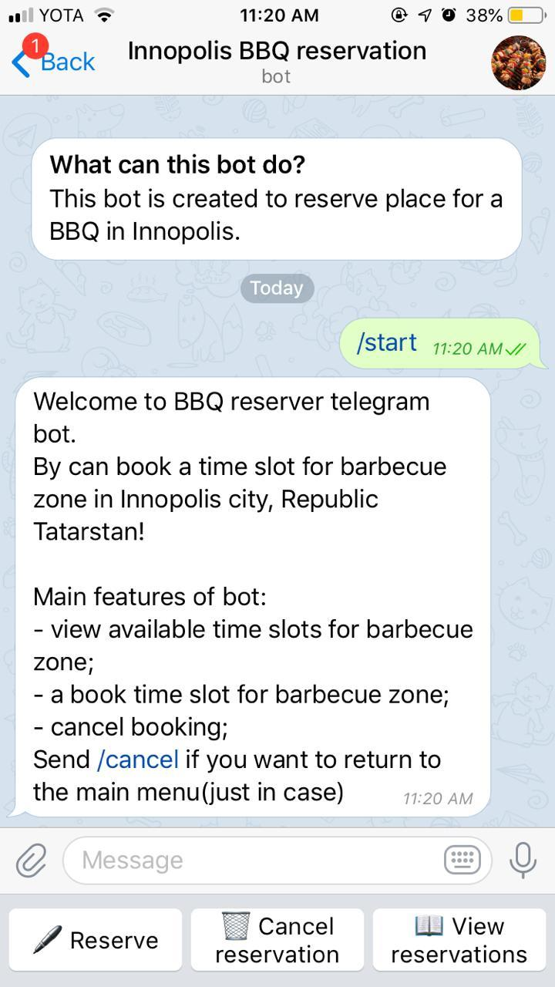

Figure 1: Reservation page

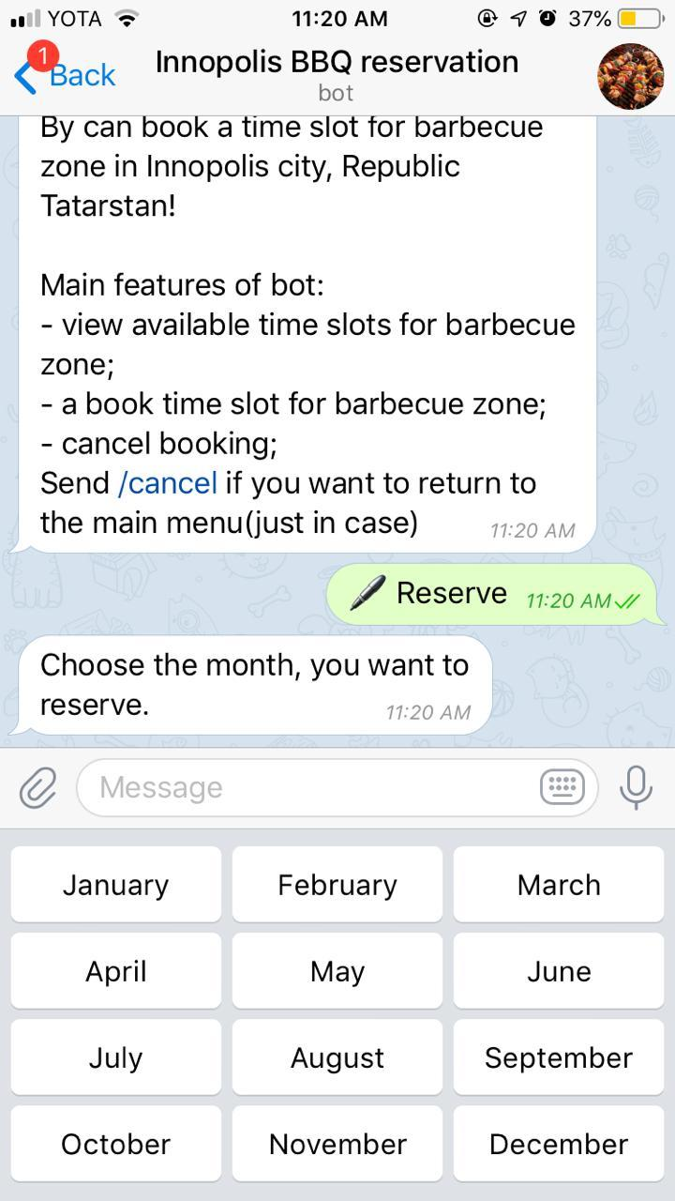

Figure 2: Choosing reservation month

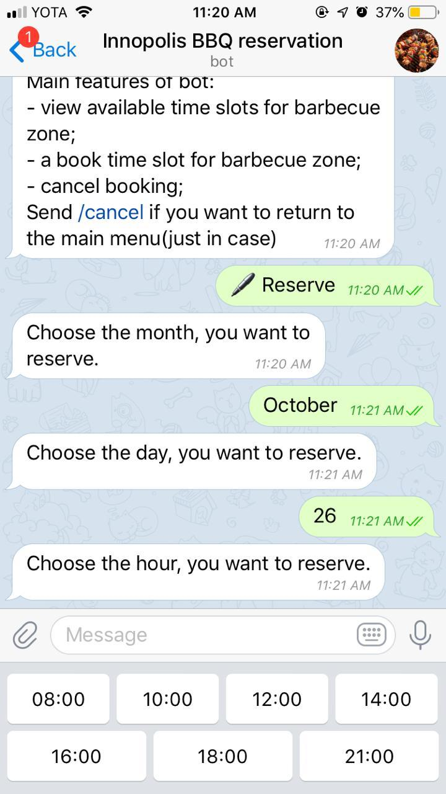

Figure 3: Choosing date of reservation

**Surveys and Statistics**

Preliminary testing by users showed positive results. All the users who tested the application preferred it to the current existing system. All 7 users were happy with the MVP application they have tested.

**Software Architecture**

Below is the image describing the BBQ reservation software architecture.

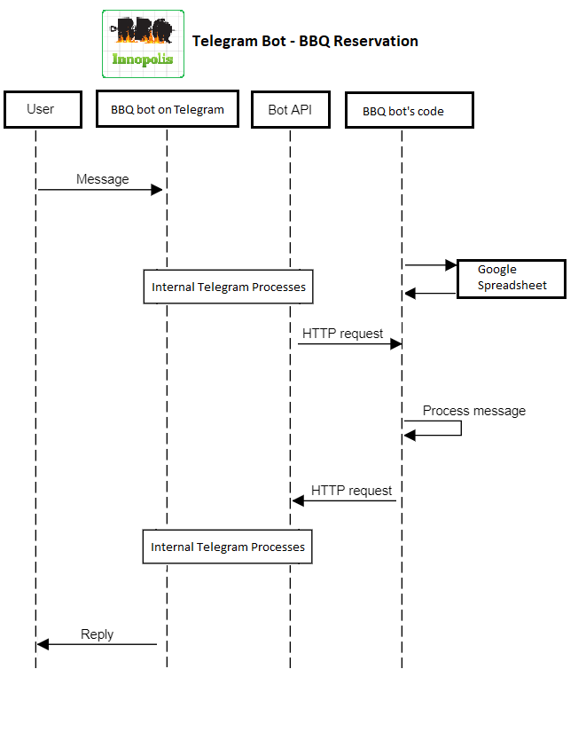

**Future development**

We are planning to extend our mvp to expand the functionalities of our mvp and implement some other requirements presented in the requirements in a better manner.

**Documentation of Application**

Installation:

1. git clone

2. cd to directory with recuirements

3. python3 -m venv venv

source venv/bin/activate

4. pip install -r requirements

5. put a token somewhere as a function parameter

6. run the main module

7. Write our bot @InnoBBQbot