ADGL Appendix D - Reference Toolkit, Conformance, and Evaluation
GBSN Research
Lisbon, Portugal | Correspondence: www.gbsnresearch.com (use Contacts)
Reference Toolkit 0.5.0 | Research Release 0.4.0

D.1 PURPOSE AND SCOPE
The ADGL Reference Toolkit is an executable research artifact, not a production governance service. It implements deterministic semantics sufficient to inspect, test, and falsify the proposed architecture. It contains no foundation model and performs no live enterprise action.

D.2 REPOSITORY STRUCTURE
adgl/ core engine, pipeline engine, analysis, consequence, audit
schemas/ core/pipeline policy, knowledge, model, analysis-result, action, grant, profile
examples/ eight reference cases
profiles/ illustrative non-normative domain profiles
conformance/ executable results
benchmarks/ reproducible benchmark harness and results
docs/ semantics, profiles, threat model, implementation status
tests/ automated software tests

D.3 IMPLEMENTATION STATUS
Capability | Status
Knowledge admission/lifecycle/evidence roles | Implemented core subset
Authority/priority/applicability | Implemented core subset
Derived restriction propagation | Implemented basic propagation
Model/processing-region eligibility | Implemented
Deterministic base policy composition | Implemented
Analysis method allowlist | Implemented
Corroboration/evidence sufficiency | Implemented
No-infer-missing | Implemented
Human validation inside Analysis | Implemented basic gate
INFORM / DECIDE / ACT | Implemented
DECIDE -> ACT | Implemented
Capability-grant action authorization | Implemented basic action/case/value/expiry checks
Live API/tool enforcement | Not implemented; external integration
Production IAM/workflow/sandbox | Not implemented; external enforcement
Full independent implementation portability | Not yet established
Three-stage pipeline policy validation | Implemented schema + embedded core validation
Stage-qualified analytical transformations | Partial; legacy collection operations retained in core engine
Pipeline-native model/region stage placement | Partial; core-compatible routing reused

D.4 CONFORMANCE RESULTS
The packaged software test suite reports 10/10 passing tests. The normative/reference conformance runner reports 25/25 passing checks.
Check | Result
C01 Exclusion safety | PASS
C02 Quarantine isolation | PASS
C03 Embargo enforcement | PASS
C04 Supersession | PASS
C05 Priority/authority separation | PASS
C06 Applicability gating | PASS
C07 Model eligibility | PASS
C08 Region safety | PASS
C09 Fallback safety | PASS
C10 Mandatory evidence | PASS
C11 Conflict preservation | PASS
C12 Derived restriction propagation | PASS
C13 Audit completeness | PASS
C14 Deterministic replay | PASS
C15 Portable-subset equivalence | PASS
C16 Deterministic policy composition | PASS
C17 Analysis method governance | PASS
C18 No-infer-missing | PASS
C19 Analysis corroboration gate | PASS
C20 INFORM disposition | PASS
C21 DECIDE disposition | PASS
C22 ACT capability authorization | PASS
C23 DECIDE-to-ACT transition | PASS
C24 End-to-end audit stage coverage | PASS
C25 Task-scoped action grant | PASS

D.5 CORE RUNTIME BENCHMARK
The benchmark measures only deterministic governance-engine overhead. It excludes retrieval, model inference, network latency, connector I/O, token generation, external persistence, and execution of real actions. Smaller workloads use 20 measured runs after warmup; the largest 5,000-object and 150-rule workloads use 12 measured runs. Median and interquartile range (IQR) are used as the primary descriptive statistics.
Objects | Rules | Runs | Median ms | IQR ms
10 | 10 | 20 | 0.60 | 0.02
100 | 10 | 20 | 4.79 | 0.16
1000 | 10 | 20 | 48.35 | 2.31
5000 | 10 | 12 | 227.29 | 12.03

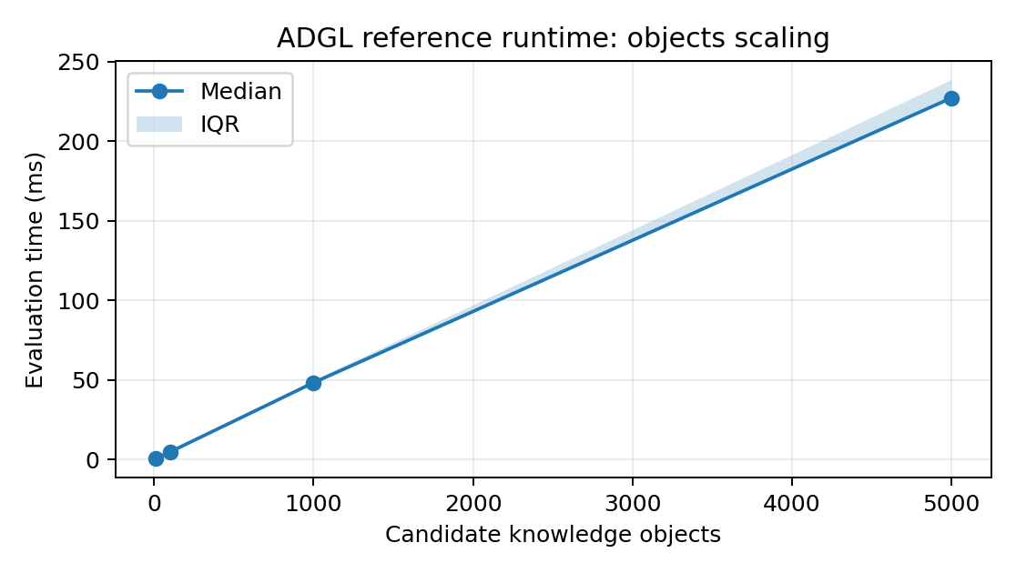
Fig. D-1. Object-scaling benchmark.
Objects | Rules | Runs | Median ms | IQR ms
1000 | 0 | 20 | 36.10 | 0.85
1000 | 5 | 20 | 42.46 | 1.79
1000 | 25 | 20 | 64.85 | 2.61
1000 | 100 | 20 | 155.75 | 31.22
1000 | 150 | 12 | 218.54 | 93.80

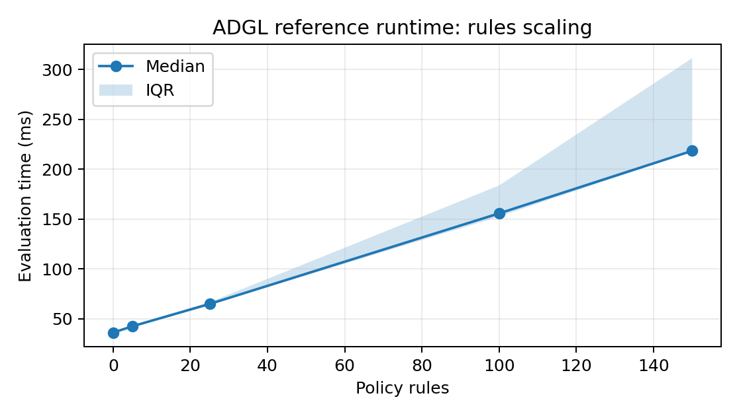
Fig. D-2. Rule-scaling benchmark.

D.6 THREE-STAGE PIPELINE BENCHMARK
A second microbenchmark executes the three-stage reference pipeline over 1,000 objects for INFORM, DECIDE, and ACT routing. The benchmark stops at the governance decision and does not execute an external human workflow or API action. It is a warmed single-process microbenchmark and is reported with median/IQR only.
Disposition | Objects | Runs | Median ms | IQR ms
INFORM | 1000 | 20 | 55.74 | 3.00
DECIDE | 1000 | 20 | 57.59 | 7.24
ACT | 1000 | 20 | 55.07 | 3.11
The three dispositions have similar governance-decision cost in this reference implementation because object-policy evaluation dominates the measured workload. This should not be interpreted as evidence that real-world human review or machine action has equivalent end-to-end latency.

D.7 REPRODUCIBILITY
python -m pip install -e .
adgl validate examples/regulatory_product_claim_review/policy.yaml
adgl run examples/regulatory_product_claim_review/policy.yaml --input examples/regulatory_product_claim_review/input.json
adgl pipeline examples/autonomous_machine_action/policy.yaml --input examples/autonomous_machine_action/input.json
adgl conformance
PYTHONPATH=. python benchmarks/benchmark.py --iterations 20
PYTHONPATH=. python benchmarks/pipeline_benchmark.py

D.8 INTERPRETATION LIMITS
The reference implementation demonstrates executability and internal conformance, not production readiness. C15 uses an independent mini-interpreter bundled in the same research project; it is not third-party validation. Production deployment requires stronger identity, enforcement, persistence, policy distribution, tamper resistance, observability, and security engineering. Analysis/consequence semantics, stage-qualified transformations, and pipeline-native model routing remain working-draft or future work.

