**General Chairs**

C.-C. Jay Kuo, USC, USA

Truong Nguyen, UCSD, USA Wenjun Zeng, MSRA, China

**Program Chairs**

Pamela Cosman, UCSD, USA

Yap-Peng Tan, NTU, Singapore

Sanghoon Lee, Yonsei U., Korea

Min Chen, U. of Washington, Bothell, USA

Mugen Peng, Beijing U of Posts & Telecom, China

Junsong Yuan, NTU, Singapore

**Plenary Chairs**

John Apostolopoulos, Cisco, USA Haohong Wang, TCL, USA

**Workshop Chairs**

Mohan S. Kankanhalli, NUS, Singapore

Kai Yang, Tongji U, China

**Tutorial Chairs**

Jane Wang, UBC, Canada

Vicky Zhao, Tsinghua, China

**Panel Chairs**

Jiebo Luo, U. of Rochester, USA Qi Tian, UT San Antonio, USA

**Industrial Program Chairs** Khaled El-Maleh, Qualcomm, USA

Yan Ye, InterDigital, USA

**Grand Challenge Chairs**

Vasudev Bhaskaran, Qualcomm, USA

Lei Zhang, MSR, USA

**Special Session Chairs**

Yonggang Wen, NTU, Singapore

Chia-Wen Lin, NTHU, Taiwan

**Demo/Expo Chairs**

Liangping Ma, InterDigital, USA

Michel Sarkis, Qualcomm, USA Heather Yu, Huawei, USA

**Student Program Chair**

Prasad Calyam, U. of Missouri, USA

**Finance Chair**

Yan Sun, U. of Rhode Island, USA

**Publication Chair** Alessandro Piva, U. of Florence, Italy

**Publicity Chairs**

Panayiotis Georgiou, USC, USA William Grosky, U. of Michigan, USA

Mark Liao, Acad. Sinica, Taiwan Liang Zhou, Nanjing U. of Posts and

Telecommunication, China

**Registration Chair**

Yusuf Ozturk, SDSU, USA

**Local/event Chair**

Sunil Kumar, SDSU, USA







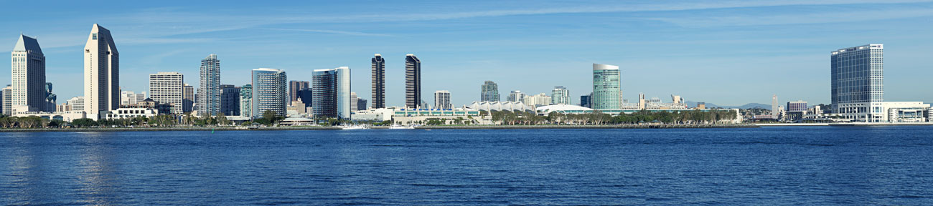

**IEEE International Conference on Multimedia and Expo (ICME) 2018**

**CALL FOR PAPERS**

**IEEE International Conference on Multimedia and Expo (ICME) 2018**

**July 23-27, 2018** • **San Diego, USA**

The IEEE International Conference on Multimedia & Expo (ICME) has been the multimedia conference sponsored by four IEEE societies since 2000. It serves as a forum to promote the exchange of the latest advances in multimedia technologies, systems, and applications from both the research and development perspectives of the circuits and systems, communications, computer, and signal processing communities. An exposition of multimedia products, animations and industries will be held in conjunction with the conference. The theme of the 2018 conference will be “Data-driven Media Computing”, which plays a key role in modern multimedia technologies.

Authors are invited to submit a full paper (two-column format, 6 pages maximum) according to the guidelines available on the conference website at <http://www.icme2018.org/>. Reviewing will be double blind. Only electronic submissions will be accepted. Topics of interest include, but are not limited to:

* Big multimedia data design and creation
* Deep learning for multimedia
* Multimedia search and recommendation
* Multimedia content analytics
* Social and cloud-based multimedia
* 3D multimedia and AR/VR
* Multimedia quality assessment and metrics
* Multi-modal media computing and human-machine interaction
* Multimedia representation and processing
* Multimedia communications, networking and mobility
* Multimedia security, privacy and forensics
* Multimedia software, hardware and application systems
* Multimedia standards, trends and related issues

ICME 2018 will showcase high quality oral and poster presentations and demonstration sessions. It will also feature IEEE societies sponsored Workshops. We welcome researchers, developers and practitioners to organize Workshops on various new emerging topics. Industrial exhibitions are held in conjunction with the main conference. Proposals for Tutorials, Special Sessions, and Demos are also invited. Please visit the ICME 2018 website for submission details.

The conference will select and recognize one diamond and six platinum awards by following the10K Best paper awards established by the ICME Steering Committee in 2017. Several other awards sponsored by industry and institutions will also be offered. Accepted papers have to be registered and presented; otherwise, they will not be included in the IEEE Xplore Library.

**Special Session Proposals Due: October 2, 2017 Notification of Special Session Proposal Acceptance: October 16, 2017 Workshop/Panel/Tutorial Proposals Due: October 23, 2017 Notification of Workshop/Panel/Tutorial Proposal Acceptance: November 6, 2017 Regular Paper Abstract Submission: November 24, 2017**

**Regular Paper Submission: December 1, 2017**

**Notification of Regular Paper Acceptance: March 12, 2018**

**Workshop & Demo Paper Submission: March 19, 2018**

**Camera-Ready Regular Paper Due: April 13, 2018**

**Notification of Workshop & Demo Paper Acceptance: April 23, 2018**

**Camera-Ready Workshop & Demo Paper Due: May 11, 2018**

**G:\icme2018\app\assets\images\logos\mitsubishi.png**MicrosoftG:\icme2018\app\assets\images\logos\interdigital.png