Preconditions
You will need latest version of Visual Studio and .NET 9. Different versions of the NorthWind database you can to download from Google site. There is no need to download SQLite version: a copy of this file is included into this tutorial. You will need SQLite browser if you will be working with this database. Download it from sqlitebrowser site.
Archyve https://github.com/gbukauskas/BlazorTutor has collection of branches BlazorTutor_xx. The number xx corresponds to a step in this document.

Step 1: create the application
Create new application using “Blazor Web App” template. On next screen don’t check flag "Place solution and project in the same directory". All other values you can change there. Uncheck flag "Configure for Https" on last screen, exclude interactive render mode and click "Create“ button:
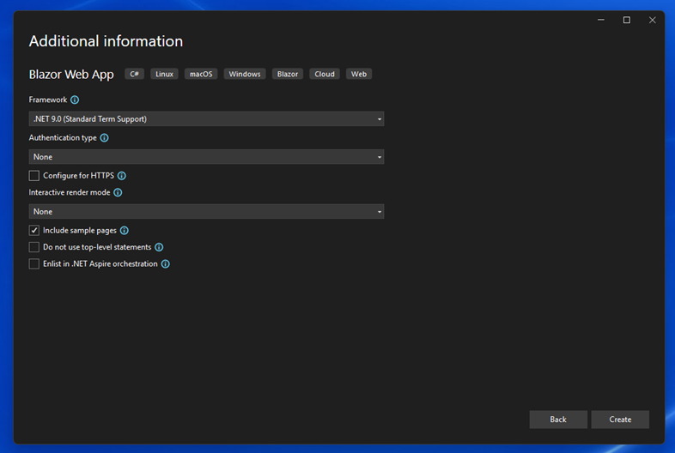
These settings will create Static Server Render page. Interactive render mode may be set to "Server": you can change it later at any moment by adding or removing AddInteractiveServerRenderMode() commands:
builder.Services.AddRazorComponents()
.AddInteractiveServerComponents();
...
app.MapStaticAssets();
app.MapRazorComponents<App>()
.AddInteractiveServerRenderMode();
app.Run();
Sending data to server with HTML Forms or processing events in C# requires interactive mode.
Install Entity Framework Core. The process is described in the "https://www.entityframeworktutorial.net/efcore/install-entity-framework-core.aspx". Add NorthWind database and generate Entity framework classes for your database. Follow the "https://www.entityframeworktutorial.net/efcore/create-model-for-existing-database-in-ef-core.aspx" article. I selected SQLite because of a simple installation. After selecting another DB engine you will need:
- install the database on your local computer,
- change command options.UseSqlite in the Program.cs file,
- modify connection string in the appsettings.json file,
- change HasColumnType in all files inside DBContex/Models directory.
Scaffolding generates long OnModelCreating procedure. You can split it using partial files but it would be better to move the configuration into entity classes. Look at the NorthwindContext.cs file and entities in the Models directory.
Read instructions on Microsoft site in case of trouble.

Disable Prerendering
The default rendering settings enable prerendering. The initialization functions (OnInitialized, OnInitializedAsync) are executed twice when application is running in this mode. Prerendering may make a sense in WebAssembly, but in server mode it causes more problems than it solves. Disable this beast in file App.razor:
<!DOCTYPE html>
<html lang="en">
<head>
<meta charset="utf-8" />
<meta name="viewport" content="width=device-width, initial-scale=1.0" />
<base href="/" />
<link rel="stylesheet" href="@Assets["lib/bootstrap/dist/css/bootstrap.min.css"]" />
<link rel="stylesheet" href="@Assets["app.css"]" />
<link rel="stylesheet" href="@Assets["WEBtransitions.styles.css"]" />
<ImportMap />
<link rel="icon" type="image/png" href="favicon.png" />
<HeadOutlet @rendermode="new InteractiveServerRenderMode(prerender: false)" />
</head>
<body>
<Routes @rendermode="new InteractiveServerRenderMode(prerender: false)" />
<script src="_framework/blazor.web.js" suppress-error="BL9992"></script>
<script type="module" src="~/js/customExpander.js"></script>
</body>
</html>

Step 2: attach tests
NorthwindContext will be used in two modules:
- WEB application
- xUnit tests.
For this reason, a new application, ClassLibraryDatabase, was created and the NorthwindContext.cs file was moved into it. In the transferred file, I changed the namespace names for matching them names of the directories.
I added a static function CreateDBcontext in the autogenerated NorthwindContext file. This function allows me to create a DB context for tests.
xUnit tests work with a separate copy the database and do not touch a real DB context. This code is executed only once before the first test starts.
The Test1 method tests all tables and views in NorthWind database. You can split this method if you wish. Don’t forget to correct Assert statement after correcting any filtering condition.
Some views in the NorthWind were modified because of incorrect data filters.

Step 3: Multilevel menu
WEB contains many examples on creating collapsible submenu. Look at stackoverflow for an example. The problem is that all they are based on handling Blazor events and this turns on a completely unwanted interactive mode. Using the details/summary HTML element, I got exactly the same results without using events. Look at file NavMenu.razor:
<div class="nav-item px-3">
<details class="nav-item"
style="color: var(--bs-light); padding-left: var(--bs-nav-link-padding-x);">
<summary>Classificators</summary>
<NavLink class="nav-link" href="Employees">
<span class="bi bi-northwind-employees"
aria-hidden="true"></span> Employees
</NavLink>
<NavLink class="nav-link" href="Customers">
<span class="bi bi-northwind-customers"
aria-hidden="true"></span> Customers
</NavLink>
</details>
</div>

Step 4: List of employees
Page Employees.razor follows template Weather.razor provided by Microsoft. The differences are:
- The data are retrieved from the Northwind database (table dbo.Employees),
- The table uses zebra format,
- The table can be sorted by any column,
- The component has optional parameter sortname. This parameter defines sorting.
List of employees comes from the database and is displayed in the HTML table list-of-employees.
Page Customers.razor follows the same template.

Sorting
Header of the list-of-employees table consists of links that reloads the page with sortname parameter. This parameter has listed below format:
sortCharacter_{field name}
The parameter is optional and stands no sorting if it is not defined. sortCharacter has listed below values:
n – no sorting,
a – sort ascending,
d – sort descending.
The sortCharacter changes sequentially after subsequent clicks on the same header:
n → a → d → n
A header of the table has two attributes related to the sorting: data-sort and href. First one informs CSS, second one – sends information to the server.

Paging
Processing Customers table requires methods from both interfaces (IPagedCollection and IDatabaseSvc) thus file Program.cs registers service CustomerSvc storing the object itself:
builder.Services.AddSingleton<CustomerSvc>();
The Customers.razor component displays a list of customers divided into pages. Since this list may be sorted and filtered, the standard Linq SELECT operator does not work. After several unsuccessful attempts, I chose the FromSqlRaw function, see the GetCurrentPageAsync function in the CustomerSvc.cs file.
The function FromSqlRaw("SELECT COUNT(*) FROM Customers") does not work. You must use the SQL operator AS:
FromSqlRaw("SELECT COUNT(*) AS Value FROM Customers")
Page buttons in the PagerControl.razor component are links. They are reloading the Customers component with pagesize and pagenumber parameters.
The filtering element is placed into a Generic component FilterControl.razor, which adds to the DropDown list the only properties marked with the AllowFiltering attribute, see the class description inside the Customers.cs file.
Standard POST method of the EditForm component refreshes the form itself. Server side processes POST event and current version of the Blazor fails on redirection. Thus I have used HTML form element with GET method.
Paging and sorting requires reflection for switching from field names to object properties. Look to component Employees.razor in BlazorTutor_05 branch. This slows down the program a lot. I solved this problem by reading the lists with ADO DataReader. Look at procedure OnParametersSetAsync() in the Customers.razor.
Images at right end of every row are HTML links packed in the CrudLinksContro.razor component.
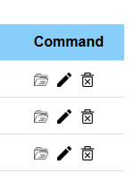

All they open the same EditCustomer.razor component with different parameters:
<a href="@Url/view/@Id">
<a href="@Url/edit/@Id">
<a href="@Url/delete/@Id">

Concurrency
In most scenarios, databases are used concurrently by multiple application instances, each performing modifications to data independently of each other. When the same data gets modified at the same time, inconsistencies and data corruption can occur, e.g. when two clients modify different columns in the same row which are related in some way. This problem is called "concurrency conflicts". Entity Framework Core has great built-in support for optimistic concurrency control. The best way to utilize this on SQL Server is via a rowversion column. The Entity Framework itself handles race conditions when the database is described in this way:
public class SampleContext : DbContext
{
public DbSet<Author> Authors { get; set; }

protected override void OnModelCreating(ModelBuilder modelBuilder)
{
modelBuilder.Entity<Author>()
.Property(a => a.RowVersion).IsRowVersion();
}
}
public class Author
{
public int AuthorId { get; set; }
public string FirstName { get; set; }
public string LastName { get; set; }
public string Biography { get; set; }
public ICollection<Book> Books { get; set; }
public byte[] RowVersion { get; set; }
}
In Microsoft SQL Server, the timestamp data type is a synonym for the rowversion data type. It is used to automatically generate a unique binary number for each row whenever the row is inserted or updated. Don’t update RowVersion field from your application.
SQLite has no such feature and you must to protect your application from these types of errors. I followed the SQLite and EF Core Concurrency Tokens | Brice’s Blog article and created two SQL scripts:
- AddVersion.MS_SQL.sql
- AddVersion.SQLight.sql
They both perform the same task: adding two fields (IsDeleted, and Version) into the tables:
// SQLite
ALTER TABLE Categories ADD IsDeleted INTEGER NOT NULL DEFAULT 0;
ALTER TABLE Categories ADD Version INTEGER NOT NULL DEFAULT 0;
...
// MS SQL
ALTER TABLE dbo.Categories ADD IsDeleted BIT NOT NULL DEFAULT 0;
ALTER TABLE dbo.Categories ADD Version rowversion;
MS SQL Server updates itself the field Version, Since SQLite does not have a data type similar to timestamp, I used an integer field and two triggers in each tracked table:
CREATE TRIGGER IF NOT EXISTS UpdateCustomersVersion
AFTER UPDATE ON Customers
WHEN NEW.Version >= 0
BEGIN
UPDATE Customers
SET Version = Version + 1
WHERE rowid = NEW.rowid;
END;

CREATE TRIGGER IF NOT EXISTS TestVersionCustomers
BEFORE UPDATE ON Customers
WHEN NEW.Version >= 0
BEGIN
SELECT
CASE
WHEN NEW.Version < OLD.Version THEN RAISE (ABORT, 'Concurrency error')
END;
END;
First trigger increments of the Version column, converting it into auto-increment field. The second one raises database exception after detecting conflict. The project does not delete records from the database thus both triggers work on update operation only. The condition WHEN NEW.Version >= 0 allows you to ignore concurrency conflicts.
Corresponding changes were also made in the model files (see DBContext/Model files):
// Customer.cs, SQLite version
...
public byte IsDeleted { get; set; }
public int Version { get; set; }
...
entity.Property(e => e.IsDeleted).HasColumnType("INTEGER").HasDefaultValue(0);
entity.Property(e => e.Version).HasColumnType("INTEGER").HasDefaultValue(0);

// Customer.cs, MS SQL Server version
...
public byte IsDeleted { get; set; }
public byte[] Version { get; set; }
...
entity.Property(e => e.IsDeleted).HasColumnType("BIT").HasDefaultValue(0);
entity.Property(e => e.Version).HasColumnType("ROWVERSION").IsRowVersion();
Note that the SQLite variant does not use the IsRowVersion() function: the fight against concurrency errors is handled by triggers inside database.

Edit screen
Standard Edit screen (name above value) provided in many Blazor and Bootstrap tutors results to narrow long screen. It is good for mobiles only. I placed name and control on the same row following pragimtech recommendations. HTML Form is main part of the edit screen. The EditCustomer.razor component is used for the following operations:
- edit a previously entered record (edit action),
- view all customer’s details (view action),
- delete record about the customer (delete action),
- create a new customer (new action).
Action is defined as the first parameter of the URL:
@page "/EditCustomer/{action}/{argument?}"
Parameter argument contains id of the customer. Parameter is optional for the new action.

Custom Controls
Control for the input region is not drop-down. The control (file Autocomplete.razor) demonstrates creating of the custom input control. You need to create Blazor component that inherits from generic component InputBase<T> for using it inside EditForm. Add command
@inherits InputBase<string>
at a top of the component. You can use any other type instead of the string. Parameters, Child Content and custom events are standard tools for the communication with a custom component:

<!-- Parent component -->
<Autocomplete name="region" @bind-Value=@Model!.Region
style="width: 500px; display: inline-block;"
RegionChanged="RegionChangedHanler">
@foreach (var item in allRegions)
{
<option value=@item />
}
</Autocomplete>
...
internal void RegionChangedHanler(string newRegion)
{
this.Model!.Region = newRegion;
}
…
…

<!-- Childcomponent (Autocomplete) -->
<input type="text" name="@Name" value=@Value class="@AllClasses"
style="@Style" autocomplete="off" list="@UUID-datalistOptions"
placeholder="Type a name or select it from the drop-down"
@onchange="UpdateSelection"/>
<datalist id="@UUID-datalistOptions">
@ChildContent
</datalist>
...
[Parameter]
public EventCallback<string> RegionChanged { get; set; }
...
private async Task UpdateSelection(ChangeEventArgs e)
{
string newValue = (string)(e.Value ??= "");
if (this.InitialValue != newValue)
{
await RegionChanged.InvokeAsync(newValue);
}
}

Sending Messages
We usually get a tree structure constructing a complex component:
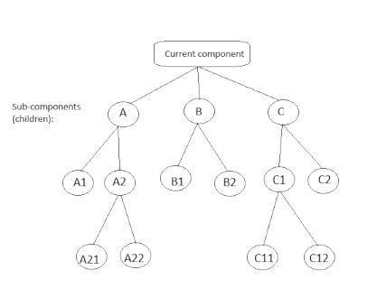

The EventCallback allows the component (sub-component B1 for an example) to send message one level up (sub-component B). Virtual functions OnParametersSetAsync and OnParametersSet allow the sub-component B1 to capture message from the parent (B). For sending messages over longer distances (for an example from A21 into C2) the RX library is required. Nick Polyak published concise version of the same material.

// Bootstrap Grid System: A Detailed Guide | Medium
// Forms · Bootstrap

// Beginner's Blazor State Management Tutorial (Part 1)

// Forms with .NET 8 Blazor SSR (Static Server-Side Rendering) & Enhanced Navigation🔥
// (15) Forms with .NET 8 Blazor SSR (Static Server-Side Rendering) & Enhanced Navigation🔥 - YouTube
// https://www.youtube.com/watch?v=WfMHUp8tOVE

// Bing Videos
// https://console.cloud.google.com
// Building Real-Time Applications with Blazor Server and Firestore | Twilio

