# Prepare the work environment

## Operating system

These tutorials will be done in a Linux environment primarily because all the necessary tools can be downloaded from the Internet for free and no piracy is required. The next reason is that Linux requires much less resources and demonstrates normal speed on computers where even Windows 10 is too slow.

Nowadays, there are an endless number of Linux distributions, and if you read the advertisement for any variant, you will understand that this particular variant is the best. I’d recommend choosing Ubuntu: the constructors of this distribution paid a lot of attention to simplifying the installation and support. Even novice users will easily install this system in the computer. Ubuntu desktop is built for individual users and the standard installation provides almost all the software needed for work.

## Installation

Taking an old, unused laptop and installing Linux on it is the easiest way to do these lessons. And do not be afraid that Windows 10 works too slowly there: I installed Xubuntu on an Acer TravelMate with just a 2.2GHz Intel processor.

Now that professional programmers are forced to switch on Windows 11, you can buy a good enough computer at an affordable price. When buying a used one, make sure that it has a DVD drive or the BIOS allows you to boot the system from a USB stick.

You can build a dual boot system if you have a good computer and plenty of space on a hard drive or SSD. Although Linux installations are well-tested and usually uneventful, make sure to create a Windows recovery disc and backup data before installing Linux next to Windows.

Installation is described on site [Install Ubuntu desktop | Ubuntu](https://ubuntu.com/tutorials/install-ubuntu-desktop" \l "1-overview). This link describes the installation in great detail, so there's no need to repeat it here: just follow the instructions and you'll have a working operating system after the process is complete. The site describes installation from USB stick, installation from DVD is almost the same: you will need to create bootable DVD instead of the stick. I'll just add a few comments:

* Drop the [Xubuntu](https://xubuntu.org/) ISO file instead of [Ubuntu](https://ubuntu.com/download). Xubuntu installs [xfce](https://xfce.org/) desktop environment and requires much less resources from the computer, the graphical interface is very simple and you will be able to master it in a few hours. When pressed, you can always expand the system by installing additional software from the Ubuntu archives. You can also reinstall Linux and switch to GNOME or KDE, as long as your computer is powerful enough.
* The system will ask for root username and password during installation. Write down these values somewhere, as you will need them when upgrading the system.
* Choose your native language during installation - this way you will avoid many misunderstandings.

## XFCE desktop environment

Xfce is a lightweight and configurable desktop environment for Unix-like operating systems. After booting XUbuntu, the screen will look something like this:

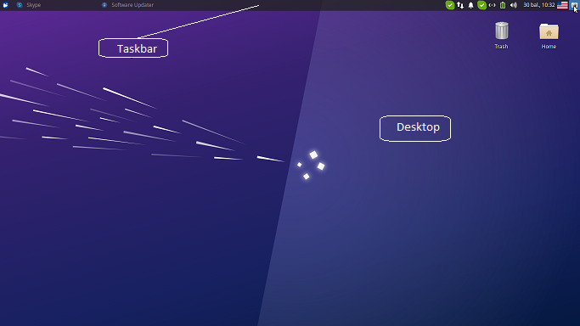Fig. 1: Slightly adjusted XFCE screen. I added language switching and screenshot icons there.

At the site [XFCE desktop](https://docs.openeuler.org/en/docs/21.09/docs/desktop/Xfce-user-guide.html" \l "4-shortcut-operation-bar) you will find a brief description of what can be gutted in this environment. For a complete description of the environment, see the [XFCE home site](https://docs.xfce.org/).

Right click on free space in the task bar or desktop and follow popup menu for configuring the region.

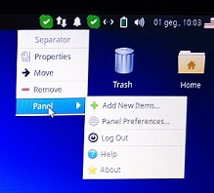

Fig. 2: Expanded taskbar management menu.

Right-click on an icon and follow the context menu instructions for updating or removing it from the taskbar. Modifying the desktop icon is exactly the same.

There is a lot of material on YouTube about configuring XFCE. I recommend watching [How to Customize XFCE](https://www.youtube.com/watch?v=mgyTCqr51iI): the tricks shown there will really impress Windows users. Don't mess around with the configuration too long: there are many free XFCE themes in the [Xfce-look](https://www.xfce-look.org/browse?cat=138&ord=latest&ref=itsfoss.com) portal. Choose the right theme for you and install it according to the instructions in the [themes](https://itsfoss.com/install-themes-xfce-xubuntu/) site.

Add a keyboard switch button to the taskbar if you need to work with multiple languages. Also a very useful thing is the workspace switcher. Activate 2 workspaces to begin with, you can increase the number later when you see benefits of this feature.

## Package manager

A package manager or package-management system is a collection of software tools that automates the process of installing, upgrading, configuring, and removing computer programs for a computer in a consistent manner ([Wikipedia](https://en.wikipedia.org/wiki/Package_manager)). Ubuntu inherited Advanced Package Tool (or APT), the main command-line package manager from Debian. The apt system consists of three console applications: apt, apt-get, apt-cache. They require admin rights in most cases thus add magical word **sudo** in front of command.

A typical Ubuntu installation has a graphical tool ([Synaptic](https://www.ubuntugeek.com/synaptic-package-manager-beginners-guide-for-ubuntu-users.html)) for working with packages. Read this article and use its recommendations for managing your system. I provide **apt** management from the terminal, since theese commands may be used even on Linux having no Xwindow. Here is an abbreviated description of the **apt** command. You will receive complete and accurate information by typing

man 8 apt

in the terminal.

The **apt** commandline is designed as end user tool and you can use it instead of specializated tools **apt-get** or **apt-cache**. Type in terminal command

*apt help*

and you will get a list of commands. Here is short description some of them.

#### List

The command **apt list** types long list of packages thus paginate output with **less** command or filter it with **grep** command:

apt list | less

apt list | grep chess

The first commmand displays paginated list, second one displays packages containing phrase chess.

#### Search

The command outputs packages with phrase inside description. Once again, you can send an output to the less or grep commands:

apt search chess | less

apt search chess | grep gnu

#### Show

The command shows package details:

apt show gnuchess-book

#### Install, Reinstall, Remove, Autoremove, Purge

Performs the requested action on one or more packages. All of these commands require administrator privileges, so start the command with the word **sudo**. Packets are separated from each other by a space. The **remove** command leaves the configuration files behind, while **purge** discards everything. By the way, **purge** can also be used for packages that were discarded with **remove**.

The listed commands may be remitted via **apt** or via **apt-get:**

sudo apt install gnuchess

sudo apt purge gnuchess

The first command installs gnuchess, second one removes it with all dependencies and configuration files.

Different packages may be installed and removed in a single command. Add the installable packages marked with a plus sign (+) in the **remove** command. Packages may be removed in the **install** command adding them with a minus sign (-).

sudo apt install tilde -vim

sudo apt remove vim +tilde

Both commands delete the text editor **vim** and install **tilde**.

After executing the **full-upgrade** command, sometimes unnecessary packages remain in the system. The **full-upgrade** command will notify you about this. In this case, run the autoremove command:

sudo apt autoremove

* + - 1. The install command allows you to install local *.deb files as well. Type the command
      2. sudo apt install <path_and_name_of_the_file>.deb

#### Update, Upgrade, Full-upgrade

[Canonical](https://canonical.com/), the developer and maintainer of Ubuntu, periodically publishes a new release of their operating system. The site maintains a large online repository with tens of thousands of software packages for each Ubuntu release. Before you can update the software packages installed on your Ubuntu system, you first download the latest software package information from this online repository. Your Ubuntu system needs this information to detect the availability of an upgrade for an already installed software package.

To update the software package information from the online repository, run **update** command in the terminal:

sudo apt update

Once the command completed, the last line in the output shows if updates are available for installed software packages on your Ubuntu system.

The **upgrade** command does the following:

* it upgrades a software package and even installs new packages, if its dependencies require this,
* it will never remove packages. If a package removal is required, the upgrade is not performed.

In contrast to this, the **full-upgrade** command does the same as **upgrade**, but will also remove packages if needed. Use this command upgrading from one major operating system release to the next.

Some software packages require a system reboot to complete the update. You can verify that writing command

cat /var/run/reboot-required

Reboot your system if this command reports „System restart required“. The command will find no file if your system does not require rebooting. The **reboot** command can be run from the main menu or the terminal.

#### Edit-sources

Packets can be dropped from different links (sources). Information about this is stored in the /etc/apt/sources.list file. The edit-sources command allows you to select a text editor and start editing this file.

Sudo apt edit-sources

After editing the sources, it is necessary to run the **update** and **upgrade** commands.

## GitHub, GitLab

Storing your code in external repositories is useful even when you're working alone. When working in a team, it is simply necessary. The GitHub and GitLab repositories described here are good because they work with the standard [git](https://git-scm.com/) program available on Linux, Windows and MAC OS.

A standard XUbuntu installation should have git. You can check by running

git --version

in the terminal. Install **git** if this command says it didn't find the **git** command:

sudo apt install git

GitHub and GitLab use a public/private key for authentication, so you will need to configure a local git and register the public key with the repository. Generating a new key and registering it in the GitHub repository is described [here](https://dev.to/kellycarvalho/how-to-configure-git-on-ubuntu-and-adding-ssh-key-to-github-4h5d). Read this article please.

If you already have a GitHub or GitLab account and have installed GIT on another computer, then go to that computer and find out what credentials you have registered with. This will be told by the following two commands that you need to run from the terminal (Windows users refer to the terminal as "Command Prompt"):

git config --global user.name

git config --global user.email

Use the responses from these two commands for configuring git in a Linux environment:

git config --global user.name "your_user_name"

git config --global user.email "your_email"

Now generate the public/private key pair:

ssh-keygen -t ed25519 -C "your_email"

The **ssh-keygen** command will ask for a password. You can come up with whatever you want, but not too long, because you will need to enter this password when you commit the code into repository (**push** command).

**Ssh-keygen** command will not only generate the keys, but also tell you the directory where they are placed. They will probably be in the ~/.ssh directory. This directory is hidden and the file manager will show it only after enabling the checkbox "Show hidden files" in the view menu. Open the file id_ed25519.pub with mousepad or nano and upload this text to GitHub. The upload procedure is described on site [How to configure Git on Ubuntu](https://dev.to/kellycarvalho/how-to-configure-git-on-ubuntu-and-adding-ssh-key-to-github-4h5d).

Join some project on github and copy the ssh link:

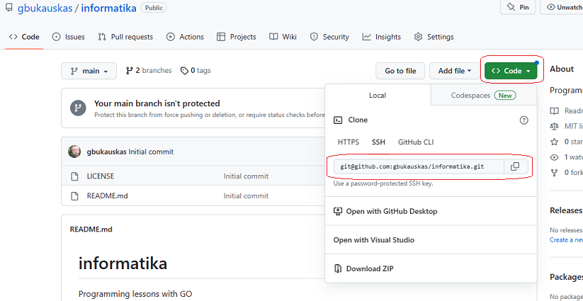Now in your terminal navigate to the directory where you want to have the project and type the command:

git clone ssh_address-from_git

Git will ask for confirmation the first time you run this command with new keys. Answer "yes" and you will work without any problems later.

GitLab configuration is almost the same. Read a [book](https://about.gitlab.com/handbook/) or watch a [video](https://www.youtube.com/watch?v=8aV5AxJrHDg).

There is a very good book on [git](https://git-scm.com/book/en/v2) commands. Sooner or later you will have to read it, but for now I will only present here the most important commands needed for daily work.

#### Clone

The command copies the archive. The third optional parameter of the command specifies where to copy. This is usually a dot (current directory), but any other value may be specified.

git clone https://github.com/linuxacademy/content-source-control-git.git .

The command also allows you to copy a local archive:

git clone --local /mnt/baserepo .

The target directory must be empty. Both commands will not be executed if the current directory contains any file or directory. You can read more about the clone command at the [Git Guides](https://github.com/git-guides/git-clone) site.

#### Init

If you have a project directory that is currently not under version control and you want to start controlling it with Git, you first need to go to that project’s directory and emit init there:

cd /home/user/my_project

git init

At this point, nothing in your project is tracked yet. You will need to add the files with the following commands:

git add -A -v

git commit -m 'Initial project version'

The archive created in this way will work perfectly, but it will not be connected to remote archives (GitHub, GitLab, BitBucket, ...). The [kbroman](https://kbroman.org/github_tutorial/pages/init.html) link describes how to connect such a local archive to GitHub. Follow the instructions in the section "Connect it to github".

The --bare flag allows you to create a local git server and not use online archives:

git init --bare <directory>

You would create a bare repository to **git push** and **git pull** from, but never directly commit to it. Conventionally, repositories initialized with the **--bare** flag end in **.git**. For example, the bare version of a repository called my-project should be stored in a directory called **my-project.git**.

[Atlassian](https://www.atlassian.com/git/tutorials/setting-up-a-repository/git-init) describes creating a shared repository under the "Bare repositories" section.

#### Config

The **git config** command is a convenience function that is used to set Git configuration values on a global or local project level. The use of the **config** command has already been demonstrated by entering the username and email. On the [Atlassian](https://www.atlassian.com/git/tutorials/setting-up-a-repository/git-config) site you will find a short but sufficiently detailed description of this command. Here I will mention that the config command allows you to set:

* user’s **name**,
* **email**,
* text **editor** - the **commit** command opens a text editor if the **-m** parameter is not specified. By default this is the **vim** editor, but you can change it with one of the 8 available editors (see the [Atlassian](https://www.atlassian.com/git/tutorials/setting-up-a-repository/git-config) site),
* In the event of a **merge** conflict, Git will launch a "merge tool." By default, Git uses an internal implementation of the common Unix **diff** program. **Branches**, **merge conflicts** and their resolution methods will be explained in the following sections. Now it is enough to know that you can set one of 13 programs: **meld, opendiff, kdiff3, tkdiff, xxdiff**, **tortoisemerge, gvimdiff, diffuse, ecmerge, p4merge, araxis, vimdiff, emerge**.

git config --global merge.tool kdiff3

This command sets the kdiff3 program to be used for conflict resolution,

* Git supports colored terminal output and config command configures colors

git config --global color.ui false

The given command disables coloring.

The **--global** parameter in the examples restricts the scope of the settings. You can use the following three values:

* **--local** - the settings only apply to the project where git config was used,
* **--global** - the settings are valid for all projects of the currently logged-in user,
* **--system** - system-level configuration is applied across an entire machine. This covers all users on an operating system and all repos.

#### Add, Commit

The **commit** command writes modifications into a local repository but you must specify which files should be saved, so **commit** is always executed in pair with the **add** command. The **add** command includes staging list all modified files. After adding the **-A** option the command will also include new files. **Add** command with the **-v** option will print the names of the files included in the staging list. Therefore, write

git add -A -v

git commit -m “some_message“

for saving your code.

#### Branch

GIT is rightly proud of its branching system. Branching and merging have made GIT the primary tool for programming in the team.

https://git-scm.com/book/en/v2/Git-Branching-Basic-Branching-and-Merging