

Release Notes

DMS Application V2.2.20160210

© 2015 BlueBin, Inc. All rights reserved.

This document is for informational purposes only. BlueBin makes no warranties, expressed or implied through the production of this document. All product names mentioned herein are registered trademarks of the respective holders. Information in this document is subject to change without notice. No part of this document shall be reproduced, in any form or by any means, other than for professional use, without the expressed written permission of BlueBin.

Table of Contents

Complete Release 3

Enhancements 4

Add Pause Button to the Dashboard 4

Description 4

Create Job Status job 5

Description 5

New Dashboard Enhancement-Overall Line Vol Report-sort by Dept 6

Description 6

New Menu Permissions for Users 7

Description 7

Nesting Tree View for Scans Page 8

Description 8

Add Descriptions to Config Items 9

Description 9

Upload Utility for Operations Procedures 10

Description 10

Update Legends in Workbooks 11

Description 11

Change Roles, RoleOperations, Operations to Wildcard search 12

Description 12

Defect Fixes 13

Warehouse Volume report in Dashboard 13

Description 13

DNS update 14

Description 14

SSL Certification 14

Description 14

Item Locator showing incorrect items 14

Description 14

Move all Client Images into 1 directory 14

Description 14

# Complete Release

Below is a listing of the complete items for the V2.2 Release of the Daily Management System (DMS) Application. There are other minor fixes not included I the below listing as they were a direct result of the fixes or a product of the previous functionality not being available.

**Enhancement** – An item that is new functionality to the system

**Defect** – An error within the system



# Enhancements

## Add Pause Button to the Dashboard

### Description

The Dashboard Reports now contain a pause button to allow for pausing updates when changing filter items.

To enable, click on “Pause Report Refresh” prior to clicking on a filter, and click on “Resume Report Refresh” when you would like the updates to continue. This enhancement allows for changing of multiple dropdowns without taking the time to refresh data you don’t need.

Default to ON

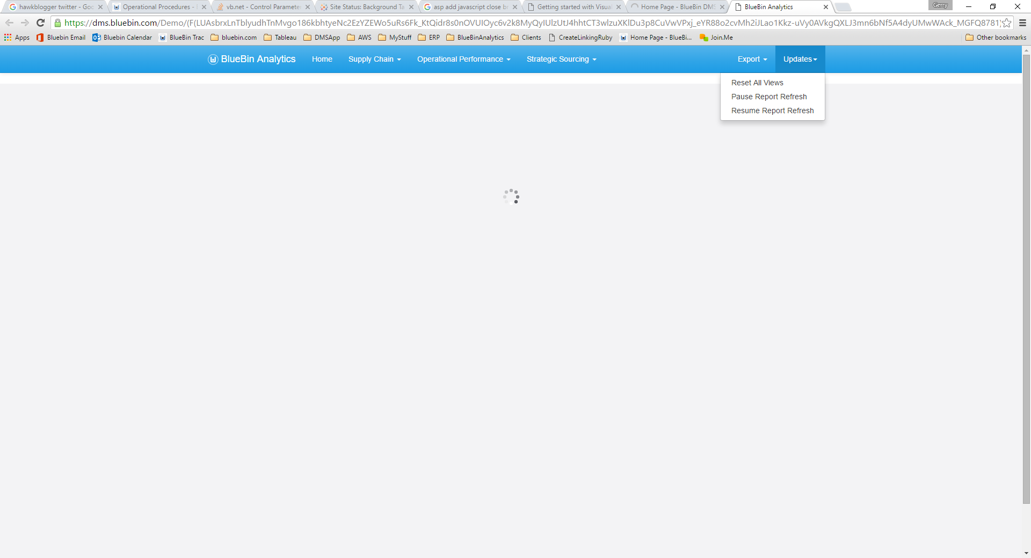

## Create Job Status job

### Description

There is a new internal report to view the status of jobs and client dashboards being up to date. It is run daily and available via subscription (create Trac ticket for subscription request) to view daily whether the data you are expecting is making it into the current Dashboard.

Default to ON

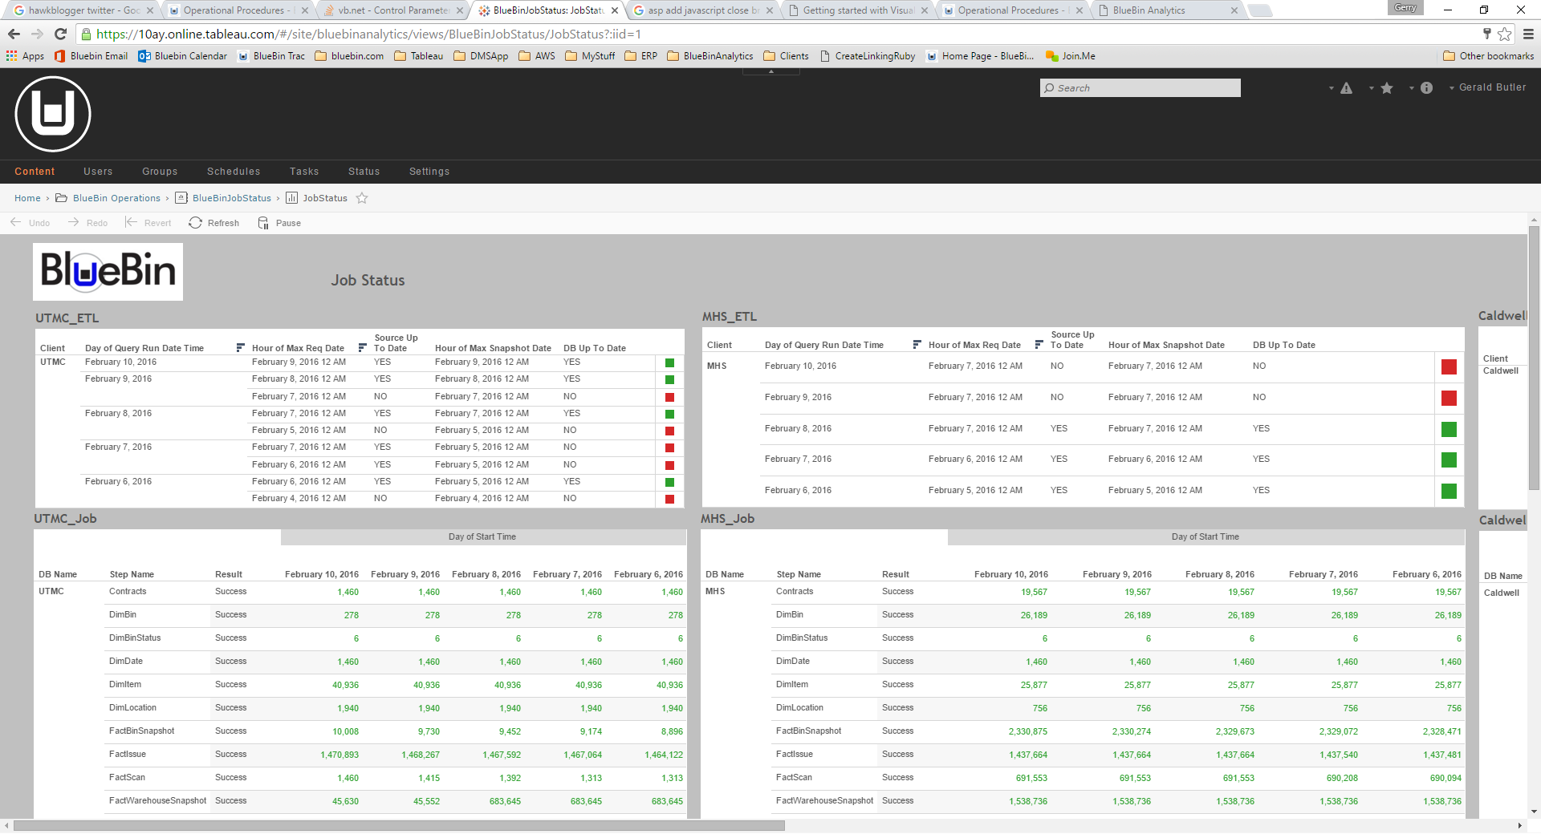

## New Dashboard Enhancement-Overall Line Vol Report-sort by Dept

### Description

Overall Line Volume now has the ability to Filter down to Facility and Location ID

Default to ON

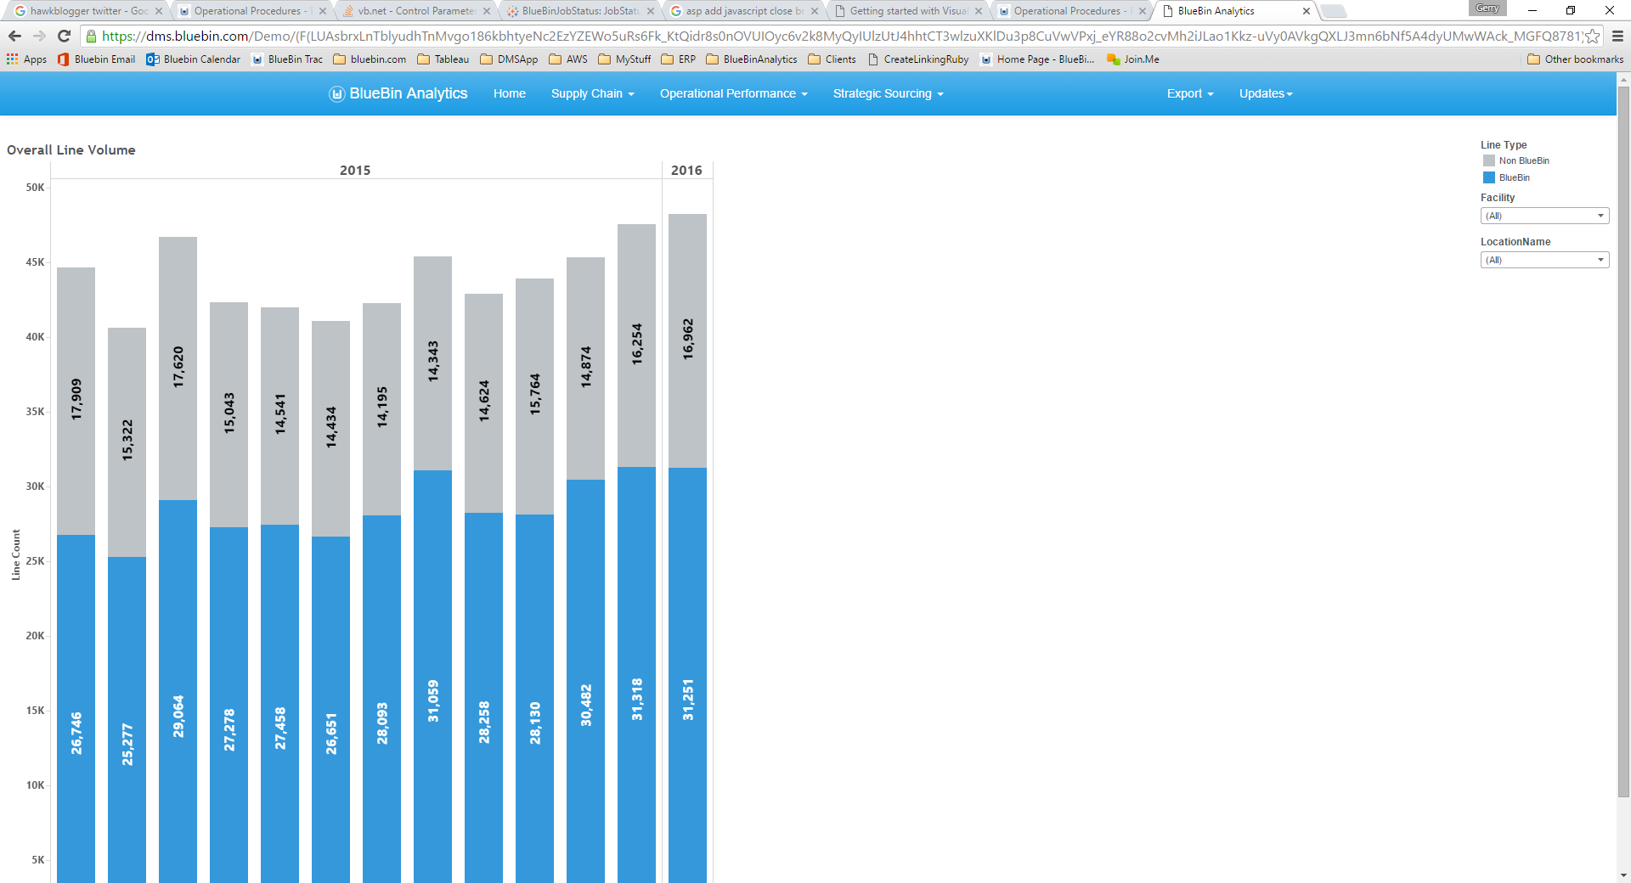

## New Menu Permissions for Users

### Description

There are now new restrictions for Users with Roles to limit the ability to access every module within the DMS application. These new restrictions include the ability to prevent access to:

QCN

Gemba

Hardware

Scanning

Admin (all Views)

Dashboard

Huddle Board

Upload Operational Procedures

Default to ON (Matching current application permissions)

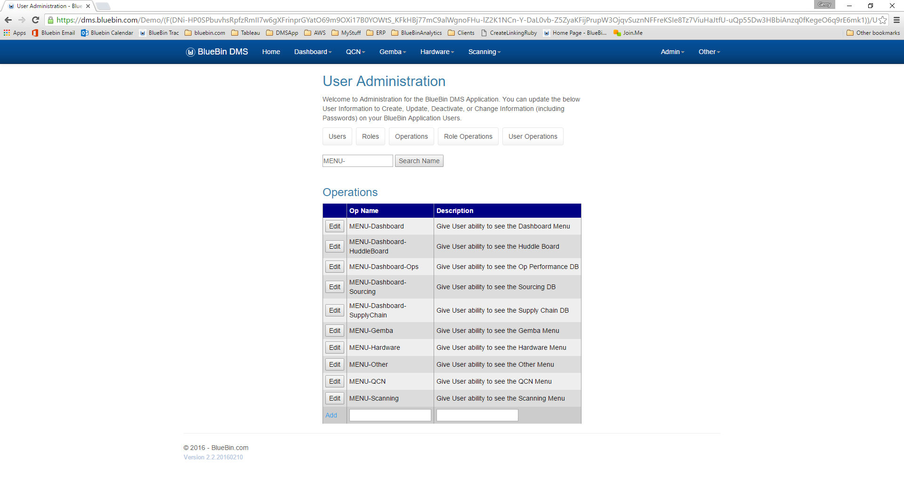

## Nesting Tree View for Scans Page

### Description

The scanning application (from v2.0) lists all the Batches/Nodes scanned in a long list. It is now possible to filter this list to single days if necessary using a new “Search Date” dropdown. Select the data to apply.

Default to ON

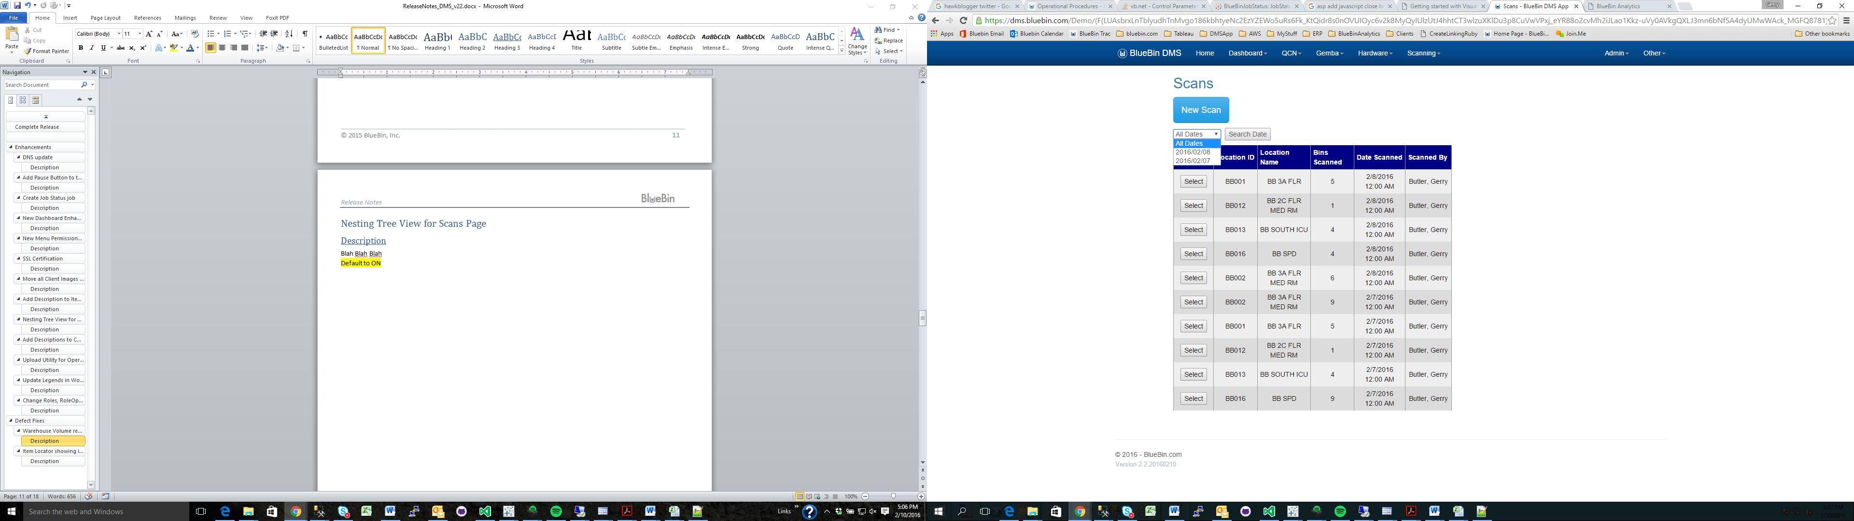

## Add Descriptions to Config Items

### Description

Previously config items did not have descriptions that were detailed on what the configs were. If you hover over any Config Name now, the description will show as a tool tip. These can only be edited by BlueBin Tech Personnel.

Default to ON

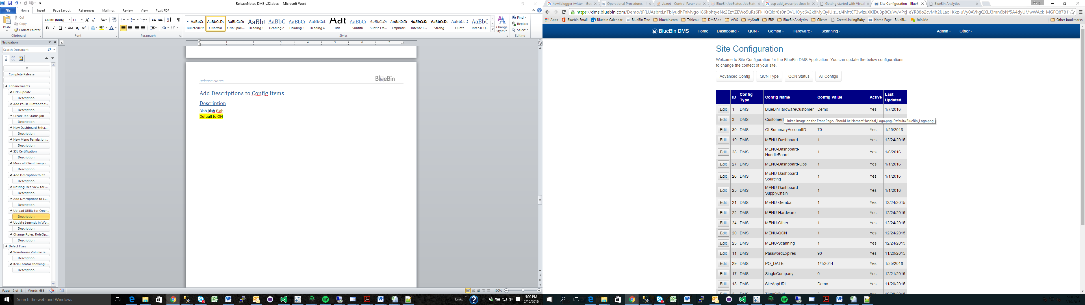

## Upload Utility for Operations Procedures

### Description

Operational Procedures were previously a static listing of documents based on a default list accessible by every client. These Op Procedures are in fact custom for each client and now separated by individual installation.

The default list is loaded, but can be edited during implementation using the Upload/Update Documents Module. Select the matching Group to upload to, the Document Name (match the name if you would like to replace an existing document) and browse for the document on your local machine. If successful, the application will give you a green message (red error if not) and the document will now be available. If updating a current document, the “Updated <date>” entry wil change to the current date.

Default to ON

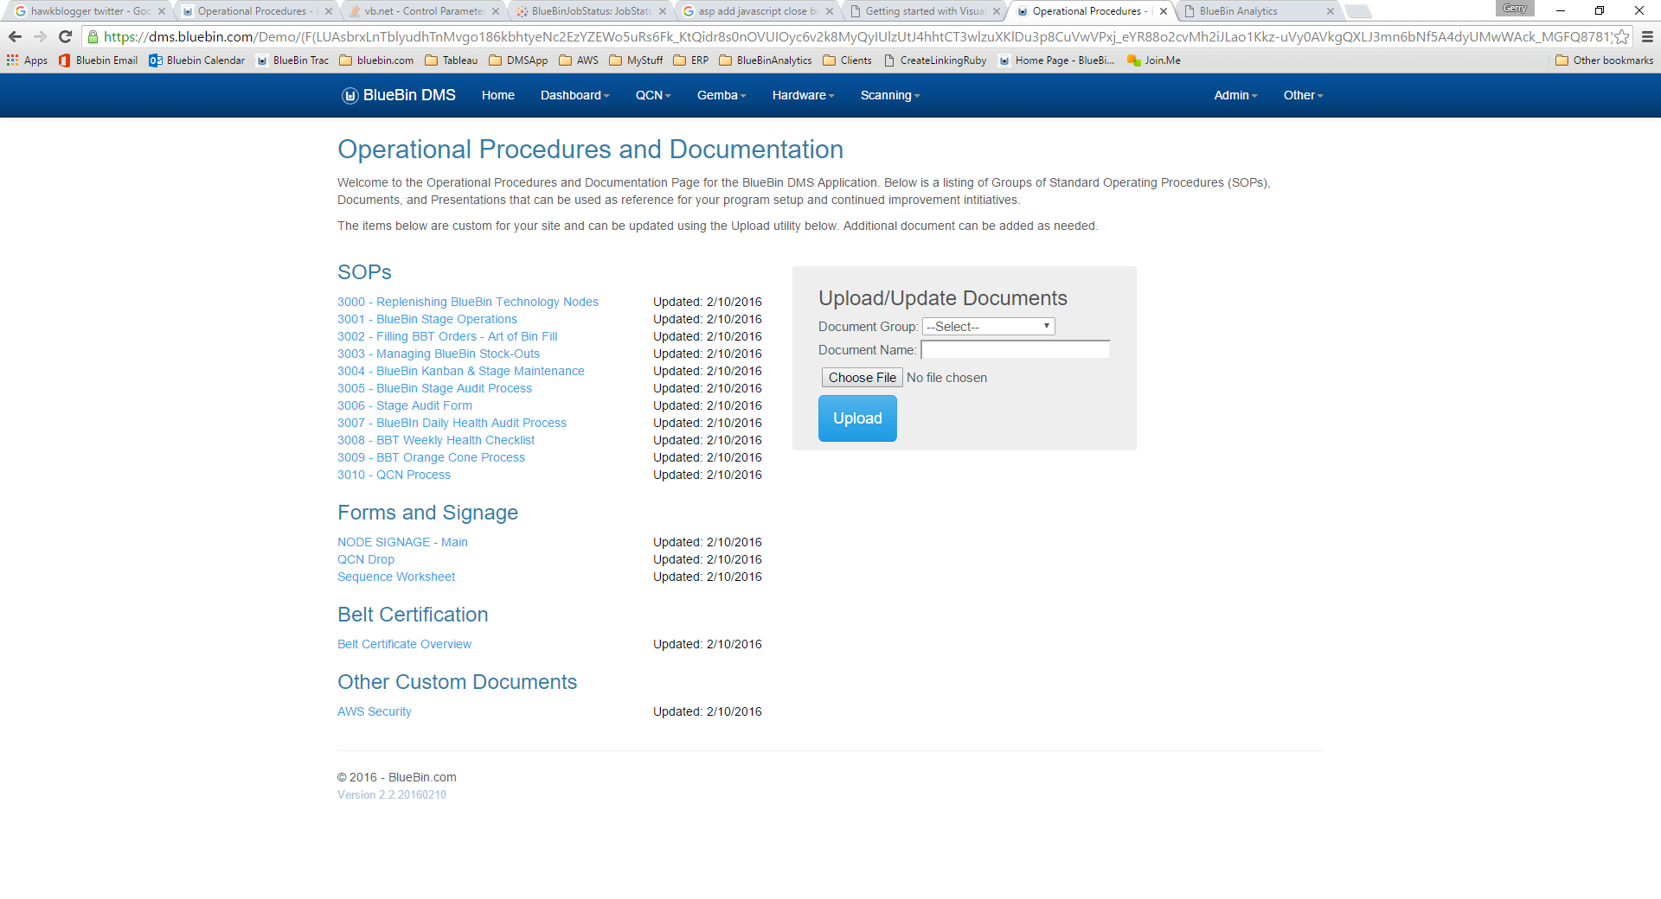

## Update Legends in Workbooks

### Description

Blah Blah Blah

Default to ON

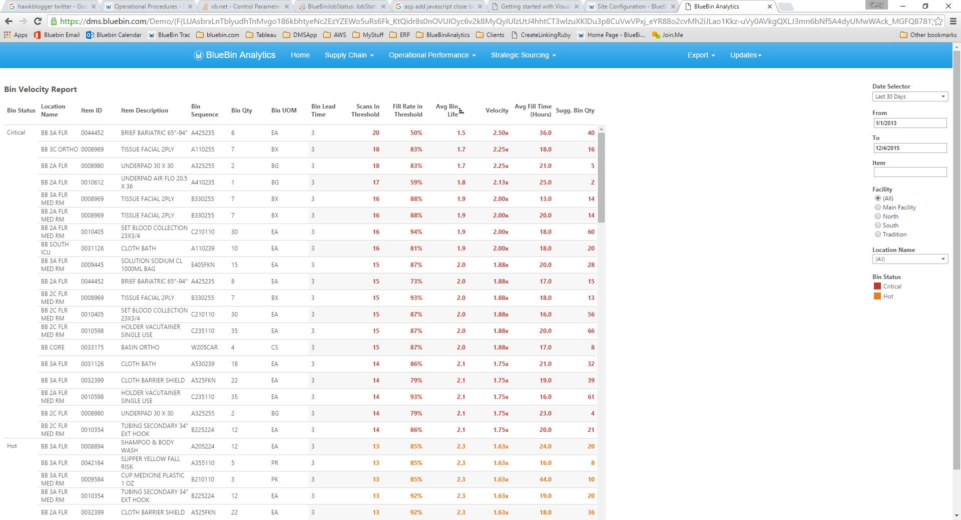

## Change Roles, RoleOperations, Operations to Wildcard search

### Description

There is now search functionality with the Role and Operations section to make it easier to troubleshoot individual access.

Default to ON

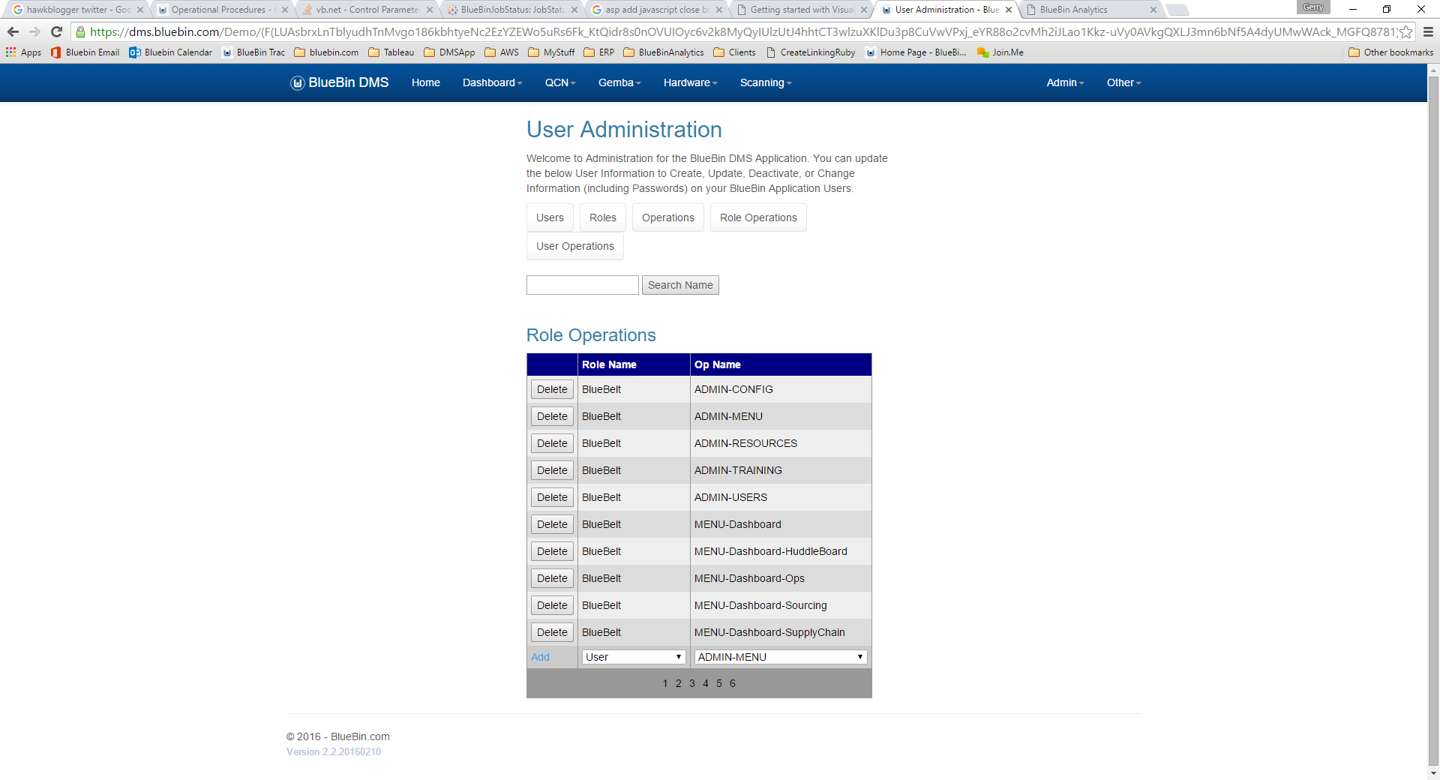

# Defect Fixes

## Warehouse Volume report in Dashboard

### Description

The Warehouse Volume Report previously pulled data from the REQ_LOCAITONS in the system (Nodes) instead of the LOCATION (warehouse location) causing incorrect reporting of the warehouse size. This has been altered to reflect the true value of the Warehouse.

Default to ON

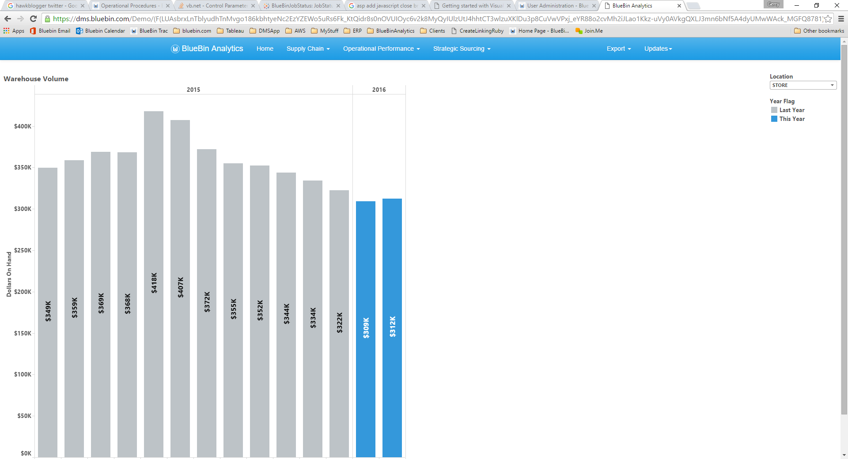

## DNS update

### Description

The navigation to the DMS application has changed from dashboard.bluebin.com to dms.bluebin.com. All previous address will redirect.

Default to ON

## SSL Certification

### Description

Blah Blah Blah

Default to ON

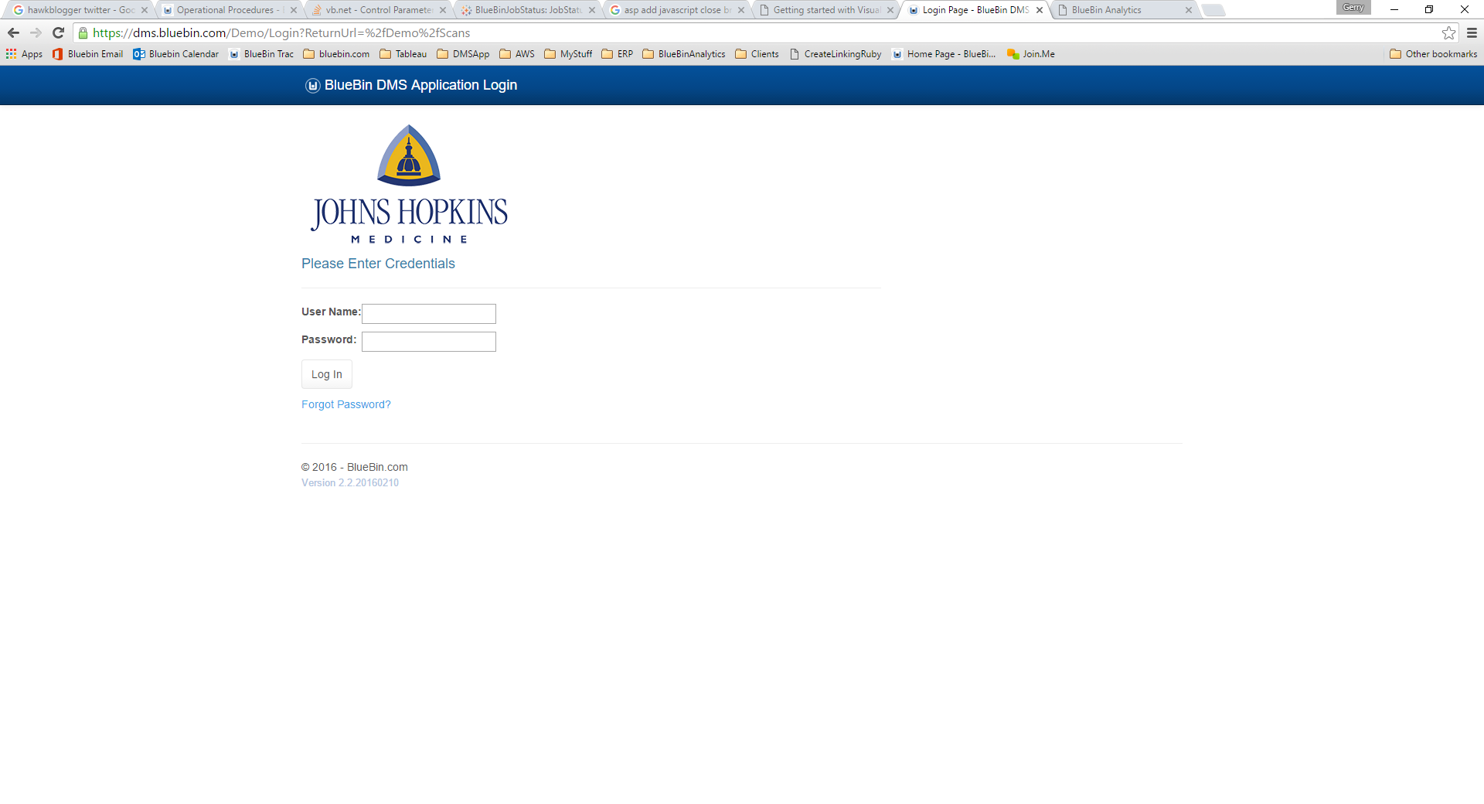

## Item Locator showing incorrect items

### Description

The Item Locator has been updated to pull multiple values in IC12 of Lawson (ITEMLOC table). It will now look in USERFIELD3 first, then USERFIELD1 if no values are present. This conforms with various site customizations.

Default to ON

## Move all Client Images into 1 directory

### Description

Previously each installation of the DMS contained the entire listing of logo images. This is now moved into a single directory for all to reference.

Default to ON