North Kitsap United (NKU) Youth Sports & Active Recreational Complex Project

Background & History:
NKU was formed several years ago by local volunteers, community leaders, youth sports organizations, Rotary members, and civic partners who recognized a growing need for recreational, athletic, health, and community spaces in North Kitsap.
What began as conversations around additional youth sports fields at our Kingston-North Kitsap Rotary Club in May 2018; evolved into a much larger community vision: creating a centralized destination for youth development, recreation, wellness, and community connection.

What NKU Will Be:
The NKU project is envisioned as a regional community asset that may ultimately include:
- Indoor and outdoor youth sports facilities
- Multi-use athletic fields (football, baseball, softball, lacrosse, soccer, etc.)
- Outdoor sport courts (Tennis, Pickleball, Volleyball, Basketball, etc.)
- Walking trails and open space
- Dog park
- 18-hole frisbee/disc golf course
- Playgrounds and family recreation areas
- Community gathering and event spaces
- Health and wellness programming
- Intergenerational recreation opportunities
- Youth mentorship and leadership programs
- A future YMCA facility with a pool serving North Kitsap families
It is ~100-acres of active recreation space and 300+ acres of extended open space and trails that backs-up against an already ~5,000-acre park (Port Gamble Heritage Park) that contains hundreds of miles worth of trails and connects to a world-class mountain bike park gaining national recognition. The goal is to create a centralized destination that serves youth, families, seniors, schools, tribal communities, nonprofits, and the broader North Kitsap region.
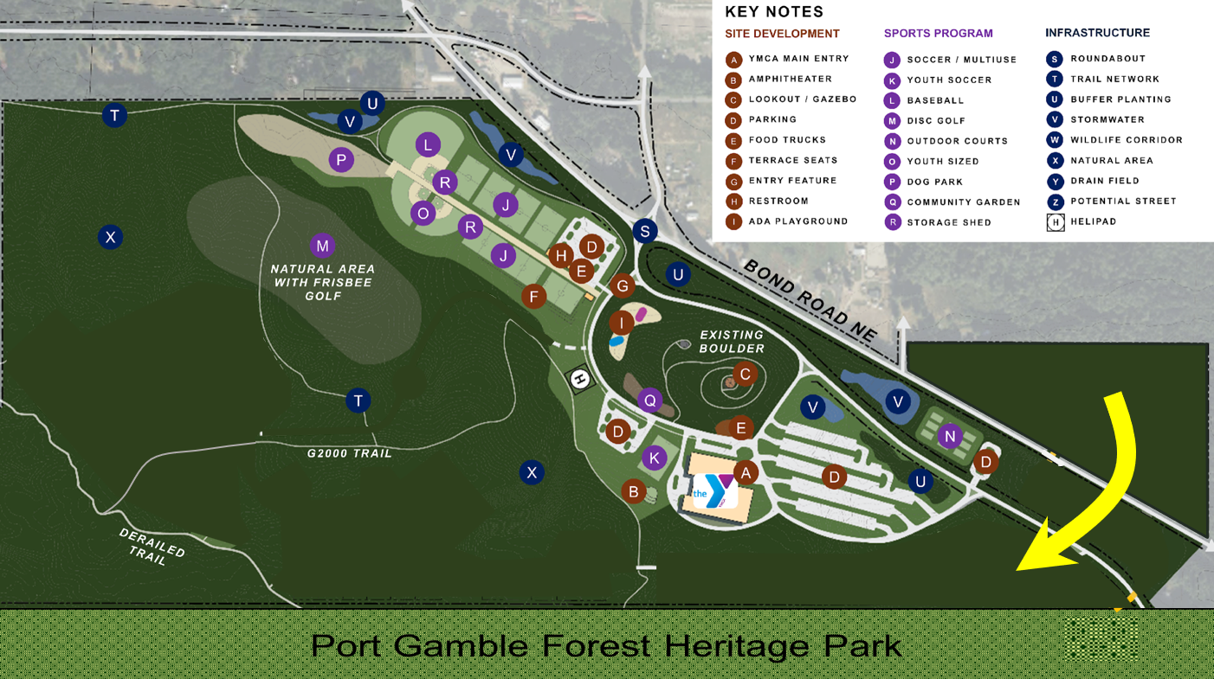
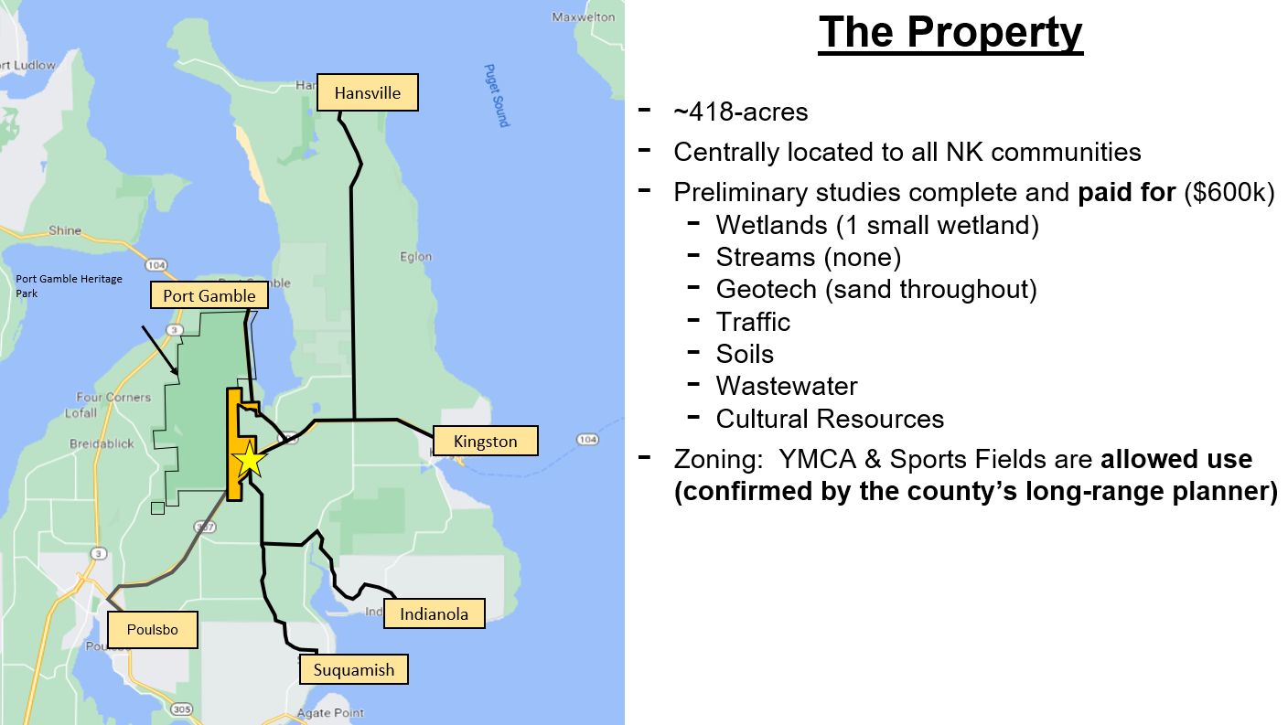

The Need & What Our Feasibility Study Found:
In December 2024, our Rotary Club paid for BERK Consulting to do a comprehensive feasibility study on the merits of regional recreation for North Kitsap. The study identified significant deficiencies in athletic fields, recreation opportunities, community gathering spaces, and indoor recreation infrastructure: our community has half the number of youth sports & active recreational facilities that an average community of our size has throughout WA and the US.
It also found that drive times for residents currently shuttling their kids to and from activities in Kingston, Hansville, Eglon, Indianola, Poulsbo and Suquamish would be cut roughly in half!
In a March 2026 economic study and analysis report, Kitsap Economic Development Alliance (KEDA) determined this project will likely bring over $100M to our local economy!
FYI - The last time Kitsap County built any youth field or active recreational amenity in North Kitsap was 1951 !! (Snider Park - Poulsbo). The population then was 75,724… today we have 277,673 residents.
The County did have a project of similar scope and size as this project back in 2003 - but no such complex was built.

Community Partnerships & Letters of Support:
- YMCA of Pierce & Kitsap Counties
- Kingston-North Kitsap Rotary Club
- Kingston Kiwanis Club
- Kingston Stakeholders
- Kitsap County Commissioners
- Kitsap County Parks Department
- Kitsap County Department of Community Development (DCD)
- Kitsap Transit
- Kingston Chamber of Commerce
- Port of Kingston
- The Mayor & City of Poulsbo
- Kitsap Economic Development Alliance (KEDA)
- WA State Representative Greg Nance
- Kingston Youth Sports Association (KYSA)
- North Kitsap Soccer Club (NKSC)
- Bainbridge Island Soccer Club (BISC)
- Kingston Kings Baseball
- Osprey’s Baseball & Softball
- North Kitsap Little League (NKLL)
- North Kitsap School District (NKSD)
- Port Gamble S’Klallam Tribe & Noo-Kayet Investments
- West Sound Disc Golf Association
We are in conversations to finalize a partnership with the Cal Ripken, Sr. Foundation and their team of general contractors (Sports Field Inc) to likely take the lead in the construction of our project.

The YMCA and their board voted to approve managing, operating and maintaining our sports fields in perpetuity before they build their facility on this property (likely 3-5 years away). We have a generous community member who has verbally committed $1M to establish an endowment fund to pay for the maintenance of the fields – to keep us from taxing the people in our community to have this tremendous benefit in our backyard.
The YMCA will also address another major unmet need in our community – child care. Right now, it is a minimum of a 3 to 4 year waiting list for child care in our community… why our school enrollment continues to suffer and why we can only seem to attract retirees to our community. A bedroom, retirement community is a dying community… one of the many reasons why we believe our County continues to have a growing deficit year after year.
For more information about our project, visit our website: www.northkitsapunited.com

