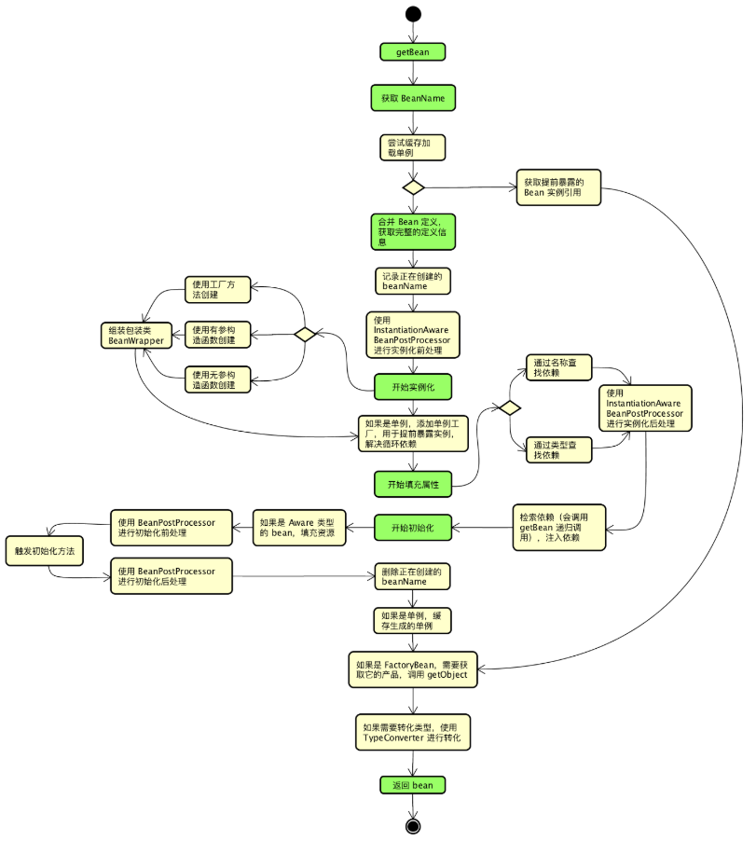

* 实例化BeanFactoryPostProcessor实现类
* 调用BeanFactoryPostProcessor#postProcessBeanFactory
* 实例化BeanPostProcessor实现类
* 调用InstantiationAwareBeanPostProcessor#postProcessBeforeInstantiation
* 实例化Bean
* 调用InstantiationAwareBeanProcessor#postProcessAfterInstantiation
* 调用InstantiationAwareBeanPostProcessor#postProcessPropertyValues
* 为Bean注入属性
* 调用BeanNameAware#setBeanName
* 调用BeanClassLoaderAware#setBeanClassLoader
* 调用BeanFactoryAware#setBeanFactory
* 调用BeanPostProcessor#postProcessBeforeInitialization
* 调用InitializingBean#afterPropertiesSet
* 调用Bean的init-method
* 调用BeanPostProcessor#postProcessAfterInitialization