[Required Information]

That section must be filled by the content editor/writer.

The information in that section is necessary for the web developer.

While you are reviewing the content make sure you apply some best practices:

* HTML first, if you have an alternative version (word, pdf) a link will be on the page.
* Use only the predefine style in word, Heading 1 Heading 2 etc.
* Anywhere there is link we should have the detail in bracket
  + example:
    - [*EN 301 549* (PDF, 2.3MB)](https://www.etsi.org/deliver/etsi_en/301500_301599/301549/03.02.01_60/en_301549v030201p.pdf)
    - [*EN 301 549* (PDF 2.3Mo) (disponible seulement en anglais)](https://www.etsi.org/deliver/etsi_en/301500_301599/301549/03.02.01_60/en_301549v030201p.pdf)

**Short Introduction / Description**

When to use sign language interpretation and bilingual videos, tools and samples of accessible videos.

category:

  - How to's

sub-category:

  - Create web content

audience:

  - Everyone

Language of Audio/Video Content

Table of Contents

Language of Audio/Video Content 4

Sign language interpretation 4

Bilingual videos 4

Sample accessible video 4

# Language of Audio/Video Content

The first rule is to avoid bilingual videos.

## Sign language interpretation

Closed Captions and transcript are enough for a unilingual video with audio to meet WCAG 2.1, but to reach everyone you need to add sign language interpretation (WCAG AAA).

## Bilingual videos

Bilingual video is a subject to the Official Language Act and needs to include the audio of the speaker's language, interpreted in official languages.

Closed captions have to be all in the spoken language, and they have to be synchronized with the speech. English speaker - English captions, and vice versa for French.

* Captions are required on videos and need to be synchronized with the audio. English speaker should have English captions and French speaker should have French captions. Captions are used by people who are Deaf, have cognitive difficulties or process written information better than audio and others who cannot hear the audio, for example, in loud (busses) or quiet environments (library), etc. If there are no captions these users will be left out.

### Sample accessible video

A good example of an accessible video, from the ESDC, Treasury Board of Canada’s live broadcast of the launch of Canada’s first public service accessibility strategy. ASL, LSQ, closed captioning and transcript included. Note that the event was bilingual, but in the end, we changed one bilingual video into two videos: one in French and one in English.

Bilingual video, French version: [La première Stratégie sur l’accessibilité de la fonction publique du Canada](https://www.youtube.com/watch?v=acWNxPWQnrE)

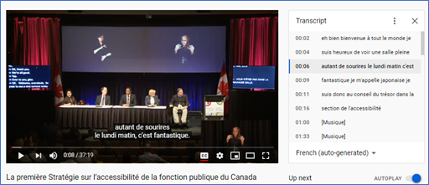

Bilingual video, English version: [Canada’s First Public Service Accessibility Strategy](https://www.youtube.com/watch?v=zhrz1NIZkjc&list=PLSUro1UBralqyMDgYaLlF7q3gMGEvEyte&index=2)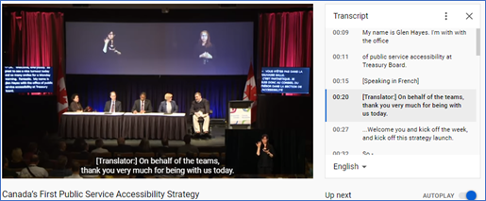

#### Bad example

Here is a video that has the overlay of the subtitles over captions, which creates an obstruction of text, and makes it not accessible: [Linguistic Duality Day](https://www.youtube.com/watch?v=L7JOlOQAK58), from 2017.