**Documentation for Module 1 Project**

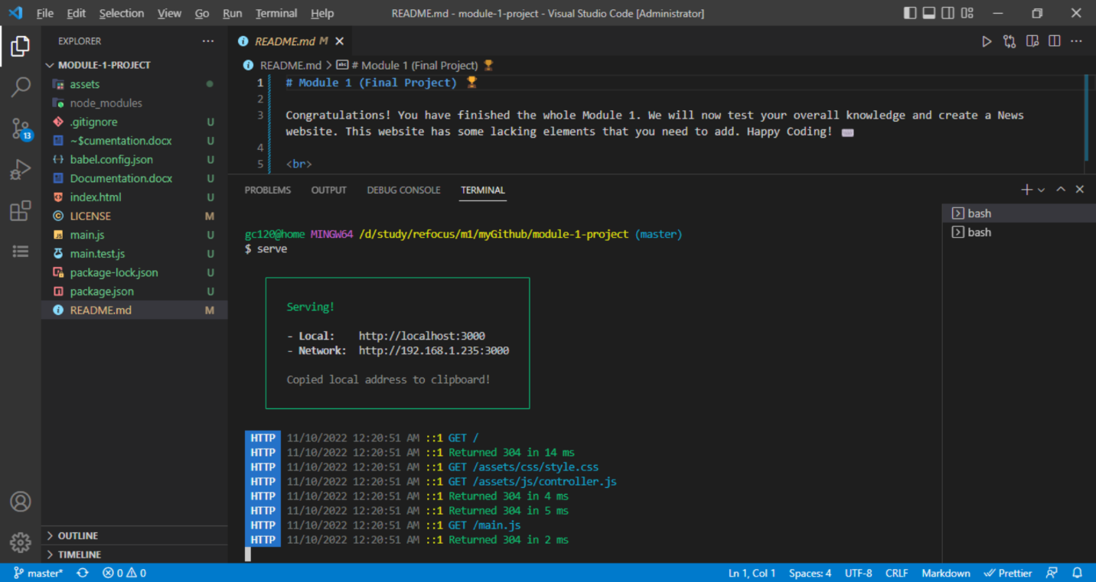

After running “npm install” command in the CLI, launching the project webpage using “**serve”** command.

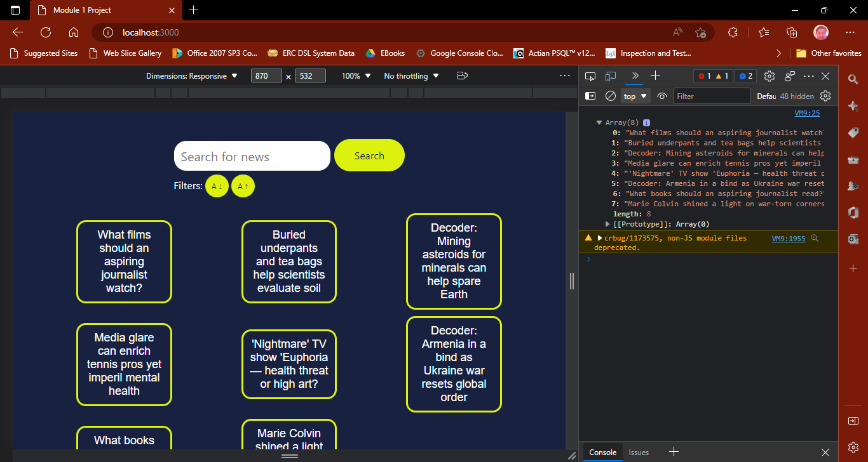

Sample web page output for the project after invoking “serve” on CLI