**Delivery Hiring**

O processo de integração Delivery Hiring tem por finalidade obter o orçamento de duas empresas de delivery para a entrega de produtos de um E-Commerce. A cada 60 minutos, o processo de integração acessa a base de dados do sistema de vendas e copia os dados referente as vendas realizadas nos últimos 60 minutos. Os dados referentes a cada venda são encaminhados separadamente para duas empresas de delivery. As empresas de delivery disponibilizam para seus clientes, APIs para simular e obter os orçamentos. Por meio dessas APIs, o processo de integração interage com as aplicações das empresas de delivery e obtém os orçamentos necessários para a entrega dos produtos. A seguir é descrito o conjunto de tarefas (tratamentos dos dados e comunicação com as APIs) realizados pelo processo de integração para viabilizar comunicação entre as aplicações envolvidas nesse cenário.

A porta P1 executa a operação Read, lê os registros da base de dados do sistema de vendas, os registros obtidos são encaminhados para a tarefa T1 por meio do slot S1. A tarefa T1 é um spliter, essa tarefa recebe os registros como uma mensagem única e os separa, ou seja, para cada registro existente na mensagem recebida é gerada uma mensagem única, contendo apenas os dados referente a um registro.

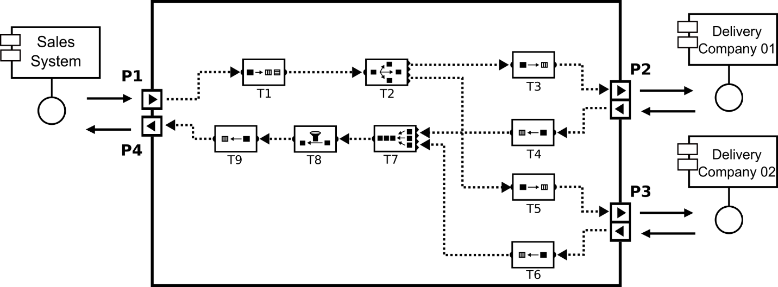

S1

Verificar a possibilidade de escolher o melhor orçamento (valor e tempo de entrega)

Replicador,

**Rights and Obligations of the STORE**

**Rights**

The STORE has the right to send orders to the Fast Delivery company from Monday to Friday, between 8:30 am and 6:30 pm.

The STORE has the right to send up to 10 delivery orders per day to the Fast Delivery company and up to 200 delivery orders per month.

**Obligations**

A delivery request to the Fast Delivery company must contain the origin address, where the package/product will be picked up, and a destination address, where the delivery must delivery.

**Obligations of the Fast Delivery Company**

**Obligations**

The Fast Delivery company must respond to requests within a maximum of 15 minutes.

The Delivery System must provide a budget containing the cost of the service that will be provided.

**Representar os termos e condições em um contrato utilizando o Jabuti DSL**

The request for deliveries is carried out automatically through an integration process. In this context, communication occurs independently between the integration process and each application (Sales System and Delivery System). The communication between the integration process and the applications occurs through the communication ports. Considering the Delivery Hiring case study, the communication between the integration process and the Sales System application occurs through ports **A** and **C**, and the communication with the Delivery System application occurs through port **B**.

Considering that the integration process belongs to STORE and the aim is to monitor the delivery requests made to the Delivery System application, it is possible to define a smart contract using the Jabuti DSL. Through this smart contract, it is possible to express the terms and conditions defined for the delivery service providers and monitor the communication between the integration process and the Delivery System application through port **B**.

The following describes the terms and conditions regarding the provision of service by the company Fast Delivery, considering the communication rules between the integration process and the Delivery System.

**Integration Process**

**Rights of the Integration Process**

The integration process has the right to send orders to the Delivery System from Monday to Friday, between 8:30 am and 6:30 pm.

The integration process has the right to send up to 10 delivery orders per day to the Delivery System and cannot exceed 200 delivery orders per month.

**Obligations of the Integration Process**

A delivery order sent to the Delivery System must contain only an origin address, where the package/product will be picked up, and a destination address, where the delivery must take place.

**Delivery System**

**Obligations of the Delivery System**

The Delivery System must respond to requests within a maximum of 15 minutes.

The Delivery System must provide a budget containing the cost of the service that will be provided.