**Introduction**

This document describes a trading system I have developed (from here on, "the system"), which allows for unsupervised operation and can therefore be run in fully automated mode.

The system is based on extremely basic concepts, it does not use technical analysis or other techniques that can be prone to interpretation, and can be applied to almost any trading instrument.

The performance and predictability of the system are more similar to a fixed-income investment than the typical trading setup, making the system interesting as an extra source of regular income.

Following is a step-by-step guide on how to set up and maintain the system, as well as a discussion of its behavior over time.

**1. Choose what to trade**

For reasons that will become apparent later on, the system's performance is directly correlated with the volatility and inversely correlated with the width of the historical range of the traded instrument(s).

Also, although one could run the system on one single instrument, running it on 3 or more uncorrelated instruments at the same time can give a more stable and predictable outcome.

For the sake of consistency, from here on all the examples will refer to a system trading in a forex environment; as stated in the introduction, the system can be employed in any other setting, though.

**2. Preliminary Operations**

1. For each traded instrument, identify a reasonably long historical period, and take note of min. and max. values for that period. As an example, if I look at EUR/USD between 2009 and 2013 (see Picture 1), I can use 1.19 as min. and 1.51 as max. From now on, I will refer to such minimum and maximum values as “B0” and “S0”, respectively.

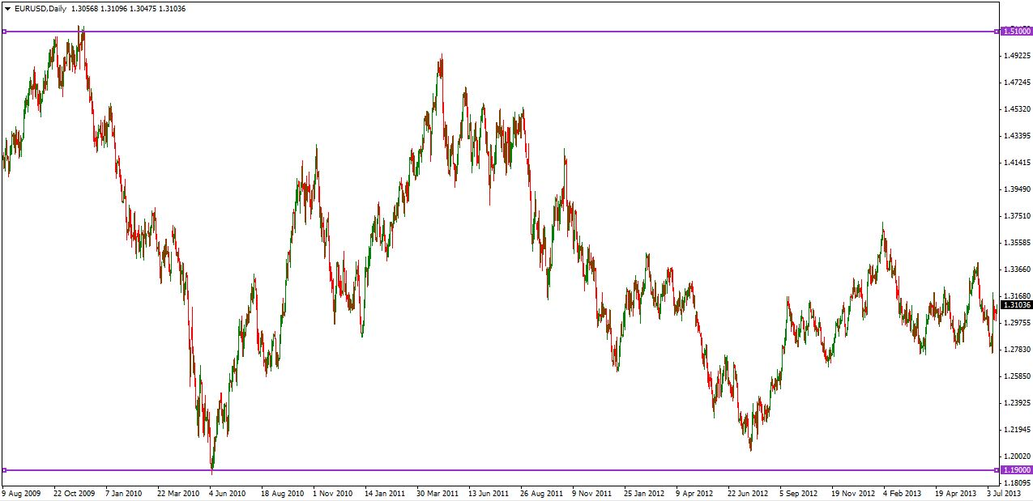

1. Divide the range in tight steps; the choice of the step width will depend on the instrument volatility (the more volatility, the wider the steps) and the transaction cost (or spread) levied by the broker; the steeper the cost, the wider the step. As an example, one could use 30 PIPs for EUR/USD, 20 PIPs for USD/CAD, and so on.
2. Set Trade Size: the system works mostly with fixed size trades, and such trade size should be set based on the starting capital and the number of the traded instruments; setting the trade size too big may cause the need to invest more capital downstream to keep the system running. As a rule of thumb, trade size should be set to <invested capital> / < number of traded instruments> / r , where r can be anywhere from 3 (more aggressive) to 6 (less aggressive). So, for example, if starting capital is $10,000 and the system trades 4 pairs, one could set trade size to $80 (r=3.1) or $40 (r=6.2)
3. Set the Leverage. The system can use both fixed and variable leverage, but because most brokers only offer the former, this whole document considers fixed-leverage settings only. When trading Forex manually, the system maintenance is easier when leverage is set towards the lower end of the spectrum, at 25x.
4. For each step, create one BUY and one SELL pending order at the same price, setting TP equal to the step width, and SL to 100%.

Example for Trade Size=$80 and Leverage=25x:

* ...
* Buy EUR/USD, Amount=$80, Price=1.3000, Take Profit=1.3030, Stop Loss=1.2600
* Sell EUR/USD, Amount=$80, Price=1.3000, Take Profit=1.2970, Stop Loss=1.3400
* Buy EUR/USD, Amount=$80, Price=1.3030, Take Profit=1.3060, Stop Loss=1.2630
* Sell EUR/USD, Amount=$80, Price=1.3030, Take Profit=1.3000, Stop Loss=1.3430
* ...

**3. Ongoing Operations**

As the price moves and step levels are reached, orders are opened, and open positions reach TP and close. Every time an open position reaches its TP and close, it must be replaced with an identical pending order. Also, make sure all positions are carried over the weekend

**4. Managing Stop Loss levels**

StopLoss must never be taken. That means that, over time, when prices move near the SL levels of previously opened positions, such SLs should be moved further away. It is advisable to always keep at least 200 pips of “safety zone” above the SELL SLs and below the BUY SLs. I personally find using a spreadsheet like <StopLoss.xlsx> very convenient; also, remember to periodically update it to reflect current SL values in your system. Until the range between BUY and SELL SL values is at least 1000 (in a 25x leverage system), it is advisable not to start withdrawing cash from the available balance, as it might be needed in the growth phase to keep SLs in check.

**5. Anchors**

As will be clear once the system has been running for some time (6-8 weeks), while profits keep coming at a regular pace, equity follows a rather “bumpy”, albeit rising path (see “Expected System Behavior”); in order to level out the equity curve, it is advisable (though not essential) to add a number of “Anchors”. Anchors are additional positions that should be opened when price reaches certain levels; specifically:

* S0: Anchor should be opened as a SELL position when price reaches S0 (top of the channel);
* S10: Anchor should be opened as a SELL position when price reaches S0-(S0-B0)*0.1
* S20: Anchor should be opened as a SELL position when price reaches S0-(S0-B0)*0.2
* B20 Anchor should be opened as a BUY position when price reaches B0+(S0-B0)*0.2
* B10: Anchor should be opened as a BUY position when price reaches B0+(S0-B0)*0.1
* B0: Anchor should be opened as a BUY position when price reaches B0 (bottom of the channel)

All anchors should be opened with no take profit; that is, either set it to 0 (if the broker allows it) or set it to 100% (400pips for a 25x leverage system); in the latter case, you should extend as needed, in the same way you do for SL on standard positions.

SL should be set and handled in the same way as for standard positions.

Ideally, Anchors should be opened with same amount and higher leverage than standard position; however, since most brokers do not allow variable leverage, we will use same leverage, higher amount settings throughout this document. Anchors’ size should be a multiple of standard trade size; a rough setting could be 4x for B20 and S20, 8x for B10 and S10, and 16x for B0 and S0. A finer estimate of the anchors’ multipliers can be found here: <Anchors.xlsx>

**5. Expected System Behavior**

In the initial phase since the inception, and for each instrument, the system works by creating a “basket” of open BUY and SELL positions at a constant distance (“Step”); the first time price touches a new step level (a level never reached since the start of the system), a BUY and a SELL order at the same price are executed; at the same time, a previously opened position is closed by TP (a SELL position if price is moving down or a BUY position if price is moving up).

Therefore, the first period after the system inception, as price oscillates between a number of steps, the number of open positions will increase quickly, as will the invested amount; once the price has carved a reasonably stable range, however, reaching any particular step will entail opening one position only (BUY or SELL), because the opposite will already be there; therefore, the invested amount will grow inverse-exponentially (i.e. will taper off), while profits will follow a linear growth curve that started at inception.

This means that, after an initial phase (which I will refer to as “the dig”), where equity could be in red (because the cost of digging exceeds the profits made in the same period), when prices oscillate in a relatively “known” (e.g. previously visited) price range, the break even will come, and from that point on the system will display a relatively fixed invested amount, and constantly growing profits from closed positions.

The amount of time the system takes to complete the initial dig is directly correlated to the volatility of the instrument, because the more step-crossing moves, the more profits will close; it is also inversely correlated to the “trendiness” of the instrument: the stronger the trend a chosen instrument is in at system inception, the stronger the pace of the digging (hence the pace of the increase in invested amount); therefore, choosing an instrument at the beginning of a strong and long-running trend will postpone the breakeven for that particular instrument.

For the same reason, it is advisable to start the system on multiple instruments simultaneously: should one or two of them find themselves in a strong trend at system inception, the equity imbalance they would generate in the initial phase would be averaged out by the remaining instruments exhibiting a less trendy behavior. In any case, keep in mind that Anchors do precisely the job to keep equity in balance, so long term the system will be balanced even with one instrument only; the problem with anchors is that they typically get into the picture at a later stage, when price gets in the vicinity (20%) of the historical minimum or maximum values. Obviously, starting multiple instruments means either multiplying the invested amount or dividing the trade size accordingly.

Working with high volatile instruments such as Forex, and choosing uncorrelated instruments (to minimize the chance that the appearance of a trend in one does not generate a similar or inverse trend in another one), the experience shows that a 4-currencies system reaches a stable state in 4 to 8 weeks (see below).

