Emma

links:
website: https://myemma.com
github: https://github.com/jerryneal/bottledweather

Features:

  - Templates can be customized with the Emma newsletter app. An html editor is available for the code and it is possible to upload html code. Template editor is simple and easy to use.
  - Lits of contacts can be managed by the user and segmented so a specific group within the list will get the email.
  - Emails can be sent with this app.
  - Email analytics is stored on the website itself. It can tell if an email has bounced, a user from the list opened the email and other problems. It stores information on past mailings to be used for later use.

Pros:
  - Programmed in python and there are several github libraries that are focused on using this app.
  - App's template interface is simple and easy to use. Interface is simple to understand and easy to use right away.
  - Events can be done with recipients of your emails which means there is a level of interactivity with the user.
  - Can upload CSV files.
  - Python code is up to date with current one.

Cons:

- There are issues with emails bouncing. Failed delivery of emails to their recipients but it seems to be a bug.
- Not many issues seem to present in this newsletter tool.

Templates
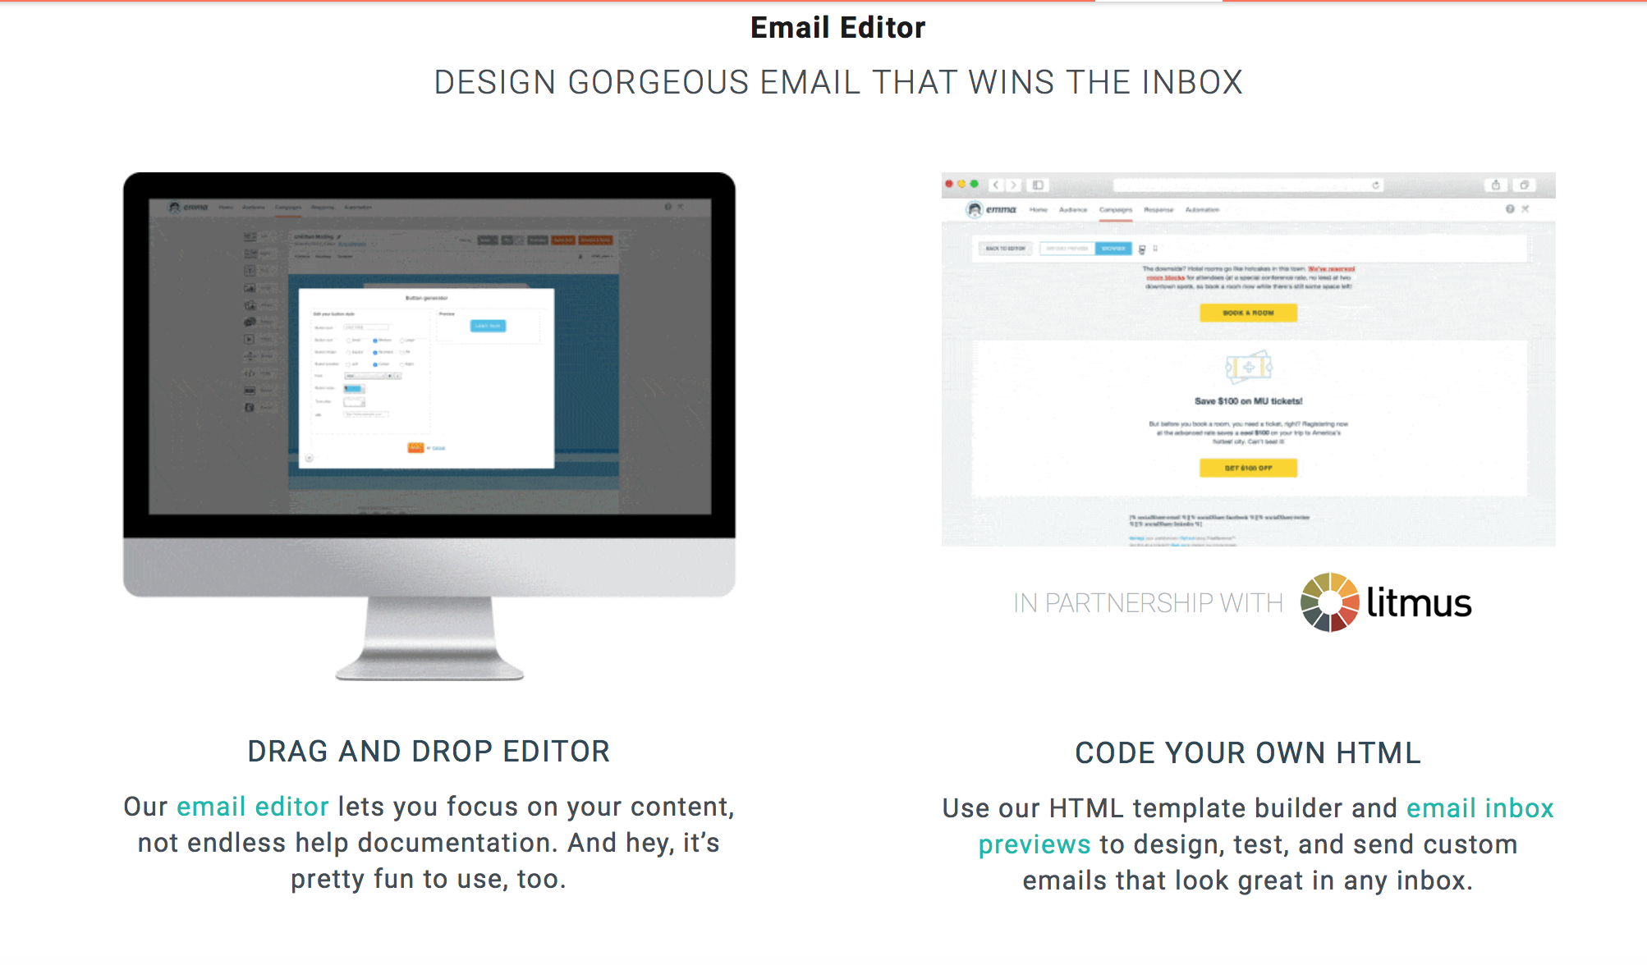

Analytics

