HF Noise Reduction Unit
Quick-Reference User Guide — OLED display build
This little box sits between your receiver's audio output and your speaker/headphones. It listens continuously and, in real time, quietens down atmospheric and band noise and nulls out steady whistles and heterodynes — while trying hard not to make speech sound processed or robotic in the process. Nothing here is destructive: every control just changes how the effect is applied, and BYPASS always gives you the raw signal back instantly for comparison.

The Controls
Three knobs and two buttons are always live — no menu-diving needed for the controls you'll reach for most:
Control | Type | What it does
NR AMOUNT | Knob, always live | Overall noise-reduction strength. Fully anti-clockwise = no reduction, fully clockwise = maximum. Start around the middle and back it off if voices start to sound “watery” or robotic.
NOTCH DEPTH | Knob, always live | How deeply steady whistles/heterodynes get nulled once the unit locks onto them. Turn up for a harder null on a persistent carrier; turn down if it's nulling something you actually want to hear.
OUTPUT GAIN | Knob, always live | Final volume trim after all processing, −12 dB to +12 dB. Centre ≈ 0 dB (unity).
BYPASS | Push-button, toggle | Instantly A/B compares against the raw, unprocessed audio. Screen shows “BYPASSED” in large text while engaged. Good first step whenever you want to check the unit is actually helping.
LIMITER | Push-button, toggle | Turns on a gentle soft limiter that rounds off loud peaks instead of letting them clip harshly. Leave it on unless you have a specific reason not to — it's on by default.
ENCODER (turn) | Rotary | Adjusts whichever menu parameter is currently selected (see below). Each detent is a small step.
ENCODER (press) | Push-button | Steps to the next menu parameter (there are 9, then it wraps back to the first). The screen header briefly flashes to confirm the new selection.

Reading the Screen
From top to bottom (numbers below match the diagram):
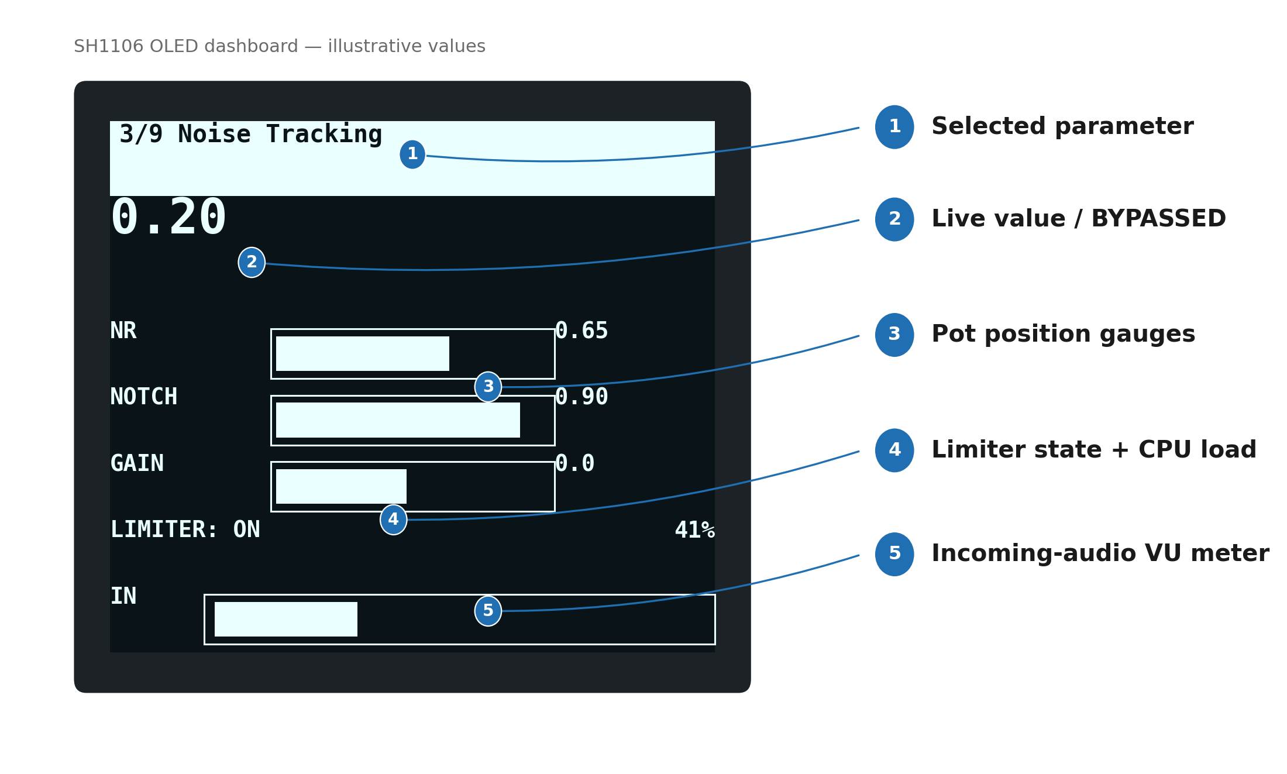
- Selected parameter — which of the 9 menu parameters is currently chosen (name + a running number, e.g. “3/9”), and briefly flashes when you press the encoder to change it.
- Live value / BYPASSED — that parameter's current value. Shows “BYPASSED” instead whenever the BYPASS button is engaged, since none of these controls are doing anything to the audio at that moment.
- Pot position gauges (NR / NOTCH / GAIN) — always show where the three knobs are currently set, regardless of what's selected in the menu above.
- Limiter state + CPU load — the limiter's on/off state, and the processor's CPU load on the right (just a headroom indicator — nothing to worry about unless it's pinned near 100%).
- Incoming-audio VU meter — a live level meter of the audio reaching the unit, so you can see straight away whether signal is getting through and get a feel for gain-staging.

The Menu — 9 Adjustable Parameters
Press the encoder to step through these; turn it to adjust whichever one is currently selected. All of them have sensible defaults — you shouldn't need to touch most of these day-to-day, but they're here for fine-tuning to your ear, your rig, and band conditions.
Parameter | Default | What it does | Turn it up when…
Oversub | 1.6 | How aggressively the spectral-subtraction stage removes noise energy from each frequency bin. | Band noise is heavy and you want it gone — but too high sounds “watery”/warbly, so back it off if voices start to sound processed.
Spectral Floor | 0.10 | The minimum amount of the original signal always left in, even in bins judged to be pure noise — a safety net against total silence between words. | You hear odd musical/chirping artefacts in the quiet gaps — raising this smooths them out at the cost of a bit more residual hiss.
Noise Tracking | 0.20 | How fast the unit updates its idea of “what the noise floor currently is.” | Band conditions are changing quickly and the unit feels like it's a step behind. Lower it (toward frozen) on a stable, quiet band for steadier reduction.
Notch Width | 60 Hz | How wide a notch is cut around each detected whistle/heterodyne. | A tone wanders in frequency and keeps slipping partly out of the notch. Keep it narrow when tones are steady, to avoid nibbling nearby audio.
Notch Attack | 40 ms | How quickly a newly confirmed tone gets notched once the unit locks onto it. | You want whistles suppressed the instant they're detected. Rarely needs changing.
Notch Release | 400 ms | How slowly a notch relaxes once its tone disappears. | You're copying CW and don't want the notch snapping open/shut between dits and dahs — raise it. Lower it if a notch lingers annoyingly after a tone is gone.
Speech Enhance | 0.25 | A gentle boost centred on the 300–3000 Hz voice band, to help intelligibility. | Copy is noise-reduced but still feels muffled or hard to pick out — nudge this up.
Gain Attack | 8 ms | How fast the overall noise-reduction amount reacts as a signal appears. | Rarely needs changing — it's already fast enough to catch speech onsets.
Gain Release | 80 ms | How fast the overall noise-reduction amount relaxes back after a signal drops. | Audio pumps or “breathes” noticeably after loud words/peaks — raising this smooths that out.

Suggested Starting Points
Situation | Try this
General atmospheric/static hiss on SSB | Start from the defaults. Turn NR AMOUNT up until the hiss is well down, then back off slightly the moment voices start sounding “watery.”
Persistent whistle / heterodyne / carrier | Turn NOTCH DEPTH up toward maximum. If the tone drifts and keeps escaping the notch, increase the Notch Width menu parameter a little.
Weak SSB voice, want max clarity | Raise the Speech Enhance menu parameter (try 0.4–0.5) alongside a moderate NR AMOUNT.
Copying CW near a noisy/busy band | Leave Notch Release at its default (400 ms) or raise it — this stops notches snapping open and shut between dits and dahs.
Audio distorting or crackling on loud peaks | Make sure LIMITER is on (default), then reduce OUTPUT GAIN a little.
Not sure the unit is helping at all | Press BYPASS to A/B compare instantly against the raw signal.

A Few Notes
- This is very much a work in progress, being tested and refined with help from the club — if something behaves oddly or you think of a better default, say so.
- All settings apply instantly; there's no “save” step and nothing is ever damaged by experimenting.
- If in doubt, BYPASS is your friend — it always tells you exactly what the unit is doing for you (or not) at that moment.

