How to build the RXDSP_4732

I’s simple to build ths project because it is a standard Arduino project and requires only the IDE and tre additional libraries.

Here the main steps:

**STEP 1 -** Install the latest Arduino ide from: [www.arduino.cc/en/software/](http://www.arduino.cc/en/software/)

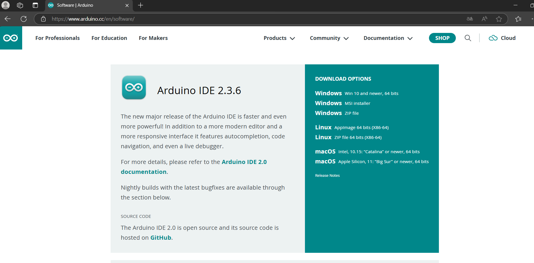

In this tutorial I installed the version 2.3.6 , but it must works also with next versions.

**STEP 2 -** Download the project from the site: github.com/gcallipo

and next move to the RXDSP_4732 project folder folder

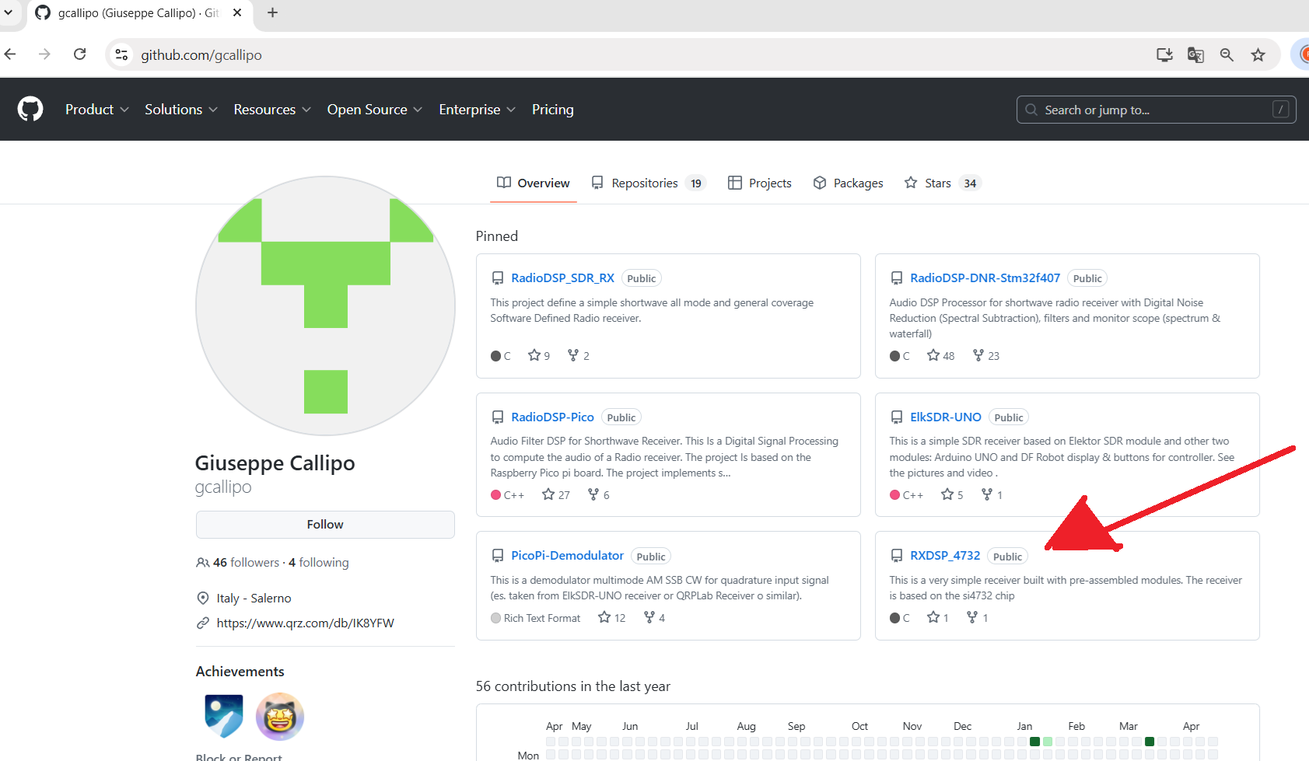

Here you must download the whole project selecting “Code” and next “Download Zip”

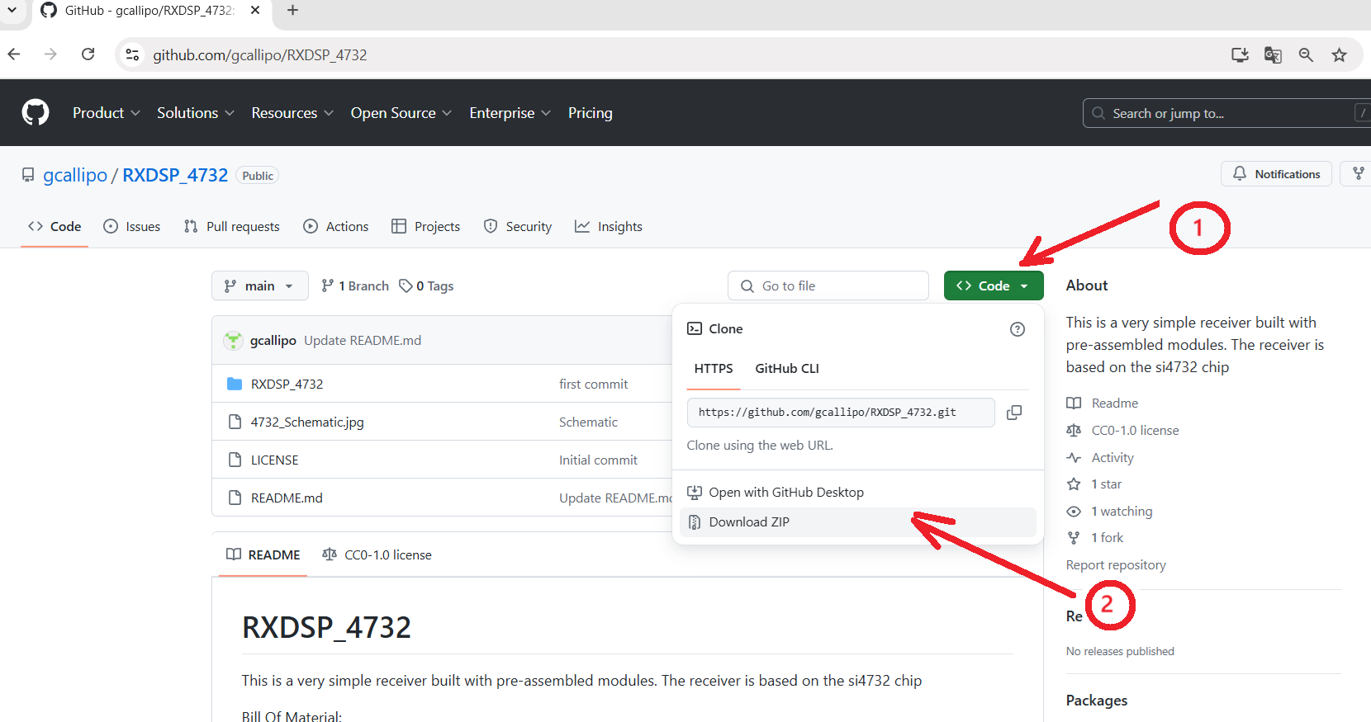

Save the projext in the arduino default folder, you must locate it in your :

Documents –> Arduino

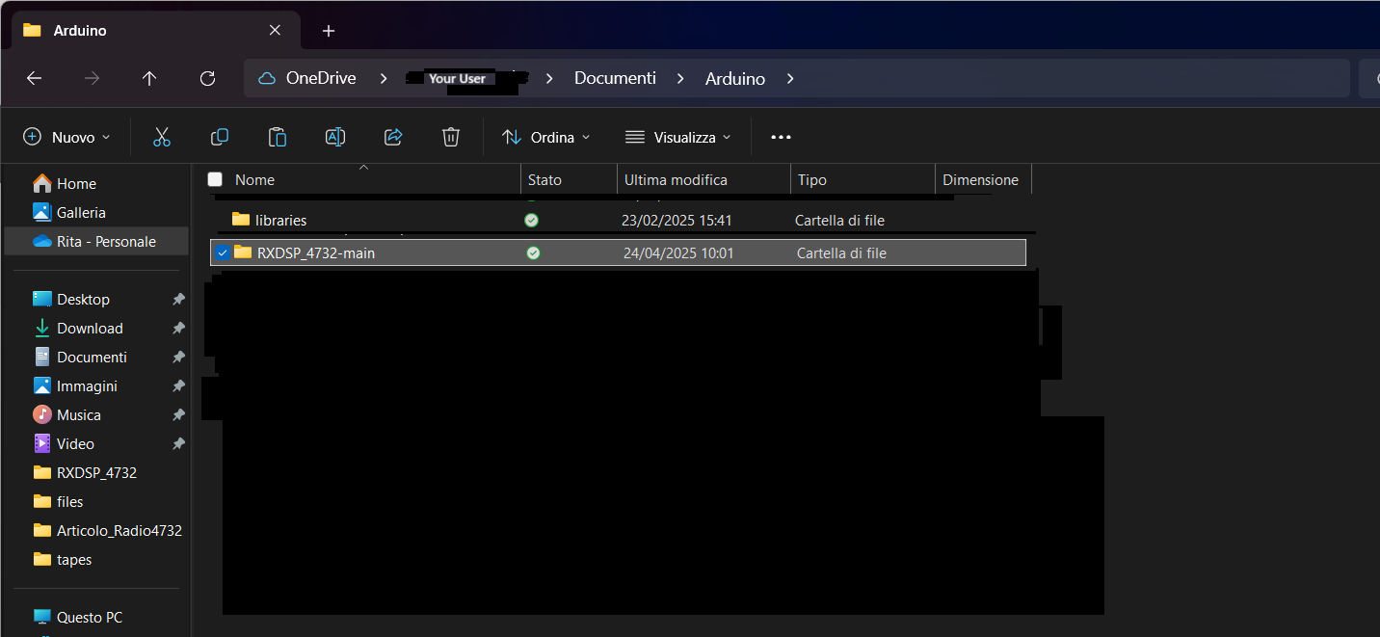

now you can open it form Arduino.

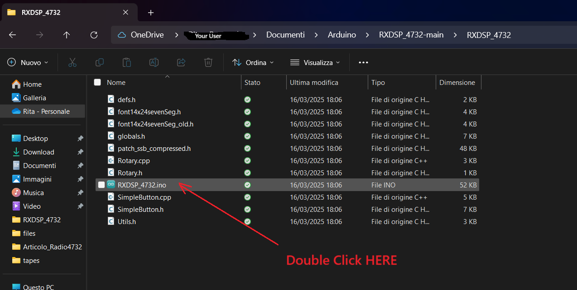

**STEP 3 -**  Install the additional libraries, to make this, open the tab library and write and search the name of the library, we must install 3 libs. Flollow the next pictures to instal them:

This is for the main library 4732:



The same procedure is for the Tiny4kOLED that will install the display support in two libraries.

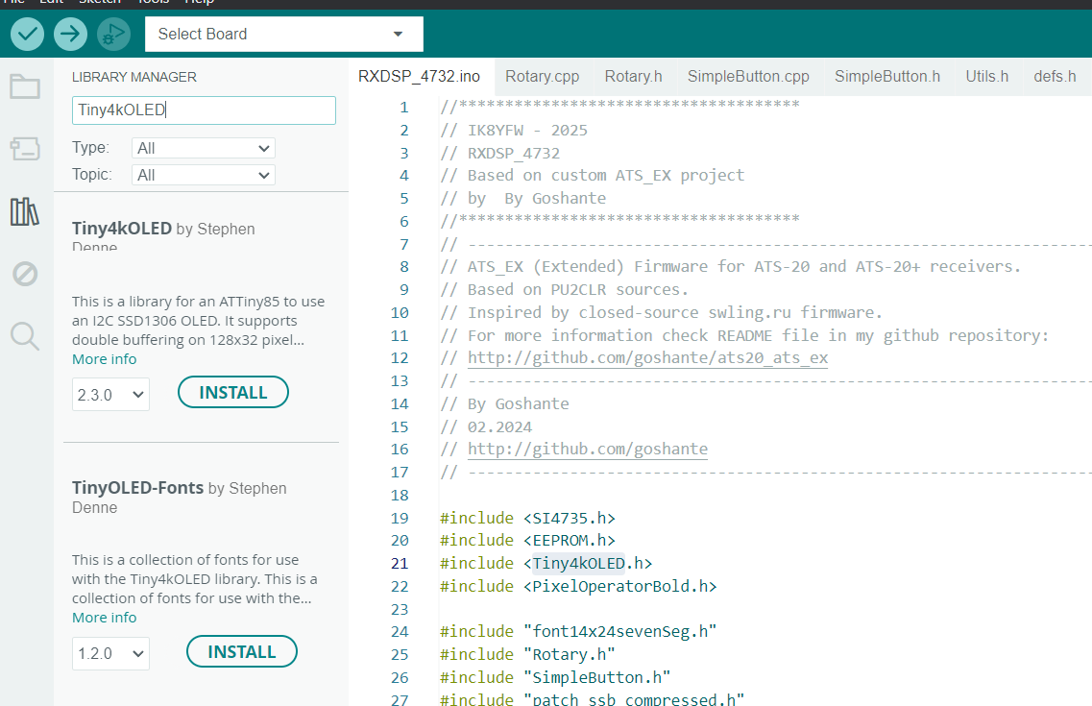

The version tested on the date of tutorial are the: 2.1.8 for the 4732 lib and the 1.2.0 and 2.3.0 for the Tiny libraryes, but we cannot excludes that it can works also with future releases.

**STEP 4** – Compile the project on IDE as standard Arduino NANO and upload to module.

**Latest update: 24.04.2025**

**Giuseppe Callipo, IK8YFW**