How To Make

This is a working progress document, it describe fast hand on radio dsp project.

The circuit:

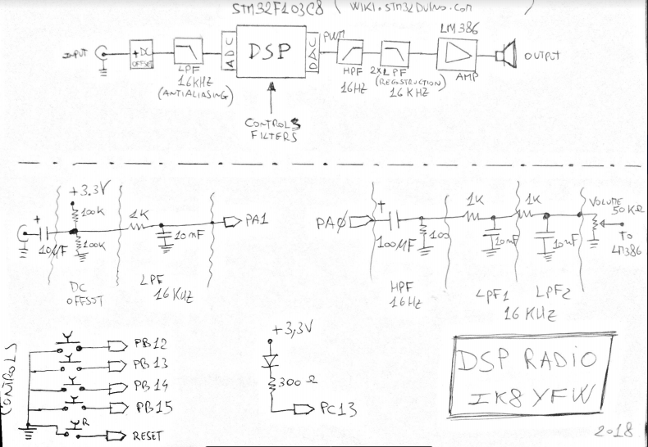

How to load Firmware:

1) Download the Demostrator GUI Flasher from ST site:

http://www.st.com/en/development-tools/flasher-stm32.html

2) Buy a USB to UART converter programmer running at 3.3 v, like this:

TTL USB2.0 To 6Pin CH340G Converter for STC Arduino PRO

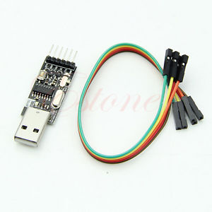

3) Connect the programmes as show below:

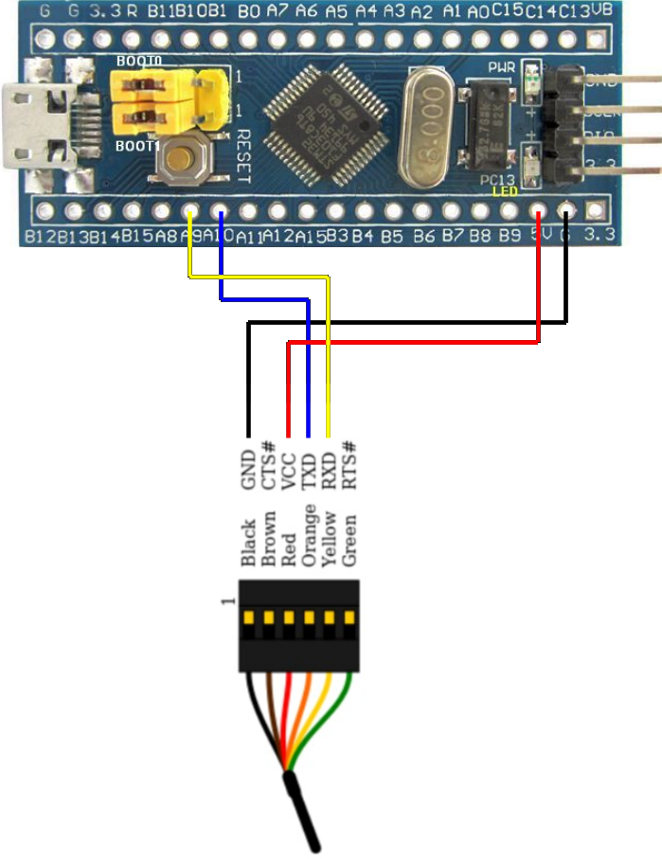

4) Move the Programming pin on the CPU Board (BOOT 0) to position 1;

5) Connect the programmer to USB port PC and start the Demostrator.

6) Load the pre-compiled firmare file:

RadioDSP-Stm32f103/pre-compiled/Release/RadioDSP_Fast.hex

