

Brain Tumour Classification Using MRI Images: A Comparative Study of Classical, Deep Learning and Hybrid Models
George Caluian

School of Computing and Mathematical Sciences
Birkbeck, University of London
Word count 11742

Declaration
I, George Caluian, declare that the work carried out and reported on by this document and the contents of this document, titled Brain Tumour Classification Using MRI Images: A Comparative Study of Classical, Deep Learning and Hybrid Models, and accompanying artefacts, except for where attributed to other sources by way of citations within the body of this document and listed under the References section of this document, is formed of my own original work, which has never before been produced for any other purpose, and has been created solely as part of delivery of MSc Data Science Project for or under the supervision of George Magoulas.
All information in this document and accompanying artefacts has been obtained and presented in accordance with the relevant ethical conduct and academic rules.

Abstract
This study compares classical machine-learning, deep-learning and hybrid methods for classifying brain MRI images into four classes: glioma, meningioma, pituitary tumour and no tumour. Eight model configurations were tested using the same dataset and evaluation framework. These included HOG–GLCM features with Support Vector Machine (SVM) and Random Forest, end-to-end ResNet50 and EfficientNetB0 models, and hybrid models combining pretrained CNN features with SVM or Random Forest. Performance was evaluated using repeated five-fold cross-validation and a separate held-out Testing set, with macro F1-score used as the main measure.
The best overall model was EfficientNetB0 features + SVM, which achieved a mean macro F1-score of 0.9636 in repeated cross-validation and 0.9405 on the Testing set. The SVM-based hybrid models performed better than the Random Forest-based hybrids, while ResNet50 and EfficientNetB0 gave similar results when used as end-to-end CNNs. Glioma was the most difficult class to identify and was often confused with meningioma. Overall, the results show that combining pretrained CNN features with SVM was the most effective approach tested in this study.

Contents
Declaration I
Abstract II
Contents III
1 Introduction 1
2 Background and Literature Review 2
2.1 Classification Task 2
2.2 Preprocessing in Brain Tumour Classification 2
2.3 Validation and Data Splitting 3
2.4 Findings from Previous Studies 4
2.5 Challenges and Research Gap 5
3 Methodology and Methods 6
3.1 Research Design 6
3.2 Data Description 6
3.3 Dataset Inspection and Preprocessing 7
3.4 Data Partitioning and Cross-Validation 11
3.5 Handcrafted Feature Extraction 14
3.6 Classical Machine Learning Models 15
3.6.1 Support Vector Machine 15
3.6.2 Random Forest 15
3.7 Deep Learning Models 16
3.7.1 ResNet50 16
3.7.2 EfficientNetB0 17
3.8 Hybrid Models 18
3.8.1 CNN Feature Extraction 18
3.8.2 Architecture-Specific Feature Representations 19
3.8.3 Hybrid Support Vector Machine 19
3.8.4 Hybrid Random Forest 20
3.9 Hyperparameter Tuning 20
3.9.1 Classical SVM Hyperparameter Tuning 21
3.9.2 Classical Random Forest Hyperparameter Tuning 22
3.9.3 ResNet50 Hyperparameter Tuning and Model Selection 23
3.9.4 EfficientNetB0 Hyperparameter Tuning and Model Selection 24
3.9.5 Hybrid SVM Model Selection 26
3.9.6 Hybrid Random Forest Model Selection 27
3.10 Evaluation Metrics 28
3.11 Computational Performance 29
4 Requirements Specification and Design 30
4.1 Experimental System Requirements 30
4.2 System Architecture 30
4.3 Experiment Execution and Management 31
5 Implementation 32
5.1 Implementation Overview and Development Environment 32
5.2 Repeated Cross-Validation Implementation 35
6 Testing and Evaluation 36
7 Results and Discussion 37
7.1 Classical Models 37
7.2 Deep Learning Models 38
7.3 Hybrid Models 40
7.4 Statistical Comparison 44
7.5 Misclassification and Error Analysis 46
7.6 Computational Performance 48
8 Conclusion, Limitations and Future Work 49
8.1 Conclusion 49
8.2 Limitations 49
8.3 Future Work 50
References 51
Appendix A 55
Appendix B Use of AI Tools 56

Introduction

Brain tumours are serious medical conditions that can affect the structure and function of the brain. MRI is widely used to examine brain tumours because it provides detailed images of soft tissue without using ionising radiation. In recent years, machine-learning methods have increasingly been applied to MRI images to support tasks such as tumour detection and classification, including the distinction between different tumour types (Amin et al., 2022).
Despite significant progress in this area, several challenges remain. Studies often use different datasets, preprocessing techniques and evaluation methods, which makes it difficult to directly compare the performance of different models (Amin et al., 2022; Kumar, Jyoti and Kumar, 2024). Brain tumour MRI datasets may also be relatively small or specific to a particular source, which can increase the risk of overfitting and reduce a model's ability to generalise to new data (Wong et al., 2025).
This project aims to provide a systematic comparison of classical machine-learning, deep-learning and hybrid methods under consistent experimental conditions. The comparison considers predictive performance, class-level behaviour and computational requirements using the same dataset, preprocessing and evaluation framework. It focuses on four-class brain tumour classification using MRI images of glioma, meningioma, pituitary tumour and no tumour. Eight model configurations are compared across three groups: classical machine-learning models using handcrafted features, transfer-learning CNN models and hybrid models that combine CNN feature extraction with classical classifiers.
The report follows the following structure: review of the relevant literature, description of the methodology and system design, implementation, testing and evaluation, results and discussion, followed by the conclusions, limitations and future work.

Background and Literature Review
This chapter reviews the research relevant to brain tumour classification using MRI images. It focuses on classical machine-learning methods, transfer-learning CNNs and hybrid methods that combine CNN feature extraction with classical classifiers. It also considers preprocessing, validation and evaluation methods relevant to the experimental design used in this study.

Classification Task
Brain tumour classification studies can involve different types of prediction tasks. Some studies use binary classification, where MRI images are classified as tumour or no tumour, while others use multi-class classification to distinguish between several tumour types. Multi-class classification is more difficult because the model must separate classes that may share similar visual features (Gautam, Ahlawat and Mittal, 2022). This project uses multi-class classification with four classes: glioma, meningioma, pituitary tumour and no tumour.
Brain tumour MRI research also includes related tasks such as tumour detection, segmentation and grading. Detection focuses on identifying whether a tumour is present, while segmentation aims to locate the tumour and separate it from the surrounding tissue. Grading is used to estimate the severity or grade of a tumour. These tasks are different from the image-level classification used in this project, where each MRI image is assigned to one of the four predefined classes (Amin et al., 2022; Akinyelu et al., 2022).

Preprocessing in Brain Tumour Classification
MRI images can undergo several preprocessing steps before they are used for machine-learning or deep-learning models. Common methods include resizing images to a consistent size, intensity normalisation or standardisation, noise reduction, contrast enhancement, bias-field correction, skull stripping, cropping and image registration. Some studies also use histogram equalisation to improve contrast, while data augmentation techniques such as rotation, flipping, shifting and zooming may be applied to the training data to increase its variety. The exact preprocessing procedure varies between studies and depends on the characteristics of the dataset and the classification task (Amin et al., 2022).
More extensive preprocessing is not always better. Methods such as skull stripping and aggressive cropping can remove irrelevant background information, but if they are

inaccurate they may also remove useful parts of the brain or tumour region. Some studies therefore use lighter preprocessing and allow the model to identify relevant features within the remaining anatomical background (Krishnapriya and Karuna, 2024; Uthra and Sivashankari, 2026).

Validation and Data Splitting
How the dataset is divided for training and evaluation can strongly affect the reliability of reported results. A simple train-test split is commonly used, while cross-validation provides a more stable estimate by evaluating the model on several different training and validation partitions. In classification problems, stratified cross-validation is often used so that each fold contains a similar proportion of samples from each class. When hyperparameters are tuned, nested cross-validation can be used, with an inner loop for model selection and an outer loop for estimating model performance. This helps reduce optimistic bias when model selection and evaluation are carried out on the same dataset (Varma and Simon, 2006).
An important issue in medical-image validation is whether the data are split by image or by patient. When several images or scans come from the same patient, placing some in the training set and others in the validation or test set can cause data leakage because those images may contain very similar patient-specific information. Patient-level splitting avoids this by keeping all images from the same patient in the same partition and gives a more reliable estimate of performance on unseen patients (Rouzrokh et al., 2022).
Cross-validation can also be repeated using different fold assignments to reduce dependence on a single split of the data. The repeated results provide paired performance estimates that can be used for statistical comparison between models. The Wilcoxon signed-rank test is a non-parametric paired test for comparing two classifiers when paired performance measurements are available (Demšar, 2006).

Findings from Previous Studies
A range of classical machine-learning methods have been used for brain tumour MRI classification. These studies commonly combine image features with classifiers such as SVM, Random Forest, k-Nearest Neighbours and other traditional algorithms. Handcrafted descriptors such as HOG and GLCM have been used to represent structural and texture information from MRI images before classification. Research in this area shows that classical methods can achieve useful performance, although their results depend strongly on the selected preprocessing and feature-extraction methods (Pattanaik et al., 2022; Kumar, Jyoti and Kumar, 2024).
Deep-learning studies have increasingly used transfer learning rather than training CNNs completely from scratch. Swati et al. (2019), for example, investigated transfer learning and fine-tuning for multi-class brain tumour MRI classification. Other studies have used established pretrained architectures such as ResNet, VGG, DenseNet and EfficientNet. These models can reuse visual features learned from large image datasets and then adapt them to MRI classification through further training on the target dataset (Swati et al., 2019; Krishnapriya and Karuna, 2023; Zulfiqar, Bajwa and Mehmood, 2023).
Hybrid methods provide another way of using pretrained CNNs. Instead of using the CNN's own final classification layer, features extracted from the network can be supplied to a separate machine-learning classifier. Kang, Ullah and Gwak (2021), for example, investigated deep features extracted from CNN models together with machine-learning classifiers for brain tumour MRI classification. This type of method is useful because it allows the feature-learning ability of deep networks to be combined with classifiers such as SVM and Random Forest.
Ensemble methods have also been used in brain tumour classification. Rather than relying on a single model, an ensemble combines information or predictions from several models. This can include traditional ensemble methods such as boosting and Random Forest, as well as ensembles of several deep-learning models. Kang, Ullah and Gwak (2021), for example, combined deep features obtained from several pretrained CNNs with machine-learning classifiers. Tummala et al. (2022) investigated an ensemble of Vision Transformer models for brain tumour MRI classification. Ensemble methods can improve performance when the individual models learn different useful information from the images, although they can also increase computational cost and model complexity (Kang, Ullah and Gwak, 2021; Tummala et al., 2022).
Other architectures have also been explored beyond standard CNNs. Vision Transformers divide images into patches and use attention mechanisms to learn relationships between different parts of an image, including information across larger image regions. Capsule Networks have also been investigated for brain tumour classification because they are designed to preserve spatial relationships between image features and can be more resistant to changes such as rotation. In addition, radiomics-based methods extract large numbers of quantitative features describing properties such as intensity, texture and shape before applying machine-learning models to these features. These methods show that brain tumour classification research extends beyond conventional CNN and classical machine-learning approaches (Akinyelu et al., 2022; Nayak et al., 2024).
Previous research therefore shows that strong results can be obtained using several different types of models. However, the reported performance of one study cannot always be compared directly with another because the studies may use different datasets, preprocessing procedures, data splits, model-selection methods and evaluation metrics. A model reporting higher accuracy in one paper is not necessarily better than another model evaluated under different experimental conditions (Amin et al., 2022; Kumar, Jyoti and Kumar, 2024).

Challenges and Research Gap
One of the main difficulties in comparing brain tumour classification studies is the variation between the datasets used. Datasets can differ in size, class distribution, image quality and acquisition characteristics (Amin et al., 2022). Class imbalance can also influence performance because models may become biased towards classes that contain more training examples (Deepak and Ameer, 2023).
Differences in MRI scanners and acquisition conditions can introduce further variation into the images. Kushol et al. (2023), for example, investigated the effect of MRI scanner manufacturers on classification tasks using multi-centre MRI data. This is important because a model trained using images from one source may not perform in the same way when images are obtained using different scanners or acquisition conditions.
These differences can make it difficult to determine whether reported improvements come from the model itself or from differences in datasets, preprocessing, training procedures or evaluation methods. Reviews of brain tumour classification research have identified substantial variation in these factors across studies, making direct comparison of reported performance difficult (Amin et al., 2022; Xie et al., 2022).
This creates the main research gap addressed by this project. Rather than proposing a new classification architecture, the study aims to compare representative classical machine-learning, pre-trained deep-learning models and hybrid models that use pretrained deep-learning models within a common experimental framework. The same MRI dataset, data partitions and evaluation metrics are used across the selected models, while model-specific preprocessing, feature representation and model-selection procedures are applied where required.

Methodology and Methods

Research Design
The study used a comparative experimental research design to evaluate three machine-learning approaches for multi-class brain tumour classification: classical machine learning, deep learning and hybrid machine-learning methods that use pretrained CNNs for feature extraction followed by classical classifiers. The classification task contains four classes: glioma, meningioma, pituitary tumour and no tumour. Eight model configurations were evaluated, comprising two classical models, two end-to-end deep-learning models and four hybrid models:
- HOG and GLCM features with SVM
- HOG and GLCM features with Random Forest
- ResNet50
- EfficientNetB0
- ResNet50 feature extraction with SVM
- ResNet50 feature extraction with Random Forest
- EfficientNetB0 feature extraction with SVM
- EfficientNetB0 feature extraction with Random Forest

Data Description
The dataset used in this study was the Brain Tumor MRI Dataset published by Masoud Nickparvar on Kaggle (Nickparvar, n.d.). It contains 7,200 labelled human brain MRI images divided into four classes: glioma, meningioma, pituitary tumour and no tumour. The original Training and Testing partitioning was retained. Table 1 summarises the number of images in each class and partition.
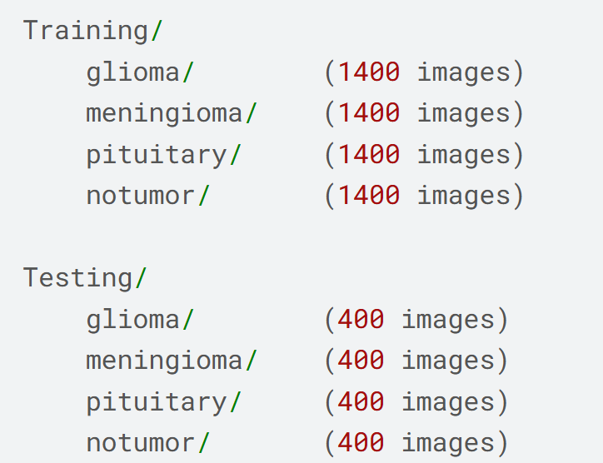

Table 1

According to the dataset creator, Version 2 was prepared by removing duplicate images, balancing the four classes and eliminating overlap between the predefined Training and Testing partitions to reduce the risk of data leakage (Nickparvar, n.d.). These claims were not independently verified in this study. The dataset also does not provide patient identifiers or metadata linking individual images to individual patients.

Dataset Inspection and Preprocessing
The dataset inspection began by checking every file for readability, file extension, dimensions, class label and partition. All 7,200 images were successfully opened and were stored as JPEG (.jpg) files. The images had varying original dimensions and were stored using several image modes: 4,129 images in RGB mode, 3,067 images in grayscale (L) mode, three images in RGBA mode and one image in palette-based (P) mode.

The 4,129 RGB images were then examined to determine whether they contained genuine colour information. Channel-level comparison showed that 4,003 images had identical red, green and blue channel values and were therefore effectively grayscale despite being stored in RGB mode. The remaining 126 images contained non-identical channel values, and all belonged to the no-tumour class. Visual inspection of images with the largest channel differences identified non-medical coloured ribbons at the top or bottom of some images. Because these artefacts occurred only in the no-tumour class, they could provide class-specific visual cues unrelated to the tumour itself. A contour-based margin-cropping procedure was therefore applied to reduce non-medical peripheral content. An example of this coloured ribbon artefact is shown in Image 1.

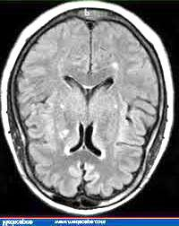

Image 1

The implementation was adapted from Nickparvar’s published preprocessing code, which converts a copy of the image to grayscale, applies Gaussian blurring, thresholding, erosion and dilation, selects the largest external contour, and uses its topmost, bottommost, leftmost and rightmost points to produce a rectangular crop (Nickparvar, n.d.). An example of the detected cropping area and resulting crop is shown in Image 2.
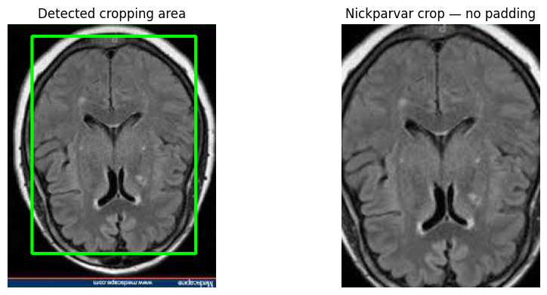

Image 2

The procedure successfully removed the visible ribbons from most of the affected images. However, a ribbon remained within the detected crop for two images in the Testing partition: Te-no_297.jpg and Te-no_279.jpg. These images were excluded from the processed dataset because the remaining non-medical artefacts could provide unintended class-specific information. The original files were retained unchanged in the source dataset. An example of this unsuccessful ribbon removal is shown in Image 3.
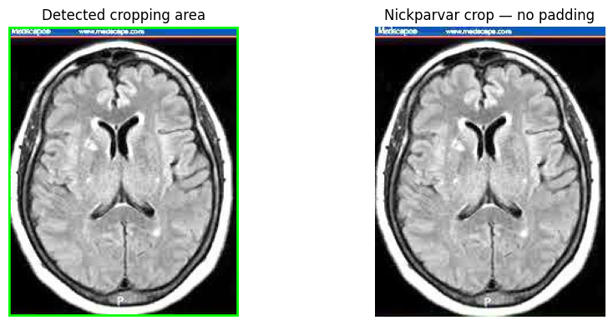

Image 3

The contour-based cropping procedure was then applied to the remaining images in the dataset. For each image, the proportion of the original image area retained after cropping was calculated. Images with low retained-area percentages were visually inspected to determine whether the crop preserved the complete brain region. This inspection identified 59 images for which the procedure removed a substantial part of the brain. Because the original MRI images were valid, they were not excluded; instead, their uncropped versions were retained. An example of this excessive cropping is shown in Image 4. The final processed dataset therefore contained 7,139 successfully cropped images, 59 uncropped images and two excluded images, resulting in 7,198 processed images in total. All retained images were converted to single-channel grayscale, resized to 224 × 224 pixels and saved in lossless PNG format. PNG was selected to avoid introducing additional compression artefacts during preprocessing.

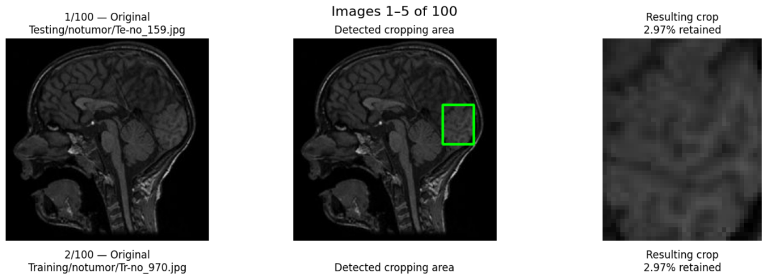

Image 4

The principal trade-off is that cropping can remove irrelevant margins, coloured ribbons and other non-medical artefacts that might provide unintended classification shortcuts. However, inaccurate contour detection can also remove useful anatomical information, while resizing may alter the original aspect ratio and the apparent spatial scale of the brain.

Similar contour-based preprocessing methods have been used in previous brain tumour MRI studies. Kang, Ullah and Gwak (2021) and Krishnapriya and Karuna (2023) used contour boundaries to identify the brain region before removing peripheral areas and resizing the images. More extensive preprocessing methods have also been reported. Krishnapriya and Karuna (2024), for example, used Otsu thresholding, skull removal and masking as part of a tumour-localisation pipeline, while Uthra and Sivashankari (2026) used simpler resizing and intensity normalisation and noted that exact skull stripping can be error-prone. The contour-based cropping used in this study was therefore retained as a simpler method for reducing peripheral artefacts without attempting full skull stripping.

For the classical models, the single-channel grayscale images were used to extract HOG and GLCM features. For the pretrained CNN models, the grayscale channel was repeated three times when the images were loaded,

producing a 224 x 224 x 3 pseudo-RGB input without introducing additional colour information. Stathopoulos et al. (2024) similarly replicated grayscale MRI values across three channels to produce 224 x 224 x 3 inputs for pretrained CNN architectures, including ResNet50. Khan et al. (2022) also repeated grayscale pixel intensities across three channels, converting 256 x 256 x 1 MRI images into 128 x 128 x 3 inputs compatible with a pretrained VGG16.

Data Partitioning and Cross-Validation

Five-fold stratified cross-validation was applied exclusively to the 5,600 images in the original Training partition during initial model development. The separate Testing partition contained 1,598 images following preprocessing and was excluded from model selection, training, hyperparameter tuning and cross-validation. It was used for the final evaluation of the model configurations selected during the initial model-development stage.

For the initial five-fold cross-validation, the 5,600 Training images were assigned at image level to five folds using a fixed random seed of 42. Stratification maintained an equal class distribution across the folds, with each fold containing 1,120 images comprising 280 images from each of the four classes. During each outer cross-validation iteration, 4,480 images formed the outer-training partition and 1,120 images formed the outer-validation partition. The same fold assignments were used across all eight model configurations to support a consistent comparison during model development and selection.

The model-selection procedure differed between the model families. For the classical and hybrid SVM and Random Forest classifiers, nested cross-validation was used, with three-fold stratified inner cross-validation performed within each outer-training partition for hyperparameter selection (Varma and Simon, 2006). The selected configuration was then refitted using the complete outer-training partition and evaluated on the corresponding outer-validation fold. For ResNet50 and EfficientNetB0, an inner cross-validation loop was not used because repeating CNN training across additional inner folds would substantially increase computational cost. Instead, each outer-training partition was divided into model-training and internal-validation subsets. For each candidate configuration, the internal-validation data were used for training control, early stopping, learning-rate adjustment and checkpoint selection. The selected checkpoint was then evaluated on the corresponding outer-validation fold. Candidate hyperparameter configurations were subsequently compared using their mean performance across the five outer folds. The separate Testing partition remained untouched during this process and provided the final held-out evaluation after model selection.

Following the initial model-development and Testing evaluation, five-fold stratified cross-validation was repeated ten times to assess the stability of model performance across different fold assignments and to provide paired results for statistical comparison. Each repeat used a new stratified five-fold assignment of the same 5,600 Training images, producing 50 outer-fold evaluations for each model. For statistical comparison, the five outer-fold results within each repeat were averaged to produce one repeat-level performance value, giving ten paired values for each model. The same fold assignments were used for all eight model configurations within each repeat so that their performance could be compared on identical partitions. For the classical and hybrid classifiers, the nested three-fold inner cross-validation procedure was repeated independently within each outer-training fold. For the CNN models, each 4,480-image outer-training partition was divided into 4,032 model-training images and 448 internal-validation images. Candidate configurations were trained using these partitions, with the internal-validation data used for training control, checkpoint selection and hyperparameter selection. The selected configuration was then refitted using all 4,480 outer-training images and evaluated once on the corresponding 1,120-image outer-validation fold. This differed from the initial CNN model-development procedure because the repeated outer-validation folds were themselves used to estimate model performance and therefore had to remain independent of hyperparameter selection. The Testing partition was not used in this repeated cross-validation analysis. The repeated cross-validation procedure used for all eight models is summarised in Figure 1.
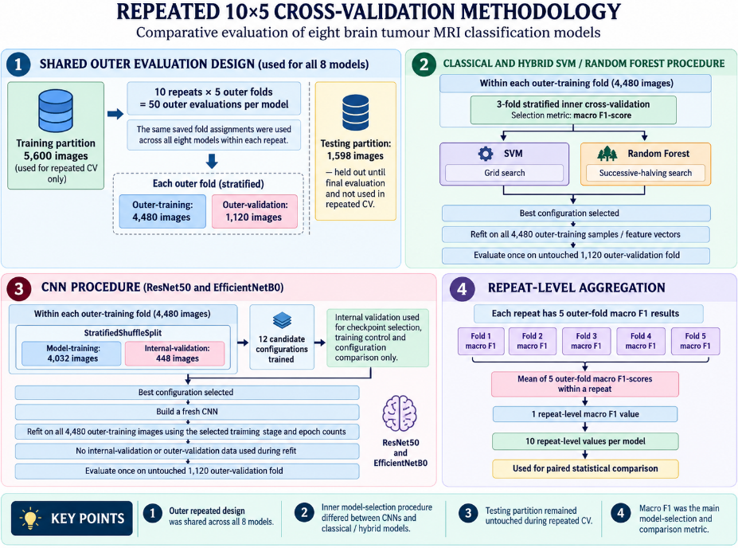

Figure 1

The dataset did not provide patient identifiers or metadata linking individual MRI images to patients. Consequently, both the initial and repeated cross-validation folds could only be constructed at image level and patient-level separation could not be verified. This represents a limitation because, if multiple images originated from the same patient, images from that patient could potentially occur in different folds.

Handcrafted Feature Extraction

Handcrafted features were extracted from each preprocessed 224 x 224-pixel grayscale MRI image using Histogram of Oriented Gradients (HOG) and the Grey-Level Co-occurrence Matrix (GLCM). These handcrafted features were included to provide a classical feature-based baseline against which the pretrained deep-learning and hybrid approaches could be compared. Unlike CNNs, which learn features automatically during training, HOG and GLCM provide predefined representations of image structure and texture. Including both approaches therefore allowed the study to evaluate whether automatically learned CNN features provided an advantage over traditional handcrafted features. HOG was used to describe local edge directions and structural patterns within the images through distributions of gradient orientations calculated over local regions (Dalal and Triggs, 2005). Nine orientation bins were calculated using 16 x 16-pixel cells and 2 x 2-cell blocks. Overlapping blocks were normalised using the L2-Hys method, while square-root intensity transformation was applied before gradient calculation. This configuration produced 6,084 HOG features for each image.

GLCM features were used to represent spatial texture relationships between neighbouring pixel intensities, following the texture-analysis principles introduced by Haralick, Shanmugam and Dinstein (1973). Before constructing the GLCMs, the grayscale images were quantised from 256 intensity values to 32 grey levels. GLCMs were calculated at pixel distances of 1, 2 and 4 at angles of 0, 45, 90, and 135 degrees. Six texture properties were extracted: contrast, dissimilarity, homogeneity, energy, correlation and angular second moment. For each property and distance, the values obtained across the four angles were averaged, producing 18 GLCM features per image.

The HOG and GLCM vectors were concatenated to form a combined representation containing 6,102 features for each MRI image. Combining handcrafted descriptors including HOG and GLCM is consistent with previous brain tumour MRI research using feature fusion for classical machine-learning classification (Pattanaik et al., 2022). The extracted feature values were stored using 32-bit floating-point precision to reduce memory usage. Feature extraction was deterministic and did not require fitting to the data.

Classical Machine Learning Models
Two classical classifiers were evaluated: Support Vector Machine (SVM) and Random Forest (RF). Both models used the same 6,102-dimensional HOG-GLCM feature representation described in Section 3.5. Hyperparameter selection for both classifiers is described in Section 3.9.

Support Vector Machine
A Support Vector Machine (SVM) was selected because of its suitability for high-dimensional feature spaces (Cortes and Vapnik, 1995). An RBF kernel was used to model potentially nonlinear relationships between the handcrafted features and the four tumour classes. Feature standardisation was applied before training the SVM because the HOG and GLCM features can have different numerical scales. A StandardScaler was included in the scikit-learn pipeline. During cross-validation, the scaler was fitted using only the training data in each fold and the same transformation was then applied to the corresponding validation data. This ensured that information from the validation data was not used during model training.

Random Forest
A Random Forest (RF) classifier was selected as a tree-based ensemble method and as a contrasting classical model to the SVM. Random Forest combines the predictions of multiple decision trees to produce a final class prediction (Breiman, 2001). Feature standardisation was not applied because tree-based models divide the feature space using threshold-based splits and do not require all features to share the same numerical scale. Class weighting was not applied because the Training partition contained an equal number of images from each class. Hyperparameter selection for the Random Forest classifier is described in Section 3.9.

Deep Learning Models
The deep-learning component evaluated end-to-end transfer-learning models based on ResNet50 (He et al., 2016) and EfficientNetB0 (Tan and Le, 2019) for four-class brain tumour classification. Unlike the classical models, which used pre-extracted HOG and GLCM features, the CNN models learned image representations directly from the preprocessed MRI images. Transfer learning was applied by initialising the convolutional layers with ImageNet-pretrained weights and adapting them to the MRI classification task. Swati et al. (2019) similarly applied transfer learning and fine-tuning to multiclass brain tumour classification using MRI images. The architecture-specific configurations and training procedures are described in Sections 3.7.1, 3.7.2 and 3.9.

ResNet50
ResNet50, introduced by He et al. (2016), was selected as an established residual CNN architecture. The model was initialised with ImageNet-pretrained weights and used without its original ImageNet classification layers. The 224 × 224 grayscale MRI images were loaded as three-channel pseudo-RGB inputs, as described in Section 3.3, and ResNet50-specific input preprocessing was applied. The original classification component was replaced with a global average pooling layer, a dropout layer with a rate of 0.30 and a four-unit dense output layer with softmax activation, corresponding to the glioma, meningioma, no-tumour and pituitary-tumour classes.

EfficientNetB0
EfficientNetB0, introduced by Tan and Le (2019), was selected as a computationally efficient CNN architecture that uses compound scaling to balance network depth, width and input resolution. An ImageNet-pretrained EfficientNetB0 backbone was used in this study, with the original ImageNet classification head removed and replaced by a task-specific classifier for the four tumour classes.

The 224 × 224 grayscale MRI images were loaded as three-channel pseudo-RGB inputs, as described in Section 3.3. Unlike ResNet50, no external preprocess_input transformation was applied because the Keras EfficientNetB0 implementation performs the required input rescaling internally. The model therefore received float32 pixel values in the [0, 255] range. The classifier consisted of global average pooled backbone features, a dropout layer with a rate of 0.30 and a four-unit dense output layer with softmax activation.

Training was performed in two stages. During the first stage, the EfficientNetB0 backbone was frozen and only the newly added classification head was trained. In the second stage, selected upper backbone layers were fine-tuned starting from block7a_expand_conv, while Batch Normalisation layers remained frozen. No image augmentation was applied. This transfer-learning and fine-tuning strategy is consistent with previous brain-tumour MRI classification research using pretrained EfficientNet architectures (Zulfiqar, Bajwa and Mehmood, 2023).

Hybrid Models
Hybrid models were included to assess whether fixed deep CNN feature representations could improve classical classification compared with the handcrafted HOG–GLCM representation and the end-to-end CNN models. Previous work has shown that features extracted from pretrained CNNs can be used as fixed representations for classical classifiers (Donahue et al., 2014; Razavian et al., 2014), including for brain-tumour MRI classification (Kang, Ullah and Gwak, 2021). In this study, ImageNet-pretrained ResNet50 and EfficientNetB0 were used as fixed feature extractors and each was paired independently with an SVM and a Random Forest classifier.

This produced four hybrid model configurations:

- ResNet50 features + Support Vector Machine
- ResNet50 features + Random Forest
- EfficientNetB0 features + Support Vector Machine
- EfficientNetB0 features + Random Forest

CNN Feature Extraction
For hybrid feature extraction, fresh ImageNet-pretrained ResNet50 and EfficientNetB0 models were used. The original ImageNet classification heads were removed and global average pooling was applied to the final convolutional outputs to produce fixed feature vectors. All CNN layers remained frozen and the models were run in inference mode throughout feature extraction. No CNN fine-tuning or image augmentation was applied. Augmentation was not used because the purpose of the hybrid experiments was to evaluate the fixed CNN feature representations without introducing additional modified images as another experimental variable. The previously fine-tuned MRI classification models were not reused as feature extractors, because doing so could allow information from other Training folds to influence the hybrid cross-validation procedure.

Architecture-Specific Feature Representations
Both architectures received the same 224 × 224 grayscale MRI images. As described in Section 3.3, the grayscale channel was repeated three times to create a 224 × 224 × 3 pseudo-RGB input. For ResNet50, images were converted to 32-bit floating-point format and processed using the standard ResNet50 ImageNet preprocessing function. Global average pooling produced a 2,048-dimensional feature vector for each image, resulting in a Training feature matrix of 5,600 × 2,048. For EfficientNetB0, images were also converted to 32-bit floating-point format, but no external preprocessing function was applied because the Keras implementation performs the required input rescaling internally. Global average pooling produced a 1,280-dimensional feature vector for each image, resulting in a Training feature matrix of 5,600 × 1,280.

Hybrid Support Vector Machine
For the SVM-based hybrid models, the fixed feature vectors extracted by ResNet50 and EfficientNetB0 were used as inputs to separate Support Vector Machine classifiers. Each SVM used a radial basis function (RBF) kernel and was implemented within a pipeline containing StandardScaler followed by the SVM classifier. Standardisation was included because SVM performance can be affected by differences in feature scale. During cross-validation, the scaler was fitted using only the relevant training data and the same transformation was then applied to the corresponding validation data. This prevented information from the validation data from being used during model training. The same procedure was applied independently to the ResNet50 and EfficientNetB0 feature representations. Hyperparameter selection for the hybrid SVM models is described in Section 3.9.

Hybrid Random Forest
The same fixed feature vectors extracted by ResNet50 and EfficientNetB0 were also used as inputs to separate Random Forest classifiers. Unlike the hybrid SVM models, feature standardisation was not applied before Random Forest classification. Random Forests make decisions by splitting individual features at threshold values and are therefore generally not sensitive to differences in feature scale. The ResNet50 and EfficientNetB0 feature matrices were supplied directly to their respective Random Forest classifiers, with a separate Random Forest model trained for each CNN feature representation. Hyperparameter selection for the hybrid Random Forest models is described in Section 3.9.

Hyperparameter Tuning
Hyperparameter tuning and model selection were performed using only the 5,600-image Training partition, with the Testing partition excluded from all selection decisions. During initial model development, the classical and hybrid SVM and Random Forest classifiers used nested cross-validation, with three-fold stratified inner cross-validation performed within each of the five outer-training folds. ResNet50 and EfficientNetB0 used a different procedure because applying an additional inner cross-validation loop to every CNN configuration would have substantially increased computational cost. Within each outer-training partition, an internal-validation subset was therefore used for training control, early stopping, learning-rate adjustment and checkpoint selection. Each candidate CNN configuration was then evaluated on the corresponding outer-validation fold, and the configurations were compared using their mean performance across the five outer folds. Because the separate Testing partition remained untouched, these initial cross-validation results could be used for configuration selection while preserving an independent held-out evaluation after model selection. Macro F1-score was used as the primary selection metric across the model families because it gives equal importance to each of the four classes.
The subsequent ten repeats of five-fold stratified cross-validation had a different purpose: to assess performance stability across different fold assignments and provide paired results for statistical comparison. The outer-validation folds therefore needed to remain independent of hyperparameter selection, since using the same data for both model selection and performance evaluation can introduce selection bias (Cawley and Talbot, 2010). For the classical and hybrid classifiers, the nested three-fold inner searches were repeated within each outer-training partition. For ResNet50 and EfficientNetB0, candidate configurations were instead searched and compared using only an internal-validation subset drawn from the corresponding outer-training partition. The selected CNN configuration was then refitted using the complete outer-training partition and evaluated once on the untouched outer-validation fold. This ensured that the repeated outer-fold results used for performance comparison were not also used to select the model configuration. The complete hyperparameter search spaces and selected final configurations for all eight models are summarised in Appendix A.

Classical SVM Hyperparameter Tuning
An exhaustive grid search was used to select the C and gamma hyperparameters for the classical SVM using the combined HOG–GLCM feature representation. Three-fold stratified inner cross-validation was used within each outer-training fold, with mean macro F1-score used to select the best configuration. StandardScaler remained within the SVM pipeline throughout this process so that scaling was fitted only using the relevant training data.
All five outer folds selected the same SVM configuration. This configuration was then trained using all 5,600 Training images before evaluation on the held-out Testing partition. The complete HOG–GLCM + SVM workflow is shown in Figure 2.

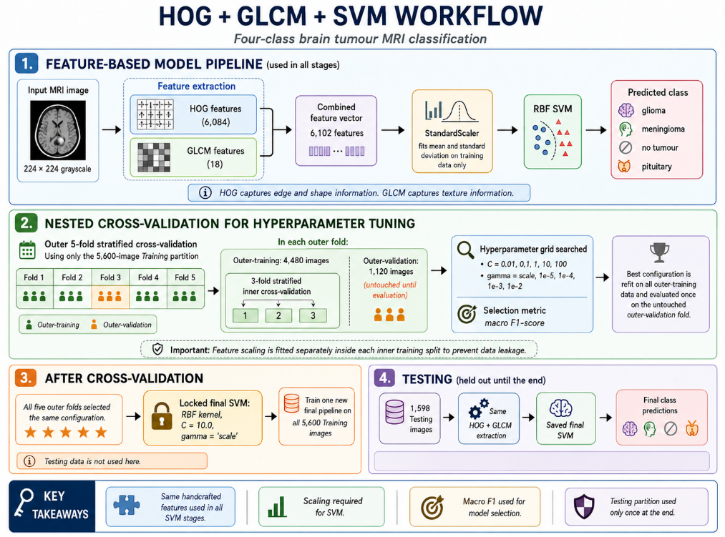

Figure 2

Classical Random Forest Hyperparameter Tuning
The classical Random Forest classifier was tuned using a successive-halving randomised search because its hyperparameter space was larger than that of the SVM. During initial model development, 100 candidate configurations were evaluated within each outer-training fold using three-fold stratified inner cross-validation, with mean macro F1-score used for selection. The number of trees was used as the successive-halving resource so that weaker configurations could be removed as the search progressed.
The configuration selected most often across the five outer folds was adopted for final training. This Random Forest was then fitted using all 5,600 Training images before evaluation on the held-out Testing partition. The complete HOG–GLCM + Random Forest workflow is shown in Figure 3.

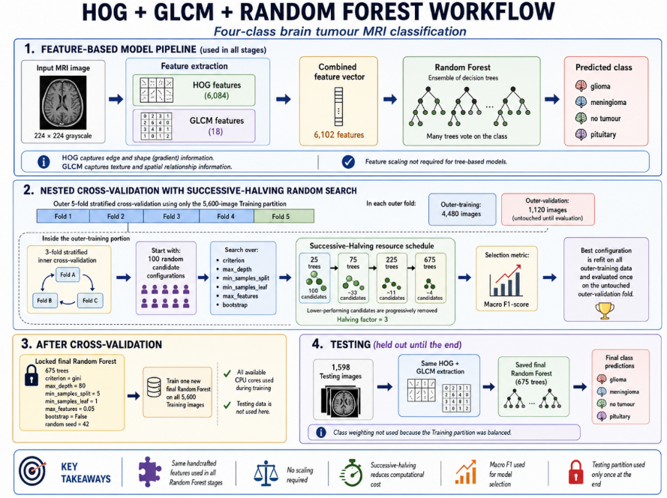

Figure 3

ResNet50 Hyperparameter Tuning and Model Selection

ResNet50 used a model-specific selection procedure within the initial five-fold cross-validation framework. An inner cross-validation loop was not used because of the computational cost of repeatedly training the CNN. Instead, each outer-training partition was divided into model-training and internal-validation subsets. The internal-validation data were used for early stopping, learning-rate control and checkpoint selection, while the corresponding outer-validation fold was used to evaluate each candidate configuration.
Training was performed in two stages using the Adam optimiser and sparse categorical cross-entropy loss. The pretrained backbone was first frozen while the new classification head was trained, followed by fine-tuning of the upper ResNet50

layers while Batch Normalisation layers remained frozen. Candidate configurations were compared primarily using mean macro F1-score across the five outer folds.
The selected configuration and training duration were then used to train a fresh ResNet50 model on all 5,600 Training images before evaluation on the held-out Testing partition. The ResNet50 transfer-learning workflow is shown in Figure 4.
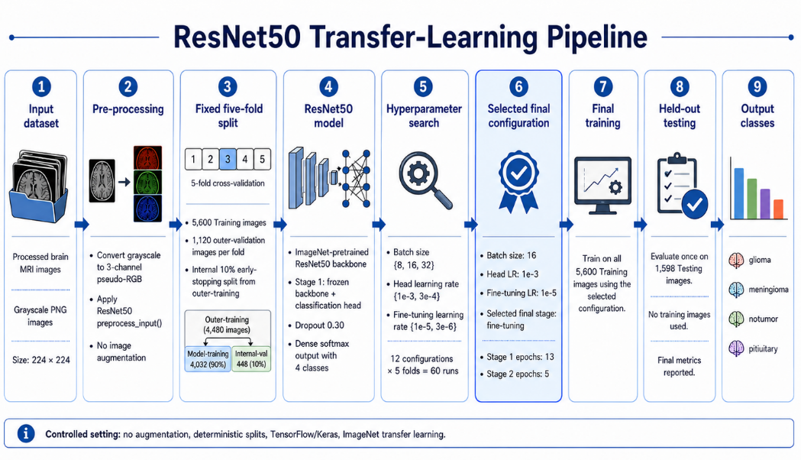

Figure 4

EfficientNetB0 Hyperparameter Tuning and Model Selection

EfficientNetB0 followed the same model-selection procedure used for ResNet50. Each outer-training partition was divided into model-training and internal-validation subsets, with the internal-validation data used for early stopping, learning-rate control and checkpoint selection. The corresponding outer-validation fold was then used to evaluate each candidate configuration.

Training was performed in two stages using the Adam optimiser and sparse categorical cross-entropy loss. The pretrained EfficientNetB0 backbone was first frozen while the new classification head was trained, followed by fine-tuning of the upper layers while Batch Normalisation layers remained frozen. Candidate configurations were compared primarily using mean macro F1-score across the five outer folds.
The selected configuration and training duration were then used to train a fresh EfficientNetB0 model on all 5,600 Training images before evaluation on the held-out Testing partition. The EfficientNetB0 transfer-learning workflow is shown in Figure 5.
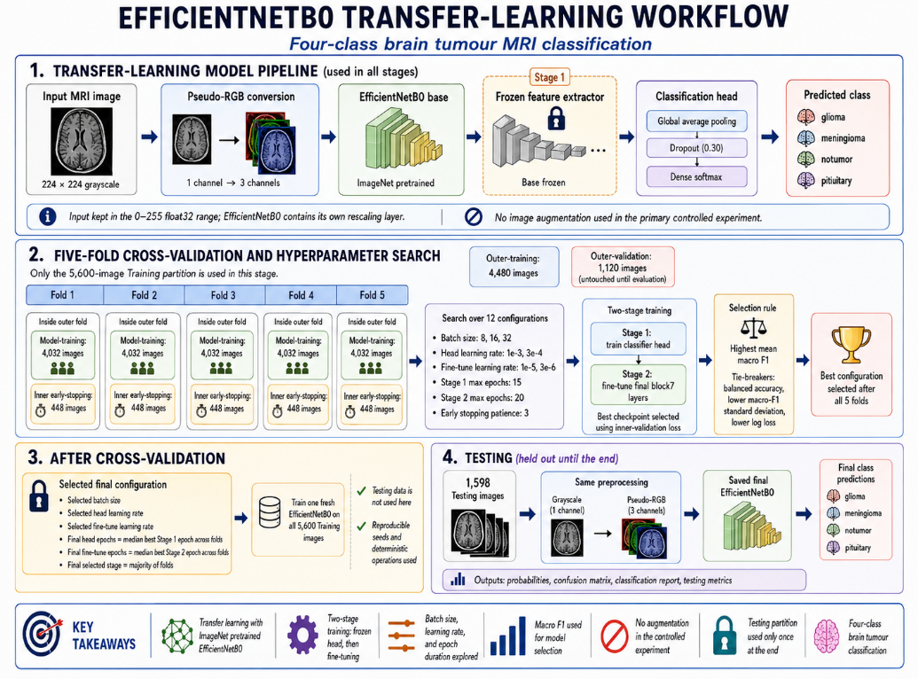

Figure 5

Hybrid SVM Model Selection
The ResNet50 and EfficientNetB0 hybrid SVM models were tuned independently using their respective fixed CNN feature representations. An exhaustive grid search was used with three-fold stratified inner cross-validation, and mean macro F1-score was used to select the best configuration. StandardScaler remained within each SVM pipeline so that scaling was fitted only using the relevant training data.
After the initial five outer folds, a final three-fold grid search was performed using all 5,600 Training feature vectors for each CNN representation. The selected pipelines were then refitted using all Training features before evaluation on the held-out Testing partition. The hybrid SVM methodology is shown in Figure 6.

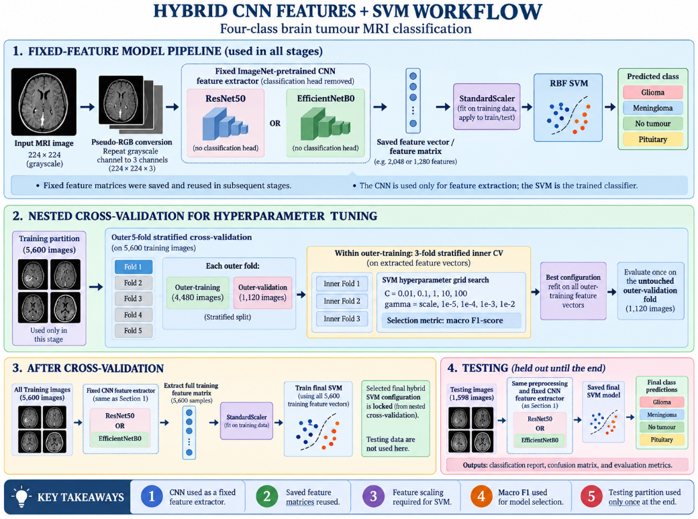

Figure 6

Hybrid Random Forest Model Selection

The ResNet50 and EfficientNetB0 hybrid Random Forest models were tuned independently using their respective fixed CNN feature representations. A successive-halving randomised search was used, with three-fold stratified inner cross-validation and mean macro F1-score used to select the best configuration. The number of trees was used as the successive-halving resource so that weaker configurations could be removed as the search progressed.
After the five outer folds, a final successive-halving search was performed using all 5,600 Training feature vectors for each CNN representation. The selected Random Forest models were then refitted using all Training features before evaluation on the held-out Testing partition. The hybrid Random Forest methodology is shown in Figure 7.
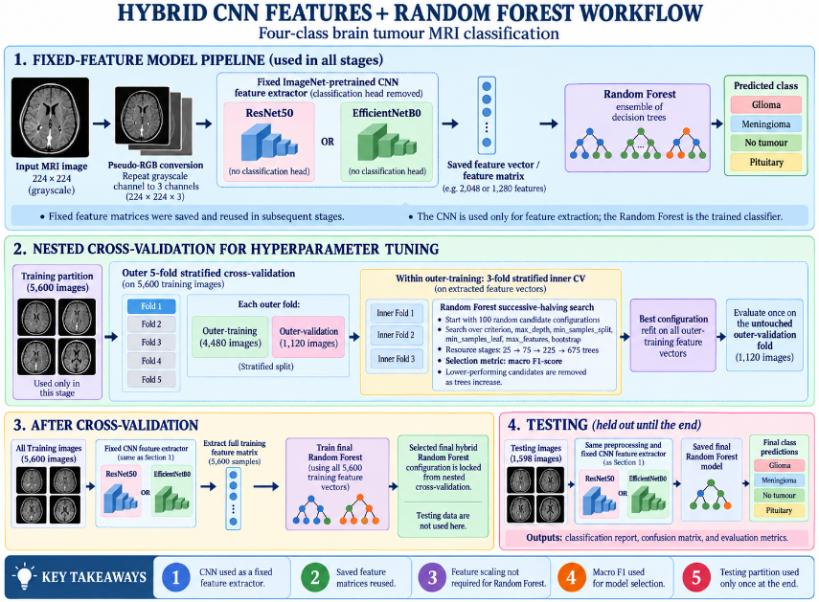

Figure 7

Evaluation Metrics

The same core evaluation metrics were used across all model families to support a consistent comparison. Accuracy measured the proportion of images classified correctly. Precision measured the proportion of predictions assigned to a class that were correct, while recall measured the proportion of images belonging to that class that were correctly identified. The F1-score represented the harmonic mean of precision and recall. Macro F1-score was used as the primary model-selection and comparison metric because it gives equal importance to each of the four classes. Class-level precision, recall and F1-score were also reported alongside confusion matrices to identify specific patterns of misclassification between the tumour classes. Balanced accuracy and log loss were additionally used as secondary model-selection criteria where required.

During the initial model-development stage, cross-validation performance was summarised using the mean and standard deviation across the five outer folds. After model selection, each final model was trained or refitted using all 5,600 Training images, or the corresponding feature representation, and evaluated on the held-out Testing partition. Testing performance was reported using accuracy, macro precision, macro recall and macro F1-score, together with class-level precision, recall and F1-score and the corresponding confusion matrix.

The subsequent ten repeats of five-fold stratified cross-validation were used to examine the stability of model performance across different fold assignments. For each model and repeat, macro F1-score was averaged across the five outer folds, producing ten repeat-level macro F1 values for each model. These values were summarised using the mean and standard deviation across the ten repeats. Aggregating the five folds within each repeat avoided treating the 50 individual outer-fold results as independent observations.

The Wilcoxon signed-rank test was used to compare paired repeat-level macro F1 results between models (Demšar, 2006). Because all models used the same fold assignments within each repeat, their results could be paired directly. Different random seeds were used across the repeated runs, introducing variation in processes such as model initialisation and training. The repeated results therefore represent independent training runs of the same model configurations on the same dataset.

Computational Performance
Computational performance was recorded alongside predictive performance to provide an indication of the computational cost associated with each model. Elapsed times were measured in seconds using Python's time.perf_counter(), with timing started immediately before the operation being measured and stopped immediately afterwards. Hyperparameter-search and final fitting times were recorded for the classical and hybrid classifiers where available. For the deep-learning models, classifier-head training and fine-tuning durations were recorded separately and combined to represent total final training time. In the repeated cross-validation experiments, the recorded search or model-selection time and final refitting time from the five outer folds were combined to obtain the computational time for each repeat.

During held-out Testing evaluation, prediction time was also measured. For ResNet50 and EfficientNetB0, image preprocessing and model inference were timed separately, and inference timing was performed after a warm-up pass so that initial TensorFlow setup and graph tracing were not included. For the hybrid models, CNN feature-extraction time and classifier prediction time were recorded separately, with their sum representing the end-to-end Testing inference time for the complete hybrid pipeline.

Computational timings were treated as descriptive measurements rather than as a strict comparison of model efficiency, because the experiments were executed across separate computational sessions and were not necessarily run under identical hardware and runtime conditions.

Requirements Specification and Design
This chapter translates the experimental methodology defined in Chapter 3 into the requirements and high-level design of the experimental system. It describes the system requirements, overall architecture and experiment-management structure used to support the eight model configurations. Detailed implementation decisions and code-level procedures are presented separately in Chapter 5.

Experimental System Requirements
The experimental system needed to support the execution and comparison of all eight model configurations within a common framework. Its main requirements were to manage the processed MRI dataset and predefined data partitions, generate and store the required handcrafted and CNN-derived feature representations, execute the classical, deep-learning and hybrid models, apply the predefined model-selection procedures, and save the outputs required for evaluation and later analysis. Because several experiments were long running, the system also needed persistent storage and the ability to save completed work and resume interrupted runs.

System Architecture
The experimental system was organised around a shared data layer and three model-processing branches, as illustrated in Figure 8. The shared layer contained the processed MRI images, class labels and saved cross-validation assignments. The classical branch generated HOG–GLCM features for the SVM and Random Forest classifiers; the deep-learning branch supplied the processed images to ResNet50 and EfficientNetB0; and the hybrid branch used fixed ImageNet-pretrained ResNet50 and EfficientNetB0 models to generate feature vectors for separate SVM and Random Forest classifiers. The Training and Testing partitions were maintained as separate data paths. Cross-validation, hyperparameter tuning and model selection operated only on the Training partition, while the Testing partition was accessed only for final evaluation after model selection.

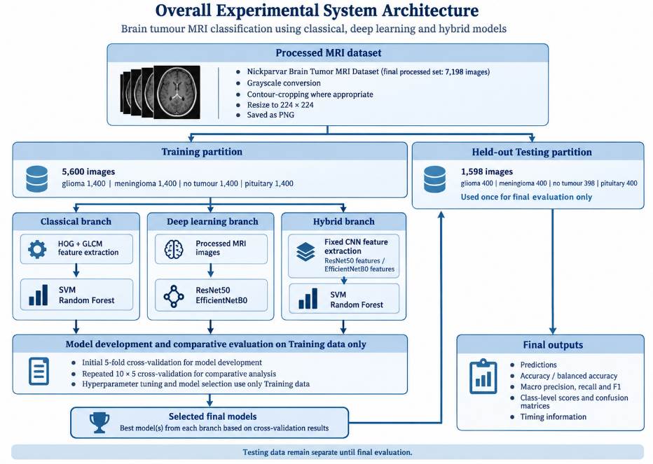

Figure 8

Experiment Execution and Management
The experiments were designed to run reliably across multiple computational sessions and across both local and cloud-based environments. VS Code was used on the local computer for code development, organisation and parts of the experimental workflow, while Google Colab was used for computationally intensive experiments, particularly those requiring access to GPU resources. Predefined cross-validation assignment files were loaded rather than regenerated during individual model runs, while handcrafted and CNN-derived feature matrices were cached and reused where appropriate to avoid unnecessary repeated computation. Long-running hyperparameter searches and CNN experiments saved intermediate outputs as processing progressed, and completion checks were used to identify previously finished runs so that interrupted experiments could resume without repeating valid results.
Experimental outputs were organised by model and, where applicable, by repeat and fold so that individual results could be traced back to the run that produced them. Saved outputs included model configurations, predictions, evaluation metrics, confusion matrices, training histories and timing information. Storage was distributed between the local computer and Google Drive, with Google Drive providing persistent storage across Colab sessions and local storage used for project files and downloaded experimental outputs. Separate directory structures were used for the different model families and repeated cross-validation experiments to support later aggregation and comparison of results.

Implementation
This chapter describes the software implementation of the experimental system, including the development environment, model implementations, repeated cross-validation procedures, computational timing and management of experimental outputs.

Implementation Overview and Development Environment
The project was implemented in Python using both local and cloud-based environments. VS Code was used on the local computer for code development, organisation and parts of the experimental workflow, while Google Colab was used for computationally intensive experiments, particularly CNN training and feature extraction where GPU acceleration was available. Google Drive provided persistent storage across Colab sessions, while project files and downloaded experimental outputs were also stored locally. GitHub was used to maintain a versioned copy of the project code.
The local computer used Windows 11 and was equipped with an AMD Ryzen 7 8840HS processor and 16 GB of RAM. Google Colab provided GPU resources for the deep-learning experiments, with NVIDIA T4 GPUs used for the initial ResNet50 and EfficientNetB0 cross-validation and Testing runs, and NVIDIA A100 GPUs used for the repeated CNN experiments and CNN feature extraction for the hybrid models. The scikit-learn SVM and Random Forest classifiers were CPU-based, including when they were executed within Colab.

The main Python libraries were scikit-learn, TensorFlow/Keras, OpenCV, scikit-image, NumPy, pandas, Pillow and joblib. Scikit-learn provided the classical classifiers, cross-validation procedures, hyperparameter-search utilities and evaluation metrics. TensorFlow and Keras were used to implement ResNet50 and EfficientNetB0 and to extract CNN features for the hybrid models. OpenCV was used for image loading and preprocessing, while Pillow was used during dataset exploration to inspect image dimensions and storage modes. Scikit-image provided the HOG and GLCM feature-extraction functions. NumPy and pandas were used to store and manipulate feature matrices, predictions and experimental results. Joblib was used to save fitted scikit-learn models for later reuse.
Before model execution, the code loaded the required dataset paths, class labels and saved cross-validation assignments and checked that the expected files, class counts and fold distributions were present where applicable. These checks were intended to identify missing files or incorrect assignments before computationally expensive experiments were started. The preprocessing implementation used OpenCV for grayscale conversion, contour-based cropping, resizing and image output. Processed images were resized to 224 × 224 pixels using cv2.resize() with cv2.INTER_AREA interpolation and saved as PNG files using cv2.imwrite(). The contour-cropping function also used imutils.grab_contours() to handle the contours returned by OpenCV.
Classical MRI images were loaded using cv2.imread(..., cv2.IMREAD_GRAYSCALE). HOG features were generated using skimage.feature.hog(), while GLCM matrices and properties were calculated using graycomatrix() and graycoprops(). Separate feature-extraction functions generated the HOG and GLCM descriptors before concatenating them into the 6,102-dimensional handcrafted feature vectors. The resulting NumPy feature matrices were cached and reused by the SVM and Random Forest implementations.
The classical SVM was implemented using scikit-learn's Pipeline, combining StandardScaler and SVC. Hyperparameter searches were executed using GridSearchCV.fit(). Random Forest models were implemented using RandomForestClassifier, with HalvingRandomSearchCV.fit() used for successive-halving searches. The number of trees was supplied as the successive-halving resource so that weaker candidate configurations could be removed as computational resources increased.
ResNet50 and EfficientNetB0 were implemented using tf.keras.applications.ResNet50() and tf.keras.applications.EfficientNetB0() with ImageNet weights and the original classification heads removed. PNG images were decoded through the TensorFlow data pipeline and the single grayscale channel was repeated to produce three-channel input tensors. Global average pooling, dropout and a four-unit softmax output layer formed the new classification heads. Training used model.fit(), with ModelCheckpoint, EarlyStopping, ReduceLROnPlateau and TerminateOnNaN callbacks used where required during model development. The implementation also controlled which pretrained layers remained frozen and which became trainable during fine-tuning.
The hybrid implementations used separate fixed ImageNet-pretrained ResNet50 and EfficientNetB0 feature extractors. The extracted CNN feature matrices were saved and reused by both classical classifiers. Hybrid SVM models again used a StandardScaler–SVC pipeline with GridSearchCV, while hybrid Random Forest models used RandomForestClassifier with HalvingRandomSearchCV.
Computational durations were measured using time.perf_counter(). For the CNNs, classifier-head training and fine-tuning were timed separately during final training. Prediction and feature-extraction timings were also recorded where required, with hybrid CNN feature extraction and classifier prediction measured separately.
Experimental outputs were saved primarily as CSV and JSON files and included predictions, selected hyperparameters, training histories, evaluation metrics, classification reports, confusion matrices and timing information. NumPy arrays and trained model files were also stored where required. Long-running experiments checked existing completion markers and required output files before execution so that completed folds could be skipped and interrupted runs resumed. In some ResNet50 procedures, JSON results were first written to a temporary file and then moved to their final location to reduce the risk of an incomplete write being treated as a valid completed result.

Repeated Cross-Validation Implementation
The repeated cross-validation runs used StratifiedKFold to create ten saved sets of five-fold stratified assignments of the 5,600 Training images. Each repeat contained five outer folds, giving 50 outer-fold evaluations for each model. The same fold assignments were used by all eight models so that each model was evaluated using the same training and validation images within a given repeat. Different random seeds were used across the repeated runs. For the stochastic models, the training process also used different seeds. This introduced variation between runs while keeping the same fold assignments for all models within each repeat. The separate Testing partition was not used during these repeated runs.
For the classical SVM, each repeated outer-training fold used the same scikit-learn Pipeline containing StandardScaler and SVC. The C and gamma values were searched using GridSearchCV with three-fold stratified inner cross-validation, using macro F1-score to select the best configuration. For the Random Forest, RandomForestClassifier was used and the repeated runs used the same search settings and tree stages as the initial development runs. One hundred candidate configurations were started in each outer fold, with the number of trees increased through 25, 75, 225 and 675 while weaker candidates were removed. For both models, after the best configuration was selected, the classifier was fitted using all 4,480 outer-training samples and predictions were generated for the 1,120 outer-validation samples.
For ResNet50 and EfficientNetB0, the repeated runs were implemented in TensorFlow and Keras. Within each 4,480-image outer-training partition, StratifiedShuffleSplit was used to create 4,032 model-training images and 448 internal-validation images. The 12 candidate configurations were trained using model.fit(), with the internal-validation subset used for training control, checkpoint selection and comparison of the candidate configurations. The same layer-freezing and fine-tuning rules used during initial model development were retained. After the best configuration for the outer fold had been selected using only the internal-validation results, a fresh model was built and refitted using all 4,480 outer-training images. The refit used the selected training stage and epoch counts, without using an internal-validation or outer-validation set. It was then evaluated once on the untouched 1,120-image outer-validation fold.

For the hybrid repeated runs, the previously saved ResNet50 and EfficientNetB0 feature matrices were loaded and partitioned using the same outer-fold assignments as the other models. The hybrid SVM models used a scikit-learn Pipeline containing StandardScaler and SVC, with GridSearchCV used for three-fold stratified inner cross-validation and macro F1-score used to select the best configuration. The hybrid Random Forest models used RandomForestClassifier with a checkpointed successive-halving procedure using the same 25, 75, 225 and 675-tree resource stages. Completed inner-CV fits were saved so that interrupted searches could resume without repeating completed fits. After the best classifier configuration was selected within each outer-training fold, it was refitted using all 4,480 outer-training feature vectors and evaluated on the corresponding 1,120 outer-validation feature vectors.
After each outer fold was completed, the code saved the predictions, selected hyperparameters, evaluation metrics and timing information in the folder for that model, repeat and fold. The evaluation values were calculated using scikit-learn metric functions such as accuracy_score(), balanced_accuracy_score() and f1_score(). CSV and JSON files were used to store the results, and completion files were checked before starting a fold so that finished runs could be skipped. After all five folds of a repeat were complete, their macro F1-scores were combined to produce one mean macro F1 value for that repeat. This gave ten repeat-level macro F1 values for each model for the later Wilcoxon signed-rank comparisons.

Testing and Evaluation
Model evaluation was carried out in three stages. The eight models were first assessed using five-fold cross-validation on the 5,600 Training images for model development and selection. The selected configurations were then evaluated on the separate Testing partition. Finally, ten repeats of five-fold stratified cross-validation were used to assess performance stability and provide paired results for statistical comparison.
Performance was measured using accuracy, balanced accuracy, macro precision, macro recall and macro F1-score. Macro F1-score was used as the main comparison metric. Class-level precision, recall and F1-scores and confusion matrices were also used to examine performance for each tumour class and identify misclassifications. Initial cross-validation results were summarised using the mean and standard deviation across the five folds. For repeated cross-validation, the five outer-fold macro F1-scores within each repeat were averaged to produce one repeat-level value. This produced ten paired macro F1 values for each model for the later Wilcoxon signed-rank comparisons.
After model selection, each selected model was trained or refitted using all 5,600 Training images, or the full Training feature matrix where applicable, and evaluated once on the held-out Testing partition. The Testing data were not used during model selection or cross-validation.

Results and Discussion

Classical Models
The HOG–GLCM SVM achieved a mean macro F1-score of 0.9137 during the initial five-fold cross-validation, with a standard deviation of 0.0059. On the held-out Testing partition, the model achieved an accuracy of 0.8974 and a macro F1-score of 0.8947. The repeated cross-validation produced a very similar mean macro F1-score of 0.9137 across the ten repeats, indicating that the model's performance was stable across different fold assignments.
In comparison, the HOG–GLCM Random Forest produced a lower mean macro F1-score of 0.8647 during the initial five-fold cross-validation, with a standard deviation of 0.0076. On the held-out Testing partition, it achieved an accuracy of 0.8335 and a macro F1-score of 0.8279. Across the ten repeated runs, its mean macro F1-score was 0.8636. On the Testing partition, no tumour had the highest class F1-score at 0.9308, while glioma had the lowest at 0.7007. Overall, the Random Forest performed below the SVM across all three evaluation stages.
As shown in Figures 9 and 10, glioma was the most difficult class for both classical models. The SVM correctly classified 289 of the 400 glioma images, while the Random Forest correctly classified 247. In both models, glioma was most often confused with meningioma. In contrast, no tumour was classified very well, with all 398 images correctly identified by the SVM and 397 by the Random Forest. This suggests that the HOG–GLCM features separated no-tumour images more effectively than some of the tumour classes.

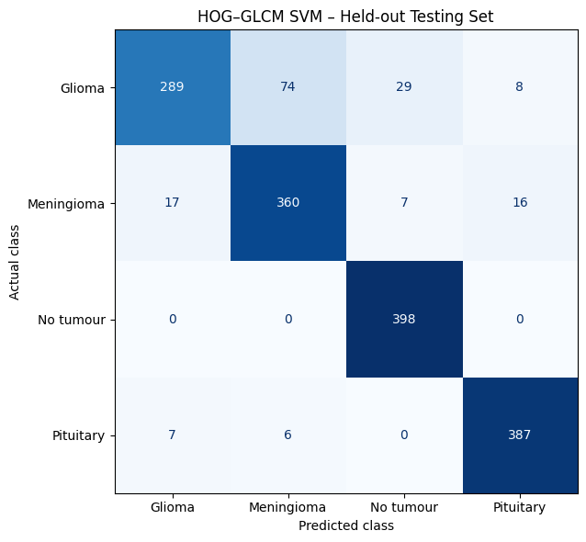
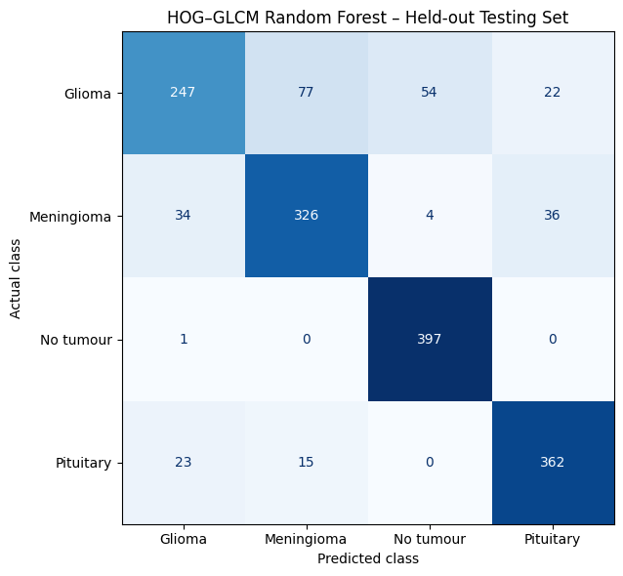

Figure 9 Figure 10

Deep Learning Models
ResNet50 achieved a mean macro F1-score of 0.9556 during the initial five-fold cross-validation, with a standard deviation of 0.0050. On the held-out Testing partition, the model achieved an accuracy of 0.9293 and a macro F1-score of 0.9285. Across the ten repeated five-fold cross-validation runs, the mean macro F1-score was 0.9542. The close agreement between the initial and repeated cross-validation results indicates that ResNet50 produced stable performance across different fold assignments.
The held-out Testing results showed that ResNet50 performed strongest on the no-tumour and pituitary classes, with F1-scores of 0.9755 and 0.9721, respectively. Glioma remained the most difficult class, with an F1-score of 0.8680 and recall of 0.7975. Of the 400 glioma images, 60 were classified as meningioma and 18 as no tumour. All 398 no-tumour images were correctly classified.
EfficientNetB0 achieved a mean macro F1-score of 0.9464 during the initial five-fold cross-validation, with a standard deviation of 0.0064. On the held-out Testing partition, the model achieved an accuracy of 0.9324 and a macro F1-score of 0.9308. Across the ten repeated five-fold cross-validation runs, the mean macro F1-score was 0.9535. On the

Testing partition, the model performed best on the pituitary and no-tumour classes, with F1-scores of 0.9825 and 0.9767, respectively, while glioma was again the most difficult class with an F1-score of 0.8591. Overall, EfficientNetB0 performed very similarly to ResNet50 on the held-out Testing data.
Overall, the two deep learning models produced very similar results. ResNet50 achieved the higher macro F1-score during the initial five-fold cross-validation, at 0.9556 compared with 0.9464 for EfficientNetB0. ResNet50 also achieved a slightly higher mean macro F1-score in repeated cross-validation, at 0.9542 compared with 0.9535. However, EfficientNetB0 achieved a slightly higher Testing macro F1-score of 0.9308 compared with 0.9285 for ResNet50. As shown in Figures 11 and 12, no tumour and pituitary were classified very well for both models, while glioma remained the most difficult class.
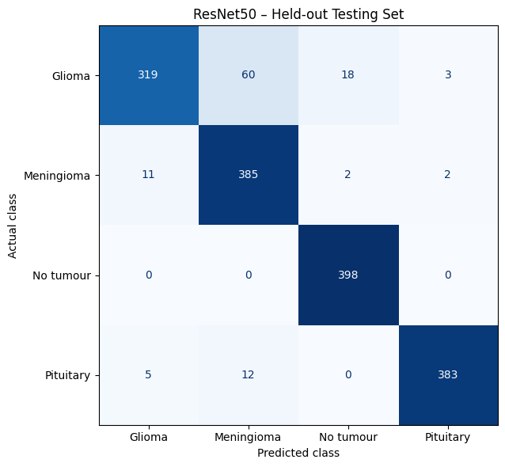
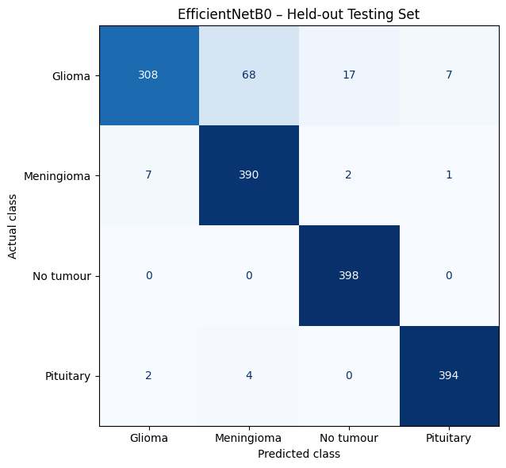

Figure 11 Figure 12

Hybrid Models
The ResNet50 + SVM hybrid model achieved a mean macro F1-score of 0.9545 during the initial five-fold cross-validation, with a standard deviation of 0.0073. On the held-out Testing partition, it achieved an accuracy of 0.9368 and a macro F1-score of 0.9353. Across the ten repeated five-fold cross-validation runs, the mean macro F1-score was 0.9570. These results were very similar across the cross-validation stages and remained strong on the held-out Testing data.
On the Testing partition, pituitary had the highest class F1-score at 0.9888, followed by no tumour at 0.9695. Glioma was again the most difficult class, with an F1-score of 0.8698 and recall of 0.7850. Of the 400 glioma images, 61 were classified as meningioma and 22 as no tumour. All 398 no-tumour images were correctly classified.
The ResNet50 + Random Forest hybrid model achieved a mean macro F1-score of 0.9195 during the initial five-fold cross-validation, with a standard deviation of 0.0106. On the held-out Testing partition, it achieved an accuracy of 0.8955 and a macro F1-score of 0.8922. Across the ten repeated five-fold cross-validation runs, the mean macro F1-score was 0.9180. These results were similar across the initial and repeated cross-validation procedures.
On the Testing partition, no tumour had the highest class F1-score at 0.9602, followed closely by pituitary at 0.9579. Glioma was the most difficult class, with an F1-score of 0.7982 and recall of 0.6825. Of the 400 glioma images, 91 were classified as meningioma and 30 as no tumour. The model correctly classified all 398 no-tumour images.
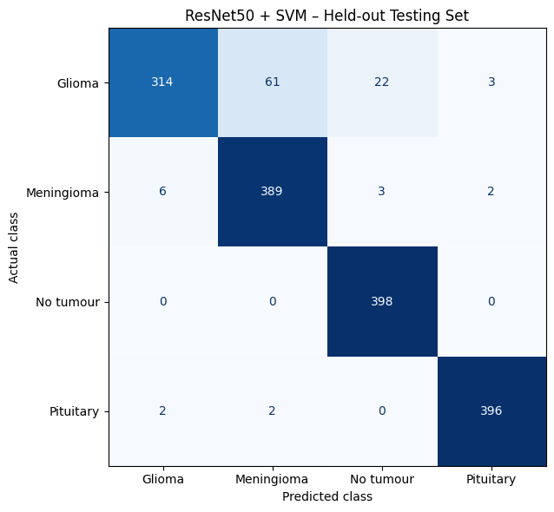
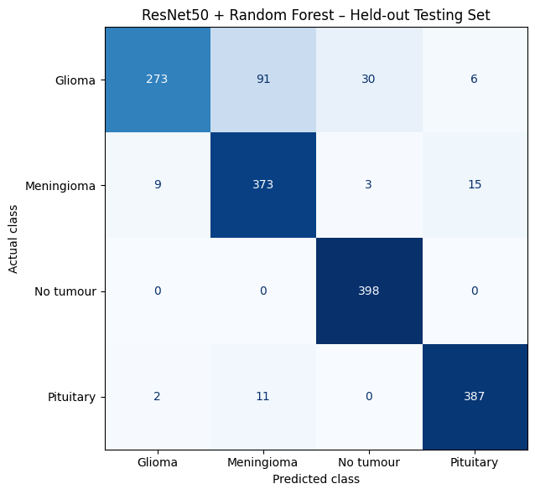

Figure 13 Figure 14

The EfficientNetB0 + SVM hybrid model achieved a mean macro F1-score of 0.9628 during the initial five-fold cross-validation, with a standard deviation of 0.0065. On the held-out Testing partition, it achieved an accuracy of 0.9418 and a macro F1-score of 0.9405. Across the ten repeated five-fold cross-validation runs, the mean macro F1-score was 0.9636. The close agreement between the initial and repeated cross-validation results indicates that the model performed consistently across different fold assignments.
On the Testing partition, pituitary had the highest class F1-score at 0.9912, followed by no tumour at 0.9791. Glioma was again the most difficult class, with an F1-score of 0.8745 and recall of 0.7925. Of the 400 glioma images, 65 were classified as meningioma and 16 as no tumour. All 398 no-tumour images were correctly classified.
The EfficientNetB0 + Random Forest hybrid model achieved a mean macro F1-score of 0.9166 during the initial five-fold cross-validation, with a standard deviation of 0.0044. On the held-out Testing partition, it achieved an accuracy of 0.9111 and a macro F1-score of 0.9095. Across the ten repeated five-fold cross-validation runs, the mean macro F1-score was 0.9173. These results were very similar across the two cross-validation procedures.
On the Testing partition, no tumour had the highest class F1-score at 0.9707, followed by pituitary at 0.9675. Glioma was again the most difficult class, with an F1-score of 0.8312 and recall of 0.7450. Of the 400 glioma images, 77 were classified as meningioma and 20 as no tumour. The model correctly classified all 398 no-tumour images.
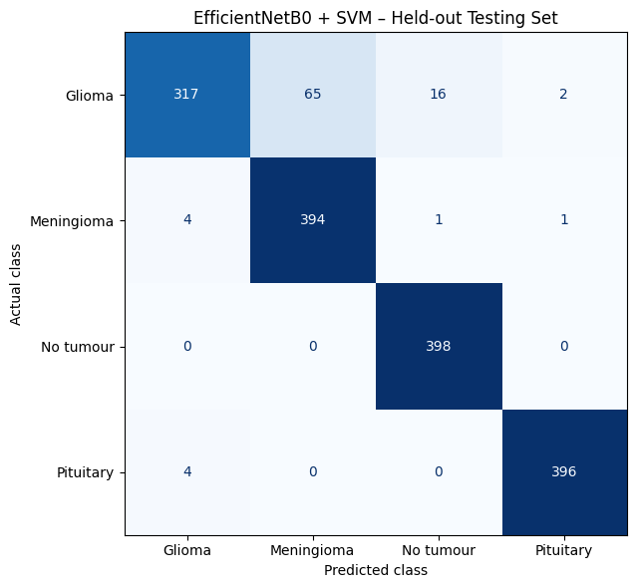
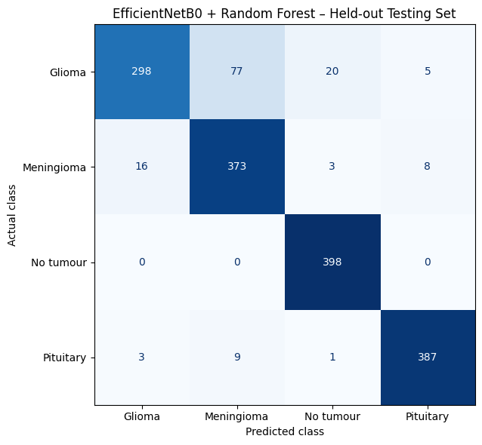

Figure 15 Figure 16

Comparing the two SVM-based hybrid models, EfficientNetB0 + SVM achieved the stronger results overall. Its initial cross-validation macro F1-score was 0.9628 compared with 0.9545 for ResNet50 + SVM, while its repeated cross-validation mean was 0.9636 compared with 0.9570. EfficientNetB0 + SVM also achieved the higher Testing macro F1-score, at 0.9405 compared with 0.9353, and the higher Testing accuracy, at 0.9418 compared with 0.9368.
The SVM-based hybrid models also performed better than their corresponding end-to-end deep learning models. ResNet50 + SVM achieved a higher repeated cross-validation macro F1-score than ResNet50, at 0.9570 compared with 0.9542, and a higher Testing macro F1-score of 0.9353 compared with 0.9285. EfficientNetB0 + SVM showed a clearer improvement over EfficientNetB0, achieving 0.9636 compared with 0.9535 in repeated cross-validation and 0.9405 compared with 0.9308 on the Testing partition.
For the ResNet50 features, the SVM performed better than the Random Forest in both the initial cross-validation and held-out Testing results. The SVM achieved an initial macro F1-score of 0.9545 compared with 0.9195 for the Random Forest. On the Testing partition, the SVM also achieved a higher macro F1-score of 0.9353 compared with 0.8922 for the Random Forest.
Across all four hybrid models, glioma remained the most difficult class to classify, while no tumour was consistently one of the strongest classes. All four hybrid models correctly classified all 398 no-tumour images. The SVM-based hybrids produced stronger glioma F1-scores than the Random Forest hybrids, with 0.8698 for ResNet50 + SVM and 0.8745 for EfficientNetB0 + SVM, compared with 0.7982 and 0.8312 for the corresponding Random Forest models.
Figure 17 shows that the highest held-out Testing macro F1-score was achieved by EfficientNetB0 + SVM, followed by ResNet50 + SVM, while HOG–GLCM Random Forest produced the lowest result.

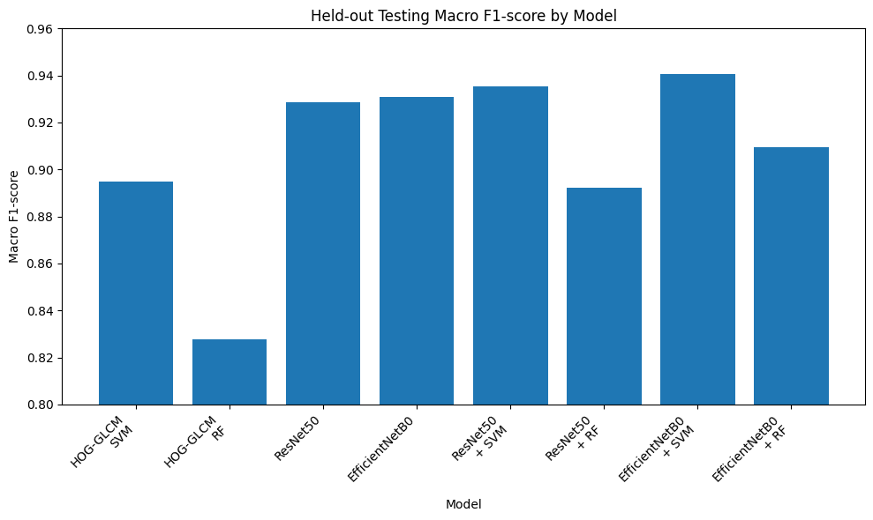

Figure 17

Across most models, the held-out Testing macro F1-score was slightly lower than the initial cross-validation result, although the overall ranking of the stronger models remained similar. This can be seen in Figure 18.
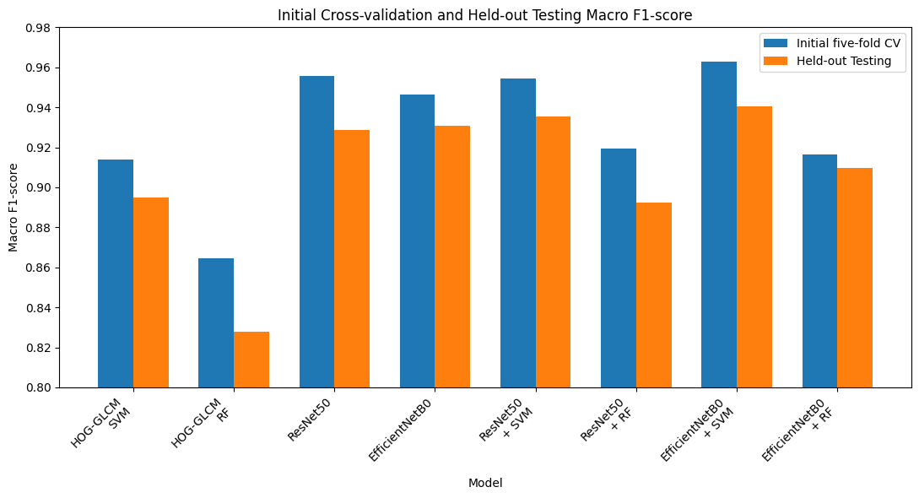

Figure 18

Table 2 summarises the performance of all eight final models on the held-out Testing partition using accuracy, macro precision, macro recall and macro F1-score.
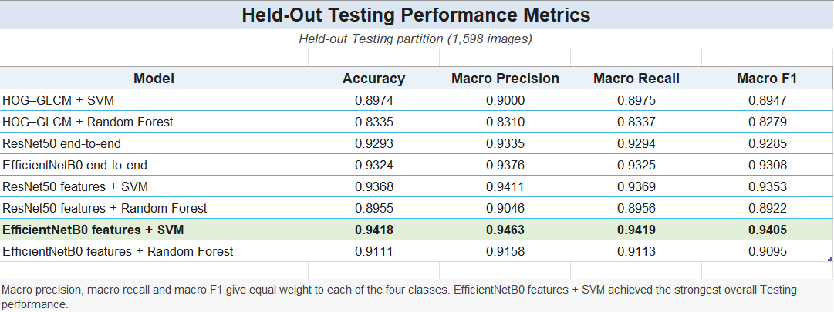

Table 2

Statistical Comparison
The repeated cross-validation results were used to determine whether the observed differences in macro F1-score between the model configurations were statistically significant. As described in the methodology, the five outer-fold macro F1-scores within each repeat were averaged to produce ten paired repeat-level values for each model, and the two-sided Wilcoxon signed-rank test was applied using a significance level of 0.05. Within the classical models, HOG–GLCM + SVM significantly outperformed HOG–GLCM + Random Forest, with W = 0 and p = 0.001953, supporting the higher repeated cross-validation macro F1-score of 0.9137 compared with 0.8636. In contrast, no statistically significant difference was found between the two end-to-end CNN models. ResNet50 achieved a repeated cross-validation macro F1-score of 0.9542 compared with 0.9535 for EfficientNetB0, but the Wilcoxon result was W = 20 and p = 0.492188. This indicates that the small difference between the two CNN architectures was not statistically significant, which is consistent with their similar descriptive performance.
Within the hybrid models, the choice of classifier had a clear influence on performance. ResNet50 features + SVM significantly outperformed ResNet50 features + Random Forest, with W = 0 and p = 0.001953. EfficientNetB0 features + SVM also significantly outperformed EfficientNetB0 features + Random Forest, again with W = 0 and p =

0.001953. The two SVM-based hybrid models were the strongest configurations overall, with EfficientNetB0 features + SVM achieving the highest repeated cross-validation mean macro F1-score of 0.9636, followed by ResNet50 features + SVM at 0.9570. EfficientNetB0 features + SVM also significantly outperformed ResNet50 features + SVM, with W = 0 and p = 0.001953. These results indicate that SVM was substantially better suited than Random Forest to the fixed CNN feature representations used in this study.
Comparison of the hybrid SVM models with the end-to-end CNNs showed that the hybrid approach could improve performance when SVM was used as the downstream classifier. EfficientNetB0 features + SVM significantly outperformed EfficientNetB0 end-to-end, with W = 0 and p = 0.001953 and also significantly outperformed ResNet50 end-to-end, with W = 1 and p = 0.003906. ResNet50 features + SVM significantly outperformed EfficientNetB0 end-to-end, with W = 1 and p = 0.003906, although its comparison with ResNet50 end-to-end was not statistically significant, with W = 12 and p = 0.130859. This distinction is important because it shows that the higher descriptive performance of the SVM-based hybrid models did not translate into statistical significance in every individual comparison. The Random Forest hybrid models showed the opposite pattern: both ResNet50 features + Random Forest and EfficientNetB0 features + Random Forest performed significantly below the two end-to-end CNN models, with p = 0.001953 in each of these comparisons. The descriptive results in the report similarly show that the SVM-based hybrids were substantially stronger than the Random Forest hybrids.
Overall, the statistical comparisons showed that classifier choice had an important effect on performance. SVM significantly outperformed Random Forest when applied to both the handcrafted HOG–GLCM features and the fixed CNN feature representations. The two end-to-end CNN architectures, ResNet50 and EfficientNetB0, did not differ significantly from each other. The strongest overall configuration was EfficientNetB0 features + SVM, while the SVM-based hybrid models generally performed better than the end-to-end CNN models. In contrast, the Random Forest hybrid models performed significantly below the end-to-end CNNs. These findings indicate that the benefit of using fixed CNN features depended strongly on the downstream classifier, with SVM providing substantially stronger performance than Random Forest.

Misclassification and Error Analysis
The held-out Testing predictions were analysed to examine the types of errors made by the eight final models. Across the 1,598 Testing images, 339 were misclassified by at least one model, while 47 images were misclassified by all eight models. Of these 47 common errors, 46 were glioma images and one was a meningioma image. This shows that the shared errors were strongly concentrated in the glioma class.
Among the 47 images misclassified by every model, 21 received the same incorrect prediction from all eight models. Eleven glioma images were classified as meningioma, nine glioma images were classified as no tumour, and one meningioma image was classified as no tumour. This supports the class-level results reported earlier, where glioma was consistently the most difficult class to classify.
To investigate whether preprocessing may have contributed to these shared errors, the commonly misclassified images were visually inspected individually, with particular attention to whether the contour-based cropping had removed too much of the brain region. Most of the images appeared to have been cropped appropriately, and only a small number appeared potentially over-cropped. There was therefore no clear evidence that cropping errors were the main cause of the common glioma misclassifications.
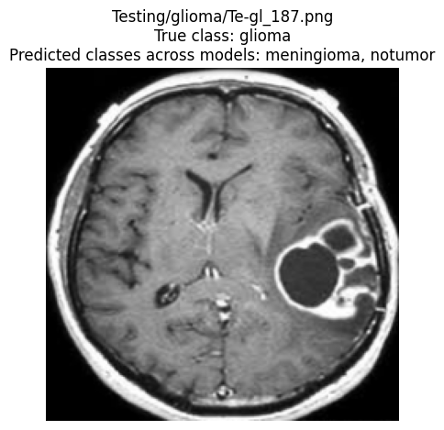
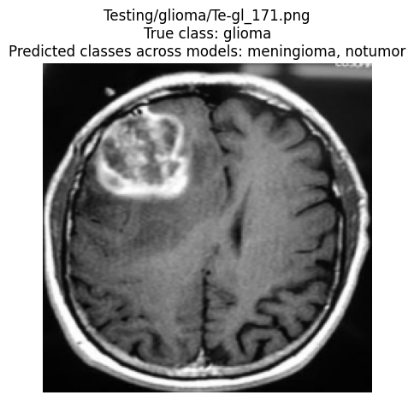

Figure 19: Examples of glioma images misclassified by all models
False-positive and false-negative counts were also calculated for each class across all eight final models using a one-versus-rest interpretation. False negatives represent images belonging to a class that were incorrectly classified as another class, while false positives represent images from other classes that were incorrectly assigned to that class. These counts provide additional information about the types of errors made by each model beyond the overall accuracy and macro F1-score.
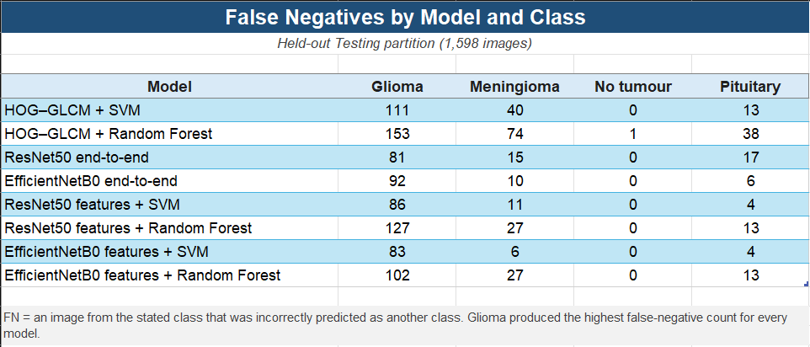

Table 3

Glioma produced the highest false-negative count for every model, confirming that it was the most difficult class to identify. ResNet50 end-to-end had the lowest glioma false-negative count at 81, while HOG–GLCM + Random Forest had the highest at 153. No-tumour false negatives were almost absent, with all models recording zero except HOG–GLCM + Random Forest, which recorded one.
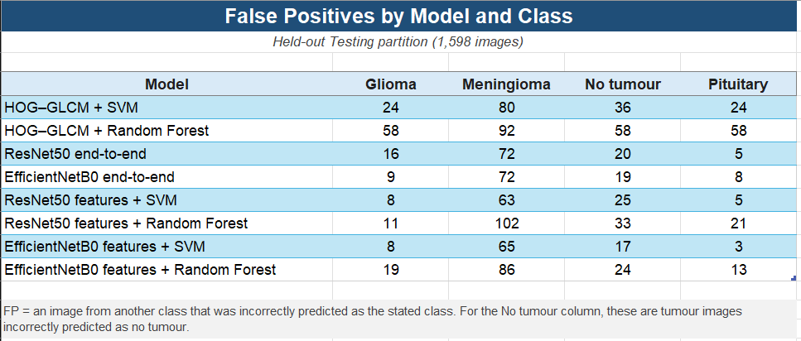

Table 4

Meningioma produced relatively high false-positive counts across several models, which is consistent with the frequent confusion of glioma images with meningioma. False positives for the no-tumour class are particularly important because they represent tumour images incorrectly classified as no tumour. EfficientNetB0 features + SVM had the lowest no-tumour false-positive count at 17, while HOG–GLCM + Random Forest had the highest at 58.

Computational Performance
The recorded cross-validation timings showed clear differences in computational cost between the models. HOG–GLCM + Random Forest was the most demanding, taking about 16.3 hours per five-fold repeat, while HOG–GLCM + SVM required about 3.4 hours. The end-to-end ResNet50 and EfficientNetB0 models required approximately 3.2 hours and 4.4 hours per repeat, respectively. The SVM-based hybrid models generally required less computational time than the Random Forest-based hybrid models. EfficientNetB0 + Random Forest showed greater variation because its repeated runs were completed across different Colab runtime environments.
As described in Section 5.1, the experiments were carried out across local and Google Colab environments with different hardware resources. The timings are therefore used as a general indication of computational cost rather than as a strict comparison of model speed.

Conclusion, Limitations and Future Work

Conclusion
The results showed that the hybrid models using SVM achieved the strongest overall performance. EfficientNetB0 features + SVM was the best-performing model, achieving a mean macro F1-score of 0.9636 across the repeated cross-validation runs and 0.9405 on the held-out Testing partition. ResNet50 features + SVM was the next strongest hybrid model, with repeated cross-validation and Testing macro F1-scores of 0.9570 and 0.9353, respectively. The statistical comparisons also showed that SVM performed significantly better than Random Forest when applied to both handcrafted and CNN-derived features. Among the classical models, HOG–GLCM + SVM consistently outperformed HOG–GLCM + Random Forest, although both performed below the strongest deep-learning and hybrid configurations. In contrast, ResNet50 and EfficientNetB0 produced very similar results when trained as end-to-end CNN models.
Model performance also differed across the four classes. No tumour and pituitary tumour were generally classified well, while glioma was consistently the most difficult class across the different model families. Glioma was frequently confused with meningioma, showing that distinguishing between these two tumour classes remained one of the main difficulties in the classification task.
Overall, the findings show that combining fixed pretrained CNN features with an SVM was the most effective approach tested in this study. The results also show that the choice of classifier had a strong effect on hybrid-model performance, as the SVM-based hybrids clearly outperformed the Random Forest-based hybrids.

Limitations
Several limitations should be considered when interpreting the results. First, the study used a single public MRI dataset. A separate held-out Testing partition was used to evaluate the final models on data that were not used during training, model selection or cross-validation. However, both the Training and Testing partitions came from the same dataset, so the study does not show how the models would perform on MRI data from a different source.
A further limitation is that the dataset does not provide patient identifiers. The dataset creator states that duplicate images and overlap between the Training and Testing partitions were removed, but this could not be independently verified in this study. The

cross-validation folds could therefore only be created at image level, and it was not possible to confirm that images from the same patient were kept within the same partition. If several images came from the same patient, this could lead to related images appearing in different folds. The preprocessing procedure also involved cropping and resizing the MRI images. Although the images were checked during preprocessing, cropping and resizing may still remove or alter some anatomical information.
Finally, the computational timings should be interpreted with caution because the experiments were carried out across different local and cloud-based runtime environments. The recorded times therefore show the approximate computational cost of the experiments rather than providing a direct comparison of model speed.

Future Work
A useful next step would be to evaluate the selected models on one or more separate MRI datasets from different sources. This would provide stronger evidence that the results are not specific to the dataset used in this study and would give a better indication of how well the models generalise to new data. Where patient information is available, patient-level data splitting should also be used so that all images from the same patient remain within the same training, validation or testing partition.
The range of models could also be expanded. This study compared two classical models, two end-to-end CNN models and four hybrid models. With more time and computational resources, additional classical classifiers, CNN architectures and hybrid combinations could be evaluated using the same experimental framework. This would allow a broader comparison of the strengths and weaknesses of each model group.
Another area for further investigation is the classification of glioma and meningioma, which produced many of the errors in this study. Alternative preprocessing methods, data augmentation, and tumour localisation or segmentation could be explored to determine whether these classes can be separated more effectively. Computational performance could also be evaluated under the same hardware and runtime conditions so that training and model-selection times can be compared more directly across the different model groups.

References
Abdalla, P.A., Mohammed, B.A. and Saeed, A.M. (2023) ‘The impact of image augmentation techniques of MRI patients in deep transfer learning networks for brain tumor detection’, Journal of Electrical Systems and Information Technology, 10, Article 51. doi: 10.1186/s43067-023-00119-9.
Akinyelu, A.A., Zaccagna, F., Grist, J.T., Castelli, M. and Rundo, L. (2022) ‘Brain Tumor Diagnosis Using Machine Learning, Convolutional Neural Networks, Capsule Neural Networks and Vision Transformers, Applied to MRI: A Survey’, Journal of Imaging, 8(8), Article 205, doi: 10.3390/jimaging8080205.
Amarnath, A., Al Bataineh, A. and Hansen, J.A. (2024) ‘Transfer-Learning Approach for Enhanced Brain Tumor Classification in MRI Imaging’, BioMedInformatics, 4(3), pp. 1745–1756. doi: 10.3390/biomedinformatics4030095.
Amin, J., Sharif, M., Haldorai, A., Yasmin, M. and Nayak, R.S. (2022) ‘Brain tumor detection and classification using machine learning: a comprehensive survey’, Complex & Intelligent Systems, 8, pp. 3161–3183. doi: 10.1007/s40747-021-00563-y.
Bergstra, J. and Bengio, Y. (2012) ‘Random search for hyper-parameter optimization’, Journal of Machine Learning Research, 13, pp. 281–305. Available at: https://jmlr.org/papers/v13/bergstra12a.html (Accessed: 28 July 2026).
Breiman, L. (2001) ‘Random forests’, Machine Learning, 45(1), pp. 5–32. doi: 10.1023/A:1010933404324.
Cawley, G.C. and Talbot, N.L.C. (2010) ‘On over-fitting in model selection and subsequent selection bias in performance evaluation’, Journal of Machine Learning Research, 11, pp. 2079–2107.
Cortes, C. and Vapnik, V. (1995) ‘Support-vector networks’, Machine Learning, 20(3), pp. 273–297. doi: 10.1007/BF00994018.
Dalal, N. and Triggs, B. (2005) ‘Histograms of oriented gradients for human detection’, in Proceedings of the 2005 IEEE Computer Society Conference on Computer Vision and Pattern Recognition, San Diego, CA, USA, pp. 886–893. doi: 10.1109/CVPR.2005.177.
Deepak, S. and Ameer, P.M. (2023) ‘Brain tumor categorization from imbalanced MRI dataset using weighted loss and deep feature fusion’, Neurocomputing, 520, pp. 94–102. doi: 10.1016/j.neucom.2022.11.039.
Demšar, J. (2006) ‘Statistical Comparisons of Classifiers over Multiple Data Sets’, Journal of Machine Learning Research, 7, pp. 1–30.
Donahue, J., Jia, Y., Vinyals, O., Hoffman, J., Zhang, N., Tzeng, E. and Darrell, T. (2014) ‘DeCAF: A deep convolutional activation feature for generic visual recognition’, Proceedings of the 31st International Conference on Machine Learning, 32(1), pp. 647–655.
Gao, P. et al. (2022) ‘Development and Validation of a Deep Learning Model for Brain Tumor Diagnosis and Classification Using Magnetic Resonance Imaging’, JAMA Network Open, 5(8), e2225608. doi: 10.1001/jamanetworkopen.2022.25608.
Gautam, S., Ahlawat, S. and Mittal, P. (2022) ‘Binary and Multi-class Classification of Brain Tumors using MRI Images’, International Journal of Experimental Research and Review, 29, pp. 1–9. doi: 10.52756/ijerr.2022.v29.001.
Haralick, R.M., Shanmugam, K. and Dinstein, I. (1973) ‘Textural features for image classification’, IEEE Transactions on Systems, Man, and Cybernetics, SMC-3(6), pp. 610–621. doi: 10.1109/TSMC.1973.4309314.
He, K., Zhang, X., Ren, S. and Sun, J. (2016) ‘Deep residual learning for image recognition’, Proceedings of the IEEE Conference on Computer Vision and Pattern Recognition (CVPR), pp. 770–778.
Kang, J., Ullah, Z. and Gwak, J. (2021) ‘MRI-Based Brain Tumor Classification Using Ensemble of Deep Features and Machine Learning Classifiers’, Sensors, 21(6), 2222. doi: 10.3390/s21062222.
Khan, M.S.I., Rahman, A., Debnath, T., Karim, M.R., Nasir, M.K., Band, S.S., Mosavi, A. and Dehzangi, I. (2022) ‘Accurate brain tumor detection using deep convolutional neural network’, Computational and Structural Biotechnology Journal, 20, pp. 4733–4745. doi: 10.1016/j.csbj.2022.08.039.
Kingma, D.P. and Ba, J. (2015) ‘Adam: A method for stochastic optimization’, in Proceedings of the 3rd International Conference on Learning Representations (ICLR 2015). arXiv:1412.6980.
Kouli, O., Hassane, A., Badran, D., Kouli, T., Hossain-Ibrahim, K. and Steele, J.D. (2022) ‘Automated brain tumor identification using magnetic resonance imaging: a systematic review and meta-analysis’, Neuro-Oncology Advances, 4(1), vdac081. doi: 10.1093/noajnl/vdac081.
Krishnapriya, S. and Karuna, Y. (2023) ‘Pre-trained deep learning models for brain MRI image classification’, Frontiers in Human Neuroscience, 17, Article 1150120. doi: 10.3389/fnhum.2023.1150120.
Krishnapriya, S. and Karuna, Y. (2024) ‘A deep learning model for the localization and extraction of brain tumors from MR images using YOLOv7 and grab cut algorithm’, Frontiers in Oncology, 14, Article 1347363. doi: 10.3389/fonc.2024.1347363.
Kumar, K., Jyoti, K. and Kumar, K. (2024) ‘Machine learning for brain tumor classification: evaluating feature extraction and algorithm efficiency’, Discover Artificial Intelligence, 4, Article 112. doi: 10.1007/s44163-024-00214-4.
Kushol, R., Parnianpour, P., Wilman, A.H., Kalra, S. and Yang, Y.-H. (2023) ‘Effects of MRI scanner manufacturers in classification tasks with deep learning models’, Scientific Reports, 13, Article 16791. doi: 10.1038/s41598-023-43715-5.
Nayak, S.S., Pendem, S., Menon, G.R., Sampathila, N. and Koteshwar, P. (2024) ‘Quality Assessment of MRI-Radiomics-Based Machine Learning Methods in Classification of Brain Tumors: Systematic Review’, Diagnostics, 14(23), Article 2741, doi: 10.3390/diagnostics14232741.
Nickparvar, M. (n.d.) Brain Tumor MRI Dataset. Kaggle. Available at: https://www.kaggle.com/datasets/masoudnickparvar/brain-tumor-mri-dataset (Accessed: 21/02/2026).
Nickparvar, M. (n.d.) ‘Preprocessing.py’, Brain-Tumor-MRI-Classification. GitHub. Available at: https://github.com/masoudnick/Brain-Tumor-MRI-Classification/blob/main/Preprocessing.py (Accessed: 13/07/2026).
Pattanaik, B.B., Anitha, K., Rathore, S., Biswas, P., Sethy, P.K. and Behera, S.K. (2022) ‘Brain tumor magnetic resonance images classification based machine learning paradigms’, Contemporary Oncology, 26(4), pp. 268–274. doi: 10.5114/wo.2023.124612.
Prechelt, L. (1998) ‘Automatic early stopping using cross validation: quantifying the criteria’, Neural Networks, 11(4), pp. 761–767. doi: 10.1016/S0893-6080(98)00010-0.
Razavian, A.S., Azizpour, H., Sullivan, J. and Carlsson, S. (2014) ‘CNN features off-the-shelf: An astounding baseline for recognition’, Proceedings of the IEEE Conference on Computer Vision and Pattern Recognition Workshops, pp. 806–813.
Rouzrokh, P., Khosravi, B., Faghani, S., Moassefi, M., Vera Garcia, D.V., Singh, Y., Zhang, K., Conte, G.M. and Erickson, B.J. (2022) ‘Mitigating Bias in Radiology Machine Learning: 1. Data Handling’, Radiology: Artificial Intelligence, 4(5), e210290. doi: 10.1148/ryai.210290.
Shorten, C. and Khoshgoftaar, T.M. (2019) ‘A survey on Image Data Augmentation for Deep Learning’, Journal of Big Data, 6, Article 60. doi: 10.1186/s40537-019-0197-0.
Stathopoulos, I., Serio, L., Karavasilis, E., Kouri, M.A., Velonakis, G., Kelekis, N. and Efstathopoulos, E. (2024) ‘Evaluating brain tumor detection with deep learning convolutional neural networks across multiple MRI modalities’, Journal of Imaging, 10(12), Article 296. doi: 10.3390/jimaging10120296.
Swati, Z.N.K., Zhao, Q., Kabir, M., Ali, F., Ali, Z. and Lu, J. (2019) ‘Brain tumor classification for MR images using transfer learning and fine-tuning’, Computerized Medical Imaging and Graphics, 75, pp. 34–46. doi: 10.1016/j.compmedimag.2019.05.001.
Tummala, S., Kadry, S., Bukhari, S.A.C. and Rauf, H.T. (2022) ‘Classification of Brain Tumor from Magnetic Resonance Imaging Using Vision Transformers Ensembling’, Current Oncology, 29(10), pp. 7498–7511, doi: 10.3390/curroncol29100590.
Uthra, B. and Sivashankari, R. (2026) ‘Query-guided learning for efficient and interpretable multi-class brain tumor classification in MRI’, Frontiers in Artificial Intelligence, 9, Article 1849051. doi: 10.3389/frai.2026.1849051.
Varma, S. and Simon, R. (2006) ‘Bias in error estimation when using cross-validation for model selection’, BMC Bioinformatics, 7, Article 91. doi: 10.1186/1471-2105-7-91.
Wong, Y., Su, E.L.M., Yeong, C.F., Holderbaum, W. and Yang, C. (2025) ‘Brain tumor classification using MRI images and deep learning techniques’, PLOS ONE, 20(5), e0322624. doi: 10.1371/journal.pone.0322624.
Xie, Y., Zaccagna, F., Rundo, L., Testa, C., Agati, R., Lodi, R., Manners, D.N. and Tonon, C. (2022) ‘Convolutional Neural Network Techniques for Brain Tumor Classification (from 2015 to 2022): Review, Challenges, and Future Perspectives’, Diagnostics, 12(8), Article 1850. doi: 10.3390/diagnostics12081850.
Zulfiqar, F., Bajwa, U.I. and Mehmood, Y. (2023) ‘Multi-class classification of brain tumor types from MR images using EfficientNets’, Biomedical Signal Processing and Control, 84, Article 104777. doi: 10.1016/j.bspc.2023.104777.

Appendix A
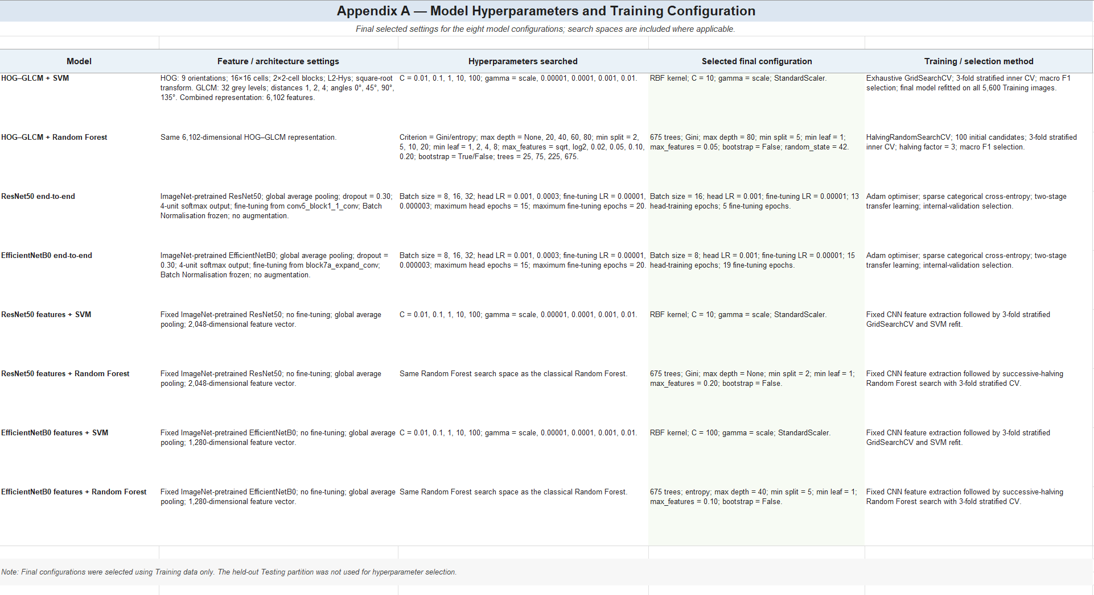

Appendix B Use of AI Tools
ChatGPT and Gemini were used as support tools to clarify technical concepts, improve structure and wording, check spelling and grammar, assist with reference formatting, and help generate some report images and diagrams. All final content, references and methodological decisions were reviewed and edited by the author.

