Parte 1: Desarrollo Base

Modelo de Datos

- Modelo Lógico
Herramienta -> Dbdiagram.com
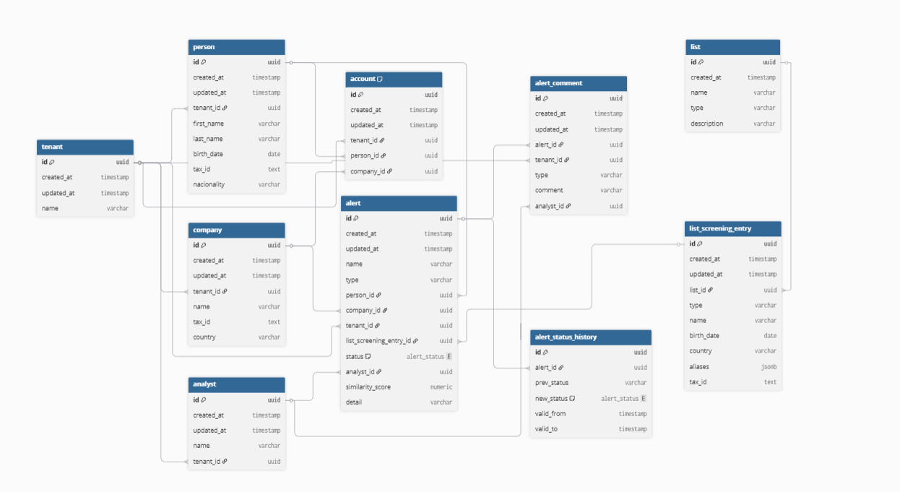
Table tenant {
id uuid [primary key]
created_at timestamp
updated_at timestamp
name varchar
}

Table person {
id uuid [primary key]
created_at timestamp
updated_at timestamp
tenant_id uuid
first_name varchar
last_name varchar
birth_date date
tax_id text
nacionality varchar
}

Table company {
id uuid [primary key]
created_at timestamp
updated_at timestamp
tenant_id uuid
name varchar
tax_id text
country varchar
}

Table account {
id uuid [primary key]
created_at timestamp
updated_at timestamp
tenant_id uuid
person_id uuid
company_id uuid

// Rule: account person/company
Note: 'each account relates to only one person or one company'
}

Table list {
id uuid [primary key]
created_at timestamp
name varchar
type varchar
description varchar
}

Table screening_list_entry {
id uuid [primary key]
created_at timestamp
updated_at timestamp
list_id uuid
type varchar
name varchar
birth_date date
country varchar
aliases jsonb
tax_id text
}

enum alert_status {
PENDING
REVIEWING
CONFIRMED
DISMISSED
}

Table alert {
id uuid [primary key]
created_at timestamp
updated_at timestamp
name varchar
type varchar
person_id uuid
company_id uuid
tenant_id uuid
screening_list_entry_id uuid
status alert_status
analyst_id uuid
similarity_score numeric
detail jsonb
}

Table analyst {
id uuid [primary key]
created_at timestamp
updated_at timestamp
name varchar
tenant_id uuid
}

Table alert_comment {
id uuid [primary key]
created_at timestamp
updated_at timestamp
alert_id uuid
tenant_id uuid
type varchar
comment varchar
analyst_id uuid
}

Table alert_status_history {
id uuid [primary key]
alert_id uuid
prev_status varchar
new_status alert_status
valid_from timestamp
valid_to timestamp
}

Ref tenant_person: person.tenant_id > tenant.id // many-to-one
Ref tenant_company: company.tenant_id > tenant.id // many-to-one
Ref tenant_account: account.tenant_id > tenant.id
Ref account_person: account.person_id > person.id // many-to-one
Ref account_company: account.company_id > company.id // many-to-one
Ref list_list_screening_entry: screening_list_entry.list_id > list.id // many-to-one
Ref screening_list_entry_alert: alert.screening_list_entry_id > screening_list_entry.id // many-to-one
Ref alert_person: alert.person_id > person.id // many-to-one
Ref alert_company: alert.company_id > company.id // many-to-one
Ref analyst_tenant: analyst.tenant_id > tenant.id
Ref alert_analyst: alert.analyst_id > analyst.id
Ref alert_tenant: alert.tenant_id > tenant.id
Ref alert_alert_comment: alert_comment.alert_id > alert.id
Ref alert_comment_tenant: alert_comment.tenant_id > tenant.id
Ref alert_comment_analyst: alert_comment.analyst_id > analyst.id
Ref alert_alert_status_history: alert_status_history.alert_id > alert.id

Fuente: https://dbdiagram.io/d/Complif-Motor-Screening-69de68dd0f7c9ef2c0f6da87

- Modelo Físico
Implementación del modelo físico mediante PgAdmin 4
Diagrama ERD - DBeaver
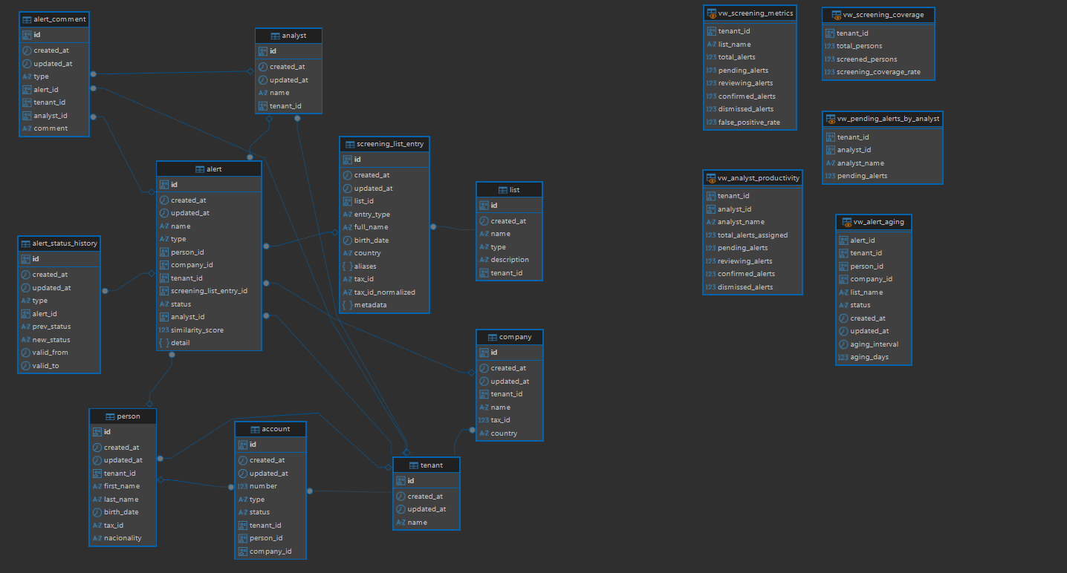

Tablas

- tenant
-- public.tenant definition

-- Drop table

-- DROP TABLE public.tenant;

CREATE TABLE public.tenant (
id uuid DEFAULT uuid_generate_v4() NOT NULL,
created_at timestamptz DEFAULT now() NOT NULL,
updated_at timestamptz DEFAULT now() NOT NULL,
"name" varchar NOT NULL,
CONSTRAINT tenant_pkey PRIMARY KEY (id)
);
ALTER TABLE public.tenant ENABLE ROW LEVEL SECURITY;

- person
-- public.person definition

-- Drop table

-- DROP TABLE public.person;

CREATE TABLE public.person (
id uuid DEFAULT uuid_generate_v4() NOT NULL,
created_at timestamptz DEFAULT now() NOT NULL,
updated_at timestamptz DEFAULT now() NOT NULL,
tenant_id uuid NULL,
first_name varchar NOT NULL,
last_name varchar NOT NULL,
birth_date date NULL,
tax_id text NULL,
nacionality varchar NULL,
CONSTRAINT person_pkey PRIMARY KEY (id),
CONSTRAINT person_tenant_id_fkey FOREIGN KEY (tenant_id) REFERENCES public.tenant(id)
);
ALTER TABLE public.person ENABLE ROW LEVEL SECURITY;

- company
-- public.company definition

-- Drop table

-- DROP TABLE public.company;

CREATE TABLE public.company (
id uuid DEFAULT uuid_generate_v4() NOT NULL,
created_at timestamptz DEFAULT now() NOT NULL,
updated_at timestamptz DEFAULT now() NOT NULL,
tenant_id uuid NOT NULL,
"name" varchar NOT NULL,
tax_id int8 NULL,
country varchar NULL,
CONSTRAINT company_pkey PRIMARY KEY (id),
CONSTRAINT company_tenant_id_fkey FOREIGN KEY (tenant_id) REFERENCES public.tenant(id)
);

- account
-- public.account definition

-- Drop table

-- DROP TABLE public.account;

CREATE TABLE public.account (
id uuid DEFAULT uuid_generate_v4() NOT NULL,
created_at timestamptz DEFAULT now() NOT NULL,
updated_at timestamptz DEFAULT now() NOT NULL,
"number" int4 NOT NULL,
"type" varchar NULL,
status varchar NULL,
tenant_id uuid NOT NULL,
person_id uuid NULL,
company_id uuid NULL,
CONSTRAINT account_owner_check CHECK ((((person_id IS NOT NULL) AND (company_id IS NULL)) OR ((person_id IS NULL) AND (company_id IS NOT NULL)))),
CONSTRAINT account_pkey PRIMARY KEY (id),
CONSTRAINT account_person_id_fkey FOREIGN KEY (person_id) REFERENCES public.person(id),
CONSTRAINT account_tenant_id_fkey FOREIGN KEY (tenant_id) REFERENCES public.tenant(id)
);

- list
-- public.list definition

-- Drop table

-- DROP TABLE public.list;

CREATE TABLE public.list (
id uuid DEFAULT uuid_generate_v4() NOT NULL,
created_at timestamptz DEFAULT now() NOT NULL,
"name" varchar NULL,
"type" varchar NULL,
description varchar NULL,
tenant_id uuid NULL,
CONSTRAINT list_pkey PRIMARY KEY (id)
);

- screening_list_entry
-- public.screening_list_entry definition

-- Drop table

-- DROP TABLE public.screening_list_entry;

CREATE TABLE public.screening_list_entry (
id uuid DEFAULT uuid_generate_v4() NOT NULL,
created_at timestamptz DEFAULT now() NOT NULL,
updated_at timestamptz DEFAULT now() NOT NULL,
list_id uuid NOT NULL,
entry_type varchar NULL,
full_name varchar NULL,
birth_date date NULL,
country varchar NULL,
aliases jsonb NULL,
tax_id text NULL,
tax_id_normalized text NULL,
metadata jsonb NULL,
CONSTRAINT screening_list_entry_pkey PRIMARY KEY (id),
CONSTRAINT screening_list_entry_list_id_fkey FOREIGN KEY (list_id) REFERENCES public.list(id)
);

- analyst
-- public.analyst definition

-- Drop table

-- DROP TABLE public.analyst;

CREATE TABLE public.analyst (
id uuid DEFAULT uuid_generate_v4() NOT NULL,
created_at timestamptz DEFAULT now() NOT NULL,
updated_at timestamptz DEFAULT now() NOT NULL,
"name" varchar NOT NULL,
tenant_id uuid NULL,
CONSTRAINT analyst_pkey PRIMARY KEY (id),
CONSTRAINT analyts_tenant_id_fkey FOREIGN KEY (tenant_id) REFERENCES public.tenant(id)
);

- alert
-- public.alert definition

-- Drop table

-- DROP TABLE public.alert;

CREATE TABLE public.alert (
id uuid DEFAULT uuid_generate_v4() NOT NULL,
created_at timestamptz DEFAULT now() NOT NULL,
updated_at timestamptz DEFAULT now() NOT NULL,
"name" varchar NULL,
"type" varchar NULL,
person_id uuid NULL,
company_id uuid NULL,
tenant_id uuid NOT NULL,
screening_list_entry_id uuid NULL,
status varchar NULL,
analyst_id uuid NULL,
similarity_score numeric NULL,
detail jsonb NULL,
CONSTRAINT alert_owner_check CHECK ((((person_id IS NOT NULL) AND (company_id IS NULL)) OR ((person_id IS NULL) AND (company_id IS NOT NULL)))),
CONSTRAINT alert_pkey PRIMARY KEY (id),
CONSTRAINT alert_status_check CHECK (((status)::text = ANY ((ARRAY['PENDING'::character varying, 'REVIEWING'::character varying, 'CONFIRMED'::character varying, 'DISMISSED'::character varying])::text[]))),
CONSTRAINT alert_analyst_id_fkey FOREIGN KEY (analyst_id) REFERENCES public.analyst(id),
CONSTRAINT alert_company_id_fkey FOREIGN KEY (company_id) REFERENCES public.company(id),
CONSTRAINT alert_person_id_fkey FOREIGN KEY (person_id) REFERENCES public.person(id),
CONSTRAINT alert_screening_list_entry_id_fkey FOREIGN KEY (screening_list_entry_id) REFERENCES public.screening_list_entry(id),
CONSTRAINT alert_tenant_id_fkey FOREIGN KEY (tenant_id) REFERENCES public.tenant(id)
);
CREATE UNIQUE INDEX uq_alert_person_match ON public.alert USING btree (tenant_id, person_id, screening_list_entry_id) WHERE (person_id IS NOT NULL);

-- Table Triggers

create trigger trg_alert_status_history after
update
of status on
public.alert for each row execute function fn_log_alert_status_change();

- alert_status_history
-- public.alert_status_history definition

-- Drop table

-- DROP TABLE public.alert_status_history;

CREATE TABLE public.alert_status_history (
id uuid DEFAULT uuid_generate_v4() NOT NULL,
created_at timestamptz DEFAULT now() NOT NULL,
updated_at timestamptz DEFAULT now() NOT NULL,
"type" varchar NULL,
alert_id uuid NULL,
prev_status varchar NULL,
new_status varchar NULL,
valid_from timestamp NOT NULL,
valid_to timestamp NULL,
CONSTRAINT alert_status_history_pkey PRIMARY KEY (id),
CONSTRAINT alert_status_history_alert_id_fkey FOREIGN KEY (alert_id) REFERENCES public.alert(id)
);

- alert_comment
-- public.alert_comment definition

-- Drop table

-- DROP TABLE public.alert_comment;

CREATE TABLE public.alert_comment (
id uuid DEFAULT uuid_generate_v4() NOT NULL,
created_at timestamptz DEFAULT now() NOT NULL,
updated_at timestamptz DEFAULT now() NOT NULL,
"type" varchar NULL,
alert_id uuid NULL,
tenant_id uuid NULL,
analyst_id uuid NULL,
"comment" varchar NULL,
CONSTRAINT alert_comment_pkey PRIMARY KEY (id),
CONSTRAINT alert_comment_alert_id_fkey FOREIGN KEY (alert_id) REFERENCES public.alert(id),
CONSTRAINT alert_comment_analyst_id_fkey FOREIGN KEY (analyst_id) REFERENCES public.analyst(id),
CONSTRAINT alert_comment_tenant_id_fkey FOREIGN KEY (tenant_id) REFERENCES public.tenant(id)
);

Funciones

- normalize_name(text)
-- DROP FUNCTION public.normalize_name(text);

CREATE OR REPLACE FUNCTION public.normalize_name(p_name text)
RETURNS text
LANGUAGE sql
IMMUTABLE
AS $function$SELECT CASE
WHEN p_name IS NULL THEN NULL
ELSE NULLIF(
trim(
regexp_replace(
regexp_replace(
lower(unaccent(p_name)),
'[^a-z0-9]+', ' ', 'g'
),
'\s+', ' ', 'g'
)
),
''
)
END;$function$
;

- normalize_tax_id
-- DROP FUNCTION public.normalize_tax_id(text);

CREATE OR REPLACE FUNCTION public.normalize_tax_id(tax_id text)
RETURNS text
LANGUAGE sql
IMMUTABLE
AS $function$
SELECT NULLIF(
regexp_replace(upper(trim(coalesce(tax_id, ''))), '[^A-Z0-9]', '', 'g'),
''
);
$function$
;

- seach_by_tax_id
-- DROP FUNCTION public.search_by_tax_id(text, text);

CREATE OR REPLACE FUNCTION public.search_by_tax_id(p_tax_id text, p_country text DEFAULT NULL::text)
RETURNS TABLE(list_name text, entry_id uuid, matched_tax_id text, match_type text, confidence numeric)
LANGUAGE plpgsql
AS $function$
DECLARE
v_normalized_tax_id text;
BEGIN
v_normalized_tax_id := public.normalize_tax_id(p_tax_id);

IF v_normalized_tax_id IS NULL THEN
RETURN;
END IF;

RETURN QUERY
SELECT
l.name AS list_name,
sle.id AS entry_id,
sle.tax_id AS matched_tax_id,
CASE
WHEN sle.tax_id = p_tax_id THEN 'EXACT'
ELSE 'NORMALIZED'
END AS match_type,
CASE
WHEN sle.tax_id = p_tax_id THEN 100
ELSE 95
END AS confidence
FROM public.screening_list_entry sle
JOIN public.list l
ON l.id = sle.list_id
WHERE
sle.tax_id_normalized = v_normalized_tax_id
AND (
p_country IS NULL
OR sle.country = p_country
);
END;
$function$
;

- calculate_similarity
-- DROP FUNCTION public.calculate_similarity(text, text, text, text, date, date, numeric);

CREATE OR REPLACE FUNCTION public.calculate_similarity(p_name1 text, p_name2 text, p_tax_id1 text DEFAULT NULL::text, p_tax_id2 text DEFAULT NULL::text, p_birth_date1 date DEFAULT NULL::date, p_birth_date2 date DEFAULT NULL::date, p_threshold numeric DEFAULT 0.8)
RETURNS TABLE(similarity_score numeric, match_type text, details jsonb)
LANGUAGE plpgsql
AS $function$
DECLARE
v_name_similarity NUMERIC := 0;
v_tax_id_score NUMERIC := 0;
v_birth_date_score NUMERIC := 0;
v_final_score NUMERIC := 0;
BEGIN
-- Similaridad de nombres (0 a 1)
v_name_similarity := similarity(
public.normalize_name(p_name1),
public.normalize_name(p_name2)
);

-- Match exacto de tax_id normalizado
IF p_tax_id1 IS NOT NULL
AND p_tax_id2 IS NOT NULL
AND public.normalize_tax_id(p_tax_id1) = public.normalize_tax_id(p_tax_id2) THEN
v_tax_id_score := 1;
END IF;

-- Match de fecha de nacimiento
IF p_birth_date1 IS NOT NULL AND p_birth_date2 IS NOT NULL THEN
IF p_birth_date1 = p_birth_date2 THEN
v_birth_date_score := 1;
ELSIF EXTRACT(YEAR FROM p_birth_date1) = EXTRACT(YEAR FROM p_birth_date2) THEN
v_birth_date_score := 0.5;
END IF;
END IF;

-- Score final (0 a 100)
v_final_score := (
v_name_similarity * 0.5 +
v_tax_id_score * 0.3 +
v_birth_date_score * 0.2
) * 100;

similarity_score := round(v_final_score, 2);

IF v_tax_id_score = 1 THEN
match_type := 'TAX_ID_EXACT';
ELSIF v_name_similarity >= p_threshold AND v_birth_date_score = 1 THEN
match_type := 'NAME_AND_BIRTHDATE';
ELSIF v_name_similarity >= p_threshold THEN
match_type := 'NAME_FUZZY';
ELSE
match_type := 'NO_MATCH';
END IF;

details := jsonb_build_object(
'name_similarity', round(v_name_similarity::numeric, 4),
'tax_id_match', v_tax_id_score,
'birth_date_score', v_birth_date_score,
'threshold', p_threshold
);

RETURN NEXT;
END;
$function$
;

- run_screening
-- DROP FUNCTION public.run_screening(text, uuid, _text);

CREATE OR REPLACE FUNCTION public.run_screening(p_entity_type text, p_entity_id uuid, p_lists text[] DEFAULT NULL::text[])
RETURNS TABLE(alert_id uuid, list_name text, matched_entry_id uuid, similarity_score numeric, match_details jsonb)
LANGUAGE plpgsql
AS $function$
BEGIN
IF p_entity_type <> 'PERSON' THEN
RETURN;
END IF;
RETURN QUERY
WITH matches AS (
SELECT
p.tenant_id,
p.id AS person_id,
sle.id AS screening_list_entry_id,
l.name AS list_name,
cs.similarity_score,
cs.match_type,
cs.details
FROM public.person p
CROSS JOIN public.screening_list_entry sle
JOIN public.list l
ON l.id = sle.list_id
CROSS JOIN LATERAL public.calculate_similarity(
concat_ws(' ', p.first_name, p.last_name),
sle.full_name,
p.tax_id,
sle.tax_id,
p.birth_date,
sle.birth_date
) cs
WHERE
p.id = p_entity_id
AND sle.entry_type = 'PERSON'
AND (p_lists IS NULL OR l.name = ANY(p_lists))
),
filtered_matches AS (
SELECT *
FROM matches m
WHERE m.similarity_score >= 80
),
inserted_alerts AS (
INSERT INTO public.alert AS a (
id,
created_at,
updated_at,
name,
type,
person_id,
company_id,
tenant_id,
screening_list_entry_id,
status,
analyst_id,
similarity_score,
detail
)
SELECT
uuid_generate_v4(),
now(),
now(),
fm.list_name,
fm.match_type,
fm.person_id,
NULL,
fm.tenant_id,
fm.screening_list_entry_id,
'PENDING',
NULL,
fm.similarity_score,
fm.details
FROM filtered_matches fm
WHERE NOT EXISTS (
SELECT 1
FROM public.alert a2
WHERE a2.person_id = fm.person_id
AND a2.screening_list_entry_id = fm.screening_list_entry_id
AND a2.tenant_id = fm.tenant_id
)
RETURNING
a.id,
a.name,
a.screening_list_entry_id,
a.similarity_score,
a.detail
),
existing_alerts AS (
SELECT
a.id,
a.name,
a.screening_list_entry_id,
a.similarity_score,
a.detail
FROM public.alert a
JOIN filtered_matches fm
ON a.person_id = fm.person_id
AND a.screening_list_entry_id = fm.screening_list_entry_id
AND a.tenant_id = fm.tenant_id
)
SELECT
x.id::uuid AS alert_id,
x.name::text AS list_name,
x.screening_list_entry_id::uuid AS matched_entry_id,
x.similarity_score::numeric,
x.detail::jsonb AS match_details
FROM (
SELECT * FROM inserted_alerts
UNION
SELECT * FROM existing_alerts
) x;
END;
$function$
;

- fn_log_alert_status_change
-- DROP FUNCTION public.fn_log_alert_status_change();

CREATE OR REPLACE FUNCTION public.fn_log_alert_status_change()
RETURNS trigger
LANGUAGE plpgsql
AS $function$
BEGIN
IF NEW.status IS DISTINCT FROM OLD.status THEN
INSERT INTO public.alert_status_history (
id,
created_at,
updated_at,
type,
alert_id,
prev_status,
new_status,
valid_from,
valid_to
)
VALUES (
uuid_generate_v4(),
now(),
now(),
'STATUS_CHANGE',
OLD.id,
OLD.status,
NEW.status,
now(),
NULL
);
END IF;

RETURN NEW;
END;
$function$
;

Disparadores (Triggers)

- trg_alert_status_history
create trigger trg_alert_status_history after
update
of status on
public.alert for each row execute function fn_log_alert_status_change()

Vistas

- vw_alert_aging
-- public.vw_alert_aging source

CREATE OR REPLACE VIEW public.vw_alert_aging
AS SELECT id AS alert_id,
tenant_id,
person_id,
company_id,
name AS list_name,
status,
created_at,
updated_at,
now() - created_at AS aging_interval,
EXTRACT(day FROM now() - created_at) AS aging_days
FROM alert a;

- vw_analyst_productivity
-- public.vw_analyst_productivity source

CREATE OR REPLACE VIEW public.vw_analyst_productivity
AS SELECT a.tenant_id,
a.analyst_id,
an.name AS analyst_name,
count(*) AS total_alerts_assigned,
count(*) FILTER (WHERE a.status::text = 'PENDING'::text) AS pending_alerts,
count(*) FILTER (WHERE a.status::text = 'REVIEWING'::text) AS reviewing_alerts,
count(*) FILTER (WHERE a.status::text = 'CONFIRMED'::text) AS confirmed_alerts,
count(*) FILTER (WHERE a.status::text = 'DISMISSED'::text) AS dismissed_alerts
FROM alert a
LEFT JOIN analyst an ON an.id = a.analyst_id
GROUP BY a.tenant_id, a.analyst_id, an.name;

- vw_pending_alerts_by_analyst
-- public.vw_pending_alerts_by_analyst source

CREATE OR REPLACE VIEW public.vw_pending_alerts_by_analyst
AS SELECT a.tenant_id,
a.analyst_id,
an.name AS analyst_name,
count(*) AS pending_alerts
FROM alert a
LEFT JOIN analyst an ON an.id = a.analyst_id
WHERE a.status::text = ANY (ARRAY['PENDING'::character varying, 'REVIEWING'::character varying]::text[])
GROUP BY a.tenant_id, a.analyst_id, an.name;

- vw_screening_coverage
-- public.vw_screening_coverage source

CREATE OR REPLACE VIEW public.vw_screening_coverage
AS SELECT tenant_id,
count(*) AS total_persons,
count(*) FILTER (WHERE (EXISTS ( SELECT 1
FROM alert a
WHERE a.person_id = p.id))) AS screened_persons,
round(count(*) FILTER (WHERE (EXISTS ( SELECT 1
FROM alert a
WHERE a.person_id = p.id)))::numeric / NULLIF(count(*), 0)::numeric, 4) AS screening_coverage_rate
FROM person p
GROUP BY tenant_id;

- vw_screening_metrics
-- public.vw_screening_metrics source

CREATE OR REPLACE VIEW public.vw_screening_metrics
AS SELECT tenant_id,
name AS list_name,
count(*) AS total_alerts,
count(*) FILTER (WHERE status::text = 'PENDING'::text) AS pending_alerts,
count(*) FILTER (WHERE status::text = 'REVIEWING'::text) AS reviewing_alerts,
count(*) FILTER (WHERE status::text = 'CONFIRMED'::text) AS confirmed_alerts,
count(*) FILTER (WHERE status::text = 'DISMISSED'::text) AS dismissed_alerts,
round(count(*) FILTER (WHERE status::text = 'DISMISSED'::text)::numeric / NULLIF(count(*) FILTER (WHERE status::text = ANY (ARRAY['CONFIRMED'::character varying, 'DISMISSED'::character varying]::text[])), 0)::numeric, 4) AS false_positive_rate
FROM alert a
GROUP BY tenant_id, name;

