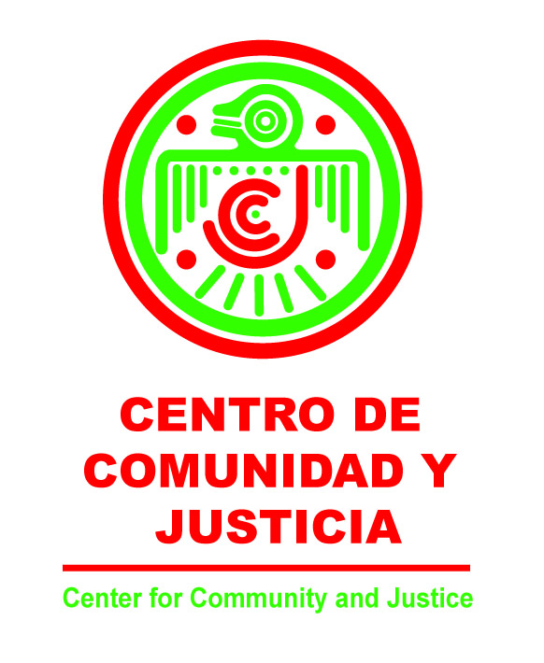

Consent Form for a Minor to participate in ¡Cuidate!
A Culturally-based Program to reduce unplanned pregnancy and
HIV sexual risk behavior among Latino youth

A program sponsored by the Center for Community & Justice

Your daughter/son, ________________________________ has the chance to participate in an exciting and fun program to help Latino youth learn about their health. The Purpose of this program is to help your daughter/son behave in ways that will support good health and protect them from unplanned pregnancy or developing serious health problems like sexually transmitted diseases including HIV/AIDS.

This program has been used with hundreds of Latino youth in the United States and Mexico and has been proven to be effective in helping reduce their risk of risky sexual behavior. As a parent you can support your son or daughter in staying healthy.

During the ¡Cuidate! program your daughter/son will be involved in a variety of leaning experiences, including small group discussions, films/videos, games, exercises, and role-playing designed to teach youth about different health problems – including teen pregnancy and STD’s including HIV/AIDS – and how they can be avoided. Your daughter/son will be learning important information in a supportive, fun, and informative program designed specifically for Latino youth.

You are welcome to review the contents of the program and the teaching materials before the program starts. If you have any questions about the program, need additional information, or to set-up a time to view the materials, please contact Alfredo Hernandez or Sam Byrd at (208) 378-1368.

I have read and understand the information given above. I have been given the opportunity to ask questions and review program materials. My questions have been answered to my satisfaction.

I agree to have my daughter/son participate in the program. Upon signing below, I understand that one copy of this document will be kept together with your records

Student’s Name: ________________________________________________________________

Parent/Guardian Name: __________________________________________________________

Parent/Guardian/s Signature: ______________________________________Date: ___________


Phone Number:___________________________________

