Gwen Carter
EKU CSC 340 11/07/2025
Hospital management System
Design Specification Report

Table of Contents
I. Introduction 2
A. Problem Statement 2
B. (System) Proposal 2
II. System Description 2
III. System Requirements 2
A. Functional Requirements 2
B. Non-Functional Requirements 2
IV. Use Case Diagram 17
V. Class Diagram 19
VI. Sequence Diagrams 19
VII. State Diagram 26
VIII. Activity Diagram 26
IX. Database Design 30
A. ER Diagram/Schema 30
B. Table Schema 30
X. Conclusion 30

Introduction

Problem Statement
The Richmond Medical Center is trying to use a computer to help their users with different requests. They don’t have a software system to do it. They are in need of a system to help with the service provided to their customers through a computer.

(System) Proposal
We propose a Hospital Management software system to help the center provide different services to its customers.

System Description
The Richmond Medical center has requested that we create a Management System that patients and staff can use. Patients are able to make or cancel an appointment, request medication, or pay their bills. A clerk is able to view paid and unpaid bills. A schedular can approve or deny an appointment request. A doctor can approve medication requests.

System Requirements

Functional Requirements
- The system shall allow a patient to make an appointment.
  - The system shall display a menu to the patient.
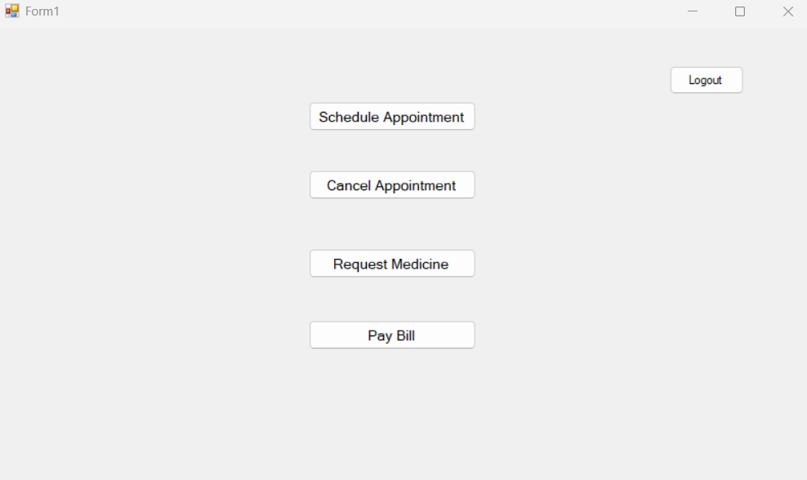
  - The patient shall press the “Schedule Appointment” button.
  - The system shall retrieve and display a list of patients’ doctors.
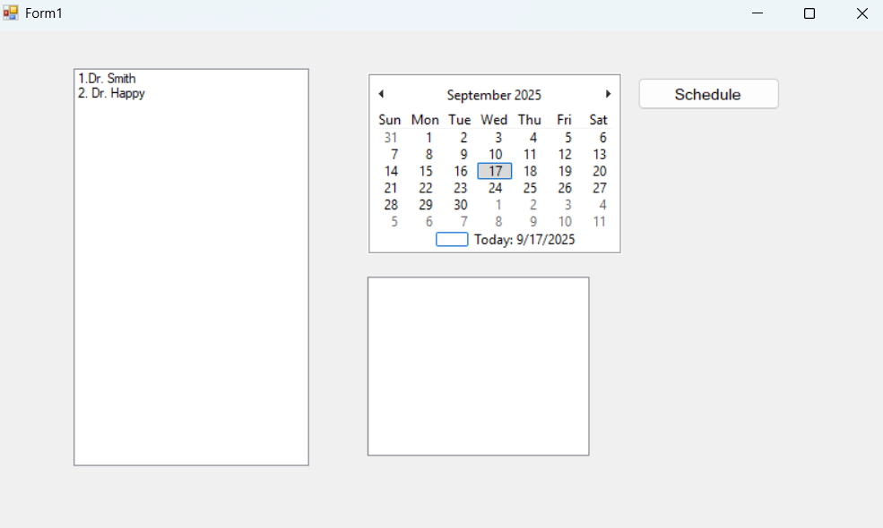
  - The patient shall select a doctor from the list.
  - The system shall display the selected doctor’s schedule for the following twelve months.
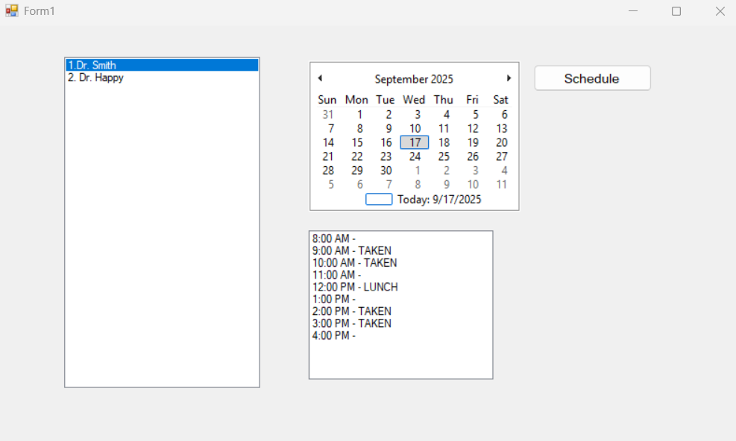
  - The patient shall select a date from the calendar.
  - The system shall display the schedule on the selected date.

  - The patient shall select a time for reserving an appointment.
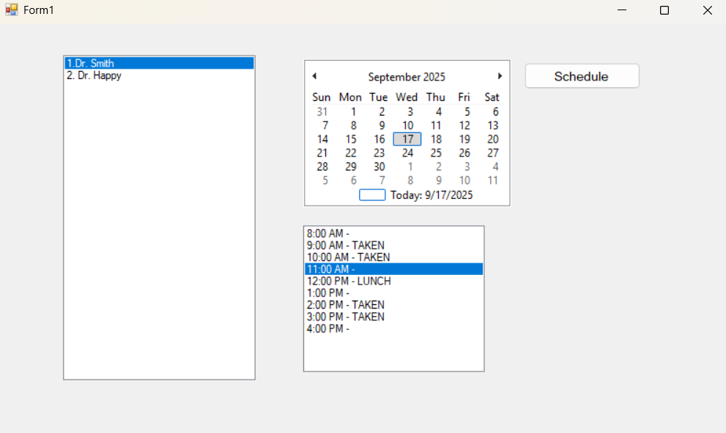
  - The system shall reserve the time and date for the patient.
    - The system shall send a note to the schedule for confirmation.
  - The system shall return to the main menu
- The system shall allow a schedule to confirm an appointment.
  - The system shall send a note to the schedule after a patient reserves an appointment
  - The system shall highlight the incoming note on the main menu.
  - The system shall display a list of incoming notes.
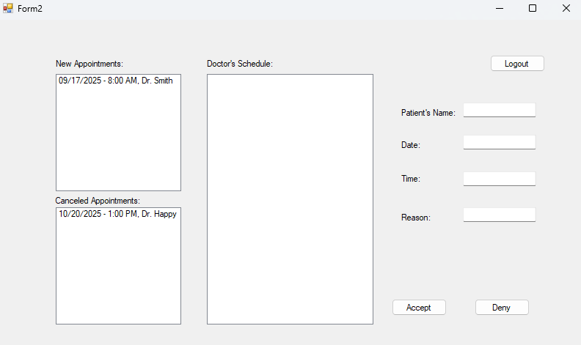
  - The schedule shall select a note from the list.
  - The system shall display the selected doctor’s schedule in the note.
  - The schedule shall open the note.
  - The system shall display the selected doctor’s schedule.
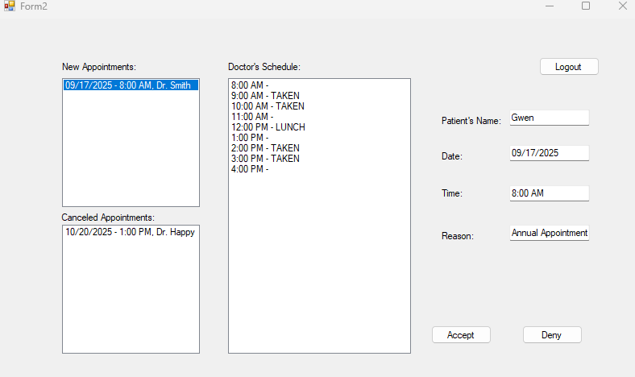
  - The schedule shall send a note back to the patient.
    - If there are no issues with the appointment, send a confirmation note to the patient.
      - The system shall save and update the confirmed appointment in the database.
    - If there is an issue, send a cancelation note to the patient.
  - The system shall return back to the main menu.
- The system shall allow the patient to cancel an appointment.
  - The system shall display a menu to the patient.

  - The patient shall press the “Cancel Appointment” Button
  - The system shall display a list of current appointments scheduled for the patient
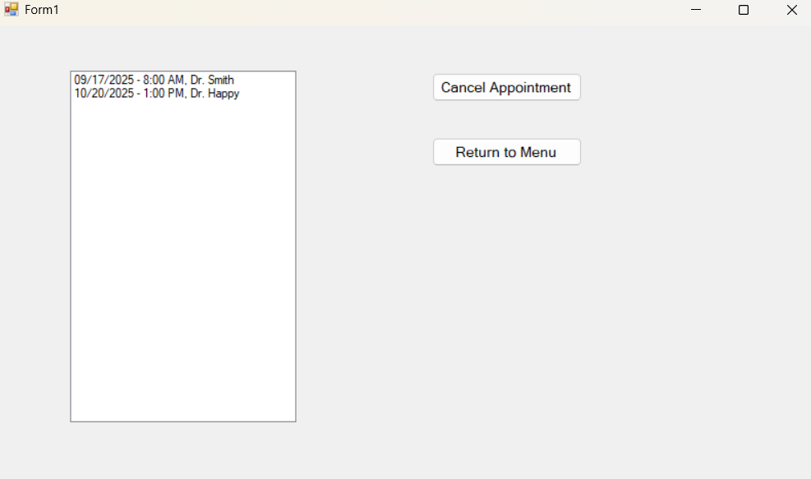
  - The patient shall select the appointment they want to cancel
  - The patient shall press the “Cancel Appointment” Button
  - The system shall send a note to the schedular.
  - The patient shall remain on the cancel appointment screen or hit a “return” button to return to the menu
- The system shall allow the schedular to confirm the cancelation.
  - The system shall send all cancelled appointments after a patient cancels their appointment to the schedular.
  - The system shall display all canceled appointments.
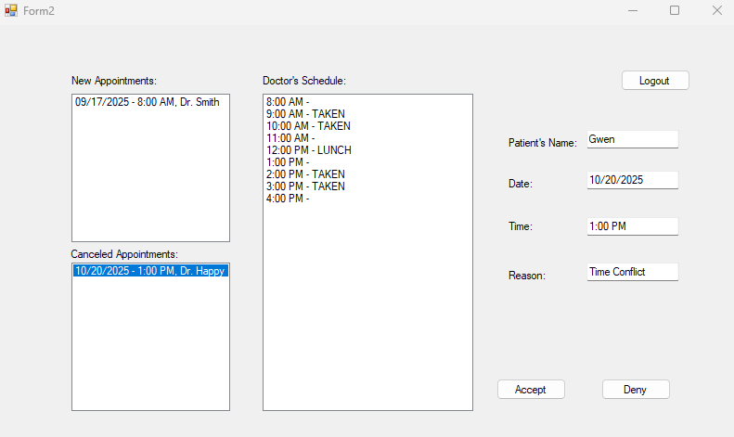
  - The schedular shall remove the appointment from the doctor’s schedule
  - The system shall send a note to the patient confirming successful cancelation.
- The system shall allow the patient to request medicine.
  - The system shall display a menu to the patient

  - The patient shall press the “Request Medicine” Button
  - The system shall display a list of available medicine.
    - If the patient wants a different medicine, they must schedule an appointment
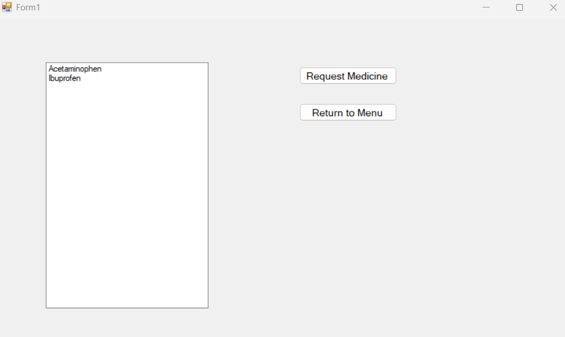
  - The patient shall select the medicine they want
  - The patient shall press the “Request Medicine” button
    - The system shall check if the patient is required to visit their doctor to request medicine
      - If the patient doesn’t, the system shall send a note to the doctor
      - If the patient does, the system shall prompt the patient to schedule an appointment
  - The system shall display a “Return” button
  - The patient shall press the “Return" button
  - The system shall return the patient to the menu
- The system shall allow the doctor to accept requested medicine
  - The system shall send a note to the doctor.
  - The system shall display all medicine requests to the doctor
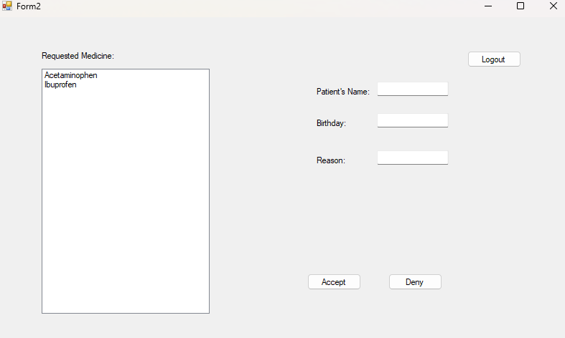
  - The doctor shall select a note
  - The system shall display the patient’s information
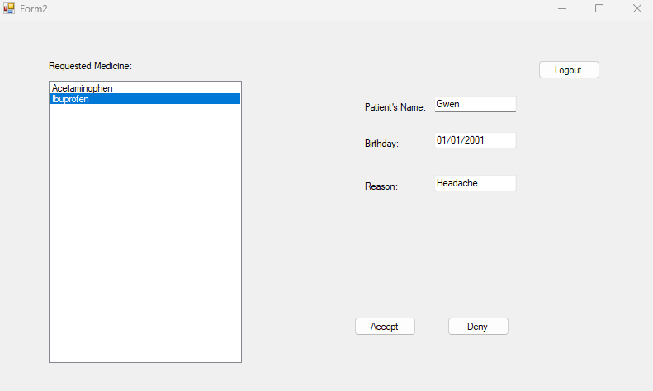
  - The doctor shall accept or reject the request.
    - If the doctor accepts the request, the system shall send a note to the patient
    - If the doctor rejects the request, the system shall allow the doctor to input a reason and the system shall send a note to the patient
  - The system shall return the doctor to the screen
- The system shall allow the patient to pay their bill
  - The system shall display a menu to the patient

  - The patient shall press the “Pay Bill” button
  - The system shall display bill information to the patient
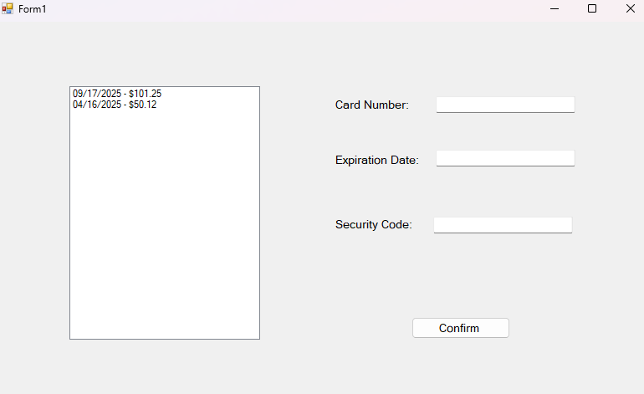
  - The system shall allow the patient to enter their payment information
  - The patient shall input their payment information into the text box
  - The patient shall press the “Confirm” button
    - If the payment goes through, send a confirmation note to the patient
      - The system shall send a note to the Clerk
    - If the payment fails, send a failure note to the patient
  - The system shall return the patient to the payment menu
- The system shall allow the clerk to review bill payment.
  - The system shall display a patient payment list
  - The system shall display two lists, one with unpaid bills and the other with paid bills
    - The system shall display the patients’ name and the amount of the bill
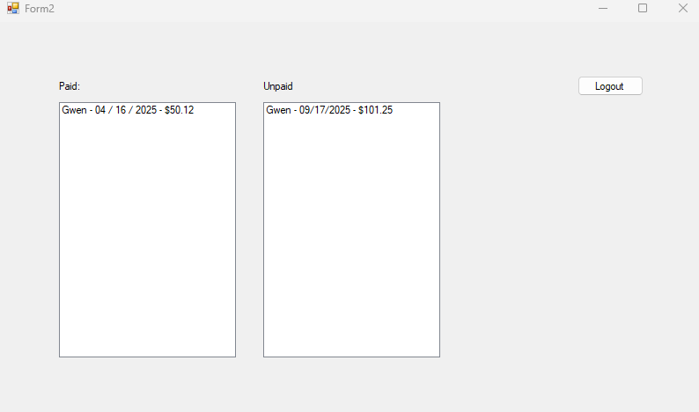
  - The clerk shall return to the menu
- The system shall allow a user to log in to the system.
  - The system shall display a login page to the user
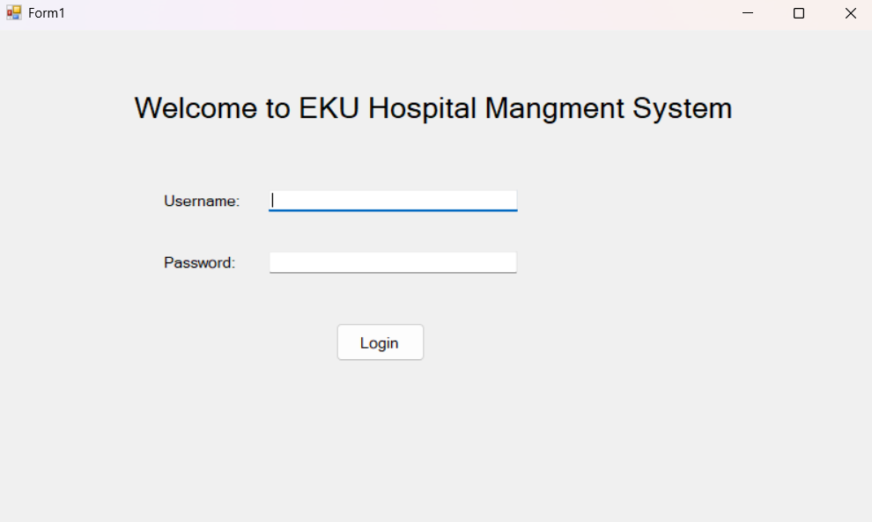
  - The User shall enter username and password and press the “Login” button
  - The system shall validate the username and password
    - If the username and password are valid, the system shall display the main menu to the user
    - If the username and password are not valid, the system shall display an error message to the user
      - The user shall press a return button
      - The system shall return the user to the login page (return to 3.1)
- The system shall allow all actors to log out.
  - The system shall display the respective actor menu to the current user
  - The system shall display a “Logout” Button
Clerk:

Doctor:

Schedular:

Patient:

  - The user shall press the “Logout” button
  - The system shall return to the login menu

Non-Functional Requirements
- The system shall be connected to a database
- The system shall effectively send notes to its different parts
- The system shall handle all new and existing clients without issue

Use Case Diagram
The following use case diagram shows the functions that will be implemented in this project. The functions include:
Make Appointment – a patient is able to request an appointment with a certain doctor provided there is an available time. A schedular confirms the appointment for the scheduled appointment.
Cancel Appointment – a patient is able to cancel any previously made appointments. A scheduler confirms the cancelation.
Logout system – all users, patients, schedular, doctor and clerk, are able to log out of the system
Request medicine – a patient is able to request medicine from their doctor. They may be required to visit their doctor in person before the doctor will approve. The doctor is able to approve the medicine request.
Pay bill – a patient is able to access a pay portal to pay any remaining balance of their account. A clerk is able to confirm and keep record of the payment.
Login system – A user is able to login to their account using a username and password.

Class Diagram
The Class Diagram showcases the attributes needed for the system as well as needed functions for their interactions. The top are the attributes, and the bottom is the functions.

Sequence Diagrams
Make Appointment:
Cancel Appointment:
Logout:
Request Medicine:
Pay Bill:
Login:
Sequence Diagrams show the order events should take place. The messages take place based on the height of the event. The lower the action, the later it takes place.

State Diagram
Figure 1 State Diagram for Appointment Reservation
State diagram of the given states the system will be in for certain action. It also shows the states the system will go to base on certain conditions.

Activity Diagram
Make Appointment:
Cancel Appointment:
Logout:
Request Medicine:
Pay Bill:
Login:
The activity diagrams show what actions are being done by each object. All objects are separated by their own swim lane.

Database Design

ER Diagram/Schema
This ER Diagram describes and shows the relationship between tables. It also shocses the tables attributes in the color purple. The relationships are shown using orange diamonds with relationships (1-1, 1-M, M-M) in text along the lines.

Table Schema
The table schema highlights the attributes of the table along with their primary keys. It also shows which tables are connected to each other.

Conclusion
This report outlines the development of a Hospital Management system. This was done through functional and non-functional requirements with pictures. This report also showcased a use case diagram and domain diagram.

