While trying to import Part_1_Crime_Data_dups_removed.csv

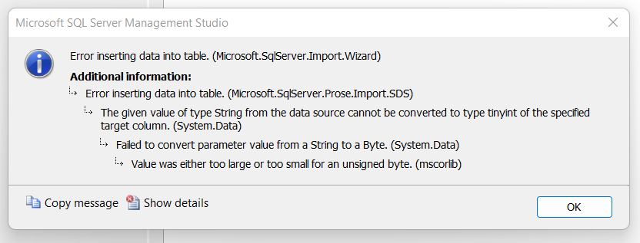

Uncheck:

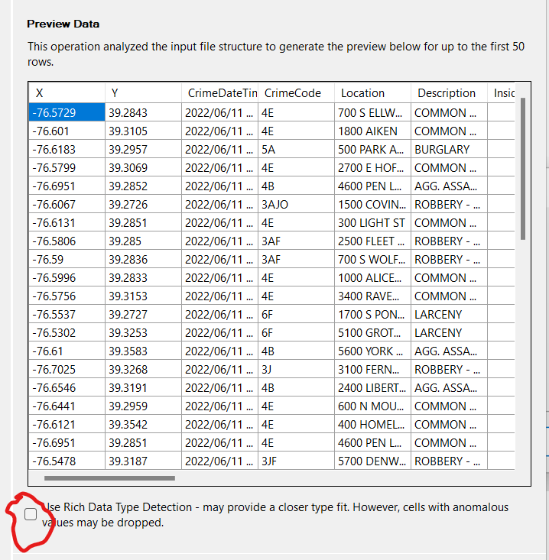

Allow NULLS for all fields

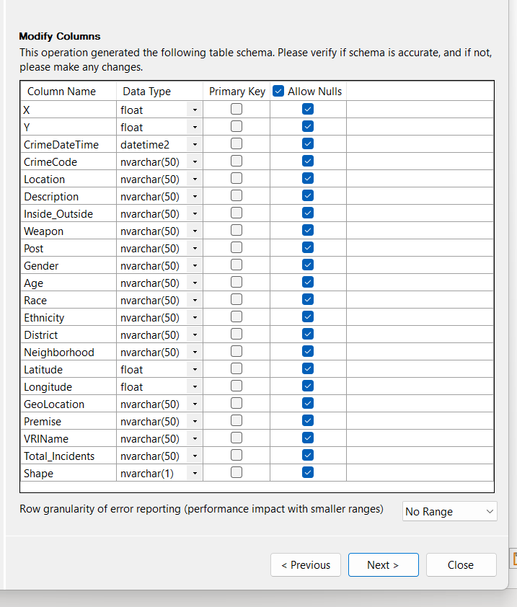

… and now insert(import) was successful

Original dataset: Part_1_Crime_Data_.csv

Rec count: 524,392

Because this is a mapping exercise we will all records missing lng and/or lat; these values would be difficult to impute.

Revised dataset: Part_1_Crime_Data_complete_lnglat_.csv

Rec count: 523,120

After omission no duplicates found

Needed to modify data types to get import to succeed

